Appendix 3: Statistics for the year ended 30 June 2006
This appendix contains statistical information on different aspects of the Tribunal’s workload during 2005–06. In some areas, information relating to previous years has been provided for the purposes of comparison.
The information contained in this appendix is summarised below.
Table or chart reference | Overview of information contained in table or chart
3.1 | Lodgements and finalisations for all jurisdictions
3.2 | Lodgements in each registry
3.3 | Finalisations in each registry
3.4 | Finalisations without a hearing
3.5 | Outcomes of matters finalised
3.6 | Status of current applications
3.7 | Current applications in each registry
3.8 | Constitution of tribunals for hearings
3.9 | Case events, including conferences and other alternative dispute resolution processes, interlocutory hearings and hearings
3.10 | Appeals lodged from decisions of the Tribunal by jurisdiction
3.11 | Outcomes of appeals from decisions of the Tribunal
3.12 | Outcomes of appeals from decisions of the Tribunal by jurisdiction

Table 3.1 provides more detailed information on the subject matter of applications lodged with the Tribunal and finalised by the Tribunal in 2005-06. Information relating to the Tribunal’s major jurisdictions is set out first. This is followed by information on other applications grouped by Australian Government portfolio.

Table 3.1 Applications lodged and finalised in 2005–06
Jurisdiction | Applications lodged |  |  | Applications finalised
Jurisdiction | No. |  | % | No. |  | %
Compensation
Australian Postal Corporation | 360 |  |  |  | 343
Comcare | 517 |  |  |  | 472
Military compensation: Safety, Rehabilitation and Compensation Act 1988 | 346 |  |  |  | 361
Optus Administration Pty Ltd | 3 |  |  |  | -
Other compensation decision-makers | 22 |  |  |  | 18
Telstra Corporation | 201 |  |  |  | 250
Seafarers’ compensation | 53 |  |  |  | 51
Subtotal | 1502 | 17 |  |  | 1495 |  | 18
Social security
Age pension | 107 |  |  |  | 98
Assurance of support decisions | 4 |  |  |  | 1
Austudy payment | 8 |  |  |  | 14
Bereavement allowance | 1 |  |  |  | 1
Carer payment/allowance | 60 |  |  |  | 56
Child care benefit | - |  |  |  | 2
Compensation preclusion period | 68 |  |  |  | 53
Disability support pension | 543 |  |  |  | 376
Double orphan pension | 1 |  |  |  | 1
Family tax benefit | 61 |  |  |  | 63
Farm household support | 1 |  |  |  | 1
Health care cards | 2 |  |  |  | 2
Maternity allowance | 21 |  |  |  | 13
Mature age allowance | 2 |  |  |  | 3
Mobility allowance | 3 |  |  |  | 6
Newstart allowance | 98 |  |  |  | 79
One-off payments | 1 |  |  |  | 2
Overpayment and debt recovery | 481 |  |  |  | 434
Parenting payment | 68 |  |  |  | 47
Partner allowance | 9 |  |  |  | 9
Pension bonus scheme | 25 |  |  |  | 27
Pensioner education supplement | 4 |  |  |  | 4
Rent assistance | 18 |  |  |  | 20
Sickness allowance | 3 |  |  |  | 2
Special benefit | 10 |  |  |  | 9
Special category visa holder determination | - |  |  |  | 2
Widow allowance/pension | 9 |  |  |  | 6
Wife pension | 2 |  |  |  | -
Youth allowance | 33 |  |  |  | 28
Subtotal | 1643 | 19 |  |  | 1359 |  | 17
Veterans’ affairs
Allowances and benefits | 10 |  |  |  | 16
Disability pension | 661 |  |  |  | 750
Gold Card | 3 |  |  |  | 3
Military compensation: Military Rehabilitation and Compensation Act 2004 | 1 |  |  |  | -
Service pension | 52 |  |  |  | 75
Veterans’ Review Board: Procedural decisions | 2 |  |  |  | 6
Widows’ pension | 181 |  |  |  | 188
Subtotal | 910 | 11 |  |  | 1038 |  | 13
Taxation (other than STCT applications) ª
Australian Business Number | 4 |  |  |  | 3
Excise | - |  |  |  | 1
Fringe benefits tax | 24 |  |  |  | 16
Goods and services tax | 240 |  |  |  | 128
Income tax (other than taxation schemes) | 746 |  |  |  | 696
Luxury car tax | 1 |  |  |  | 1
Payroll tax | - |  |  |  | 17
Product grants and benefits | 3 |  |  |  | -
Sales tax | - |  |  |  | 8
Superannuation contributions tax | 3 |  |  |  | 4
Superannuation guarantee charge | 64 |  |  |  | 20
Taxation administration | 41 |  |  |  | 33
Taxation schemes | 2354 |  |  |  | 2000
Wine equalisation tax | 1 |  |  |  | -
Subtotal | 3481 | 40 |  |  | 2927 |  | 36
Small Taxation Claims Tribunal ª
Goods and services tax | 3 |  |  |  | 4
Income tax (other than taxation schemes) | 85 |  |  |  | 108
Other matters | 52 |  |  |  | 27
Refusal of extension of time to lodge objection | 24 |  |  |  | 22
Release from taxation liabilities | 60 |  |  |  | 63
Sales tax | 3 |  |  |  | 1
Superannuation contributions tax | 5 |  |  |  | 8
Taxation schemes | - |  |  |  | 5
Subtotal | 232 | 3 |  |  | 238 |  | 3
Agriculture, Fisheries and Forestry Portfolio
Agricultural and veterinary chemicals | 2 |  |  |  | 1
Dairy produce | - |  |  |  | 1
Fisheries | 2 |  |  |  | 7
Wine and brandy | 1 |  |  |  | 1
Subtotal | 5 | <1 |  |  | 10 |  | <1
Attorney-General’s Portfolio
Bankruptcy | 30 |  |  |  | 32
Customs | 12 |  |  |  | 45
Import and export of censored goods | 1 |  |  |  | 1
Marriage celebrants | 2 |  |  |  | 2
Privacy | 1 |  |  |  | 1
Waiver of fees in courts and tribunals | 2 |  |  |  | 5
Subtotal | 48 | <1 |  |  | 86 |  | 1
Communications, Information Technology and the Arts Portfolio
Communications and media | 1 |  |  |  | 4
Subtotal | 1 | <1 |  |  | 4 |  | <1
Defence Portfolio
Defence Force retirement and death benefits | 9 |  |  |  | 11
Employer support payments | 1 |  |  |  | 1
Other | 1 |  |  |  | 1
Subtotal | 11 | <1 |  |  | 13 |  | <1
Education, Science and Training Portfolio
Higher education funding | 21 |  |  |  | 19
Mutual recognition of occupations | - |  |  |  | 3
Subtotal | 21 | <1 |  |  | 22 |  | <1
Employment and Workplace Relations Portfolio
Disability services | 1 |  |  |  | -
Subtotal | 1 | <1 |  |  | - |  | <1
Environment and Heritage Portfolio
Environment protection and biodiversity | 2 |  |  |  | 2
Great Barrier Reef Marine Park | - |  |  |  | 1
Protection of moveable cultural heritage | - |  |  |  | 1
Renewable Energy | - |  |  |  | 1
Subtotal | 2 | <1 |  |  | 5 |  | <1
Families, Community Services and Indigenous Affairs Portfolio
Aboriginal councils and associations | - |  |  |  | 1
Subtotal | - | <1 |  |  | 1 |  | <1
Finance and Administration Portfolio
Child support | 32 |  |  |  | 32
Lands acquisition | - |  |  |  | 1
Superannuation Acts | 1 |  |  |  | -
Subtotal | 33 | <1 |  |  | 33 |  | <1
Foreign Affairs and Trade Portfolio
Export market development grants | 6 |  |  |  | 6
Passports | 21 |  |  |  | 10
Subtotal | 27 | <1 |  |  | 16 |  | <1
Health and Ageing Portfolio
Aged care | 11 |  |  |  | 6
Medicare Australia decisions | 13 |  |  |  | 9
Pharmacists | 11 |  |  |  | 8
Therapeutic goods | 10 |  |  |  | 8
Subtotal | 45 | <1 |  |  | 31 |  | <1
Immigration and Multicultural Affairs Portfolio
Business visa cancellation | 119 |  |  |  | 169
Citizenship | 69 |  |  |  | 97
Criminal deportation | - |  |  |  | 2
Guardianship of children | - |  |  |  | 1
Migration agent registration | 13 |  |  |  | 31
Protection visa cancellation or refusal | 1 |  |  |  | 6
Visa refusal on character grounds: Visa applicant outside Australia | 19 |  |  |  | 52
Visa cancellation or refusal on character grounds: Visa applicant or holder in Australia | 47 |  |  |  | 60
Subtotal | 268 | 3 |  |  | 418 |  | 5
Industry, Tourism and Resources Portfolio
Automotive industry | 7 |  |  |  | 3
Industrial chemicals | 3 |  |  |  | -
Industry research and development | 5 |  |  |  | 6
Patents, designs and trademarks | - |  |  |  | 2
Textile, clothing and footwear | 3 |  |  |  | 3
Subtotal | 18 | <1 |  |  | 14 |  | <1
Transport and Regional Services Portfolio
Air navigation | - |  |  |  | 1
Airports | - |  |  |  | 3
Aviation and maritime security | 9 |  |  |  | 5
Civil aviation | 21 |  |  |  | 31
Maritime safety | 4 |  |  |  | 1
Motor vehicle standards | 19 |  |  |  | 20
Subtotal | 53 | <1 |  |  | 61 |  | <1
Treasury Portfolio
Auditors and liquidators registration | 2 |  |  |  | -
Corporations | 20 |  |  |  | 35
Insurance and superannuation regulation | 31 |  |  |  | 23
Tax agents registration | 21 |  |  |  | 25
Subtotal | 74 | <1 |  |  | 83 |  | 1
Security Appeals
ASIO assessments | 9 |  |  |  | 3
Subtotal | 9 | <1 |  |  | 3 |  | <1
Whole of Government
Freedom of Information Act 1982 | 141 |  |  |  | 146
Subtotal | 141 | 2 |  |  | 146 |  | 2
Case Management and Tribunal Decisions
No jurisdiction/Uncertain jurisdiction | 92 |  |  |  | 87
Review of taxation of costs | - |  |  |  | 1
Subtotal | 92 | 1 |  |  | 88 |  | 1
Total for all jurisdictions^{b} | 8617 | 100 |  |  | 8091 |  | 100

a These figures do not include all applications that are dealt with in the Small Taxation Claims Tribunal or the Taxation Appeals Division. For example, applications in relation to which jurisdictional issues arise are not included in these figures.
b Percentages do not total 100% due to rounding.

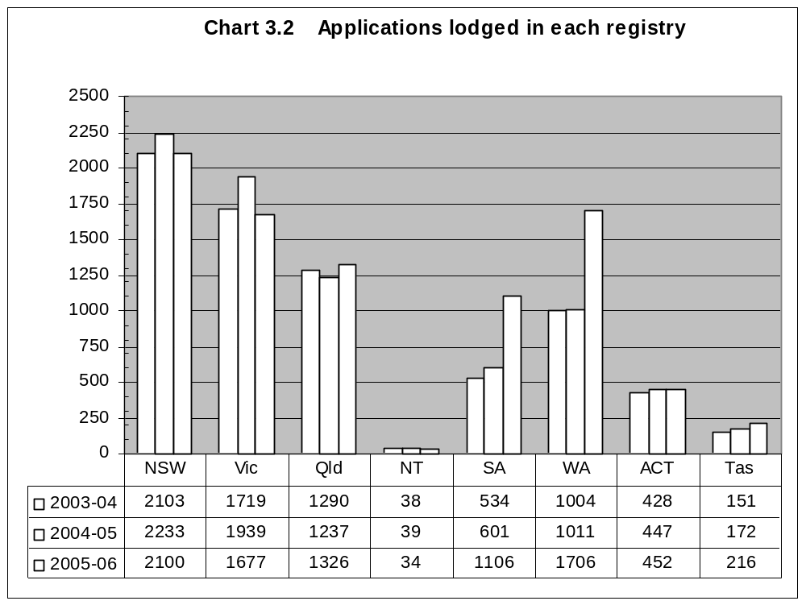
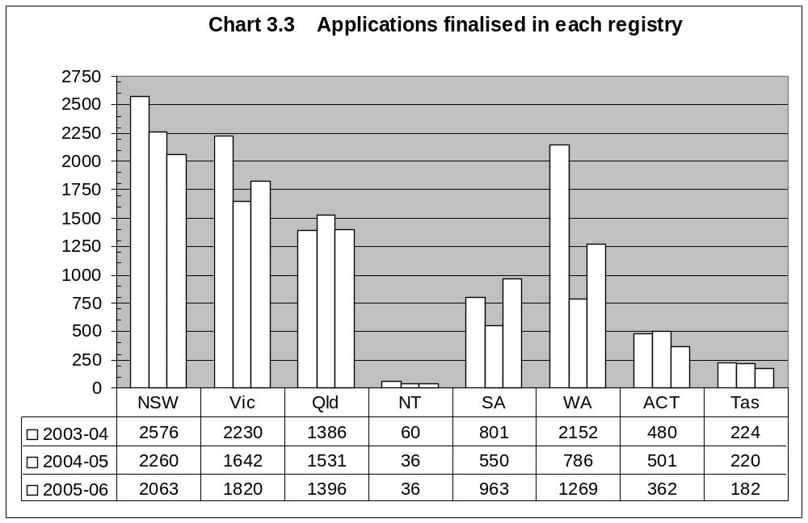
Table 3.4 Percentage of applications finalised without a hearing

Jurisdiction | 2003–04 | 2004–05 | 2005–06
 | % | % | %
All applications | 81 | 78 | 81
Compensation | 86 | 87 | 85
Social security | 69 | 73 | 68
Veterans’ affairs | 71 | 71 | 72
Taxation Division | 97 | 83 | 94
Small Taxation Claims Tribunal | 85 | 75 | 78

Note: Applications finalised without a hearing include all applications that were finalised otherwise than by a Tribunal decision following a hearing on the merits. This includes, for example, applications finalised in accordance with terms of agreement lodged by the parties pursuant to sections 34D or 42C of the AAT Act, applications withdrawn by the applicant under subsection 42A(1A) and applications dismissed by the Tribunal under sections 42A and 42B.

Table 3.5 Applications finalised in 2005–06, by outcome

 | All applications |  | Compensation |  | Social security |  | Veterans’ affairs |  | Taxation Division |  | Small Taxation Claims Tribunal
Outcome | No. | % | No. | % | No. | % | No. | % | No. | % | No. | %
By consent
Affirmed | 321 | 4 | 284 | 19 | 2 | <1 | 7 | <1 | 20 | <1 | 2 | 1
Varied | 1207 | 15 | 115 | 8 | 18 | 1 | 104 | 10 | 917 | 31 | 41 | 17
Set aside | 2009 | 25 | 493 | 33 | 159 | 12 | 281 | 27 | 876 | 30 | 30 | 12
Dismissed / Withdrawnª | 2089 | 26 | 337 | 23 | 666 | 49 | 343 | 33 | 376 | 13 | 94 | 39
By decision
Affirmed | 961 | 12 | 141 | 9 | 296 | 22 | 178 | 17 | 85 | 3 | 42 | 17
Varied | 93 | 1 | 13 | <1 | 19 | 1 | 14 | 1 | 21 | <1 | 2 | 1
Set aside | 467 | 6 | 69 | 5 | 119 | 9 | 98 | 9 | 65 | 2 | 10 | 4
No jurisdiction | 87 | 1 | 6 | <1 | 1 | <1 | 2 | <1 | 22 | <1 | 2 | 1
Dismissed^{b} | 282 | 3 | 28 | 2 | 43 | 3 | 11 | 1 | 100 | 3 | 17 | 7
Extension of time refused | 59 | <1 | 6 | <1 | 34 | 3 | 0 | 0 | 1 | <1 | 1 | <1
Other
No fee paid | 64 | <1 | N/A | - | N/A | - | N/A | - | 20 | <1 | 3 | 1
Other ^{c} | 452 | 6 | 3 | <1 | 2 | <1 | 0 | 0 | 433 | 15 | 0 | 0
Total^{d} | 8091 |  | 1495 |  | 1359 |  | 1038 |  | 2936 |  | 244

a Includes applications dismissed under subsections 42A(1) and (1B) of the AAT Act and otherwise by operation of law.
b Includes applications dismissed under subsections 42A(2) of the AAT Act (non-appearance at case event), 42A(4) (failure to show reviewable decision); 42A(5) (failure to proceed with application or to comply with a direction of the Tribunal); and 42B(1) (applications is frivolous or vexatious).
c Includes applications for review of a decision which have been lodged out of time and in relation to which no extension of time application is subsequently received as well as applications for an extension of time to lodge an application for review which have been granted and in relation to which no application for review of a decision is subsequently received. The SA Registry received 414 applications for an extension of time to lodge applications for review of decisions relating to three taxation schemes which were granted and in relation to which no applications for review were subsequently received.
d Percentages do not total 100% due to rounding.

Table 3.6 Status of applications current as at 30 June 2006

Jurisdiction | No. | %
Compensation
In pre-hearing process | 1378
Part heard | 53
Awaiting decision | 15
Subtotal | 1446 | 18
Social security
In pre-hearing process | 932
Part heard | 24
Awaiting decision | 12
Subtotal | 968 | 12
Veterans’ affairs
In pre-hearing process | 719
Part heard | 23
Awaiting decision | 15
Subtotal | 757 | 9
Taxation Division
In pre-hearing process | 4344
Part heard | 11
Awaiting decision | 11
Subtotal | 4366 | 53
Small Taxation Claims Tribunal
In pre-hearing process | 109
Part heard | 0
Awaiting decision | 0
Subtotal | 109 | 1
Other matters
In pre-hearing process | 477
Part heard | 30
Awaiting decision | 21
Subtotal | 528 | 6
Totalª | 8174 | 100
a Percentages do not total 100% due to rounding.
Chart 3.7 Applications current in each registry
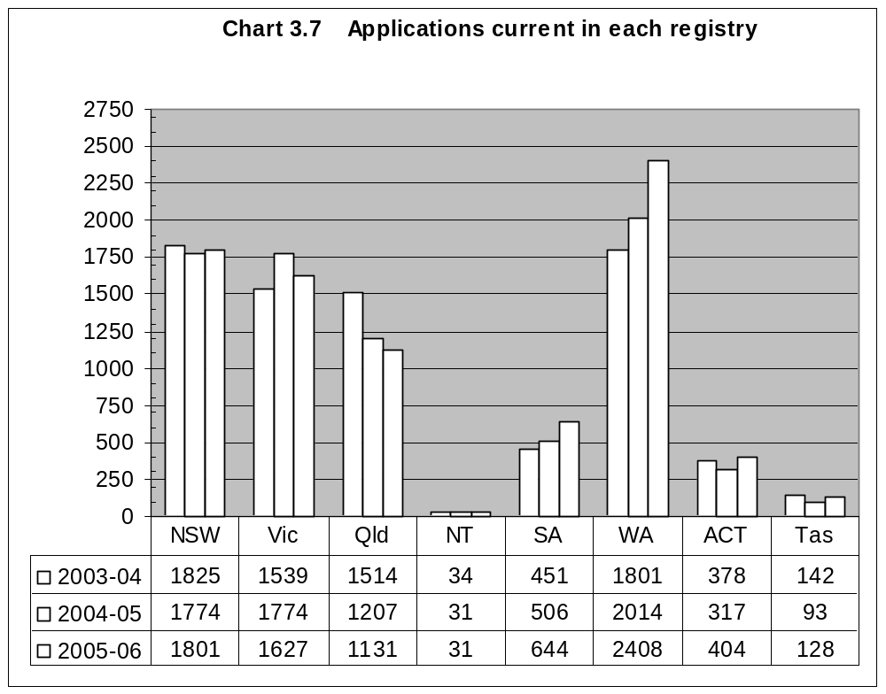
Table 3.8 Constitution of tribunals for hearings
Tribunal | 2003-04 |  | 2004-05 |  | 2005-06
Tribunal | No. | % | No. | % | No. | %
Judge alone | 10 | <1 | 10 | <1 | 8 | <1
Judge with 1 other member | 3 | <1 | 4 | <1 | 0 | 0
Judge with 2 other members | 3 | <1 | 2 | <1 | 4 | <1
Deputy President alone | 300 | 16 | 249 | 15 | 204 | 14
Deputy President with 1 other member | 37 | 2 | 36 | 2 | 37 | 2
Deputy President with 2 other members | 22 | 1 | 4 | <1 | 11 | <1
Senior Member alone | 382 | 21 | 505 | 30 | 487 | 33
Senior Member with 1 other member | 172 | 9 | 166 | 10 | 168 | 11
Senior Member with 2 other members | 27 | 1 | 11 | <1 | 2 | <1
Member alone | 882 | 48 | 696 | 41 | 518 | 35
Two Membersª | N/A | — | 5 | <1 | 48 | 3
Three Members | N/A | — | 0 | 0 | 2 | <1
Total^{b} | 1,838 | 100 | 1,688 | 100 | 1489 | 100
Total multi-member tribunals | 264 | 14 | 227 | 14 | 272 | 18

a From 16 May 2005, the Tribunal could be constituted by two or three Members.
b Percentages do not total 100% due to rounding.
Note: This table does not include hearings on the papers.

Table 3.9 Number of alternative dispute resolution processes, interlocutory hearings and hearings
Type | 2003-04 | 2004-05 | 2005-06
Conference | 9,422 | 8,942 | 8,450
Case appraisalª | N/A | 0 | 0
Conciliation | 779 | 771 | 582
Mediation | 84 | 50 | 26
Neutral evaluationª | N/A | 0 | 2
Interlocutory hearings^{b} | 444 | 396 | 488
Hearings (including hearings on the papers) | 1,961 | 1,711 | 1,527

a The Administrative Appeals Tribunal Amendment Act 2005 amended the provisions of the AAT Act relating to ADR processes. An application may be referred to any of the following ADR processes: conferencing, case appraisal, conciliation, mediation and neutral evaluation.
b Includes hearings relating to the jurisdiction of the Tribunal and hearings relating to applications for orders of the following kind:
- an extension of time to lodge an application for review;
- to be joined as a party to a proceeding;
- a confidentiality order under section 35 of the AAT Act;
- an order staying the operation or implementation of a reviewable decision;
- to dismiss an application;
- to reinstate an application.

Table 3.10 provides information in relation to appeals from decisions of the Tribunal that have been lodged in 2005-06 and the two previous years. The table distinguishes between appeals lodged in the Federal Court under section 44 of the AAT Act and applications for judicial review made under other enactments, including the Administrative Decisions (Judicial Review) Act 1977, the Judiciary Act 1903, Part 8 of the Migration Act 1958 and section 75(v) of the Constitution.
Table 3.10 Appeals from decisions of the Tribunal by jurisdiction
Jurisdiction | 2003-04 |  | 2004-05 |  | 2005-06
 | Section 44 | Other | Section 44 | Other | Section 44 | Other
Compensation | 32 | 1 | 25 | 3 | 22 | 4
Social security | 32 | 0 | 11 | 0 | 29 | 4
Veterans’ affairs | 48 | 1 | 21 | 0 | 27 | 0
Taxation Division | 9 | 1 | 21 | 0 | 19 | 0
Small Taxation Claims Tribunal | 1 | 0 | 2 | 0 | 3 | 0
Other | 33 | 11 | 47 | 8 | 42 | 15
Total | 155 | 14 | 127 | 11 | 142 | 23
Note: In some circumstances, a party may lodge an application seeking relief under section 44 of the AAT Act and under another enactment. Such applications are treated as section 44 appeals for statistical purposes.

Tables 3.11 and 3.12 provide information on the outcomes of appeals from decisions of the Tribunal that were determined in 2005–06 and in the two previous years.

Table 3.11 Appeals from decisions of the Tribunal — outcomes of appeals determined
Outcome | 2003-04 |  |  | 2004-05 |  | 2005-06
 | Section 44 |  | Other | Section 44 | Other | Section 44 | Other
Allowed/Remitted | 41 | 2 |  | 51 | 1 | 32 | 6
Dismissed | 102 | 5 |  | 80 | 5 | 67 | 11
Discontinued | 27 | 5 |  | 20 | 3 | 21 | 9
Other | 4 | 0 |  | 1 | 0 | 0 | 0
Total | 174 | 12 |  | 152 | 9 | 120 | 26
Notes: Where a decision of a Federal Magistrate, a single judge of the Federal Court or the Full Court of the Federal Court has been appealed, only the ultimate result is counted for the purpose of these statistics.
During the reporting year, fourteen appeals under section 44 of the AAT Act were determined in the Federal Magistrates Court following transfer of the appeal from the Federal Court pursuant to section 44AA of the AAT Act.

Table 3.12 Appeals from decisions of the Tribunal — outcomes of appeals determined by jurisdiction
Outcome | 2003-04 |  |  | 2004-05 |  | 2005-06
 | Section 44 |  | Other | Section 44 | Other | Section 44 | Other
Compensation
Allowed/Remitted | 6 | 0 |  | 13 | 0 | 5 | 2
Dismissed | 20 | 2 |  | 7 | 1 | 16 | 0
Discontinued | 8 | 3 |  | 4 | 0 | 4 | 0
Other | 4 | 0 |  | 0 | 0 | 0 | 0
Subtotal | 38 | 5 |  | 24 | 1 | 25 | 2
Social security
Allowed/Remitted | 6 | 0 |  | 2 | 0 | 4 | 0
Dismissed | 23 | 1 |  | 16 | 0 | 9 | 1
Discontinued | 5 | 1 |  | 5 | 0 | 8 | 3
Other | 0 | 0 |  | 0 | 0 | 0 | 0
Subtotal | 34 | 2 |  | 23 | 0 | 21 | 4
Veterans’ affairs
Allowed/Remitted | 15 | 0 |  | 19 | 0 | 9 | 0
Dismissed | 28 | 0 |  | 17 | 0 | 12 | 0
Discontinued | 5 | 0 |  | 3 | 0 | 1 | 0
Other | 0 | 0 |  | 1 | 0 | 0 | 0
Subtotal | 48 | 0 |  | 40 | 0 | 22 | 0
Taxation Division
Allowed/Remitted | 4 | 0 |  | 3 | 0 | 4 | 0
Dismissed | 4 | 0 |  | 9 | 0 | 11 | 1
Discontinued | 4 | 0 |  | 1 | 0 | 5 | 0
Other | 0 | 0 |  | 0 | 0 | 0 | 0
Subtotal | 12 | 0 |  | 13 | 0 | 20 | 1
Small Taxation Claims Tribunal
Allowed/Remitted | 1 | 0 |  | 0 | 0 | 1 | 0
Dismissed | 2 | 0 |  | 0 | 0 | 0 | 0
Discontinued | 0 | 0 |  | 1 | 0 | 0 | 0
Other | 0 | 0 |  | 0 | 0 | 0 | 0
Subtotal | 3 | 0 |  | 1 | 0 | 1 | 0
Other
Allowed/Remitted | 9 | 2 |  | 14 | 1 | 9 | 4
Dismissed | 25 | 2 |  | 31 | 4 | 19 | 9
Discontinued | 5 | 1 |  | 6 | 3 | 3 | 6
Other | 0 | 0 |  | 0 | 0 | 0 | 0
Subtotal | 39 | 5 |  | 51 | 8 | 31 | 19
Total | 174 | 12 |  | 152 | 9 | 120 | 26

