Administrative Appeals Tribunal
Annual Report
2013–14

CONTACTING THE TRIBUNAL
Adelaide Registry
11th Floor Chesser House
91 Grenfell St
ADELAIDE SA 5000
Tel 08 8201 0600
Fax 08 8201 0610
Email adelaide.registry@aat.gov.au
Brisbane Registry
Level 4 Harry Gibbs Building
Commonwealth Law Courts
119 North Quay
BRISBANE QLD 4000
Tel 07 3361 3000
Fax 07 3361 3001
Email brisbane.registry@aat.gov.au
Canberra Registry
Level 8, 14 Moore St
CANBERRA CITY ACT 2600
Tel 02 6243 4611
Fax 02 6243 4600
Email canberra.registry@aat.gov.au
Hobart Registry
Edward Braddon Building
Commonwealth Law Courts
39–41 Davey St
HOBART TAS 7000
Tel 03 6232 1622
Fax 03 6232 1601
Email hobart.registry@aat.gov.au
Melbourne Registry
Level 16 HWT Tower
40 City Rd
SOUTHBANK VIC 3006
Tel 03 9282 8444
Fax 03 9282 8480
Email melbourne.registry@aat.gov.au
Norfolk Island Registry
c/- Supreme Court of Norfolk Island
KINGSTON Norfolk Island 2899
Tel 0011 6723 23691
Fax 0011 6723 23403
Email sydney.registry@aat.gov.au
Perth Registry
Level 5 111 St Georges Tce
PERTH WA 6000
Tel 08 9327 7200
Fax 08 9327 7299
Email perth.registry@aat.gov.au
Sydney Registry
Level 7 55 Market St
SYDNEY NSW 2000
Tel 02 9391 2400
Fax 02 9283 4881
Email sydney.registry@aat.gov.au

NATIONAL 1300 NUMBER
You can call the AAT on 1300 366 700 from anywhere in Australia. You will be connected to the AAT office in your capital city. Residents of northern NSW (postcodes 2460–2490) and the Northern Territory will be connected to the Brisbane Registry. Callers from fixed phone lines will be charged at local call rates; calls from mobiles may cost more.

Non-English speakers
Call the Translating and Interpreting Service on 131 450 and ask them to call the AAT.

If you are deaf or have a hearing or speech impairment
Call us through the National Relay Service:
TTY users:
call 133 677, then ask for 1300 366 700
Speak and Listen (speech-to-speech relay) users:
call 1300 555 727, then ask for 1300 366 700
Internet relay users:
connect to the National Relay Service, then ask for 1300 366 700
SMS relay users:
call 0423 677 767 and ask for 1300 366 700
Video relay users:
choose the available NRS video relay contact on Skype and ask for 1300 366 700.
Hearing induction loops are available for use at our Registry counters, and in conference and hearing rooms.

Post
AAT
GPO Box 9955
Your capital city
Or
AAT
c/- Supreme Court of Norfolk Island Registry
Kingston, Norfolk Island 2899

Website
www.aat.gov.au

Annual Report
2013–14
This report
An electronic version of this annual report is on the Tribunal’s website, www.aat.gov.au/Publications/AnnualReport.htm.
More information about the Tribunal is on the Tribunal’s website, www.aat.gov.au.
Photos on front cover: Graynoise, Leighton Hutchison
© Commonwealth of Australia 2014

With the exception of the Commonwealth Coat of Arms and any third party material, this work is licensed under a Creative Commons Attribution 3.0 Australia licence (creativecommons.org/licenses/by/3.0/au/deed.en).
To the extent that copyright subsists in third party material, it remains with the original owner and permission may be required to reuse the material.
The terms under which the Coat of Arms can be used are detailed on the following website:
www.itsanhonour.gov.au/coat-arms/.
Content from this publication should be attributed as: Administrative Appeals Tribunal, Annual Report 2013–14.
Enquiries regarding the licence, any use of this work, or any other queries about this report are welcome.
Registrar
Principal Registry
Administrative Appeals Tribunal
GPO Box 9955
SYDNEY NSW 2001
Tel: 02 9391 2491
Fax: 02 9391 2578
Email: principal.registry@aat.gov.au
ISSN 1035-3161
Designed by ZOO Advertising
Typeset by Ogle Digital
Printed by New Millennium Print

Letter of transmission
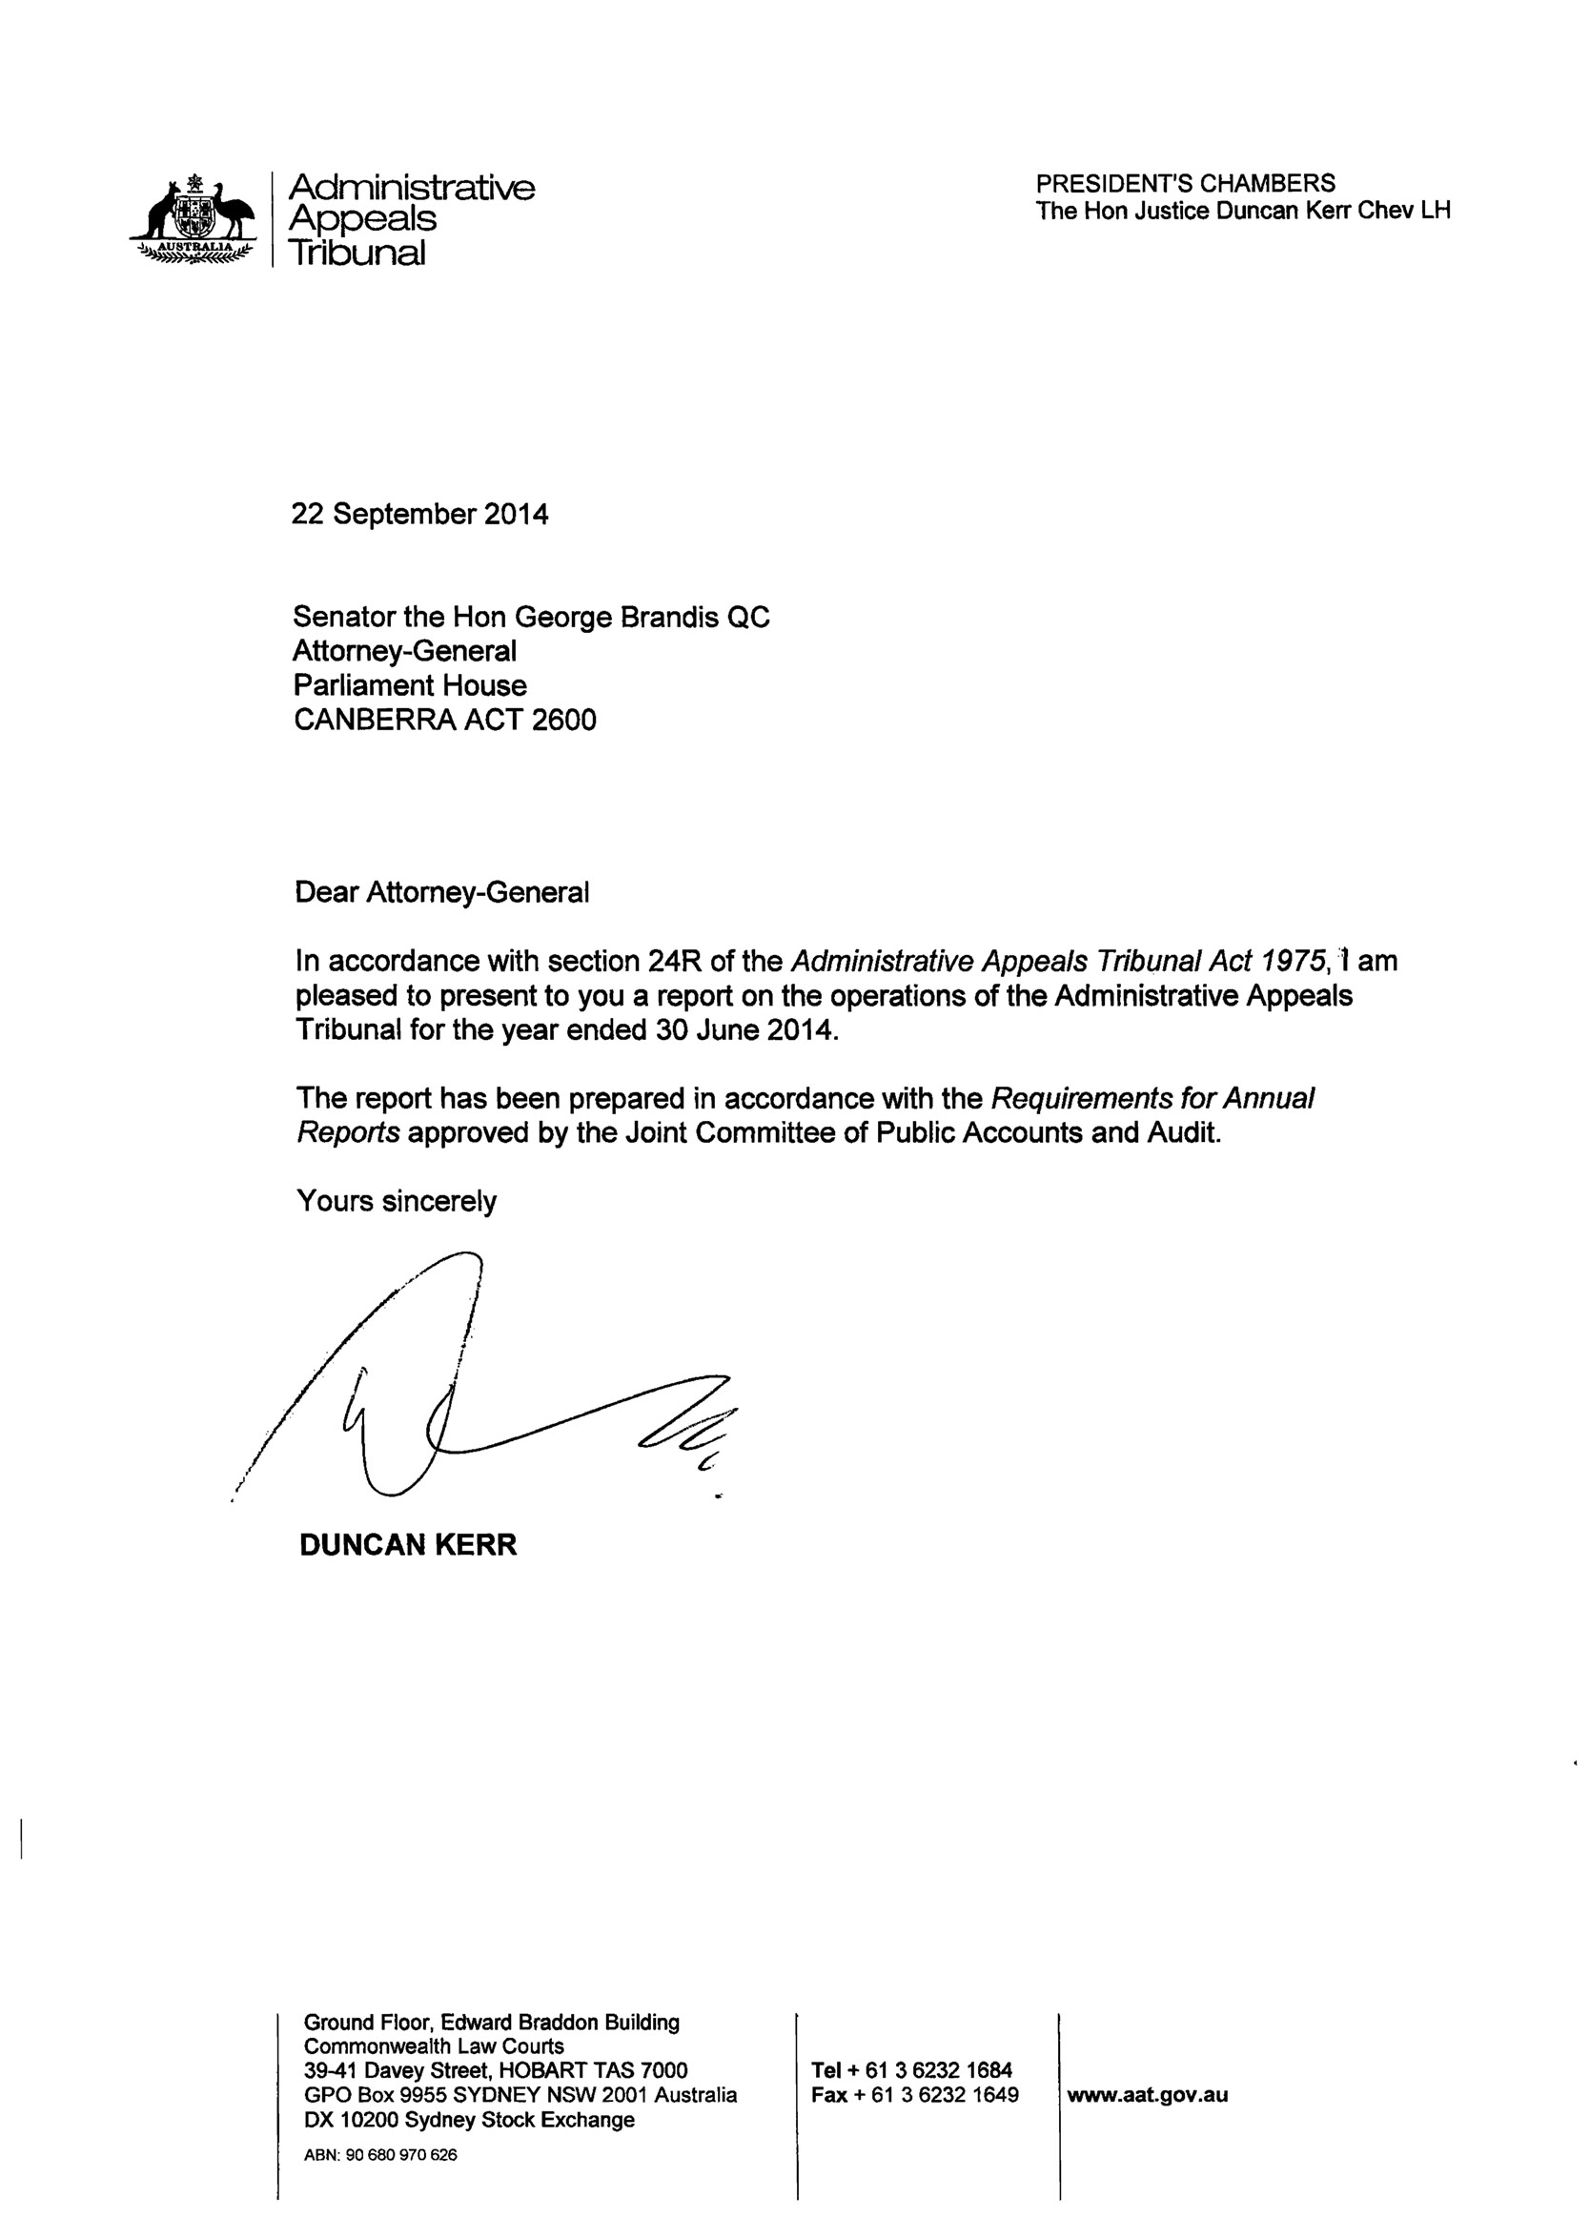

Contents
Annual Report 2013–14 1
Letter of transmission 7
Contents 8
Table of FIGURES 10
Chapter 01 12
The year in review 13
President’s overview 14
Registrar’s review 18
2013–14 Highlights and achievements 21
Chapter 02 24
Overview of the Tribunal 25
Chapter 03 36
Our performance 37
Chapter 04 53
Our users and our relationships 54
Chapter 05 66
Our organisation and our people 67
Financial statements 82
Appendixes 126
Appendix 1: Members of the Tribunal 127
Appendix 2: Staff of the Tribunal 160
Appendix 3: Tribunal jurisdiction 163
Appendix 4: Applications, outcomes, listings and appeals statistics 179
Appendix 5: Resourcing tables 202
Appendix 6: Application fees 205
Appendix 7: Decisions of interest 209
Appendix 8: Speeches, publications and other activities 222
Appendix 9: Other reporting requirements 234
End matter 237
Glossary 238
List of requirements 243
Index 249

Table of FIGURES

Chapters
Table 2.1 Tribunal membership, 30 June 2014 27
Table 2.2 Executive Deputy Presidents/Senior Member, 30 June 2014 28
Figure 2.3 Administrative structure of the Tribunal, 30 June 2014 29
Figure 2.4 Case management process 32
Table 3.8 Deliverables targets and results, 2013–14 42
Table 3.9 Key performance indicators and results, 2013–14 42
Table 3.11 Percentage of applications finalised within time standards 44
Table 3.12 Freedom of Information requests 46
Table 3.13 Service standards 47
Table 3.14 Complaints to the Tribunal 49
Table 3.15 Issues raised in complaints to the Tribunal 50
Table 3.16 Applications relating to warrants, controlled operations and other functions considered by Tribunal members 51
Table 3.17 Examinations held under the Proceeds of Crime Act 2002 52
Table 5.1 Total actual expenditure on consultancy contracts 68
Table 5.2 Trends in staffing numbers 71
Table 5.3 Trends in compensation claims 77

Appendixes
Table A2.1 Employment by registry, 30 June 2014 160
Table A2.2 Equal employment opportunity data, 30 June 2014 160
Table A2.3 Employment status and arrangements, 30 June 2014 161
Table A4.1 Applications lodged and applications finalised, 2013–14 179
Table A4.4 Percentage of applications finalised without a hearingª 193
Table A4.5 Outcomes of applications for review of a decision finalised in 2013–14 193
Table A4.7 Alternative dispute resolution processes, interlocutory hearings and hearings conducted by the Tribunal 196
Table A4.8 Constitution of tribunals for hearings 197
Table A4.9 Appeals against decisions of the Tribunal – By jurisdiction 198
Table A4.10 Outcomes of appeals against Tribunal decisions – By jurisdiction 199
Table A5.1 Tribunal resource statement, 2013–14 202
Table A5.2 Expenses for outcome 203
Table A6.1 Fee revenue summary: total, refunded and forgone 206
Table A6.2 Reduced fees paid 207
Table A6.3 Applications for which no fee paid where otherwise payable 207
Table A8.1 Speeches and presentations 222
Table A8.2 Competition adjudication and training 226
Table A8.3 Publications 228
Table A8.4 Other engagement activities 229
Table A9.1 Trends in non-campaign advertising 234
Table A9.2 Environmental performance reporting 234

Chapter 01
The year in review

President’s overview
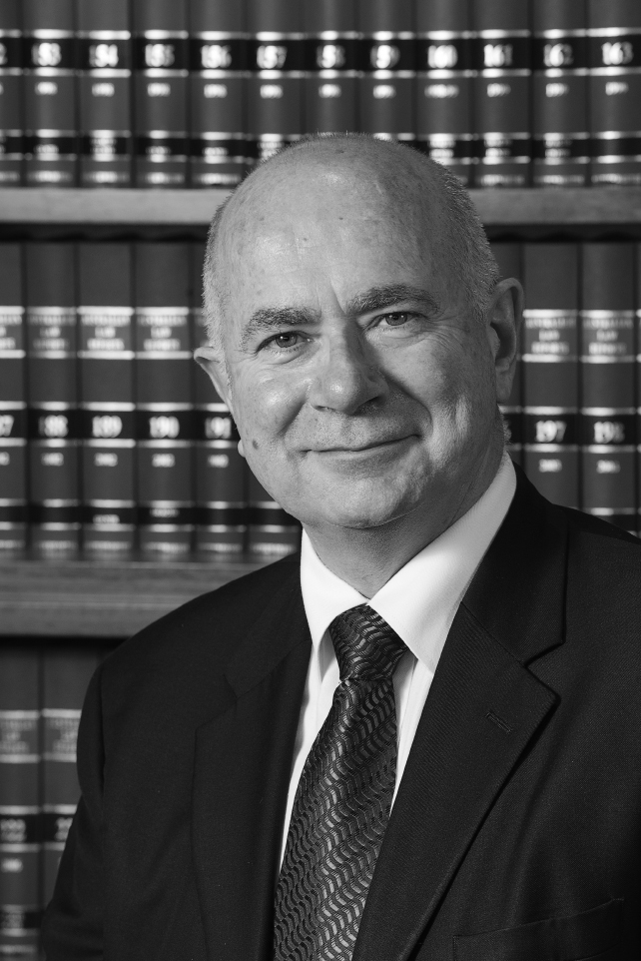
Speaking at the launch of the Merits Review Special Edition of the University of Queensland Law Journal in October 2013 I reflected on the fact that every year, while perhaps tens of thousands of Australians will seek judicial review of administrative decisions, hundreds of thousands of Australians apply for one or another form of merits review.
Following the Administrative Appeals Tribunal’s establishment in 1976, it became a model for merits review that has been drawn on across the Commonwealth and in most states and territories. After nearly 40 years the Tribunal still operates largely without fanfare offering accessible, informal and relatively cheap processes where those who are affected can challenge the merits of administrative decisions.
Merits review in the Tribunal is undertaken by independent members supported by qualified and skilled alternative dispute resolution practitioners and the Tribunal’s other registrars and support staff. The Administrative Appeals Tribunal Act 1975 allows the Tribunal to review challenged decisions and, if a better decision could have been made, to make the correct or preferable decision.
These important rights are undervalued because Australians now take them for granted. That is understandable but illusory. While merits review seems firmly built into the architecture of the Australian system of government it remains exclusively the product of statute. To retain the support of the public and the Parliament, the Tribunal is keenly aware that it must remain responsive to the obligations set out in section 2A of the AAT Act: that is to ensure that its review functions continue to be economical, prompt and fair.

Practice and procedure development
The past 12 months have seen the Tribunal build robustly on its already strong foundations.
The Tribunal issued a new practice direction to support tailor-made procedures for the review of decisions made by the National Disability Insurance Agency under the National Disability Insurance Scheme. Applicants in the NDIS Division have a single point of contact within the Tribunal and there are streamlined mechanisms to ensure that delay and complexity in reviewing issues arising under the scheme will be minimised.
After wide consultations with our stakeholders, the Tribunal has introduced a practice direction to provide for expedited review of those matters requiring urgent hearing and decision-making. It also adopted procedures intended to eliminate ‘trial by ambush’ where video surveillance evidence is concerned.
Those initiatives, and others like them, arose out of a shared commitment by the Tribunal’s staff, Conference Registrars and members to contribute to the Tribunal’s system of effective and integrated dispute resolution.
With more than 450 Acts and legislative instruments conferring jurisdiction on the Tribunal, no single approach can suit the circumstances of every review. However, these changes mean that we can be better at adapting our procedures to meet the diverse requirements of applicants, government agencies and other decision-makers across the range of jurisdictions in order to fulfil the Tribunal’s mission of undertaking high-quality merits review in a manner that is fair, just, economical, informal and quick.

Tribunal performance
Sometimes a desire for speed and the requirement for a just solution give rise to conflicting rather than complementary pressures. When that happens speed must give way to fairness because the Tribunal has a legal duty to observe the rules of natural justice.
However, it is very pleasing that during this reporting period the Tribunal has exceeded its benchmark target of ensuring that 75 per cent of all reviews are completed within a year of their being lodged.
I am particularly proud of the significant effort, chiefly encouraged by Deputy President Hack, which has been made by our members, Conference Registrars and staff in the Taxation Appeals Division to improve timeliness. A taxpayer challenging an assessment can choose between proceeding in the Tribunal or in the Federal Court of Australia. It reflects the high standing of the Tribunal members who deal with this workload in the eyes of the community that approximately 80 per cent of all tax matters are commenced in the Tribunal. The data in this report shows that from a 2012–13 baseline of 67 per cent the Tribunal has significantly improved the rate of finalisation and is currently completing 77 per cent of matters lodged within that Division within 12 months.
A highlight of the year was the Tribunal’s biennial National Conference. We were greatly honoured that the Attorney-General, Senator the Hon George Brandis QC, made himself available to open the conference. The work of the conference delegates will continue to be reflected in improving our outcomes in managing the work of the Tribunal and ensuring that we provide the best possible integrated dispute resolution system. Our members are the visible part of the iceberg—but our staff and Conference Registrars are critical parts of a team that achieves the remarkable result that approximately 80 per cent of matters lodged in the Tribunal can be resolved without a requirement for a formal hearing.

Tribunal independence
In the Tribunal’s Annual Report 2012–2013 I observed that, ‘As Peter Cane observed in Administrative Tribunals and Adjudication,
[R]eview by the AAT involve[s] the transformation of the decision-making process from a two-party to a three-party affair by the insertion of a neutral third party’.
For such a process to command the confidence of the community, Tribunal decision-makers must be, and must be perceived to be, neutral – independent of any government agency, person or body whose decision is under review.
Recently the Australasian Institute of Judicial Administration, in association with the Council of Australasian Tribunals (COAT), published Tribunal Independence based on research the Institute commissioned from Associate Professor Pamela O’Connor. As President of the Tribunal and in my roles with the Institute and the Council I want to ensure that Associate Professor O’Connor’s ground-breaking work focusing on best practice to ensure tribunal independence gets the attention it deserves. An electronic version of that report is on the COAT website.

The future
The Tribunal’s future will inevitably be impacted by the Government’s budget announcement that it intends to amalgamate the Tribunal with the Migration Review Tribunal – Refugee Review Tribunal, the Social Security Appeals Tribunal and the Classification Review Board. At the launch of the Merits Review Special Edition of the University of Queensland Law Journal, well before that announcement, I had proposed that it might be timely to revisit the recommendations of the Administrative Review Council’s Better Decisions Report of 1995 which proposed the amalgamation of all Commonwealth merits review bodies.
While the principle is sound and I have welcomed the Government’s announcement, until the details are known large change is unsettling. I will work with the staff and members of the Tribunal and liaise closely with the Attorney-General to ensure that the process builds on the Tribunal’s legacy of professional and independent decision-making. Once that fundamental objective is secured, the procedures of a merged tribunal can continue to evolve on the basis that no single approach will suit the circumstances of every case. It is in the Government’s and the Tribunal’s shared interest that the proposed amalgamated tribunal will continue to fulfil the central mission of undertaking high-quality merits review.

Our people
Finally I must take the opportunity to welcome those members of the Tribunal who were appointed during this reporting period and farewell those whose terms came to an end.

Welcome
The Tribunal was particularly pleased to welcome four part-time Members appointed because of their experience relevant to the NDIS Division. They are Lynne Coulson Barr (Victoria), Professor Ronald McCallum AO (NSW), Ms Sandra Taglieri (Tasmania) and Mr Ian Thompson (South Australia). The Tribunal also welcomed part-time Senior Member Dr Nicholas Manetta in South Australia. All of our new members have already made a significant contribution to the work of the Tribunal.

Farewell
The tenure of two of our most valuable presidential members, the Honourable Justice Cowdroy and the Honourable Justice Lander, came to an end with their departure from the Federal Court of Australia. I cannot overstate the value that the Tribunal places on having available to it the service of presidential members holding joint commissions with the Federal or Family Courts of Australia. Where matters involve great issues or are novel and complex, their willingness to contribute to the work of the Tribunal has repeatedly proven its value.
During the year Member Dr Kerry Breen AM resigned from the Tribunal to focus on his medical research and writing. He was a much used and appreciated member of the Tribunal in Melbourne and will be greatly missed.
The term of Senior Member Narelle Bell expired at the end of this reporting year. She was an outstanding member and mentor and still has much to offer to public service.
And, last but far from least, after a decade of service Deputy President Ray Groom AO advised that he would be relinquishing his position with the Tribunal and as Executive Deputy President for Tasmania. DP Groom helped me find my feet in Hobart after my appointment and I thank him for that. He departed the Tribunal with a rare record for such a long serving member: none of his decisions became the subject of a successful appeal.

Registrar’s review
In 2013–14 the Tribunal improved its performance against key indicators notwithstanding an 18 per cent increase in its workload. At the same time it continued to develop and implement a range of strategic and operational projects designed to maintain its role as an accessible, expert and innovative organisation that ensures administrative justice for individuals and organisations and improves the quality of government decision-making. I once again acknowledge the hard work of the members and staff of the Tribunal that has led to these achievements.
During the reporting year the Tribunal received 7,263 applications, compared with 6,176 in 2012–13. The number of applications finalised also increased, from 6,042 to 6,748. Eighty-two per cent of applications were finalised within 12 months of the date of lodgement, compared with 76 per cent 2012–13. The greater number of applications did, however, result in a 10 per cent increase in the number of applications on hand as at 30 June 2014. Further information about the Tribunal’s workload is set out in Chapter 3 and Appendix 4.
In the first half of 2014 the Tribunal prepared its new Strategic Plan 2014–2017. Finalisation of the Plan coincided with the Government’s announcement that the Tribunal will be merged with the Migration Review Tribunal – Refugee Review Tribunal, Social Security Appeals Tribunal and the Classification Review Board from 1 July 2015. While elements of the Plan will be refined as work towards the amalgamation progresses, most aspects will be important to the Tribunal’s operations during the next 12 months and will be relevant to the strategic priorities of the merged tribunal in the future. The proposed amalgamated tribunal creates a significant opportunity to strengthen the existing merits review system by building on the successful processes and practices of the tribunals that are to be brought together.
On 1 July 2013 the Tribunal’s jurisdiction to review certain decisions of the National Disability Insurance Agency commenced. This provided an opportunity to implement new case management procedures; increase collaboration between members, registrars and other staff; enhance the Tribunal’s electronic case management system; develop new information products and introduce new monitoring and evaluation measures (including a mechanism for regular user feedback throughout the review process). These developments are now being adopted, or are informing innovations, in other areas of the Tribunal’s jurisdiction. In particular, an integrated dispute resolution project has been established to help capture and build upon the National Disability Insurance Scheme and other initiatives.
In June 2014 the Tribunal’s Canberra District Registry moved into new accommodation following the end of its previous lease. The new design and fit-out is a considerable improvement on the previous accommodation and illustrate how the Tribunal’s property master plan and strategic property principles work in practice. During the year the Tribunal initiated discussions with the Migration Review Tribunal–Refugee Review Tribunal, Social Security Appeals Tribunal and Veterans Review Board about new opportunities for co-location in Adelaide, Brisbane and Perth as leases end. These principles and discussions will now help inform the development of a broader strategic property plan to guide the location and design of consolidated property arrangements for the amalgamated tribunal over the next few years.
During the reporting year the Tribunal continued to progress a number of projects as part of the Electronic Services and Information Management Programme. In particular, it implemented a new information and records management framework that will help to support the move to an electronic document and records management system. The Tribunal’s new records authority was formally approved by the National Archives of Australia and implemented in all registries.
In 2013–14 the Tribunal successfully developed and implemented policies and guidelines to comply with the requirements of the Protective Security Property Framework, Rehabilitation Management Scheme, Public Governance, Performance and Accountability Act 2013 and Public Interest Disclosure Act 2013. It also strengthened the governance of, and updated its policies and arrangements for, business continuity, disaster recovery, fraud control and risk management.
During the reporting year the Tribunal continued to work closely with the Attorney-General’s Department on amendments to the Administrative Appeals Tribunal Act 1975 and the Administrative Appeals Tribunal Regulations 1976. It also worked with the Department and other agencies on issues relating to expected changes in the Tribunal’s workload, including the impact of the Government’s proposal to broaden the range of corporations that may apply to be covered by the Safety, Rehabilitation and Compensation Act 1988, and to transfer the merits review of Freedom of Information matters, currently undertaken by the Office of the Australian Information Commissioner, to the Tribunal from 1 January 2015.
The Tribunal recorded an operating surplus for 2013–14, before taking depreciation into account, primarily as a result of lower than anticipated spending on supplier and employee costs during the year. This was due in part to a significantly smaller number of National Disability Insurance Scheme cases being lodged than had been expected.
During 2013–14 there were various changes in the membership and staff of the Tribunal. I record my thanks for the contributions made by those members and staff whose time at the Tribunal came to an end during this period, and welcome the members and staff who have joined us. The President’s overview sets out some of the membership changes. There were also some important staff changes, including the departure of District Registrars Clare Byrt and Lee Cross, long-serving Conference Registrar Helen Lacey and the inaugural Executive Director, Operations, Megan Cassidy. The Tribunal welcomed the return of Michelle Grau as the District Registrar in Brisbane and Catherine Cashen as the District Registrar in Adelaide, and the appointment of Franca Petrone as a Conference Registrar in Adelaide.
During the next 12 months the Tribunal must continue to provide a high-quality merits review mechanism while working towards the successful amalgamation with other key merits review tribunals from 1 July 2015. I am confident that the members and staff of the Tribunal will meet the challenges that these dual tasks present.

2013–14 Highlights and achievements
7,263 applications lodged with the Tribunal – 18 per cent more than in 2012–13
6,748 applications finalised with 82 per cent finalised other than by way of a Tribunal decision following a hearing – three percentage points higher than in the previous year
82% of applications finalised within 12 months of lodgement compared with 76 per cent in 2012–13
77% In the Taxation Appeals Division, 77 per cent of applications finalised within 12 months, an improvement of 10 percentage points over the result for the previous year
Our users – to provide a high-quality independent merits review process that is fair, just, economical, informal and quick
- 7,263 applications lodged with the Tribunal – 18 per cent more than in 2012–13
- 6,748 applications finalised with 82 per cent finalised other than by way of a Tribunal decision following a hearing – three percentage points higher than in the previous year
- 82 per cent of applications finalised within 12 months of lodgement compared with 76 per cent in 2012–13
- In the Taxation Appeals Division, 77 per cent of applications finalised within 12 months, an improvement of 10 percentage points over the result for the previous year
- The Tribunal began reviewing decisions made under the National Disability Insurance Scheme, employing a case management model that aims to deliver a review process that is accessible, fair, informal and quick.
- Changes to practice and procedure were introduced in the workers’ compensation jurisdiction to promote effective case management and the timely progress of applications
- Two new practice directions were issued, one dealing with release from the implied undertaking not to use documents obtained under compulsion in Tribunal proceedings and the second with the use of video surveillance material at the Tribunal. The Tribunal also developed and consulted on a practice direction for the expedited review of certain decisions in the Tribunal
- The Tribunal reviewed its policies and procedures relating to access to information and privacy, publishing its new Privacy Policy and new web pages dealing with access to information and documents in Tribunal proceedings
- Two new guidelines jurisdiction were issued in relation to alternative dispute resolution at the Tribunal: Confidentiality in ADR Processes and The Duty to Act in Good Faith in ADR Processes
- New fact sheets for the National Disability Insurance Scheme and access guides for each of the Tribunal’s registries were published in 2013–14. Brochures and the Service Charter were made available in more community languages
- The Tribunal’s Reconciliation Action Plan was reviewed and updated and the Working with Aboriginal and Torres Strait Islander People at the Administrative Appeals Tribunal guide for Tribunal members and staff was published
Our relationships – to engage effectively with government, tribunals, the legal profession and other interested organisations in Australia and internationally
- The Tribunal made a submission to the Productivity Commission’s Inquiry into Access to Justice Arrangements and worked with the Australian Bureau of Statistics on a project to analyse data gaps in the collection of consistent data on the civil justice system
- The Tribunal engaged with other Commonwealth merits review tribunals in a range of forums, including the Commonwealth Tribunals Collaborative Forum and the Commonwealth Heads of Tribunals, as well as with the Attorney-General’s Department in the context of the Government’s decision to amalgamate the Administrative Appeals Tribunal, the Classification Review Board, the Migration Review Tribunal–Refugee Review Tribunal and the Social Security Appeals Tribunal from 1 July 2015
- Cooperative service arrangements continued with the Federal Court, Migration Review Tribunal–Refugee Review Tribunal, Social Security Appeals Tribunal, Supreme Court of Norfolk Island and Veterans’ Review Board
- Tribunal members and staff continued to be active participants in the Council of Australasian Tribunals and other forums, and gave presentations at a wide range of conferences and seminars as well as to community organisations
- The Tribunal piloted a new Negotiating Outcomes on Time Competition (Noot) to offer students an insight into conciliation processes at the Tribunal. It complements the Tribunal’s National Mooting Competition to give students a comprehensive experience of the administrative review process at the Tribunal
- The Tribunal offered a significant number of internship and work experience placements in 2013–14. A memorandum of understanding was entered into with the University of Newcastle regarding placements for law students
Our organisation – to manage our resources strategically and effectively
- The Tribunal developed a new Strategic Plan for 2014–17
- The Tribunal reviewed and updated its Business Continuity Plans, Fraud Control Plan and Risk Management Plan
- The Tribunal achieved a high level of compliance against the Australian Government Protective Security Policy Framework
- The Canberra Registry successfully located to new, more efficient premises designed in accordance with the Tribunal’s strategic property principles
- The Tribunal implemented a new information and records management framework and policy as well as a new records authority approved by the National Archives of Australia under the Archives Act 1983
- An enhanced internal weekly AAT Bulletin was launched improving access to the latest information on reported cases, new books and journal articles
- A major server upgrade was completed and the Tribunal moved to a new secure internet gateway supporting the robustness of the Tribunal’s ICT systems
Our people – to maintain a professional, productive, rewarding and safe workplace
- The Tribunal delivered extensive training for members and staff to prepare for its new National Disability Insurance Scheme jurisdiction with sessions on disability awareness, accessibility issues, support schemes for applicants and the Tribunal’s case management approach
- A successful National Conference was held for members, registrars and staff offering an opportunity to discuss the development of more effective integrated dispute resolution processes and to build capacity through professional development on a range of practical topics
- Training on foundation and core knowledge and skills was conducted for all staff in all registries on topics including the APS Values, Code of Conduct and Employment Principles, privacy and confidentiality, records management and security awareness
- The Tribunal’s managers participated in a pilot of the Australian Public Service Commission’s new Performance Management learning program
- An audit of the Tribunal’s Rehabilitation Management System confirmed full compliance with Comcare’s Guidelines for Rehabilitation Authorities 2012
- A survey of members and staff indicated increased levels of satisfaction with internal communication following the introduction of the monthly internal newsletter in 2012–13

Chapter 02
Overview of the Tribunal
The Tribunal provides independent merits review of administrative decisions. It aims to provide a review mechanism that is fair, just, economical, informal and quick.
The Tribunal falls within the portfolio of the Attorney-General.

ESTABLISHMENT
The Tribunal was established by the Administrative Appeals Tribunal Act 1975 and commenced operations on 1 July 1976. The AAT Act and the Administrative Appeals Tribunal Regulations 1976 set out the Tribunal’s functions, powers and procedures.

FUNCTIONS AND POWERS

Review of decisions
The Tribunal reviews a wide range of administrative decisions made by Australian Government ministers, departments, agencies and some other tribunals. In limited circumstances, the Tribunal can review administrative decisions made by state government and non-government bodies. The Tribunal can also review decisions made by the Norfolk Island Government.
Merits review of an administrative decision involves considering afresh the facts, law and policy relating to that decision. The Tribunal considers the material before it and decides what is the correct — or, in a discretionary area, the preferable — decision. It will affirm, vary or set aside the decision under review.
The Tribunal is not always the first avenue of review of an administrative decision. In some cases, the Tribunal cannot review a decision until there has been an internal review of the primary decision. In other cases, review by the Tribunal is only available after intermediate review by a specialist tribunal – for example, an application for review of a family assistance or social security decision may be made only after review by the Social Security Appeals Tribunal.
Section 33 of the AAT Act requires that proceedings of the Tribunal be conducted with as little formality and technicality, and with as much expedition, as the requirements of the Act and a proper consideration of the matters before the Tribunal permit. The Tribunal is not bound by the rules of evidence and can inform itself in any manner it considers appropriate.

Jurisdiction
The Tribunal does not have a general power to review decisions made under Commonwealth or Norfolk Island legislation. The Tribunal can only review a decision if an Act, regulation or other legislative instrument states that the decision is subject to review by the Tribunal.
The Tribunal has jurisdiction to review decisions made under more than 400 Commonwealth Acts and legislative instruments. The largest part of the Tribunal’s workload arises from applications about decisions in the areas of family assistance and social security, taxation, veterans’ affairs and workers’ compensation. The Tribunal also reviews decisions relating to bankruptcy, child support, civil aviation, citizenship and immigration, corporations and financial services regulation, customs, freedom of information, industry assistance, mutual recognition of occupations, passports, and security assessments by the Australian Security Intelligence Organisation (ASIO). Since 1 July 2013, the Tribunal’s jurisdiction includes the review of decisions made under the National Disability Insurance Scheme.
In relation to Norfolk Island, the Tribunal has jurisdiction to review decisions made under 39 enactments. The decisions subject to review are specified in the Administrative Appeals Tribunal Regulations and include decisions about customs, planning and social services.
Appendix 3 contains a list of the Commonwealth and Norfolk Island enactments under which decisions may be made that can be reviewed by the Tribunal.

Divisions
The Tribunal exercises powers in divisions: the General Administrative, National Disability Insurance Scheme, Security Appeals, Taxation Appeals and Veterans’ Appeals Divisions. The Taxation Appeals Division is known as the Small Taxation Claims Tribunal for the review of certain tax decisions, including where the amount of tax in dispute is less than $5,000.

ORGANISATION
The Tribunal consists of the President, other presidential members (who may be judges or Deputy Presidents), Senior Members and Members. The President, with the assistance of the Registrar, is responsible for managing the Tribunal and its resources. Staff are employed under the Public Service Act 1999 to assist the Tribunal to carry out its functions.

Membership of the Tribunal
Members of the Tribunal are appointed by the Governor-General. The qualification requirements for the different categories of members are set out in the AAT Act and are outlined below. Appointments to the Tribunal may be full-time or part-time.
Presidential members can exercise powers in any of the Tribunal’s divisions. Senior Members and Members may only exercise powers in the division or divisions to which they have been assigned.
There were 89 members of the Tribunal at 30 June 2014. See Table 2.1 for the breakdown of full-time and part-time members by category. See Appendix 1 for a list of the Tribunal’s members by state and territory, the divisions to which each non-presidential member was assigned at 30 June 2014, and a profile of each member other than judges of the Federal Court and Family Court.

President
The Hon Justice Duncan Kerr, Chev LH was appointed a judge of the Federal Court of Australia on 10 May 2012. He was appointed President of the Tribunal on 16 May 2012 for a term of five years.
The President of the Tribunal must be a judge of the Federal Court.

Other presidential members
Judges of the Federal Court and the Family Court may be appointed as part-time presidential members of the Tribunal.
To be eligible for appointment as a Deputy President, a person must have been enrolled as a legal practitioner for at least five years.

Senior Members
A Senior Member must have been enrolled as a legal practitioner for at least five years or have special knowledge or skills relevant to the duties of a Senior Member.

Members
A Member must have knowledge or skills relevant to the duties of a Member. Current Members have expertise in areas including accountancy, aviation, disability, engineering, law, medicine, pharmacology, military affairs, public administration and taxation.
Table 2.1 Tribunal membership, 30 June 2014
Category of member | Judge | Full-time | Part-time | Total  (Women)
President | 1 |  |  | 1 (0)
Presidential members:
Federal Court judges  Family Court judges  Deputy Presidents | 11  3 | 6 | 7 | 11 (3)  3 (2)  13 (3)
Senior Members |  | 8 | 16 | 24 (11)
Members |  | 2 | 35 | 37 (13)
Total | 15 | 16 | 58 | 89 (32)

Registrar and Executive Directors
The Tribunal’s Registrar is Philip Kellow. He began his five-year appointment as Registrar on 22 July 2010.
The Registrar assists the President to manage the Tribunal and advises on its operations and performance. The Registrar may act on behalf of the President in the administration of the Tribunal.
The position of Registrar is a statutory office appointed by the Governor-General. The Registrar is the agency head for the purposes of the Public Service Act, responsible for the employment of the Tribunal’s staff on behalf of the Commonwealth. The Registrar was the Chief Executive for the purposes of the Financial Management and Accountability Act 1997, and became the Accountable Authority under the Public Governance, Performance and Accountability Act 2013 on 1 July 2014.
The Registrar is assisted by two Executive Directors who hold office as senior executives in the Australian Public Service. The Executive Director, Information and Development is Christopher Matthies and the Executive Director, Operations is Nerrilee Cuthbertson. For information on their areas of responsibility, see Figure 2.3 below.

Staff
Tribunal staff are employed under the Public Service Act as ongoing, non-ongoing or intermittent employees. At 30 June 2014, the Tribunal had 156 staff.
See Appendix 2 for more staffing information, including equal employment opportunity data.

Registries

Principal Registry
Principal Registry staff advise and assist the President and the Registrar, and provide a range of services for members and staff. They are responsible for communications, financial management, human resource management, legal and policy services, library and information services, property, security and technology services, and for overseeing the Tribunal’s alternative dispute resolution processes. Principal Registry staff are in Brisbane, Hobart, Perth and Sydney.

District Registries
There are District Registries in each of the state capital cities and in Canberra. The Brisbane Registry manages Northern Territory applications and is responsible for ensuring an effective level of service to Northern Territory residents. The registry service in Hobart is provided by the Federal Court. The Supreme Court of Norfolk Island provides basic registry services on Norfolk Island with applications managed principally by the Sydney Registry.
In each District Registry, a Deputy President or Senior Member is appointed Executive Deputy President/Senior Member. The Executive Deputy President/Senior Member and the District Registrar are responsible for local registry management. District Registrars are assisted by Deputy District Registrars.
Conference Registrars are appointed by the President in each District Registry to conduct the majority of the conferences held by the Tribunal. They also conduct other alternative dispute resolution processes.
District Registry staff:
- provide information to parties and their representatives and the general public on the operation and procedures of the Tribunal
- process applications
- facilitate the listing and conduct of conferences, other alternative dispute resolution processes and hearings, and
- provide administrative and other support services to members.
Table 2.2 lists the Executive Deputy Presidents/Senior Member at 30 June 2014.
Table 2.2 Executive Deputy Presidents/Senior Member, 30 June 2014
State/Territory | Executive Deputy Presidents/Senior Member
Australian Capital Territory | Senior Member Professor Robin Creyke
New South Wales | Deputy President Robin Handley
Queensland/Northern Territory | Deputy President Philip Hack SC
South Australia | Deputy President Katherine Bean
Tasmania | Deputy President Raymond Groom AO
Victoria | Deputy President James Constance
Western Australia | Deputy President Stanley Hotop
Figure 2.3 shows the administrative structure of the Tribunal, including senior staff.
Figure 2.3 Administrative structure of the Tribunal, 30 June 2014
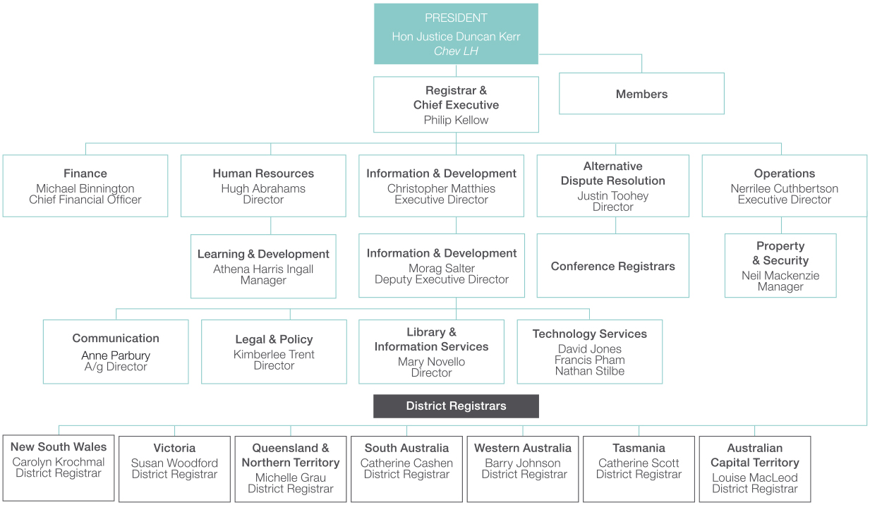

Tribunal committees
A number of committees comprising Tribunal members and staff advise and assist the President in relation to the management of the Tribunal.

Alternative Dispute Resolution Committee
The Alternative Dispute Resolution Committee considers issues relating to alternative dispute resolution processes in the Tribunal, including the development of policies and guidelines for their use. The committee is chaired by the Tribunal’s Director, Alternative Dispute Resolution and includes four members and two Conference Registrars.

Executive Committee
The Executive Committee provides high level advice and assistance to the President on executive management issues, including oversight of the Tribunal’s Strategic Plan. It is chaired by the President and its members include Deputy President Constance, the Registrar, the Executive Directors, the Director, Alternative Dispute Resolution and District Registrar Carolyn Krochmal.

Executive Deputy Presidents Committee
The Executive Deputy Presidents Committee comprises the President and the Executive Deputy President/Senior Member for each District Registry. It is the primary mechanism for the Executive Deputy Presidents to discuss issues relating to the management of the Tribunal and to provide high level input to the President on key developments.

Library Committee
The Library Committee oversees the development and improvement of the Tribunal’s library collection and the delivery of training related to the use of library services. It is chaired by Deputy President Hotop and consists of three other members, the Executive Director, Information and Development and the Director, Library and Information Services.

NDIS Monitoring Committee
The NDIS Monitoring Committee oversees the operations and performance of the Tribunal’s NDIS Division and supports best practice in the NDIS Division. The committee is chaired by Senior Member Toohey and includes Senior Member Handley, the Registrar, the Executive Directors, the Director, Alternative Dispute Resolution, and the Tribunal’s Manager, Learning and Development.

Practice and Procedure Committee
The Practice and Procedure Committee oversees the development and implementation of changes to the management and resolution of applications before the Tribunal and facilitates the adoption of consistent best practice case management practices. It is chaired by the President and includes either the Executive Deputy President/Senior Member or District Registrar from each registry, the Registrar, the Executive Directors and the Director, Alternative Dispute Resolution.

Practice and Procedure Consultative Group
The Practice and Procedure Consultative Group identifies and provides feedback to the Practice and Procedure Committee on issues and proposed improvements in relation to case management and dispute resolution. Members of the committee are the President, the Executive Deputy Presidents/Senior Member, the Registrar, the Executive Directors, the District Registrar of each registry and the Director, Alternative Dispute Resolution.

Professional Development Committee
The Professional Development Committee considers matters relating to the professional development of Tribunal members and registrars. The committee is chaired by Deputy President Hotop and consists of three other members, the Director, Alternative Dispute Resolution and the Tribunal’s Manager, Learning and Development.

Warrants Committee
The Warrants Committee deals with issues relating to the functions that are carried out by members in their personal capacity under the Surveillance Devices Act 2004, the Telecommunications (Interception and Access) Act 1979 and other similar legislation. The committee was chaired by Deputy President Handley and includes three other members who exercise these powers and the Executive Director, Operations.
For information about the Tribunal’s Audit Committee, see page 53.

CASE MANAGEMENT
The Tribunal’s case management process is designed to deal with applications in a flexible and timely manner. It aims to promote the orderly passage of applications from lodgement to resolution, equitable treatment of parties, achievement of case management targets, effective allocation and use of Tribunal resources, and public confidence in the Tribunal.

The process
When the Tribunal receives a valid application, it notifies the decision-maker that the application has been made. The decision-maker then has 28 days to provide the Tribunal and the applicant with a statement of reasons for the decision and all documents relevant to the review. These are the ‘Section 37 Documents’ or the ‘T (for Tribunal) Documents’.
In relation to most applications, the Tribunal’s approach is to assist the parties to attempt to reach an agreed outcome while ensuring that steps are taken to prepare the case for hearing in the event it cannot be resolved by agreement. A Conference Registrar or Tribunal member will hold one or more conferences with the parties, either in person or by telephone, to discuss and define the issues in dispute, identify and consider additional material that may be obtained, explore whether the matter can be settled and discuss the future conduct of the review. Where appropriate, the application may be referred to another form of alternative dispute resolution – conciliation, mediation, case appraisal or neutral evaluation. The Tribunal sets timetables and issues directions for the steps the parties must take in the review.
If agreement cannot be reached, the Tribunal – constituted by one, two or three members – conducts a hearing and makes a decision. Figure 2.4 illustrates the usual progress of an application, from lodgement to decision.
The Tribunal modifies its case management process for particular types of cases as well as in individual cases to ensure they are dealt with in the most effective and efficient way.
Some applications are managed by Tribunal members by way of directions hearings from the time of lodgement. These include applications that require an expedited review and applications about security assessments made by ASIO.
For the review of decisions under the National Disability Insurance Scheme, the Tribunal has tailored its process to seek to resolve applications as simply and quickly as possible. Some key aspects are:
- a staff member is allocated to be the applicant’s Contact Officer throughout the review and contacts the applicant within three days of receiving the application to talk about the review
- the Tribunal generally holds no more than three case events: a conference, conciliation and a hearing, with applicants able to request a fast-track hearing if they do not want to attend conciliation
- if agreement is not reached at the conference, the Tribunal prepares a written Case Plan setting out anything that has been agreed, what the parties must do and the dates for any conciliation and the hearing, and
- the Tribunal usually gives its decision and reasons orally at, or soon after, the hearing.
Figure 2.4 Case management process
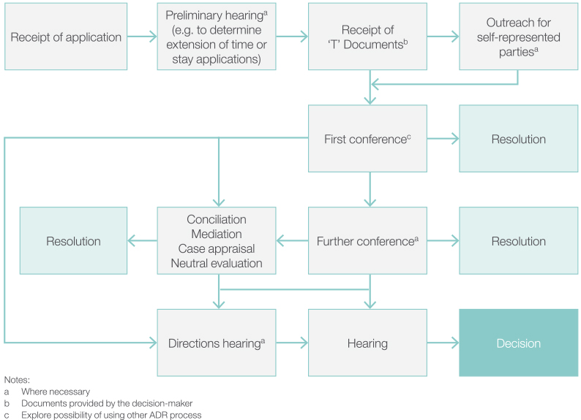

Practice directions, guides, guidelines and process models
The Tribunal has published a range of documents that describe its policies and procedures. They are designed to assist parties and their representatives to understand the Tribunal’s processes and what is expected of them during the review process. This will help the Tribunal meet its goal of providing a fair, just, economical, informal and quick mechanism of review.

Practice directions guides and guidelines
The Tribunal has issued the following practice directions and jurisdictional guides which outline the procedures for managing different types of applications.
- General Practice Direction which applies to all cases in which an applicant is represented, unless another specific legislative procedure, practice direction or jurisdictional guide applies
- Review of National Disability Insurance Scheme Decisions Practice Direction
- Small Taxation Claims Tribunal Practice Direction
- Guide to the Social Security Jurisdiction
- Guide to the Workers’ Compensation Jurisdiction
The Practice Direction for the Expedited Review of Certain Decisions, issued on 1 July 2014, outlines what parties must do to request an expedited review, how the Tribunal will handle such requests and what will occur when the Tribunal is satisfied that a review is to be expedited.
The following practice directions and guidelines deal with specific aspects of the review process.
- Practice Direction relating to section 37 of the AAT Act
- Freedom of Information Practice Direction
- Listing and Adjournment Practice Direction
- Practice Direction relating to Release from the Implied Undertaking
- Practice Direction relating to the Use of Video Surveillance Material
- Guidelines for Constituting the Tribunal
- Guidelines for Persons Giving Expert and Opinion Evidence
- Guidelines for the Use of Concurrent Evidence in the Administrative Appeals Tribunal

Alternative dispute resolution process models and guidelines
For each of the alternative dispute resolution processes that may be employed during a review, the Tribunal has a process model that gives a detailed description of what will occur. It has also developed a policy that guides the referral of applications to the different processes.
The Tribunal has also published two guidelines on aspects of alternative dispute resolution: The Duty to Act in Good Faith in ADR Processes at the AAT and Confidentiality in ADR Processes.
The practice directions, guides, guidelines and process models and are all available on the Tribunal’s website.

ACCESSING THE TRIBUNAL
The Tribunal has a range of measures designed to assist parties to access the Tribunal and participate in the review process.

Access to information about the Tribunal
The Tribunal offers information on its role and procedures in multiple formats and languages to ensure that potential applicants and other participants have access to the information they need.
Brochures and fact sheets for self-represented parties explain the Tribunal’s role, when it can assist and the stages in a review. They are designed to be clear and easy to understand, and are available in print, including large print, on the website and in multiple languages. The Tribunal has developed a specific series of fact sheets to provide information on the Tribunal’s procedures for reviewing National Disability Insurance Scheme decisions.
Comprehensive information about the Tribunal and its procedures is on the website and is regularly updated.

Outreach program
Before the first conference, Tribunal staff (Outreach officers) contact self-represented parties, usually by telephone, to explain the Tribunal’s processes and give them the opportunity to ask questions about the review process. Parties are given information about organisations that may be able to provide advice and assistance. Tribunal staff also identify whether parties will require an interpreter or assistance for people with disability.
Self-represented parties who have given the Tribunal a mobile telephone number receive an SMS reminder a few days before an upcoming case event.

Legal advice schemes and referrals
The Tribunal hosts legal advice schemes in cooperation with legal aid organisations in New South Wales, Queensland, South Australia, Victoria and Western Australia. A legal aid solicitor attends each registry on a regular basis — usually weekly or fortnightly — and provides advice and minor assistance to self-represented parties.
Further assistance, such as representation, may be provided if a person makes a successful application for legal aid.
The Tribunal advises self-represented parties of the service and makes appointments for them. The majority of these appointments are for self-represented parties in the social security jurisdiction.
The Tribunal also refers self-represented parties to community legal centres and other organisations that may be able to provide advice and assistance.

Interpreting services
If a party requires an interpreter, the Tribunal engages one and meets the cost. The Tribunal arranges interpreters who are accredited by the National Accreditation Authority for Translators and Interpreters at the ‘professional’ level. A ‘paraprofessional’ interpreter may only be used for languages without an accredited professional-level interpreter.
The Tribunal offers interpreters an information fact sheet on its procedures and terminology that is available from the Tribunal’s registries and on the website.

Access by people with disability
The Tribunal strives to make access easier for people with disability by:
- providing electronic and printed material in appropriate formats such as large print
- ensuring the website meets the World Wide Web Consortium’s Web Content Accessibility Guidelines version 2.0 (WCAG 2.0) web standard to Level A
- providing portable hearing loop systems in Tribunal premises
- facilitating telephone contact for people with a hearing or speech impairment
- making all Tribunal premises wheelchair-accessible and ensuring other premises used by the Tribunal are accessible, and
- providing facilities for participation in conferences or hearings by telephone or video-link.
The Tribunal will implement ReadSpeaker, a text to speech software service, on its website early in 2014–15.

Service Charter and complaints
The Service Charter sets out the standards of service that people can expect when they deal with the Tribunal. The Charter also includes information on how to make a complaint about the Tribunal and its complaint-handling procedures.
The Charter is written in clear, simple language and is on the Tribunal’s website and in print. The Tribunal’s compliance with its commitments under the Charter is discussed in Chapter 3, along with complaints information.

Chapter 03
Our performance
The Tribunal seeks to manage its workload in an effective and efficient manner, responding flexibly to changes in the number and nature of applications. Performance targets define standards for dealing with applications, and assist the Tribunal to meet the outcome and program requirements defined in the Portfolio Budget Statements.

WORKLOAD
The Tribunal received 7,263 applications and finalised 6,748 applications in 2013–14. There were 5,061 applications current at 30 June 2014.
Lodgements during the reporting year were 18 per cent higher than in 2012–13. In relation to the Tribunal’s major jurisdictions, increases were recorded in social security, tax and workers’ compensation. Lodgements also rose in a broad range of other types of decisions that the Tribunal can review and the Tribunal received its first applications to review decisions made under the National Disability Insurance Scheme.
The number of applications finalised rose by 12 per cent in 2013–14. Finalisations increased in the social security and workers’ compensation jurisdictions as well as in relation to the larger number of applications beyond the major jurisdictions that were lodged in 2013–14.
The number of applications on hand at 30 June 2014 was 10 per cent higher than a year earlier, reflecting the increase in lodgements in 2013–14. The majority of applications on hand at 30 June 2014 were less than 12 months old, and the proportion of cases older than 12 months decreased during the reporting year.
Chart 3.1 shows applications lodged and finalised in the three most recent reporting years, and applications current at 30 June in each year. More detailed information on the types of applications lodged and finalised, and the outcomes of cases finalised during the reporting year, is in Appendix 4.
Chart 3.1 Applications lodged, finalised and current – Total
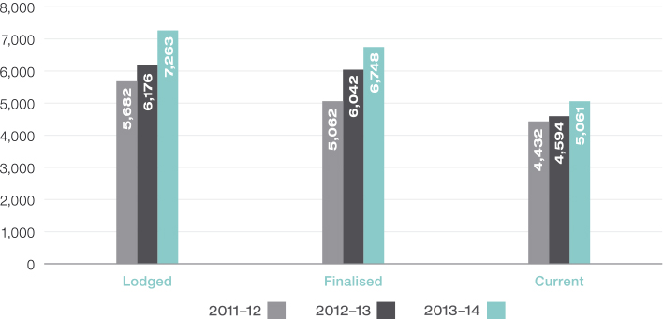

Workload by jurisdiction
Applications for review of social security and tax decisions were the most common types of applications lodged with the Tribunal in 2013–14, each constituting 28 per cent of all lodgements. Applications in the workers’ compensation and veterans’ affairs jurisdictions comprised 21 per cent and 5 per cent of all lodgements respectively. All other applications constituted 19 per cent of total lodgements.
The number of applications lodged exceeded the number that were finalised in all of the major jurisdictions, including tax when applications in the Taxation Appeals Division and Small Taxation Claims Tribunal are combined. Lodgements also exceeded finalisations in relation to other types of applications. This led to some increase in the volume of applications on hand at 30 June 2014 in all areas of work. The difference between lodgements and finalisations, and therefore the increase in current applications, was lowest in relation to social security and veterans’ affairs applications.
The number of applications lodged and finalised in each of the Tribunal’s major jurisdictions in 2013–14 and the number of applications on hand at 30 June 2014, is shown in Chart 3.2.
Chart 3.2 Applications lodged, finalised and current in 2013–14 – By jurisdiction
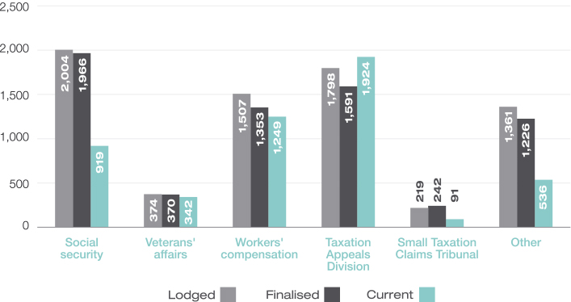

Social security
The number of applications lodged in 2013–14 for review of family assistance and social security decisions was eight per cent higher than in 2012–13, as shown in Chart 3.3. This increase was considerably less than the 29 per cent increase recorded in 2012–13. Applications about disability support pension and overpayments and debt recovery were the principal sources of the increase in lodgements in 2013–14, continuing the trend of recent years.
The departments that administer family assistance and social security entitlements made 54 of the applications that were lodged in 2013–14, up from 47 in the previous year and 38 in 2011–12.
The number of applications finalised in 2013–14 increased by 18 per cent, reflecting the increase in lodgements in this jurisdiction. The more modest increase in lodgements in 2013–14 resulted in only a three per cent increase in applications on hand at 30 June 2014.
Chart 3.3 Applications lodged, finalised and current – Social security
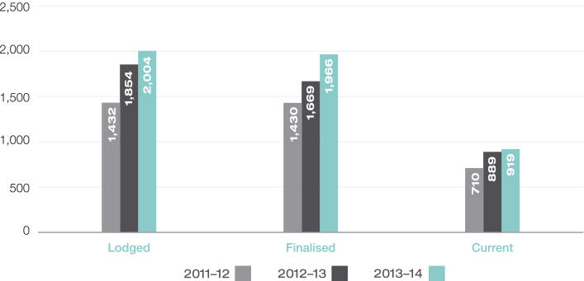

Veterans’ affairs
The number of applications lodged in the veterans’ affairs jurisdiction fell by nine per cent in 2013–14. This can be attributed to a decrease in the number of applications for review of decisions under the Veterans’ Entitlements Act 1986 relating to disability pension and war widows pension. This is consistent with the longer-term trend of fewer applications for review of these types of decisions.
The number of applications finalised in the jurisdiction decreased marginally in 2013–14, as shown in Chart 3.4. The three per cent increase in the number of current applications at 30 June 2014 reflects that it can take a longer time to resolve applications under the Veterans’ Entitlements Act.
Chart 3.4 Applications lodged, finalised and current – Veterans’ affairs
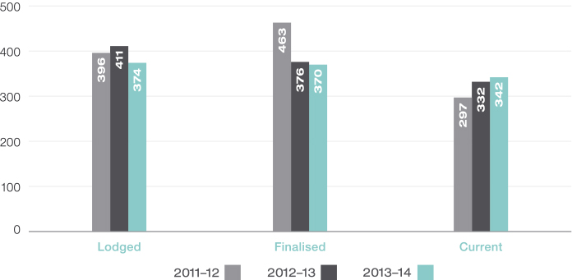

Workers’ compensation
There was a 17 per cent increase in lodgements in the workers’ compensation jurisdiction in 2013–14. In part, this can be attributed to an increase in the number of applications for review of decisions made under the Safety, Rehabilitation and Compensation Act 1988, particularly by Comcare and the Linfox companies. There was also an increase of 31 per cent in the number of applications for review under the seafarers’ compensation scheme.
The number of compensation applications finalised in 2013–14 rose by 12 per cent, reflecting the increase in lodgements in the previous and current reporting years. The 14 per cent increase in the number of applications on hand at 30 June 2014 is consistent with the increase in lodgements for 2013–14, as shown in Chart 3.5.
Chart 3.5 Applications lodged, finalised and current – Workers’ compensation
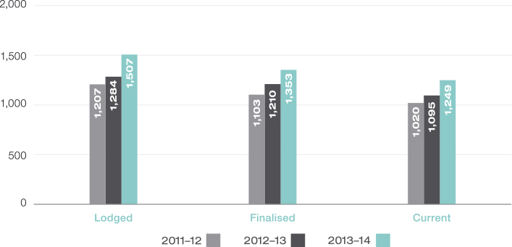

Taxation
The number of applications lodged in the Taxation Appeals Division increased in 2013–14 by 22 per cent, as shown in Chart 3.6. This increase relates primarily to a greater number of applications for review of decisions about income tax. There was an eight per cent increase in the number of applications finalised in 2013–14 and a 10 per cent increase in the number of applications on hand at 30 June 2014, trends which reflect the increase in lodgements.
In the Small Taxation Claims Tribunal, there was a small increase in lodgements of six per cent in 2013–14 which relates to an increase in the number of applications for review of income tax decisions and applications relating to release from tax liabilities. While the number of finalisations was 30 per cent lower than in the previous year, finalisations exceeded lodgements for the second consecutive year, contributing to a 27 per cent fall in the number of applications on hand at 30 June 2014.
Chart 3.6 Applications lodged, finalised and current – Taxation Appeals Division and Small Taxation Claims Tribunal
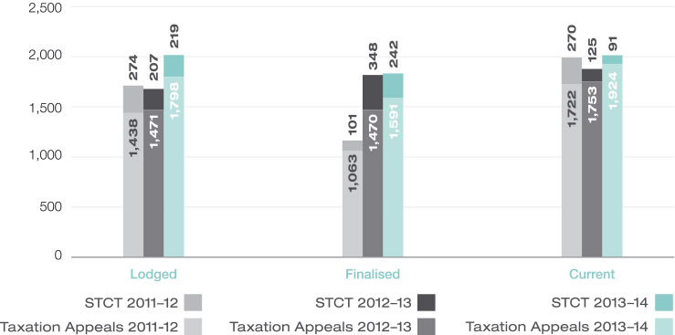

Other jurisdictions
The number of applications lodged in other jurisdictions increased by 43 per cent in 2013–14. Lodgements increased in relation to a range of other decision types, including citizenship, civil aviation regulation, customs and higher education loan schemes. There was also a significant increase in the number of stand-alone applications lodged with the Tribunal seeking an extension of time within which to lodge an application for review.
There was a 27 per cent increase in finalisations in these other areas of the Tribunal’s work in 2013–14 and a 34 per cent increase in applications on hand at 30 June 2014. These increases are consistent with the rise in the number of lodgements.
In relation to the review of decisions made by the National Disability Insurance Agency, the Tribunal received 19 applications for review of decisions in 2013–14. Eight of those applications were finalised, and 11 were current as at 30 June 2014. The number of applications lodged in this jurisdiction is expected to grow in coming years.
Chart 3.7 Applications lodged, finalised and current – Other jurisdictions
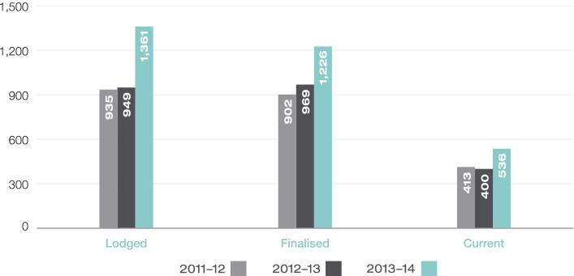

PERFORMANCE

Outcome and Program information
The Tribunal had one outcome specified in the 2013–14 Portfolio Budget Statements:
Access to a fair, just, economical, informal and quick review mechanism for applicants through reviews of government administrative decisions, including dispute resolution processes and independent formal hearings.
The Tribunal is a single program agency.

Deliverables
The Tribunal’s primary deliverable is completed reviews of decisions, and there are two paths to achieving it:
- applications finalised without a hearing, and
- applications finalised with a hearing.
The Tribunal’s deliverables targets and its actual performance for 2013–14 are shown in Table 3.8.
Table 3.8 Deliverables targets and results, 2013–14
 | Target | Result
Applications finalised without a hearing  Number of matters finalised without a hearing | 5,975 | 5,541
Applications finalised with a hearing  Number of matters finalised with a hearing | 1,494 | 1,207
The number of applications finalised by the Tribunal, both with and without a hearing, was lower than the budget projections for 2013-–14. The Tribunal received a lower than anticipated number of applications for review of National Disability Insurance Scheme decisions.

Key performance indicators
The Tribunal reviewed and changed its key performance indicators for 2013–14, to better reflect its disposition of review applications. The indicators are:
- to finalise 75 per cent of applications within 12 months of lodgement, and
- to resolve 80 per cent of applications without a hearing.
For the second indicator, the Tribunal uses alternative dispute resolution to help the parties try to reach agreement about how their case should be resolved. The Tribunal conducts a hearing and makes a decision if an application cannot otherwise be resolved.
The Tribunal’s actual performance for 2013–14 is shown in Table 3.9.
The Tribunal also measures its performance periodically through client satisfaction surveys and includes the results of the surveys in the annual report in the relevant year.
Table 3.9 Key performance indicators and results, 2013–14
 | Target | Result
Percentage of applications finalised within 12 months of lodgement | 75% | 82%
Percentage of applications resolved without a hearing | 80% | 82%
In relation to the timeliness of dealing with applications, the Tribunal exceeded its target in the Portfolio Budget Statements by seven percentage points. This target would also have been exceeded in the two previous financial years had the indicator applied in those years: 76 per cent of applications were finalised within 12 months in 2012–13 and 78 per cent in 2011–12. The Tribunal recorded a six percentage point improvement in timeliness from 2012–13 to 2013–14.
In relation to resolving applications without a hearing, the Tribunal exceeded its target by two percentage points in 2013–14. The result for each of the two previous financial years was 79 per cent, marginally below the target. For more information on the percentage of applications finalised without a hearing in the major jurisdictions, see Table A4.4 in Appendix 4.
See Appendix 5 for the summary table showing total resources for the Tribunal compared with the total payments made during 2013–14. The appendix also includes a summary table showing the total resources for the Tribunal’s outcome.

Time standards
The Tribunal monitors its performance against time standards for steps in the review process as well as for the finalisation of applications, both generally and in its major jurisdictions.

Time standards for steps in the review process
The Tribunal reports on the timeliness of completing four steps in the review process:
- the time taken by the decision-maker to lodge the documents relating to the decision under review that are required under section 37 of the Administrative Appeals Tribunal Act 1975 after receiving notice of an application
- the time between lodging an application and holding the first conference
- the time between lodging an application and holding a hearing
- the time taken by the Tribunal to deliver a decision following the last day of hearing or the date of receipt of further material after a hearing.
The decision-maker controls step one; the Tribunal and the parties share the responsibility for the timeliness of steps two and three; and the Tribunal controls the timeliness of step four.
Timeliness results for 2013–14 and the two previous reporting periods are shown in Chart 3.10.
Chart 3.10 Performance against time standards
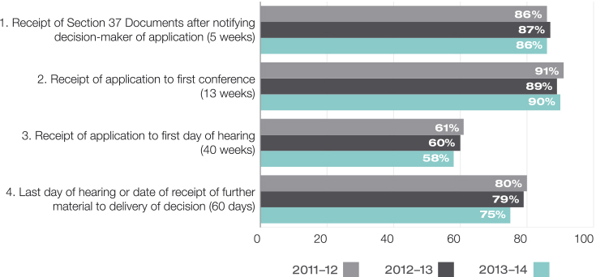
The proportion of applications in which the decision-maker lodged the Section 37 Documents within five weeks of receiving notice of the application was marginally lower in 2013–14 than in the previous year.
The Tribunal continued to hold a high proportion of first conferences within 13 weeks of the lodgement of an application and achieved a small improvement in performance in 2013–14. The proportion of applications in which the hearing was held within 40 weeks of lodgement decreased slightly in the reporting year.
In relation to the timeliness of delivering decisions after a hearing, the majority of decisions continued to be delivered within the Tribunal’s target. However, the proportion declined by four percentage points in 2013–14.

Time standards for finalising applications in major jurisdictions
The Tribunal aims to finalise the majority of applications within 12 months of lodgement and has set specific targets for each of the major jurisdictions. In relation to the Small Taxation Claims Tribunal, the Tribunal’s goal is to finalise applications within 12 weeks of lodgement.
The Tribunal’s performance for 2013–14 and the two previous reporting years are in Table 3.11.
Table 3.11 Percentage of applications finalised within time standards
Jurisdiction | Target  % | 2011–12  % | 2012–13  % | 2013–14  %
All | — | 78 | 76 | 82
Social securitya | 90 | 93 | 93 | 93
Veterans’ affairsa | 80 | 66 | 70 | 70
Workers’ compensationa | 75 | 70 | 68 | 70
Taxation Appeals Divisiona | 75 | 65 | 67 | 77
Small Taxation Claims Tribunalb | — | 41 | 27 | 33
a Time standard: percentage of applications finalised within 12 months
b Time standard: percentage of applications finalised within 12 weeks
The proportion of applications finalised within 12 months in the social security jurisdiction in 2013–14 exceeded the 90 per cent target by three percentage points, maintaining the results achieved in the previous two reporting years. Sixty-six per cent of all social security applications were finalised within six months of lodgement, and 98 per cent within 18 months.
The Tribunal was also able to maintain its level of performance in the veterans’ affairs jurisdiction in 2013–14 with 70 per cent of applications finalised within 12 months. Eighty-seven per cent of applications were finalised within 18 months.
The Tribunal has focused on improving case management in the workers’ compensation jurisdiction and has significantly improved its performance in relation to timeliness since 2009–10. Seventy per cent of workers’ compensation cases were finalised within 12 months in 2013–14, an improvement of two percentage points from 2012–13. Eighty-nine per cent of applications were finalised within 18 months, which was slightly lower than the result for 2012–13.
There was a significant improvement in timeliness in the Taxation Appeals Division in 2013–14. The proportion of applications finalised within 12 months improved by 10 percentage points from 67 per cent in 2012–13 to 77 per cent in the reporting year. Eighty-seven per cent of applications were finalised within 18 months. The result for 2013–14 continues the trend of improved performance in this division over recent reporting years.
In the Small Taxation Claims Tribunal, the proportion of applications finalised within 12 weeks improved by six percentage points but remains relatively low. The Tribunal’s experience is that applications dealt with in the Small Taxation Claims Tribunal cannot necessarily be completed faster than other types of tax reviews. Although the amount of tax in dispute may not be large, the issues in dispute can be complex and the parties may require additional time to gather relevant material.
There are a number of reasons why an application may not be finalised within the Tribunal’s time standards. The pace that applications progress through the pre-hearing stage is heavily influenced by the time the parties need to obtain expert evidence, undertake other investigations and gather relevant material. Some applications are delayed pending a decision by a department or agency on a related matter, the decision of a court in a test case, or by criminal proceedings. There are cases where additional time is required to allow the parties further opportunities to resolve the dispute without a hearing. Delays also occur when parties cannot proceed because of illness or other adverse circumstances. The Tribunal’s ability to list hearings in a timely manner is affected generally by the availability of parties, representatives and witnesses for the hearing. Delays in the delivery of decisions following a hearing can also contribute to delays in finalising applications.
The Tribunal continued to monitor the time that applications spend in each of the major stages of a review in 2013–14 and registries conducted regular file audits on older cases. The Tribunal will continue to seek to identify sources of avoidable delay, and work with stakeholders on minimising such delays.

EXTERNAL Scrutiny
Tribunal decisions may be appealed to the courts. The Tribunal’s operations are also subject to external scrutiny by way of complaints to the Commonwealth Ombudsman and other bodies, requests under the Freedom of Information Act 1982, inquiries by Parliamentary Committees, and audits by the Australian National Audit Office.

Appeals from Tribunal decisions
A party may appeal to the Federal Court, on a question of law, from most final decisions of the Tribunal pursuant to section 44 of the AAT Act. The Federal Court may transfer the appeal to the Federal Circuit Court unless the Tribunal was constituted by, or included, a presidential member.
A party may also seek judicial review of decisions made in the course of the review process and certain final decisions under the Administrative Decisions (Judicial Review) Act 1977, section 39B of the Judiciary Act 1903, Part 8 of the Migration Act 1958 or section 75(v) of the Constitution. Applications may be made to the Federal Court, the Federal Circuit Court or the High Court.
In 2013–14, 96 appeals made under section 44 of the AAT Act were lodged with the Federal Court. There were 11 applications for judicial review made under other enactments, seven relating to decisions concerning visas under the Migration Act. Table A4.9 in Appendix 4 provides information on the number of appeals lodged against decisions in each of the Tribunal’s major jurisdictions.
During the reporting year, 97 appeals lodged under section 44 of the AAT Act and 20 applications for judicial review under other enactments were determined in the courts. The Tribunal’s decision was set aside in 34 cases, representing 29 per cent of all appeals determined and fewer than one per cent of all applications that the Tribunal finalised in the reporting year. The proportion of Tribunal decisions set aside on appeal in 2013–14 was nine percentage points lower than in 2012–13.
Table A4.10 in Appendix 4 offers more information on appeals determined during the reporting year and their outcomes.
During the reporting year, there were no judicial decisions or decisions of other tribunals that had, or may have had, a significant impact on the operations of the Tribunal.

Freedom of information
The Tribunal received ten requests for access to documents under the Freedom of Information Act in 2013–14. Nine requests were finalised in the reporting year and one request was outstanding at 30 June 2014.
Table 3.12 shows the number of requests made over the last three years.
Table 3.12 Freedom of Information requests
 | 2011–12 | 2012–13 | 2013–14
Number of requests made | 5 | 7 | 10
Of the nine requests that were finalised, three requests were granted in full, three were granted in part and one was withdrawn. Two requests were refused on the basis that the Tribunal held no documents falling within the scope of the request.
The Tribunal did not receive any requests to amend or annotate records.

Information publication scheme
Agencies subject to the Freedom of Information Act are required to publish information to the public as part of the Information Publication Scheme. This requirement is in Part II of the Freedom of Information Act. The Tribunal’s plan is on the website, meeting the requirement that each agency must display on its website a plan showing what information it publishes in accordance with the IPS requirements.

Ombudsman
During 2013–14, the Commonwealth Ombudsman received 25 approaches concerning the Tribunal, two fewer than in the previous reporting year.
The Ombudsman conducted one investigation and concluded further investigation was not warranted in the circumstances.

Complaints to other bodies
There were two privacy-related complaints made to the Office of the Australian Information Commissioner during the reporting period. The Office declined both complaints, determining they were not an interference with privacy.
There were no complaints made to the Australian Human Rights Commission during the reporting period.

Reports by the Auditor-General or Parliamentary Committees
The Tribunal’s operations were not the subject of any report by the Auditor-General or any Parliamentary Committee during the reporting period.

SERVICE CHARTER
The Service Charter sets out the Tribunal’s service standards and information relating to making complaints about the Tribunal, including the standards for responding to complaints.
Information on the extent of the Tribunal’s compliance with the service standards (where information is available) is in Table 3.13.
Table 3.13 Service standards
Commitment | Result for 2013–14
We will treat you with respect and courtesy
We will be polite, respectful and courteous and use language that is clear and understandable. | Tribunal members and staff strive to be polite, respectful and courteous and use language that is clear and understandable so that Tribunal users can understand the processes. Of the complaints finalised in 2013–14, no complaints were upheld in relation to issues of this kind.
We will make ourselves accessible
Country residents can contact us on our national telephone number for the cost of a local call. | The Tribunal’s national telephone number was available throughout the year.
People who are deaf or have a hearing or speech impairment can contact the Tribunal. | The Tribunal uses the National Relay Service to provide users with a range of contact options including TTY and internet, SMS and video relay.
Wheelchair access and hearing induction loops will be available at each office. | All Tribunal premises are wheelchair-accessible and have portable induction loops available.
Hearings will be held in capital cities and in country centres. | The Tribunal conducted 83 hearings, two conferences, two mediations and one interlocutory hearing in locations outside capital cities.
Where appropriate you may participate in a hearing by telephone or by video-link. | The Tribunal conducted the following matters by telephone:  conferences — 6,031  other alternative dispute resolution processes — 7  directions hearings — 1,486  interlocutory hearings — 281  hearings — 75
If you need an interpreter, we will provide one free of charge. | The Tribunal arranges for an interpreter to participate in an alternative dispute resolution process or hearing where needed. Interpreters are provided free of charge.
If you are self-represented, we will help you understand Tribunal procedures through our Outreach program. Outreach officers will contact self-represented parties by telephone within six weeks of an application being lodged. | Data collated for Outreach, for 1,154 parties, shows the average time from lodgement of an application to Outreach was 39 days, approximately five and a half weeks.
We will deal with you fairly
A private conference will usually be held within 10 weeks of an application being lodged. | 74 per cent of first conferences were held within 10 weeks of lodgement, marginally lower than the 75 per cent result achieved in 2012–13.
We will operate in an efficient manner
If a decision was not given orally at a hearing, written decisions will usually be provided within two months. | 75 per cent of decisions were delivered within 60 days of the last day of hearing or the receipt of further submissions or other material, down from 79 per cent in 2012–13 (see Table 3.10).

Complaints to the Tribunal
Complaints may be made orally or in writing. In accordance with guidelines adopted in 2013, complaints relating to Tribunal members are dealt with by the President, while complaints about staff members or other matters are dealt with by the Registrar, one of the Executive Directors or a District Registrar.
When a complaint is made in person or by telephone, the Tribunal attempts to resolve it immediately. The Tribunal aims to respond to written complaints within 20 working days, or 30 working days if the complaint is submitted in a language other than English. The length of time before a final response is provided depends on the extent of investigation which is necessary. If more time is required, because of the complexity of the complaint or the need to consult with other persons before providing a response, the Tribunal advises the complainant of progress in handling the complaint.
If a complaint is upheld, possible responses include an apology, a change to practice and procedure or consideration of additional training and development for Tribunal personnel.
During 2013–14, the Tribunal received complaints from 25 individuals. Chart 3.14 shows the number of complaints made over the three most recent reporting years.
The 25 complaints made in 2013–14 were about the issues shown in Table 3.15.
Table 3.14 Complaints to the Tribunal
 | 2011–12 | 2012–13 | 2013–14
Number of complaints made | 41 | 24 | 25
Table 3.15 Issues raised in complaints to the Tribunal
Issue | Number of complaints
Tribunal decisions | 12
General procedural issues | 7
Conduct of Tribunal members | 4
Conduct of conferences | 2
Total | 25
The Tribunal provided a substantive response to 24 complaints in 2013–14, responding within 20 working days to 23 of the complaints. The average number of days from complaint to final response was eight working days.
The Tribunal found that it could have handled matters more appropriately in relation to three complaints which raised issues concerning timetabling and delay in the review process, and the conduct of Tribunal personnel. The Tribunal offered an apology in each case and raised the matters with the relevant personnel.
The Tribunal does not measure whether a complainant believes his or her complaint was resolved. Two complainants wrote again to the Tribunal after receiving an initial response to their complaint. They were given further information to address any outstanding concerns.

ADDITIONAL FUNCTIONS CONFERRED ON TRIBUNAL MEMBERS
As well as performing their role under the AAT Act, Tribunal members may exercise powers under a range of other Acts in their personal capacity.

Warrants, controlled operations and other functions
All Deputy Presidents and full-time Senior Members, and any part-time Senior Member or Member who has been enrolled as a legal practitioner for at least five years, may be nominated by the responsible Minister to:
- issue telecommunications interception warrants and stored communications warrants under the Telecommunications (Interception and Access) Act 1979
- issue warrants and exercise related powers under the Surveillance Devices Act 2004, and
- vary controlled operations authorities under the Crimes Act 1914.
The President, all Deputy Presidents, and any Senior Member who has been enrolled as a legal practitioner for at least five years, may be nominated to make orders allowing information given to the Inspector of Transport Security to be disclosed to another government agency under the Inspector of Transport Security Act 2006.
All Deputy Presidents, and any non-presidential member who has been enrolled as a legal practitioner for at least five years, can be nominated to issue search warrants and exercise related powers under the Tobacco Plain Packaging Act 2011.
The President and all Deputy Presidents are also eligible to be appointed as issuing authorities for making continued preventative detention orders under the Criminal Code Act 1995. All presidential members of the Tribunal may be nominated to issue examination notices under the Fair Work (Building Industry) Act 2012.
All members of the Tribunal are authorised to exercise a range of powers relating to monitoring overseas students’ compliance with visa conditions under the Education Services for Overseas Students Act 2000 and the Migration Act. Table 3.16 shows the number of occasions on which Tribunal members considered applications under any of these Acts over the past three years. There was a two per cent decrease in the number of appointments held in 2013–14.
Table 3.16 Applications relating to warrants, controlled operations and other functions considered by Tribunal members
 | 2011–12 | 2012–13 | 2013–14
Number of occasions on which applications considered | 2,496 | 2,764 | 2,715
The Tribunal is flexible in performing these functions and members are available outside standard business hours. In the reporting period, there were 171 out-of-hours appointments (before 9 am or after 5 pm on weekdays or at any time on the weekend or on a public holiday).
In a proportion of applications, the issue of a warrant or other authorisation is only granted after further information is provided at the request of the authorised member. A small number of warrant applications are refused, some only granted after conditions are imposed (including conditions in relation to privacy) and, in some instances, the warrant is issued for a lesser period of time than that sought by the law enforcement agency.

Proceeds of crime examinations
All presidential members of the Tribunal, and any Senior Member or Member, who has been enrolled as a legal practitioner for at least five years, may be appointed by the responsible Minister as an approved examiner under the Proceeds of Crime Act 2002 or the Proceeds of Crime Regulations 2002. Approved examiners are authorised to issue examination notices at the request of the Australian Federal Police and to oversee compulsory examinations in connection with confiscation proceedings.
Table 3.18 shows the number of examination sessions conducted by Tribunal members in the last three years. The number of examinations has increased since 2013–14 but remains relatively low.
Table 3.17 Examinations held under the Proceeds of Crime Act 2002
 | 2011–12 | 2012–13 | 2013–14
Number of examination sessions held | 2 | 28 | 28

Chapter 04
Our users and our relationships

OUR USERS
The principal users of the Tribunal are the parties to applications in the Tribunal, including individuals, organisations, government departments and agencies, and their representatives. This section reports on actions undertaken during the reporting period to meet Goal One in the Tribunal’s Strategic Plan 2011–2014: to provide a high-quality independent merits review process that is fair, just, economical, informal and quick. These actions include:
- promoting and facilitating the use of appropriate alternative dispute resolution processes
- providing accessible and effective registry services
- maintaining effective communication and engagement with our users and the public.

Tribunal practice and procedure
The Tribunal monitors the operation of the review process and seeks to identify ways in which practice and procedure can be improved to promote the effective and timely disposition of applications lodged with the Tribunal. The Practice and Procedure Consultative Group and the Practice and Procedure Committee oversee the Tribunal’s management of applications made under the Administrative Appeals Tribunal Act 1975. The Consultative Group met in October 2013 and May 2014 and the Practice and Procedure Committee met in August 2013 and April 2014. For information about membership of these committees, see Chapter 2.
Significant developments in relation to practice and procedure during the reporting period are discussed below.

Review of National Disability Insurance Scheme decisions
On 1 July 2013, jurisdiction was conferred on the Tribunal to review decisions made under the National Disability Insurance Scheme Act 2013. The Tribunal has developed a case management model that aims to ensure the review process is accessible, fair, informal and quick. Key features of the model are outlined in Chapter 2. The Tribunal issued a practice direction on 1 July 2013.
The Tribunal prepared for applications under the NDIS Act by:
- training members and staff in relation to disability and accessibility issues, the National Disability Insurance Scheme legislative framework and the Tribunal’s case management approach
- locating and making arrangements for the use of accessible venues in trial sites for the conduct of alternative dispute resolution processes and hearings
- developing a range of procedural guides and checklists for staff which support the case management model, and
- conducting information sessions on merits review of National Disability Insurance Scheme decisions for disability advocates and other stakeholders in the trial sites with representatives of the National Disability Insurance Agency, the Department of Social Services, the disability advocacy agencies funded to provide support services to applicants and the legal aid commissions.
The Tribunal continued to work closely with key stakeholders on issues relating to the review process and monitored the operation of the case management model in the first applications for review lodged with the Tribunal.

Practice and procedure in workers’ compensation cases
Following consultation in 2012–13, the Tribunal implemented proposals in 2013–14 to promote the timely progress of applications in the workers’ compensation jurisdiction and assist the Tribunal to meet its aim of finalising applications within 12 months of lodgement.
In September 2013, the Tribunal published a revised Guide to the Workers’ Compensation Jurisdiction which sets out the Tribunal’s procedures and its expectations of parties and their representatives. The updated guide identifies more clearly the matters that represented parties must consider before the first conference, thereby ensuring the parties focus on the real issues in dispute and take steps to gather additional evidence as early as possible. The guide is supported by a standard notice issued to the parties at the commencement of each application which, in addition to outlining what parties are required to do, specifies the months in which the Tribunal expects any conciliation or hearing to take place so that the application is finalised within 12 months. This approach gives the Tribunal and the parties a framework within which to manage progress of the case.
The Tribunal also issued two new practice directions in 2013–14 which deal with practice and procedure issues that arise most commonly in workers’ compensation cases.
The first practice direction, Practice Direction relating to Release from the Implied Undertaking, deals with the implied undertaking that a party must not, without the leave of the Tribunal, use a document that has been provided under compulsion in a Tribunal proceeding for any purpose other than the purpose for which it was given. The practice direction provides that, if the implied undertaking applies to documents in an application currently before the Tribunal and the Tribunal is dealing with one or more other applications involving the same applicant at the same time, documents provided to the Tribunal in one application may be used in each of the other applications, subject to any other direction that the Tribunal may make. This removes the need for any specific application to be made for release from the implied undertaking in applications of this kind. In any other circumstance, a party must apply in writing for leave to be released from the implied undertaking.
The second practice direction relates to the disclosure and use of video surveillance material in Tribunal proceedings. The Practice Direction relating to the Use of Video Surveillance Material requires any party intending to rely on video surveillance material to disclose its existence and make the content available to the other party and the Tribunal prior to the hearing. This is consistent with the Tribunal’s general approach that all evidence to be relied on by a party should be disclosed in advance of any hearing and will also limit the extent to which it may be necessary to adjourn hearings to give the other party an opportunity to respond to that evidence, contributing to the timely finalisation of reviews.

Practice Direction for the Expedited Review of Certain Decisions
On occasion, applications are made to the Tribunal which need to be dealt with urgently, most commonly in relation to regulatory decisions. During the reporting year, the Tribunal developed a draft practice direction aimed at clarifying how the Tribunal will manage applications of this kind. It outlined:
- what a party must do to request an expedited review
- how the Tribunal will respond to such requests, and
- the steps the Tribunal will take to expedite the review if it is satisfied that the application requires an urgent determination.
The draft practice direction was circulated to key stakeholders and made available on the Tribunal’s website for comment in late 2013. The feedback received was positive. The President issued the Practice Direction for the Expedited Review of Certain Decisions on 1 July 2014.

Access to information and privacy
During the reporting period, the Tribunal completed a review of its policies and procedures in relation to how it handles personal information and, more generally, about party and non-party access to information and documents in proceedings before the Tribunal.
The Tribunal is subject to the Privacy Act 1988 in relation to all aspects of its operations. In anticipation of the introduction of the Australian Privacy Principles on 12 March 2014, the Tribunal undertook an assessment of its practices in relation to managing personal information. To meet the requirements of the Principles, the Tribunal:
- developed and published on the website a privacy policy covering all aspects of the Tribunal’s privacy practices
- updated a range of information products, including forms and standard correspondence, to provide information about how the Tribunal handles personal information, and
- trained all staff on their obligations under the Privacy Act.
The Tribunal made available on its website clearer information about:
- what information and documents may be made available to parties and to non-parties about an application, and
- how to request access to either information or documents.

Integrated dispute resolution
The Tribunal’s Plan on a Page 2011–2014 identified as a priority the further development of highly effective and integrated dispute resolution processes as part of ensuring our review process is of a high quality.
During 2013–14, the Tribunal commenced internal consultations on ways to do this, using the concept of integrated dispute resolution as a reference point for innovation. A survey of members and staff was conducted in March 2014 and workshops undertaken with registry staff in April and May 2014. Integrated dispute resolution was explored in detail in a session at the Tribunal’s National Conference in May 2014. The consultations opened up valuable dialogue focusing on the contribution all roles make to the better resolution of disputes and opportunities for improved outcomes through the coordination of dispute resolution processes across the roles. Proposals arising out of these consultations are being evaluated with a view to implementation in 2014–15.

Alternative dispute resolution
The Tribunal makes extensive use of alternative dispute resolution. It is a core element of the review process. Alternative dispute resolution contributes to a review process that is economical, informal and quick as well as fair and just by assisting the parties to reach agreement or narrow the issues in dispute. The following initiatives were pursued during 2013–14 to promote and enhance the use of alternative dispute resolution in the Tribunal.

Improved data on ADR performance
The Tribunal started a program of analysing data relating to alternative dispute resolution processes at the Tribunal to improve the availability of performance metrics and give alternative dispute resolution practitioners more meaningful reports. New measures and data collection methods are being explored and include data on the number and duration of alternative dispute resolution events and surveying users at key stages during the review process. Early results on the number and duration of alternative dispute resolution events indicate that the alternative dispute resolution processes being used are efficient and economical for both the parties and the Tribunal.
During the reporting year, the Tribunal contributed to a data gap analysis project run by the Australian Bureau of Statistics which is discussed further below. The Tribunal also continued to participate in an independent study into the use and effectiveness of dispute resolution processes in tax disputes. The research is being conducted by the Australian Centre of Justice Innovation at Monash University, led by Professor Tania Sourdin who is a member of the Tribunal.

Raising awareness of ADR
The Tribunal released two new guidelines relating to aspects of alternative dispute resolution processes at the AAT in 2013–14: The Duty to Act in Good Faith in ADR Processes at the AAT and Confidentiality in ADR Processes. They set out the high expectations of participants in alternative dispute resolution processes and offer practical guidance on meeting the relevant legislative and ethical standards.
To raise awareness of the Tribunal’s approach to alternative dispute resolution processes, members and staff spoke at a number of external conferences and seminars: see Appendix 8 for more information. The Tribunal continued as an active member of the ADR Inter-Agency Group, a forum for Australian Government agencies which encourages sharing information and training resources for alternative dispute resolution. The Tribunal also initiated a pilot competition for university students, Negotiating Outcomes on Time, which focuses on alternative dispute resolution processes: see Tribunal competitions below for more details.

Nationally accredited mediators
All Conference Registrars and members regularly involved in conducting alternative dispute resolution processes are accredited as mediators under the National Mediator Accreditation Standards. They participated in professional development activities during the reporting year to maintain the competencies required by the Standards. Maintaining accreditation is a key measure to ensure quality and consistency in mediation practice within the Tribunal. Conference Registrars also continued with peer review and performance appraisal processes developed in 2012–13.
The Tribunal is a Registered Mediator Accreditation Body and representatives attended the Annual General Meeting of the Mediator Standards Board in Brisbane. Mediators accredited by the Tribunal have been added to the national register maintained by the Board.

eServices
The Tribunal is committed to providing accessible and effective services to our users and the public. In 2013–14, it continued work on projects aligned with its Electronic Services and Information Management Programme, which is designed to support the delivery of more online services and improve the Tribunal’s ability to manage its information digitally. The Tribunal successfully completed a pilot project with the Australian Taxation Office for the electronic notification of applications lodged with the Tribunal. This practice now applies across the Tribunal in the tax jurisdiction and has been extended to applications for review of National Disability Insurance Scheme decisions. Work is proceeding on applying the practice to other decision-making agencies in 2014–15.
Work on developing systems for the electronic lodgement of applications and the electronic lodgement and exchange of documents will continue in 2014–15 in consultation with the Migration Review Tribunal–Refugee Review Tribunal and the Social Security Appeals Tribunal in the context of the proposed amalgamation of Commonwealth merits review tribunals.

Communication and engagement with Tribunal users
The Tribunal uses a range of methods to engage with, and seek feedback from, its users in the services that it provides. It also communicates with its users in a variety of ways to assist their understanding of its role and procedures.

Consultation with users
As part of its commitment to being an open and transparent organisation, the Tribunal met with regular users and other stakeholders during 2013–14.
Members and senior Tribunal staff met with representatives of the Department of Social Services and the National Disability Insurance Scheme to discuss a range of operational issues in the National Disability Insurance Scheme jurisdiction. District Registries arranged local liaison meetings with persons and organisations who appear regularly before the Tribunal – departments, agencies and other decision-makers, private legal practitioners, legal aid bodies, community legal centres and disability advocacy organisations. Some registries held meetings with users from all jurisdictions while others arranged jurisdiction-specific meetings. The meetings are a forum in which the Tribunal can inform users of changes to practice and procedure and users can give feedback on the service the Tribunal is providing.

Agency Multicultural Plan
The Tribunal engages with many people from culturally and linguistically diverse backgrounds and strives to be accessible and responsive to their needs. The Tribunal’s Agency Multicultural Plan sets out actions for the Tribunal to take in the two years from 1 July 2013 to 30 June 2015 to maintain and improve its performance in the provision of services to users from culturally and linguistically diverse communities. The Tribunal’s aim is to ensure that good practices are embedded in the delivery of services.
Achievements for 2013–14 in relation to actions set out in the plan were:
- information about the plan and what the Tribunal has committed to do was included in the Tribunal’s internal newsletter twice during the year
- the Tribunal reviewed and confirmed the list of languages most commonly used by parties in the Tribunal for the purposes of translating information products
- the Tribunal’s brochures on hearings and decisions and the Tribunal’s Service Charter were made available in a wider range of languages
- the Tribunal updated the information on its website about making a complaint or providing feedback, including a link to the Service Charter which is now available in 28 languages, and
- the Tribunal promoted and supported Harmony Day.
The Tribunal will continue work on a range of other strategies in 2014–15.

Indigenous access to the Tribunal
The Tribunal is committed to improving access for Indigenous Australians. Among various initiatives, it has established an Indigenous Access Working Group which identifies and implements strategies in this area. A range of activities and projects were completed or progressed during 2013–14.

Reconciliation Action Plan
The Tribunal developed and published its Reconciliation Action Plan 2014–2017 during the reporting year. The Tribunal seeks to show respect, develop relationships and increase opportunities for Aboriginal and Torres Strait Islander peoples through the implementation of a range of practical actions. The plan focuses on:
- ensuring the Tribunal and its personnel respond appropriately to the needs of Indigenous people
- gathering better information and engaging with Aboriginal and Torres Strait Islander people in relation to access and service delivery issues, and
- attracting and retaining Aboriginal and Torres Strait Islander employees.
The Tribunal will report on its progress in relation to the plan in the next annual report.

Outreach activities
The Working Group has developed a program to promote communication and consultation with legal centres and advocacy organisations that deal with Indigenous clients, particularly in relation to the National Disability Insurance Scheme and social security issues. The aims of the outreach are to:
- increase awareness about the right to challenge decisions and provide information about the appeal process and where people can get help
- connect with community workers, giving them resources and information, and liaising with them on how the Tribunal could improve its accessibility for the community.
In May 2014, Conference Registrar Jennifer Lock participated in an outreach visit to the Anangu Pitjantjatjara Yankunytjatjara Lands with representatives from Centrelink, the Social Security Appeals Tribunal, the Welfare Rights Centre and the Brain Injury Network of South Australia, the disability advocacy organisation funded to provide support to applicants in the Tribunal’s National Disability Insurance Scheme jurisdiction in South Australia and the Northern Territory. They visited four remote communities and met with elders, key service providers and members of the communities.

Internship opportunities
The Working Group has engaged with law schools and other organisations to promote Indigenous internships and other work experience opportunities at the Tribunal. During the reporting period, placements were arranged with the Legal Services Commission of South Australia and the University of Newcastle.

Guide for working with Indigenous users
In May 2014, the Working Group released the guide Working with Aboriginal and Torres Strait Islander People at the Administrative Appeals Tribunal which is designed to assist Tribunal members and staff to work effectively and respectfully with Aboriginal and Torres Strait Islander users and their communities. The guide will also help the Tribunal to build strong, culturally appropriate relationships with Aboriginal and Torres Strait Islander users of the Tribunal’s services, and with their communities. Craig Eade, a Wemba Wemba man and intern from the University of Newcastle made a significant contribution to the development of the guide.

Information products
The Tribunal published a new series of fact sheets in 2013–14 relating to its jurisdiction to review decisions made by the National Disability Insurance Agency. They provide information in plain English about applying to the Tribunal and the key steps in the Tribunal’s review process, including conferences, conciliation and hearings. The Tribunal also made available a video message from the President about the new jurisdiction.
To coincide with the commencement of amendments to the Privacy Act, the Tribunal updated information about how it handles personal information in the general brochures about the AAT and the Small Taxation Claims Tribunal, and in the Privacy and Confidentiality at the AAT fact sheet.
The Tribunal developed new access guides for each of its registries which provide information about how to get to the Tribunal by car or public transport, the location of accessible parking and accessible facilities at the Tribunal, and how to contact the Tribunal, including the options available through the National Relay Service. Each of the guides includes a map that identifies key landmarks, as well as parking and transport options.

AAT Alerts and the AAT Bulletin
AAT Alerts are emails to subscribers with information about Tribunal news and events. Seven AAT Alerts were issued over the course of the reporting year.
Subscribers can also elect to receive the AAT Bulletin, a weekly publication that provides information on recent Tribunal decisions and on appeals against these decisions, changes to the Tribunal’s jurisdiction and other important developments.
During the year, the number of subscribers to AAT Alerts steadily increased, rising to 870 at 30 June 2014 compared with 750 a year earlier. At the same time there were 502 subscribers to AAT Bulletin, up from 370 a year earlier.

Website
The Tribunal continues to expand the information on its website for users and other visitors. To ensure information is accessible to all Australians, the Tribunal makes core information relating to the Tribunal and the review process easy to read and understand, and available in multiple formats and languages.
Major developments to the website during the year included:
- publishing a range of new and updated brochures, fact sheets and guidelines
- revising the web pages relating to our information handling practices
- updating the contact information pages to include the maps and other access information for each registry as well as updated National Relay Service information
- trialling ReadSpeaker text-to-voice software to be introduced in 2014–15, and
- beginning a project to make the website easier to read and navigate on mobile devices.
During the reporting year, usage of the website continued to increase with around 54,900 visits per month, approximately 9,200 per month more than in the previous year. The number of unique visits for the year was 159,423, compared with 151,133 in 2012–13.

OUR RELATIONSHIPS
This section reports on actions undertaken to meet Goal Four in the Tribunal’s Strategic Plan 2011–2014: to engage effectively with Government, tribunals, the legal profession and other interested organisations in Australia and internationally. This includes:
- contributing to strategic discussions, reviews and forums dealing with administrative review and related issues in Australia
- establishing and maintaining cooperative and collaborative engagements with courts and other tribunals, and with our international counterparts, and
- promoting greater understanding of the Tribunal and its role within the broader context of the AAT as an agency aimed at improving the accountability and transparency of government and the quality of government decision-making.

Developing and enhancing links with government, other tribunals, organisations and individuals
The Tribunal maintained and developed its relationships with a range of departments and agencies, organisations and individuals during 2013–14.

Liaison with the Attorney-General’s Department, other departments and agencies
The Tribunal worked closely with the Attorney-General’s Department during the reporting year on a wide range of issues, including the Tribunal’s membership, jurisdiction, legislation and budget. Information about the Tribunal’s engagement with the Department in relation to the amalgamation of the Commonwealth merits review tribunals is set out below.
The Tribunal is a participant in the Civil Justice Evidence Base Project, a working group of stakeholders and data experts convened by the Attorney-General’s Department, which is developing a framework for the collection of a consistent set of data on the civil justice system. During the reporting year, the Tribunal worked with the Australian Bureau of Statistics who were engaged by the Department to commence a data gap analysis project in the federal jurisdiction.
The Tribunal also engaged with other departments and agencies in the context of reviews that relate to work undertaken by the Tribunal or in relation to proposals that may impact on the Tribunal. The Tribunal made two submissions to the Productivity Commission as part of that body’s Inquiry into Access to Justice Arrangements. Liaison was also undertaken with:
- the Department of Regional Australia, Local Government, Arts and Sport in relation to the Tribunal’s jurisdiction to review decisions under the Norfolk Island Land Valuation Act 2012, and
- the Department of Employment in relation to the workload implications of the proposal to broaden the range of corporations that may apply to be covered by the Safety, Rehabilitation and Compensation Act 1988.

Liaison with other Commonwealth tribunals and amalgamation of tribunals
The Commonwealth merits review tribunals maintained their cooperative relationships in a range of ways during 2013–14, and particularly following the Government’s announcement about the amalgamation of the Tribunal, the Classification Review Board, the Migration Review Tribunal–Refugee Review Tribunal and the Social Security Appeals Tribunal. Information about formal liaison arrangements is outlined below. There was also ongoing liaison between officers of the tribunals throughout the reporting period about matters such as learning and development activities, property and staff vacancies.

Commonwealth Tribunals Collaborative Forum
The Commonwealth Tribunals Collaborative Forum – comprising the Principal Members and Registrars of the Tribunal, the Migration Review Tribunal–Refugee Review Tribunal, the Social Security Appeals Tribunal and the Veterans’ Review Board together with representatives of their portfolio departments – was established in June 2012 following acceptance by the Australian Government of a recommendation in the Report of the Strategic Review of Small and Medium Agencies in the Attorney-General’s Portfolio. The role of the forum was to:
- identify and support the implementation of efficiencies or improvements that might be achieved by cooperative or shared efforts between the tribunals, and
- help with the identification and adoption of best practice tribunal administration by, and increase cooperation between, all Commonwealth merits review bodies.
The forum met on three occasions during the financial year and progressed consideration of cooperative arrangements in relation to a range of matters, including property and technology projects. Its second report was provided to the Government in July 2013.

Commonwealth Heads of Tribunals
The Commonwealth Heads of Tribunals is a forum comprising the Principal Members and Registrars of the Tribunal, Fair Work Commission, MRT–RRT, National Native Title Tribunal, SSAT and VRB. It provides an opportunity for the tribunals to discuss a wide range of matters of mutual interest and to hear from guest speakers on topics relevant to tribunal management. The forum met twice during 2013–14.

Amalgamation of tribunals
On 13 May 2014, the Government announced its intention to amalgamate the Tribunal, the Classification Review Board, the MRT–RRT and the SSAT from 1 July 2015. It also announced that merits review of decisions under the Freedom of Information Act 1982 would be transferred from the Office of the Australian Information Commissioner to the Tribunal from 1 January 2015.
The Attorney-General’s Department is responsible for implementation of the Government’s decisions. In relation to the amalgamation of tribunals, the Tribunal is a member of the Steering Committee convened by the Department and is also represented on working groups that have been established in the areas of finance, human resources, information technology and property. The affected tribunals are continuing to work together closely on a range of issues, including matters that had been progressed by the Collaborative Forum.

Other forums

Administrative Review Council
The President of the Tribunal is an ex officio member of the Administrative Review Council. The Council’s role is to monitor, and provide advice to government on, the operation of the Commonwealth system of administrative law.

Australian Institute of Administrative Law
The Tribunal participated in the activities of the Australian Institute of Administrative Law during the year, including the National Administrative Law Conference. Senior Member Professor Robin Creyke was an officer of the National Executive of the Institute and Member Regina Perton was a committee member of the Victorian Chapter.

Council of Australasian Tribunals
The Tribunal is a member of the Council of Australasian Tribunals, an association for tribunals and those who work in, or have an interest in, tribunals in Australia and New Zealand. It consists of a National Council with local chapters, and was established to facilitate discussion and collaboration on matters relevant to tribunals.
The Tribunal continued its involvement in the Council during the year, participating in COAT conferences as well as other training and networking opportunities. Tribunal members and staff were active contributors to the work of the Council. Justice Kerr was the Treasurer of the National COAT Executive during 2013–14 until he was elected Chair in June 2014. Senior Member Anne Britton continued in her roles as the Secretary for the National COAT Executive and Convenor of the New South Wales Chapter throughout the reporting period. Deputy President Katherine Bean was the Secretary for the South Australian Chapter, and Member Regina Perton and District Registrar Susan Woodford were committee members of the Victorian Chapter.

Resource-sharing arrangements
The Tribunal has cooperative arrangements with a number of courts and tribunals in relation to the provision of facilities and services either by the Tribunal or for the Tribunal. The arrangements that were in place in 2013–14 are listed below.

Federal Court of Australia
The Tribunal and the Federal Court operated a joint registry in Hobart. Court staff provided registry services and conducted alternative dispute resolution processes for the Tribunal.

Migration Review Tribunal–Refugee Review Tribunal
The Tribunal provided accommodation and hearing room facilities for Migration Review Tribunal–Refugee Review Tribunal members, including hearing room assistance and videoconferencing facilities. Tribunal staff in Adelaide, Brisbane and Perth receive applications and handle enquiries on behalf of the Migration Review Tribunal–Refugee Review Tribunal.

Social Security Appeals Tribunal
The Tribunal provided hearing rooms and related facilities for the Social Security Appeals Tribunal in its Canberra Registry.

Supreme Court of Norfolk Island
The Tribunal had an agreement with the Norfolk Island Administration for the Supreme Court of Norfolk Island to provide basic registry services in relation to applications made to the Tribunal.

Veterans’ Review Board
The Tribunal made facilities available in its registries in Adelaide, Canberra and Perth for the Veterans’ Review Board to conduct hearings.

International relationships and delegations

International Association of Supreme Administrative Jurisdictions
The Tribunal is a member of the International Association of Supreme Administrative Jurisdictions (IASAJ), an organisation for bodies that are empowered to adjudicate public law disputes. The association’s purpose is to promote the exchange of ideas and experiences between jurisdictions. The IASAJ was founded in 1983, and the Tribunal has been a member since 2004.

International delegations
The Tribunal regularly hosts visitors from international courts and tribunals, as well as other organisations and individuals interested in gathering information on the Tribunal and its operations. These visits also provide an opportunity for the Tribunal to learn about the public law systems of other countries and how similar organisations undertake their work.
In September 2013, the Tribunal welcomed a delegation from the Ombudsman of the Republic of Indonesia. The visit was organised by the Pacific Ombudsman Alliance.

Better understanding of the Tribunal and its role
The Tribunal undertook a range of activities aimed at promoting a better understanding of the Tribunal and its role in administrative law.

Tribunal participation in external conferences, seminars and other activities
Members and staff gave presentations on the Tribunal and its operations at a number of external conferences, seminars and forums during the reporting period, helping to raise awareness of the Tribunal and its role in a variety of communities. These included a number of general information sessions conducted with other agencies and organisations about the availability of review for National Disability Insurance Scheme and social security decisions.
See Appendix 8 for more information on these activities.

Tribunal competitions
The Tribunal offered two competitions for students during the year as a means of promoting understanding of administrative law and the Tribunal’s role and processes. The National Mooting Competition gives students the opportunity to participate in an abridged version of a Tribunal hearing, while the new Negotiating Outcomes on Time Competition involves participation in an alternative dispute resolution process.

Mooting competition
The Tribunal’s National Mooting Competition continues to grow. A record number of teams from Australian universities registered for the ninth competition that began in August and concluded with the grand final in the Brisbane Registry on 8 October 2013. Twenty-seven teams participated in the 2013 competition.
Over a series of rounds, students make submissions to Tribunal members about the facts and how the law should be applied in realistic scenarios drawn from the Tribunal’s immigration and citizenship, social security, taxation, veterans’ affairs and workers’ compensation jurisdictions. The competition allows students to demonstrate their research and advocacy skills and promotes their understanding of practice in administrative law.
The grand final, adjudicated by the President Justice Kerr, Deputy President Philip Hack and Senior Member Egon Fice, was closely contested. The team from the University of Notre Dame, comprising Nathan Fawkes, Rodney Worth and Jarrod Goold, were declared the winners, ahead of the University of Queensland team of Elizabeth Stanley, Georgia Williams and Jessica Apel. Rodney Worth from the University of Notre Dame won the Best Orator Prize. The prizes were generously donated by the Law Council of Australia.

Negotiation competition
In May 2014, the Tribunal piloted a new Negotiating Outcomes on Time Competition, or Noot. The competition complements the National Mooting Competition by offering students a realistic insight into conciliation processes, promoting the importance of early settlement discussions and articulating the high standards expected of legal practitioners in alternative dispute resolution processes.
Eight enthusiastic teams of Queensland law students participated in the pilot which consisted of two rounds and a final. Students prepared for, and then participated in, conciliations conducted by Tribunal members and Conference Registrars based on fact scenarios drawn from a variety of the Tribunal’s jurisdictions.
First place was awarded to Briony Driscoll and Rebekah Oldfield from the University of Queensland. The runners-up were Brenton Day and Chris Reese from the University of Southern Queensland. Rebekah Oldfield was awarded the Best Communicator prize.
Initial feedback has encouraged the Tribunal to seek to continue the Noot, and gradually expand it to other states and territories.

Sponsored work experience placements and student visits
The Tribunal provides a range of opportunities for work experience candidates, creating meaningful opportunities for the students to develop an understanding of the Tribunal’s role and processes.
The Adelaide Registry provided placements for two students under the University of Adelaide Public Law Internship Program. Three Indigenous law cadets also visited the Tribunal as part of a program run by the Legal Services Commission of South Australia. The Brisbane Registry hosted a visit from a local primary school and the Hobart Registry provided a placement for a student from the University of Tasmania. As in previous years, students from the Leo Cussen Centre for Law undertook a placement in the Melbourne Registry.
The Sydney Registry maintained its relationship with the University of New South Wales, offering work experience placements to ten students under the Law Faculty Public Interest Internship Program. The Tribunal entered into a similar agreement with the University of Newcastle in 2013–14 and accepted five students for placements. A secondary school student also undertook a work experience placement during the reporting year.

Chapter 05
Our organisation and our people
This part of the report sets out information relating to the governance and administration of the Tribunal, including human resource management. It also provides information on actions undertaken during the reporting period to meet the two goals in the Tribunal’s Strategic Plan 2011–2014 which relate to our organisation and our people:
- to manage our resources strategically and effectively
- to maintain a professional, productive, rewarding and safe workplace.

CORPORATE MANAGEMENT
The Tribunal has structures, policies and practices in place which contribute to sound corporate governance. See Chapter 2 for information on the Tribunal’s senior leaders and the committees that comprise Tribunal members and staff. Information relating to the Tribunal’s Audit Committee follows below.

Corporate planning
The Tribunal’s Strategic Plan 2011–2014 was adopted in August 2011. A review of the plan in late 2012 culminated in the Plan on a Page 2011–14 which updated and refocused the Tribunal’s strategic priorities. These documents have guided the Tribunal’s work during the reporting year. Key achievements are noted in Chapter 1 of this report.
A planning process was conducted in 2013–14 to develop the Tribunal’s Strategic Plan 2014–17 which was released in July 2014. A range of consultation mechanisms were employed to engage members and staff, including a strategic planning day for senior members and managers, the circulation of the draft plan for comment and a dedicated session at the AAT National Conference.
The Strategic Plan 2014–17 continues to reflect the Tribunal’s commitment to providing a high-quality independent merits review process. In addition to articulating its vision and outlining the Tribunal’s core values and behaviours, the plan offers details of the strategies or means the Tribunal proposes to achieve its goals in relation to our users, our people, our organisation and our relationships.

Financial management
The Tribunal’s audited financial statements for 2013–14 follow this chapter.
The Tribunal has reported an operating surplus of $1.438 million in 2013–14 prior to unfunded depreciation charges and revaluations. The surplus is a result of lower than anticipated spending on supplier and employee costs during the year. The Tribunal’s principal focus remains on its core business.

Purchasing
The Tribunal observed the core principles of the Commonwealth Procurement Rules and relevant best practice guidelines in its purchasing activities in 2013–14. The Chief Executive Instructions and other guidance material were relied on to ensure officials with purchasing duties achieved value for money, encouraged effective competition and ensured efficient, effective, economical and ethical procurement.
In relation to major purchases and contracts, open tender or prequalified tender processes are employed unless the procurement purchase is covered by a mandatory whole-of-government arrangement or a limited tender is appropriate in the particular circumstances. For purchases and contracts below the mandatory tender threshold, at least three quotes are generally required, together with an assessment of the need justifying the purchase request and an analysis of why the selected quote will achieve value for money.

Consultants
The Tribunal engages consultants where there is a need for independent research or assessment or for specialised or professional skills that are unavailable within the Tribunal. Consultants are typically engaged to investigate an issue or problem, carry out an independent review, study or evaluation, or provide independent advice that assists with the Tribunal’s decision-making. The decision to engage a consultant is made in accordance with the Commonwealth Procurement Rules and relevant internal policies.
During 2013–14, the Tribunal entered into ten new consultancy contracts involving total actual expenditure of $139,441.60. Three ongoing consultancy contracts were active, involving total actual expenditure of $101,945.25 in 2013–14.
Table 5.1 sets out the Tribunal’s total actual expenditure on all consultancies in the three most recent reporting years.
Table 5.1 Total actual expenditure on consultancy contracts
 | 2011–12 | 2012–13 | 2013–14
Total actual expenditure (incl GST) | $253,338 | $192,209 | $241,387

Reporting on purchases
All purchases were gazetted as required. Details of all contracts of $100,000 or more that are current in the most recent calendar or financial year are available on the Tribunal’s website in accordance with the Senate order on agency contracts.
There were no contracts of $100,000 or more let in 2013–14 that did not include a clause providing for the Auditor-General to have access to the contractor’s premises.
There were no contracts of more than $10,000 (including GST) or standing offers exempt from being published on the AusTender website on the basis that they would disclose exempt matters under the Freedom of Information Act.
Annual reports contain information about actual expenditure on contracts for consultancies. Information on the value of contracts and consultancies is available on the AusTender website www.tenders.gov.au

Risk management

Audit and fraud control
The Tribunal’s Audit Committee, comprising an independent chairperson, a member drawn from the Tribunal’s part-time members, a District Registrar and the Registrar (the Tribunal’s Chief Executive Officer), met regularly during the reporting year to review operations, and to plan and approve the audit policy for the forthcoming year. The committee also advised the Registrar on matters such as the financial statements, compliance with the Financial Management and Accountability Act 1997 and fraud control.
The Tribunal’s independent internal auditor undertook an audit program covering a range of transactions to give assurance that the Tribunal’s systems were complying with the Financial Management and Accountability Act and the Chief Executive Instructions. This included auditing the Principal Registry finance and human resources operations, which are audited annually, as well as the Adelaide, Brisbane and Perth Registries. Identified issues were addressed by management and reviewed by the Audit Committee. No major issues or risks were identified by the audits.
During the reporting year, the Tribunal reviewed and updated its Fraud Control Plan, including its Fraud Risk Register. The next review is scheduled for 2015–16.
The Audit Committee has implemented processes to enable the Registrar to complete the Certificate of Compliance for the 2013–14 financial year.
During 2014–15, the Tribunal will alter its Audit Committee membership so that it contains a majority of independent members and excludes the Registrar (the Tribunal’s Accountable Authority) in accordance with the requirements of the Public Governance, Performance and Accountability Act 2013 relating to the constitution of audit committees.

CERTIFICATION OF TRIBUNAL FRAUD CONTROL ARRANGEMENTS
I, Philip Kellow, certify that I am satisfied that for 2013–14 the Tribunal:
- has prepared fraud assessments and fraud control plans
- has in place appropriate fraud prevention, detection, investigation, reporting and data collection procedures and processes that meet the specific needs of the Tribunal, and
- has taken all reasonable measures to minimise the incidence of fraud in the Tribunal and to investigate and recover the proceeds of fraud against the Tribunal.
Philip Kellow
Registrar
22 September 2014

Insurance
The Tribunal is insured through Comcover. In general terms, the Tribunal has a low risk of insurance exposure and a limited likelihood of major disruption to its services, but cover is provided should that occur. There was a small increase in the insurance premium in 2013–14.

Risk assessment and planning
The Tribunal regularly assesses its risk position, particularly for business risks that may have an impact on national operations. These assessments include registry operations, public interaction and information systems, and link with the Fraud Control Plan. The Tribunal reviewed and updated its Risk Management Plan and associated risk register in 2013–14. The Risk Management Plan is scheduled for review again in 2015–16.
The Tribunal updated its national and local business continuity plans in 2013–14 to ensure their currency. The Tribunal’s national Business Continuity Plan is on the Tribunal’s intranet for all members and staff. Officers with delegated responsibility under the plan are given a backup of the plan to use should the Tribunal’s intranet be unavailable.

Maintaining ethical standards
Rules and standards relevant to ethical conduct, including the APS Values, Code of Conduct and Employment Principles, are incorporated into Tribunal policies, guidelines and instructions. The Tribunal’s agency agreement includes a commitment that all employees accept a responsibility to contribute to Tribunal outcomes by adhering to and promoting the APS Values and Code of Conduct, and demonstrating behaviours consistent with the Values and the Code. In addition, managers are to provide employees with the tools they need to do their work efficiently, effectively, ethically and creatively.
The APS Values, Code of Conduct and Employment Principles are available on the Tribunal’s intranet. Online training relating to the Values and Code of Conduct is available to all staff and forms part of the Tribunal’s induction process. All new staff are provided with a copy of the APS Values, Code of Conduct and Employment Principles as well as relevant excerpts from the Crimes Act 1914 and the Australian Privacy Principles, and must sign a statement confirming they have read and understood them.
During 2013–14, the Registrar provided information to all members and staff in the AAT’s internal newsletter about the changes to the APS Values, Code of Conduct and Employment Principles that commenced on 1 July 2013 and the Director, Human Resources developed a presentation on the changes for delivery by managers at staff meetings. The Executive Director, Operations and the Learning and Development Manager conducted face-to-face training which was mandatory for all staff on the APS Values, Code of Conduct and Employment Principles in early 2014.

Property and security
The Tribunal operates from commercially-leased premises in Adelaide, Canberra, Melbourne, Perth and Sydney, and from the Commonwealth Law Courts buildings in Brisbane and Hobart.
The lease for the Canberra Registry expired on 30 June 2014. Following a search exercise, the Tribunal entered into a lease at a new location in February 2014. The fit-out for the new premises was designed and constructed between February and June, and operations commenced at the new address in late June.
During 2013–14, a number of recommendations from the Tribunal’s 2012 Security Risk Review and 2013 Enterprise Security Risk Assessment were implemented to improve its compliance with the Protective Security Policy Framework, including an update of security policies, plans and procedures. The Tribunal submitted its first annual Protective Security Policy Framework compliance report in September 2013, and achieved a high level of compliance.
Mandatory training on the Protective Security Policy Framework was conducted for staff in all registries during the reporting year based on training resources provided by the Protective Security Training College, Attorney-General’s Department. The Tribunal worked collaboratively with the Protective Security Training College to develop an e-learning program which is available on the Tribunal’s intranet.
The Tribunal places a high priority on security to ensure that members, staff and visitors are in safe and secure environments when in Tribunal premises. Measures currently employed to ensure physical security include secure office areas as well as duress alarms installed in conference and hearing rooms and at registry counters to protect members, staff and others in the event of an incident.
The Tribunal arranges additional security services for alternative dispute resolution processes and hearings as required. If necessary, for hearings involving a security risk, the Tribunal may arrange with the Family Court or the Federal Court to use their court rooms and security arrangements.
The Australian Government Security Vetting Agency undertakes security vetting of staff whose duties require a security clearance, in compliance with the Australian Government Protective Security Policy Framework.
The Tribunal conducted a review of the security of its ICT systems in May and June 2014.

MANAGEMENT OF HUMAN RESOURCES
This section reports on the Tribunal’s effectiveness in managing and developing its staff to achieve its objectives.

Staffing overview
At 30 June 2014, the Tribunal had 156 staff: 105 ongoing and 51 non-ongoing, of whom 20 were engaged to undertake duties that are irregular or intermittent.
Table 5.2 shows the Tribunal’s staffing numbers over the three most recent reporting years, by engagement type, classification level, full-time or part-time status, gender and location. A more detailed breakdown of staffing at 30 June 2014 is in Appendix 2.
Table 5.2 Trends in staffing numbers
 | 2011–12 | 2012–13 | 2013–14
Total | 155 | 163 | 156
By engagement type
Ongoing | 102 | 109 | 105
Non-ongoing  (irregular/intermittent) | 53  (16) | 54  (18) | 51  (20)
By classification category
SES | 2 | 2 | 2
Executive Level | 32 | 33 | 34
APS Level | 121 | 128 | 120
By full-time/part-time status
Full-time | 112 | 117 | 113
Part-time (including irregular/ intermittent) | 43 | 46 | 43
By gender
Men | 49 | 47 | 45
Women | 106 | 116 | 111
By location
Adelaide | 14 | 16 | 16
Brisbane | 39 | 38 | 38
Canberra | 11 | 11 | 11
Hobart | 4 | 5 | 4
Melbourne | 26 | 27 | 22
Perth | 15 | 18 | 17
Sydney | 46 | 48 | 48
The decrease in total staffing numbers since 30 June 2013 can be attributed primarily to the introduction of the Australian Government’s recruitment arrangements for the Australian Public Service which has placed restrictions on the Tribunal filling vacancies. The Tribunal experienced some increased turnover in its ongoing staffing complement in 2013–14 with nine staff leaving the Tribunal. Five staff were engaged or transferred at level in the same period. Consistent with previous years, turnover was greater among non-ongoing staff. The Tribunal’s practice of engaging legal graduates to work with members of the Tribunal, usually for 12 to 18 months, contributes to this.

Employment agreements and arrangements
The Tribunal’s collective workplace agreement, the Administrative Appeals Tribunal Agency Agreement 2011–2014 was approved by Fair Work Australia on 22 August 2011 and came into force on 29 August 2011. Its nominal expiry date was 30 June 2014. Most Tribunal staff are covered by the agency agreement.
The Tribunal commenced preparations in 2013–14 for the bargaining process to develop a new agency agreement. Bargaining began formally on 21 July 2014.
As at 30 June 2014, four employees had entered into Individual Flexibility Arrangements. The terms and conditions of employment of two other employees were set out in determinations made under section 24(1) of the Public Service Act 1999. No Tribunal employees were covered by an Australian Workplace Agreement.
More detail about the number of employees covered by the agency agreement and by individual employment arrangements at 30 June 2014 is shown in Table A2.3 of Appendix 2. Table A2.3 also shows the salary ranges available for the Tribunal’s employees by classification level.

Senior executive officer remuneration
Remuneration for the Tribunal’s Senior Executive Service officers is determined having regard to the remuneration for SES staff in similar Australian Government agencies. The remuneration package allows the occupant to cash out certain items in accordance with common Australian Government practice.

Performance pay
No performance bonuses were paid by the Tribunal in 2013–14. The Tribunal does not have a performance pay or bonus system for any employee.

Non-salary benefits
Non-salary benefits available to the Tribunal’s employees in 2013–14 under the agency agreement included:
- two days of paid leave between Christmas Day and New Year’s Day, other than for skeleton staff who maintained basic registry functions
- two additional weeks of paid maternity/parenting leave
- ability to participate in a Transport Loans Scheme, and
- health and wellbeing benefits such as flu vaccinations, assistance for group or individual participation in health and fitness activities, eyesight testing and the Employee Assistance Program.

Studies assistance
Under the Studies Assistance Scheme, ongoing staff may apply for assistance which can include full or partial reimbursement of fees and costs as well as limited time off work to attend lectures, tutorials and examinations. Non-ongoing staff may apply in certain circumstances for limited time off work for study purposes. The scheme allows staff to develop their own capability, as well as that of the Tribunal, through vocational education at pre-tertiary, undergraduate and postgraduate levels.
Requests for studies assistance were approved in 2013–14 for studies in accounting, business, information technology, law, management and public policy. Thirteen staff gained approval for financial support with total expenditure of $13,810.

Performance management program
In accordance with the Tribunal’s Performance Management Program, all ongoing Tribunal staff are required to have performance agreements and training and development plans. Staff advance to the next salary point if their performance is assessed as fully effective or higher. The program is linked to the agency agreement.
Salary levels for non-ongoing staff are generally reviewed at contract expiration or on the completion of 12 months’ service, whichever is earlier. Salary advancement is based on performance.
Staff appraisals are conducted in accordance with the Tribunal’s performance management guidelines, taking leave of absence and other approvals for extension into consideration.

LEARNING AND DEVELOPMENT IN THE TRIBUNAL
Learning and development are a priority for the Tribunal. During the reporting year, the Tribunal undertook a wide range of activities to meet the needs of members, staff and the Tribunal.

Major professional development activities
The Tribunal’s new jurisdiction to review decisions relating to the National Disability Insurance Scheme was an area of focus for learning and development in 2013–14. Training was provided for members and staff over the course of the year on working with people with disability, the legislative framework, the support available for applicants and the Tribunal’s case management approach. A key activity was the Tribunal’s inaugural National Disability Insurance Scheme seminar held on 4 September 2013 for members assigned to the NDIS Division, Conference Registrars, District Registrars and legal and policy staff. The Tribunal invited a range of external speakers to talk about the disability movement and disability rights in Australia, how to facilitate communication and give people with disability a voice, and a parent’s perspective on creating a life of dignity, worth and contribution.
The Tribunal also held its biennial National Conference in May 2014. Convened by Senior Member Narelle Bell, the conference offered a valuable opportunity for members, Conference Registrars, District Registrars and Principal Registry staff to share information, discuss Tribunal practice and undertake continuing education to develop the Tribunal’s capabilities. The conference was opened by the Attorney-General, Senator the Hon George Brandis QC, and speakers covered a range of topics, including dealing with parties with cognitive impairment, giving oral decisions, exploring the scope of the duty to inquire and working with Aboriginal and Torres Strait Islander peoples. Tribunal members and staff also spent time exploring ways in which the management of applications could be improved under the theme of integrated dispute resolution. The format and content of the conference promoted fruitful discussion.

Members’ professional development
The Members’ Professional Development Program is a comprehensive program based on a framework of competencies developed specifically for the Tribunal. The program comprises induction, mentoring, appraisal and other professional development opportunities. The Professional Development Committee advises on the Members’ Professional Development Program. It met in July, September, October and December 2013, and in May 2014.
The Tribunal conducted two new member induction programs in July and October 2013. Eight new members were given a comprehensive introduction to the Tribunal, its key jurisdictions and its way of operating. The Tribunal’s mentoring scheme pairs each new member with a more experienced member to assist new appointees gain a better understanding of the workings of the Tribunal and their role. Senior Member Narelle Bell was the Coordinator of the Mentoring Scheme during 2013–14.
The Tribunal’s appraisal scheme combines self-assessment with appraisal by another Tribunal member against the framework of competencies. Self-assessment and peer review give members the opportunity to reflect upon their practice and consider options for further professional development. Deputy President Stan Hotop is the Appraisal Scheme Coordinator.
A range of learning activities was offered to members during 2013–14. Members attended in-house professional development sessions, including seminars on dealing with challenging people and the effects of family violence, as well as individual and small group sessions on library and information services and recent developments such as the Public Interest Disclosure Act 2013. Members also participated in a range of external seminars, workshops and other professional activities, including those organised by the Australian Institute of Administrative Law, the Council of Australasian Tribunals, the Law Council of Australia, the National Judicial College of Australia and other national and state-based professional bodies.

Conference Registrars’ professional development
Conference Registrars conduct alternative dispute resolution processes and have primary responsibility for managing applications during the pre-hearing process. The Tribunal’s Conference Registrars’ Professional Development Program is based on a framework of competencies and includes induction, mentoring, reflective learning, peer review and performance appraisal. The Conference Registrars’ Professional Development Handbook outlines the components of the program and provides practical assistance with its operation.
Conference Registrars participated in internal and external professional development activities in 2013–14 that were focused on best practice in alternative dispute resolution, working effectively with Tribunal users and recent developments in the law. Access to continuing professional development also assisted Conference Registrars to meet requirements to remain accredited under the National Mediator Accreditation System.

Staff learning and development
Learning and development for staff reflects the Tribunal’s values and seeks to meet the learning needs of individuals and teams in all registries and to improve the Tribunal’s capacity. Staff undertook in-house activities and attended a range of external conferences, seminars and workshops during the reporting year.
The Tribunal has a formal learning and development plan and strategies to encourage staff learning through formal, structured in-house programs. The Tribunal’s comprehensive induction program was updated during 2013–14. Active learning is also encouraged through on-the-job experiences and membership of working groups and committees where possible. Participants in learning and development activities provide feedback and the programs are refined to meet operational and strategic requirements.
Internal learning and development sessions were delivered in a variety of modes that included face-to-face delivery, e-learning programs and collaborative approaches. There was a focus on foundation and core skills development in 2013–14 with sessions on the APS Values, Code of Conduct and Employment Principles, disability awareness, privacy and confidentiality, records management and security awareness. Seminars and workshops developed capabilities in coping with conflict at work, dealing with people threatening violence or self-harm and strengthening teams. Training also covered developments in Tribunal practice and procedure and case management, particularly in the National Disability Insurance Scheme jurisdiction.
Tribunal managers identified the further development of their performance management skills as a priority for the reporting period. The APSC Strategic Centre for Leadership, Learning and Development selected the Tribunal to participate in a pilot of its new Performance Management learning program. The program was facilitated over two days in November 2013 for 16 managers from around Australia. In an extensive evaluation of the program, the managers found the program content highly relevant and useful. Participation in the program also led to work commencing on the development of a revised Performance Management Framework for Tribunal staff.

Membership of learning communities
The Tribunal continues to work collaboratively with other Australian tribunals and courts on staff training initiatives through its leadership of the Commonwealth Tribunals and Courts Learning and Development Forum. Forum members share information about developments in this area and provide shared training opportunities for participant tribunals and courts.
The Tribunal continued its involvement with the Australasian Committee for Court Education. The Tribunal’s Learning and Development Manager was also part of the Courts Reference Group convened by Government Skills Australia to review and make recommendations on units of competency and proposed qualifications for court and tribunal staff.

WORK HEALTH AND SAFETY
The Tribunal is committed to providing and maintaining a healthy and safe work environment for its workers through cooperative, consultative relationships. It is also committed to introducing and promoting measures for ensuring the health, safety and welfare of all workers.
The Tribunal took steps during the reporting year to ensure that members and staff understand the Work Health and Safety Act 2011 and their duties under it. Comcare’s e-learning programs for workers and managers were available to all members and staff on the Tribunal’s intranet. All new staff, as well as those performing higher duties in roles with management or supervisory responsibilities, were required to complete the relevant module.
The Tribunal engaged the services of an external consultant, Niche Consulting, in 2013–14 to conduct an independent audit of the Tribunal’s Rehabilitation Management System as required under Comcare’s Guidelines for Rehabilitation Authorities 2012. The audit did not identify any matters of non-conformance.
The Tribunal continued with the development and implementation of a number of initiatives relating to the safety and security of its employees and visitors to the Tribunal’s premises.
Health and wellbeing initiatives available to all employees during 2013–14 included the Employee Assistance Program, eyesight testing, flu vaccinations, providing taxis to increase personal safety in certain circumstances and assistance with return to work costs.
The Tribunal continued to make available to members and staff e-learning modules on manual handling and ergonomics in the office. Workstation assessments and training were undertaken in all registries and remedial action implemented as required.
An updated Mental Health First Aid e-learning program was made available to all members and staff on the Tribunal’s intranet. It is designed to teach people to recognise the symptoms of mental health problems and how to go about guiding a person towards appropriate professional help. This is complemented by access to mental health guides from the Australian Human Rights Commission and the Australian Public Service Commission.
All Tribunal First Aid Officers completed training in 2013–14 and received guidance in the use of external defibrillators which are available in all registries. The Tribunal also funds training for backup First Aid Officers to cover staff absences.
The Tribunal’s Health and Safety Committee met four times during the reporting year and minutes of meetings were made available to all members and staff on the intranet. Health and Safety Representatives conducted regular formal and informal inspections in their registries, finding no specific registry issues that had a national impact or required central involvement.
The Tribunal continues to have a low number of compensation claims, as shown in Table 5.3. Case management of compensation matters is conducted either in-house or by external service providers, according to the location and the complexity of the matter.
Table 5.3 Trends in compensation claims
 | 2011–12 | 2012–13 | 2013–14
Number of claims accepted | 1 | 4 | 0

Notifiable incidents and investigations
There were no notifiable incidents that the Tribunal was required to report to Comcare in 2013–14 under the Work Health and Safety Act. Comcare did not undertake any investigations in relation to the Tribunal during the reporting year, nor did it issue any notices to the Tribunal.

Workplace harassment
The Tribunal’s commitment to preventing and eliminating all forms of harassment in the workplace is set out in the Prevention and Elimination of Workplace Harassment Policy which articulates the Tribunal’s expectations of members, managers and staff in preventing and dealing with workplace harassment. Managers and supervisors are actively encouraged to be familiar with, promote and support the Tribunal’s policy and strategies for dealing with harassment.
The Tribunal’s Workplace Diversity Officer is a qualified lawyer and mediator experienced in resolving disputes and dealing with harassment issues. The officer is available for all members and staff, and all discussions are confidential. The Tribunal had four Workplace Harassment Contact Officers during 2013–14, including one member.

Workplace Diversity
Valuing and making proper and effective use of the different qualities, skills, qualifications and experiences of members and staff can improve the workplace for individuals and the performance of the Tribunal in general. These attitudes are reflected in the Tribunal’s Workplace Diversity Plan and through the work of the Workplace Diversity Committee, which reviews the plan and looks for opportunities to promote the benefits of an inclusive work environment.
Appendix 2 shows the number of staff in the various equal employment opportunity categories.

National Consultative Committee
The National Consultative Committee is a forum for the exchange of information between management and employees in relation to workplace matters and for consultation on issues which have Tribunal-wide implications or which involve major change to any section of the Tribunal. It forms part of the Tribunal’s commitment to cooperative workplace relations and participatory decision-making.
The committee was reconstituted in March 2014 and new terms of reference were adopted. Meetings are chaired by the Executive Director, Operations and held on a quarterly basis. Tribunal employees may attend and participate at any meeting.

PRODUCTIVITY GAINS
The Tribunal worked effectively to deal with an 18 per cent increase in lodgements in 2013–14. With its existing resources, the Tribunal finalised 12 per cent more applications and achieved an improvement in the proportion of applications finalised within 12 months. This reflects a range of efforts to deal with cases as efficiently and effectively as possible.
The Tribunal maintained its commitment to health and wellbeing initiatives to improve employee health and reduce unplanned absences. The reported level of unplanned absences due to illness was largely unchanged in 2013–14 when compared with 2012–13.
Technology initiatives also contribute to productivity gains. The Human Resources Section continued work on a project to implement web recruitment functionality which will bring about improved controls, timeframes and consistency for its selection processes. Improvements to TRACS, the Tribunal’s electronic case management system, continue to contribute to more efficient work practices.

BENEVOLENT TRUST
The Tribunal’s benevolent trust, established in 2003, exists to assist members or staff, and their immediate families, who may require financial assistance. Voluntary contributions by members and staff fund the trust which is managed by elected trustees.
During 2013–14, the trust received one request from a staff member for financial assistance. The trustees approved a grant and an interest free loan to assist that person.

INFORMATION AND DEVELOPMENT
The Tribunal’s Information and Development Section delivers communications, legal and policy, library and information management and technology services to the Tribunal. The section contributed to achieving the Tribunal’s priorities, as set out in the Strategic Plan 2011–2014, in a number of ways including those detailed below.

Communications
The Tribunal develops, implements and supports communication strategies to meet its internal and external communication needs. These strategies include producing an internal newsletter to help keep members and staff in all registries connected, informed and up-to-date, making available a suite of external information products, including the annual report, and contributing to improvement to the content and functionality of the Tribunal’s website and intranet.

Internal communications
@ The AAT, the Tribunal’s monthly newsletter, was published throughout 2013–14 with the assistance of the Tribunal’s network of Communications Champions. A survey conducted in April 2014 to assess satisfaction with internal communication confirmed the benefits of changes, such as the monthly newsletter, implemented after the August 2012 survey. Satisfaction rates were high, and respondents rated @ The AAT highly, nominating it as a preferred method for receiving updates.

Media enquiries
The Tribunal received 41 media enquiries in the reporting period from print, online, radio and television outlets, ten more than in the previous year. Information was provided within 24 hours in relation to the majority of enquiries.

Legal and policy
The Legal and Policy area advises and assists the President, Registrar and Executive Directors on legal and policy issues affecting the Tribunal, and helps the Tribunal meet its accountability obligations. Legal and Policy also provides information and assistance to members and staff on legislative changes, case law developments and practice and procedure issues. It manages litigation when the Tribunal is named as a party, monitors appeals from Tribunal decisions, manages Freedom of Information requests, produces resource materials, coordinates reporting on Tribunal performance, and supports the Practice and Procedure Committee and the Practice and Procedure Consultative Group.
During the year, the Legal and Policy area made a range of contributions to the Tribunal meeting its objective of providing a fair, just, economical, informal and quick mechanism of review, including by:
- developing procedural documentation for the management of applications about decisions under the National Disability Insurance Scheme and establishing arrangements for monitoring the Tribunal’s performance in that jurisdiction
- finalising and launching practice and procedure documentation to support improvements to changes to improve case management in the workers’ compensation jurisdiction
- working on the draft practice direction for the expedited review of certain decisions, including coordinating consultation on the draft
- coordinating the Tribunal’s response to amendments to the Privacy Act, including the development of its Privacy Policy and related procedures for handling requests for access to information and documents held by the Tribunal
- training staff on practice and procedure developments, the NDIS Act and reforms to the Privacy Act, and
- advising on the ongoing development of the functionality and reporting capacity of the Tribunal’s case management system, including collaborating with Technology Services to develop enhancements to the system for managing data collection in relation to disability and accessibility issues.

Library and information services
The Library Network provides library and information services to all Tribunal members and staff, legal professionals appearing before the Tribunal and self-represented parties. The Library also organises, publishes and manages information on the website and intranet, and manages the delivery of Tribunal decisions to publishers, government departments and agencies, and other interested parties. Libraries are located in Principal Registry Brisbane, and the District Registries in Adelaide, Melbourne, Perth and Sydney.
Major achievements during the reporting year included: improved access to the latest information on reported cases, new books and journal articles through an expanded internal weekly AAT Bulletin; a dedicated intranet site for Tribunal delegates to the 2014 National Conference; and conducting a business and user needs analysis of the intranet.

Library Committee
The Director, Library and Information Services supports the Tribunal’s Library Committee which oversees the development of the library collection. The Committee met in October 2013, February 2014 and May 2014 and liaised regularly during the year about purchases of new library materials. It also monitored implementation of changes to the print collection that are based on changing usage patterns and designed to limit duplication and increase online availability.

Information management
The Tribunal continued its commitment to the development of a comprehensive and integrated information and records management program by engaging a project manager to implement program-related projects. Key achievements in 2013–14 included: developing and implementing an information and records management framework and policy; developing and implementing a new records authority under the Archives Act 1983 in consultation with the National Archives of Australia and publishing a Normal Administrative Practice policy; training all members and staff in records management awareness; and developing an options paper on the management of digital records before moving to an electronic document and records management system.
The work is part of a broader Tribunal-wide program to expand the use of online services and electronic management of information.

Technology services
The Technology Services area manages the planning, implementation and support of computer hardware, software, business systems and telecommunications systems that the Tribunal uses.
Projects during the year were designed to ensure that the Tribunal’s hardware and software are up-to-date, network security is enhanced and the Tribunal’s members and staff are fully supported to undertake their work. Key achievements during the year included:
- completing a major server upgrade that included implementing an enhanced business continuity planning and disaster recovery solution
- moving to a new secure internet gateway
- installing a new system to improve security compliance and other network management activities
- reviewing the security of the Tribunal’s ICT systems, and
- implementing improvements and developments to the case management system, TRACS.

Financial statements
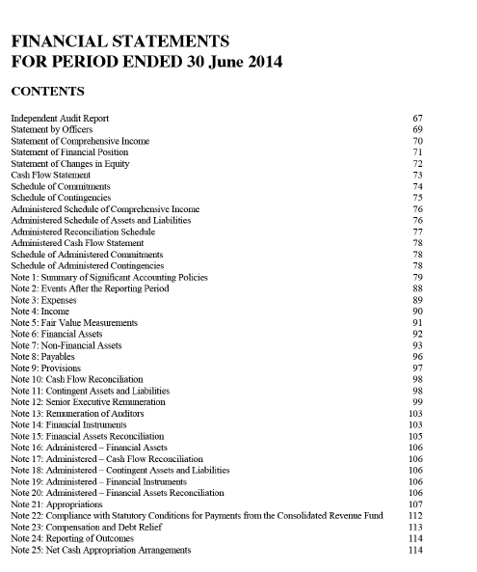
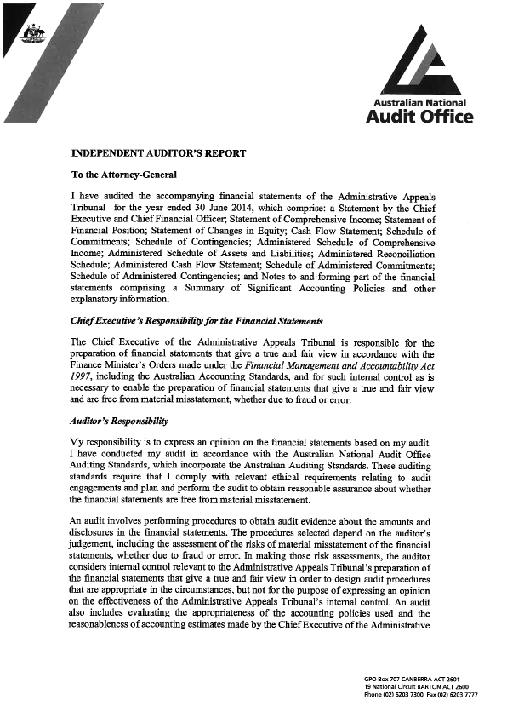
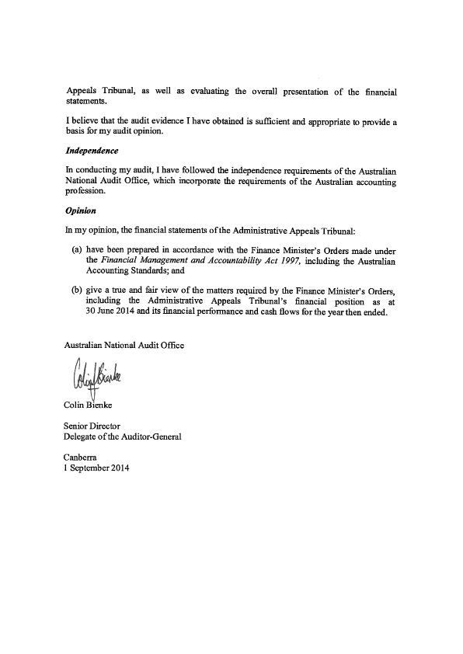
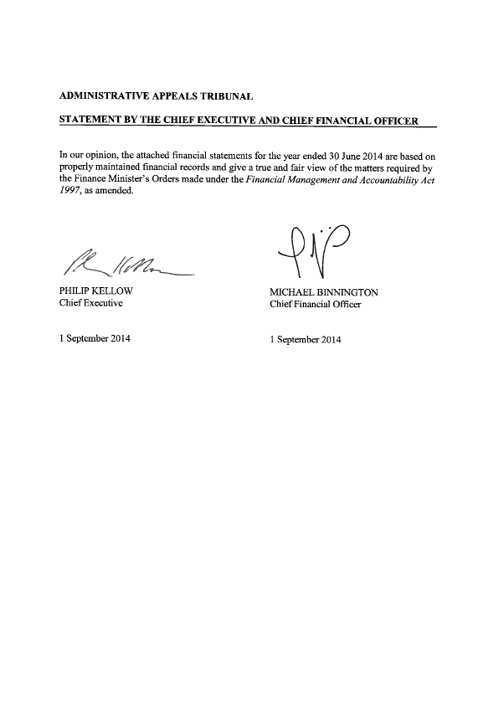
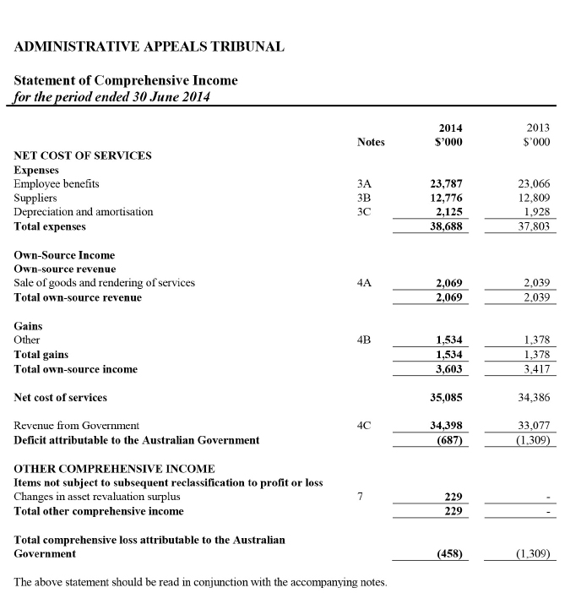
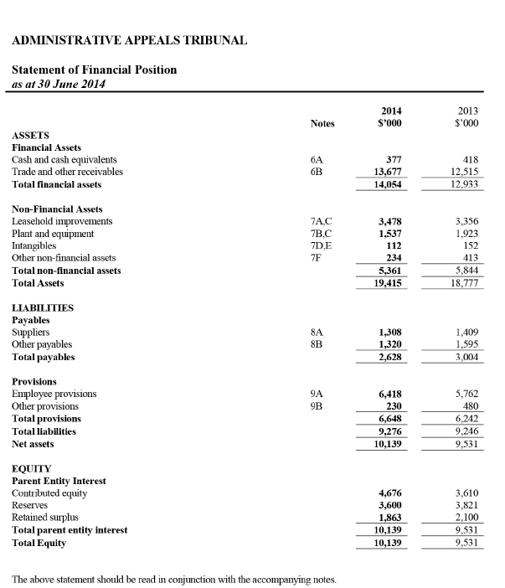
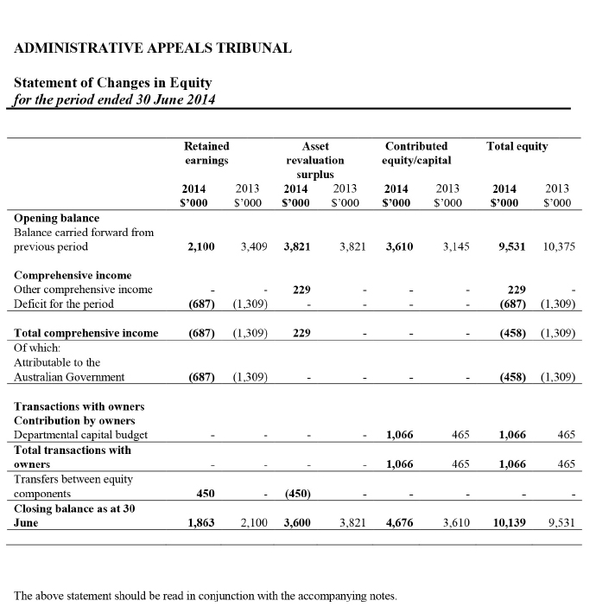
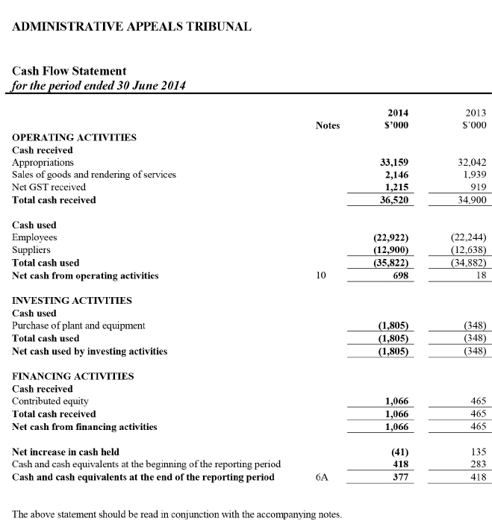
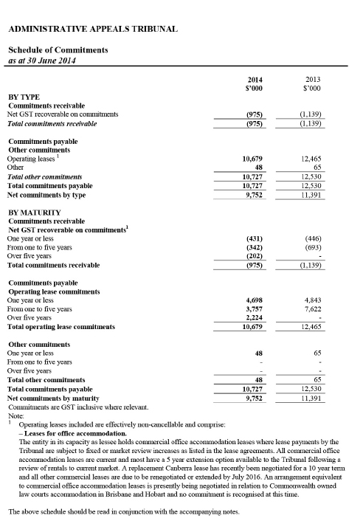
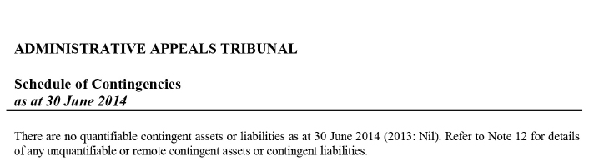
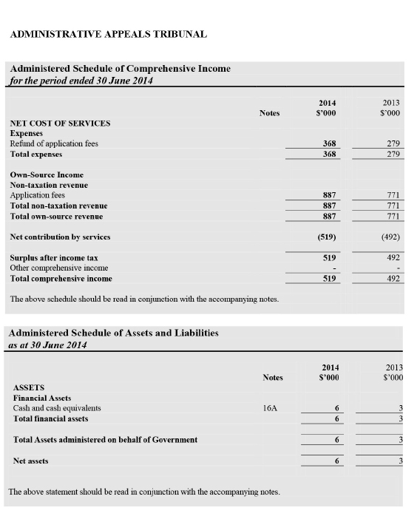
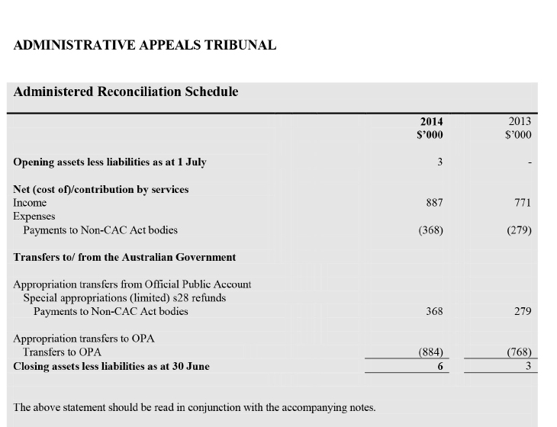
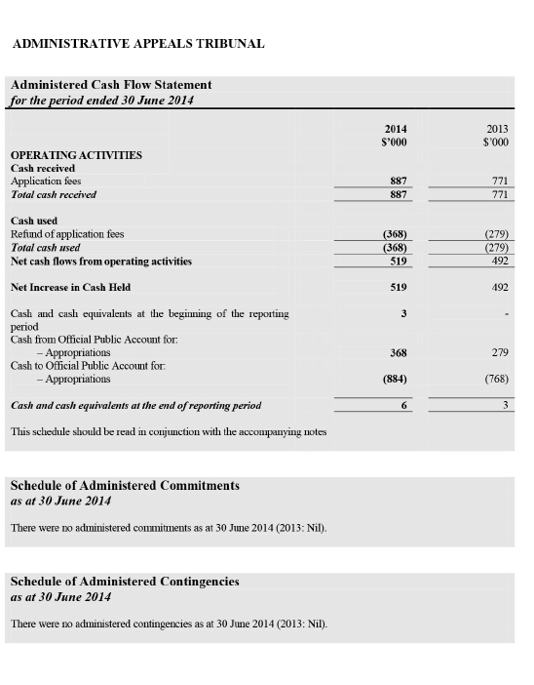
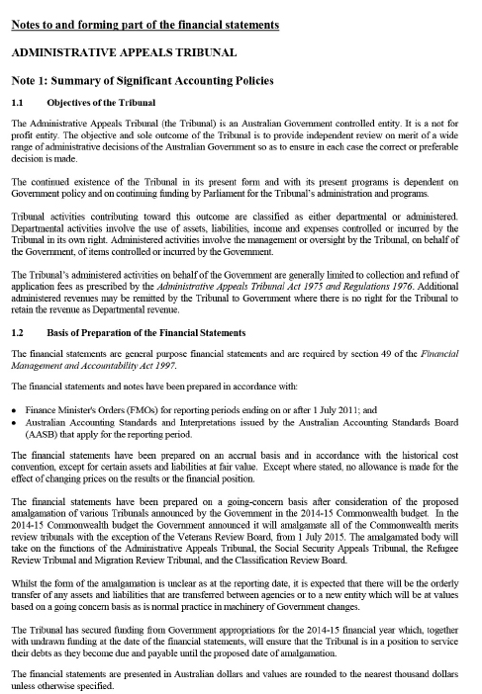
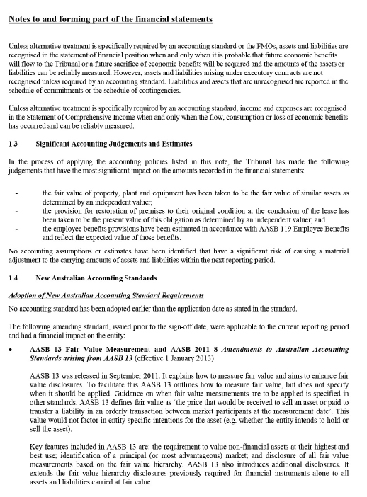
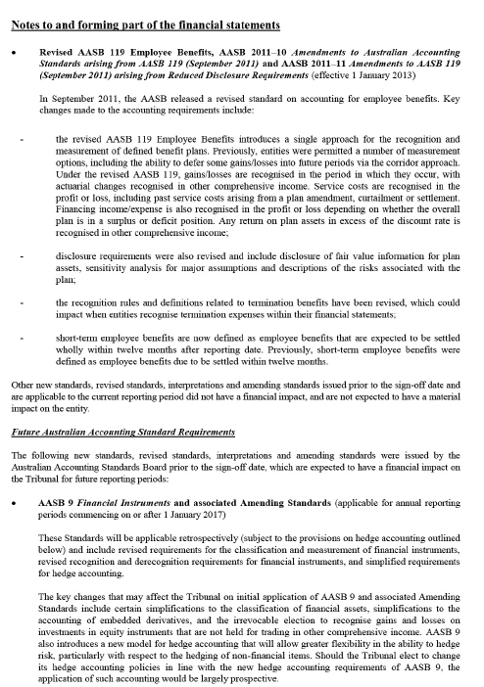
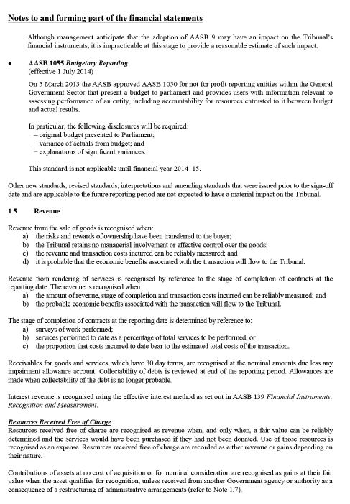
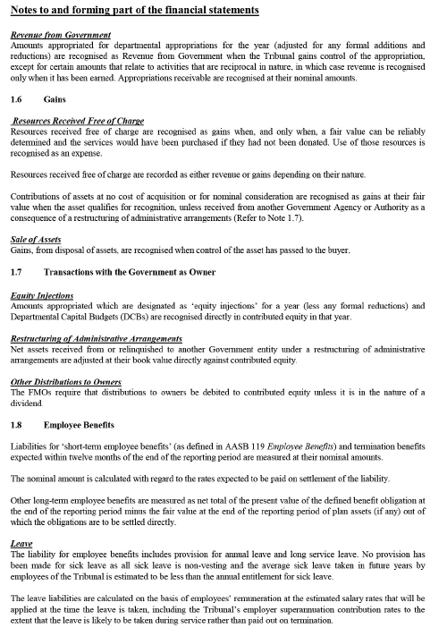
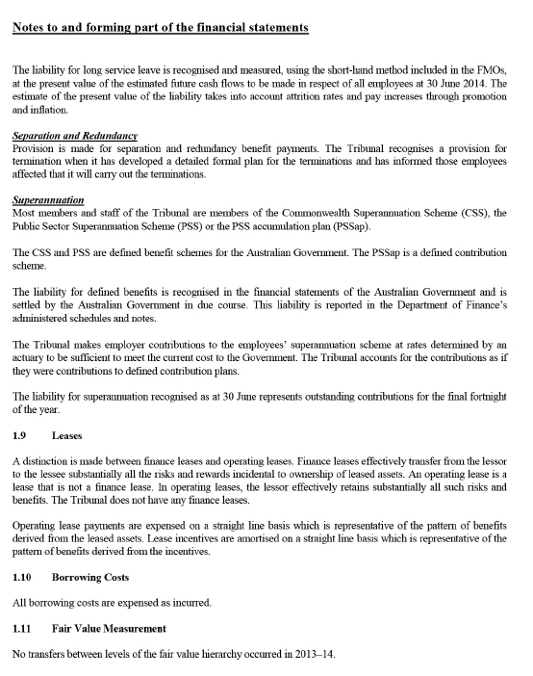
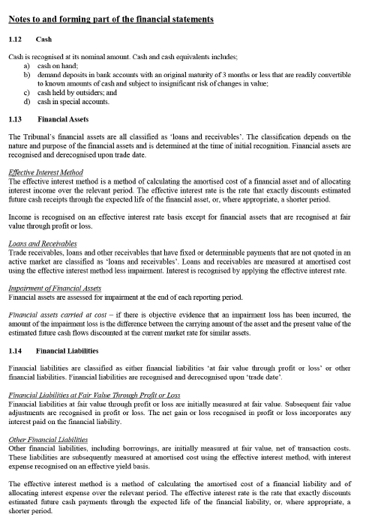
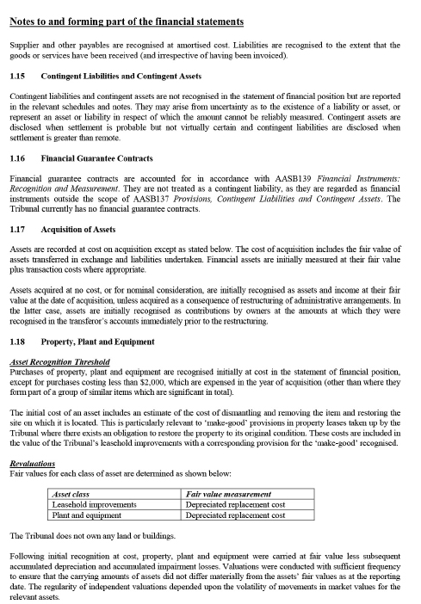
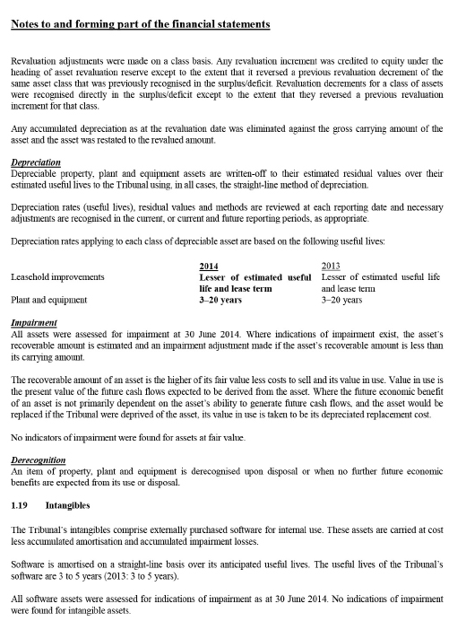
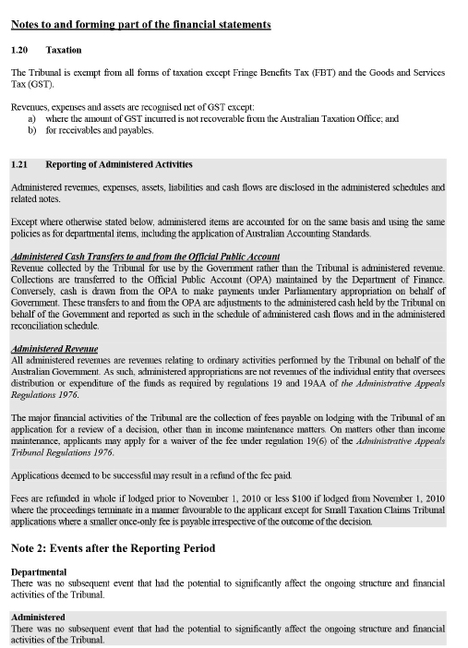
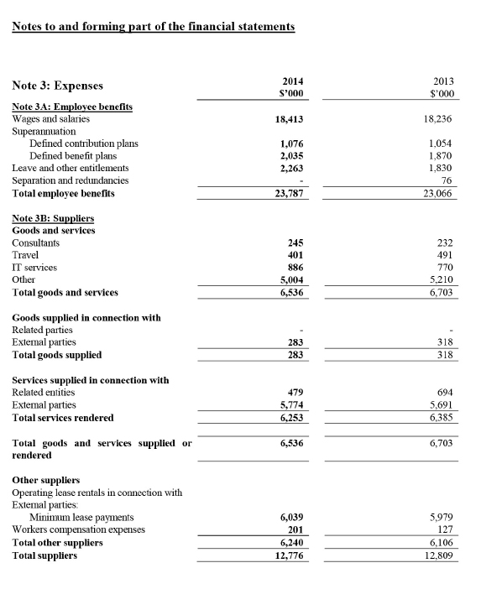
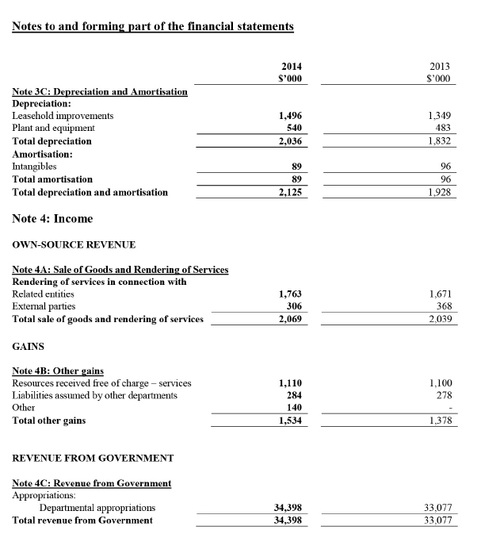
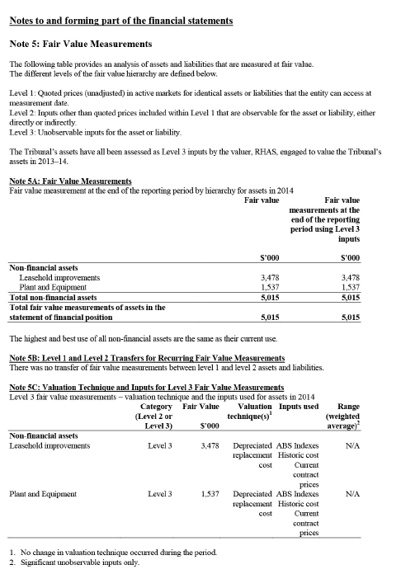
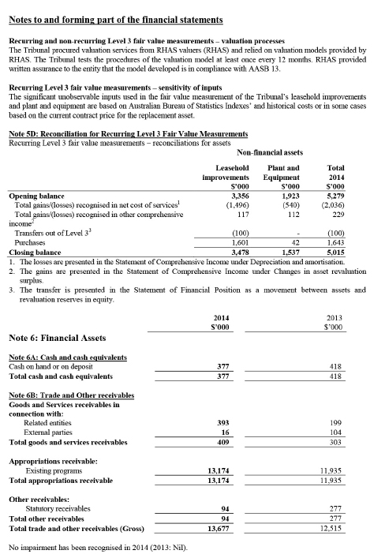
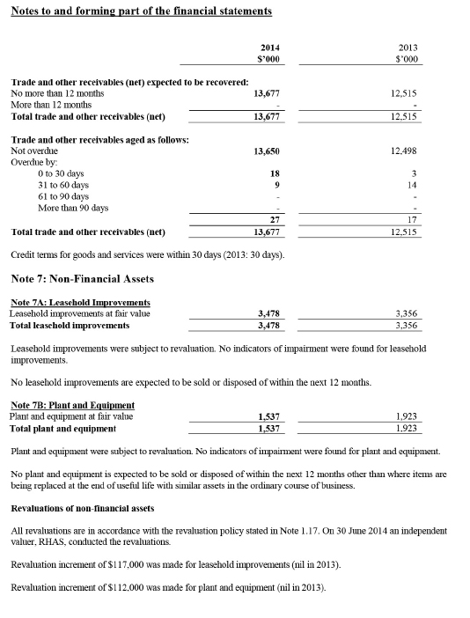
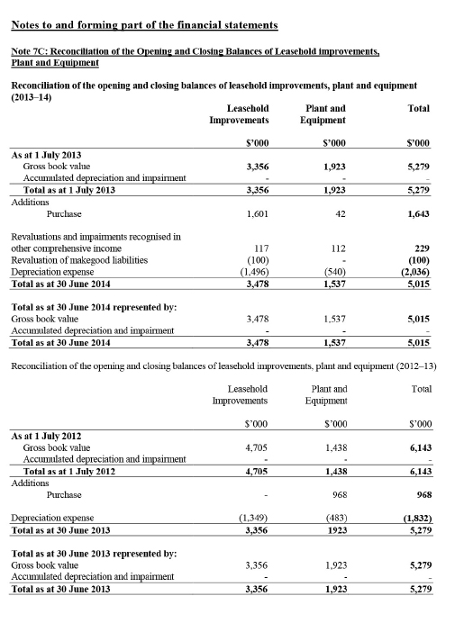
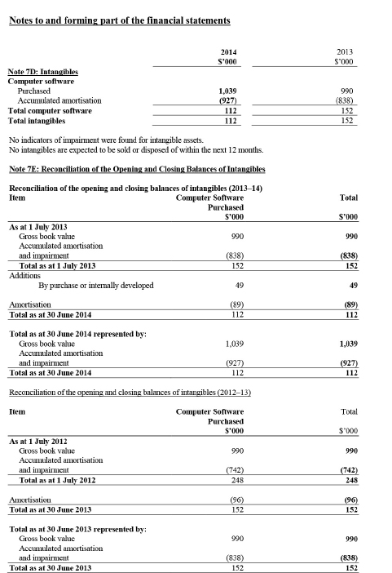
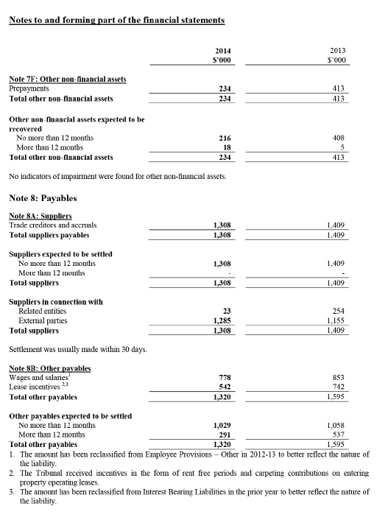
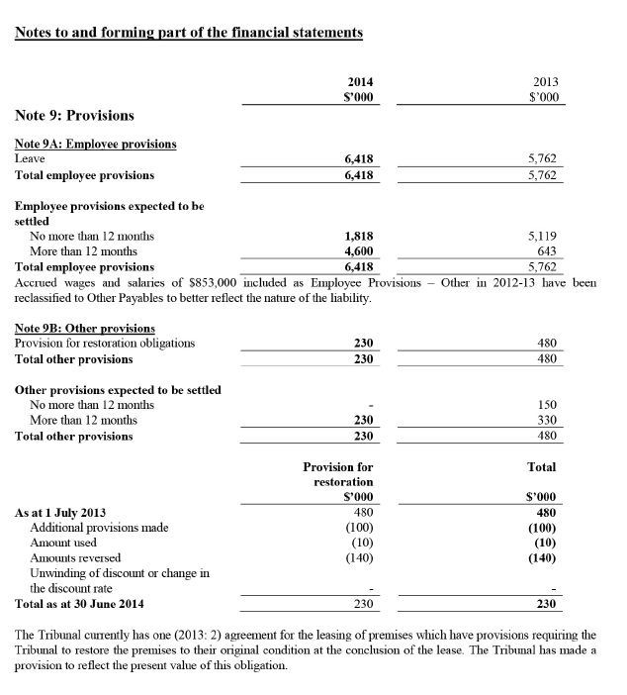
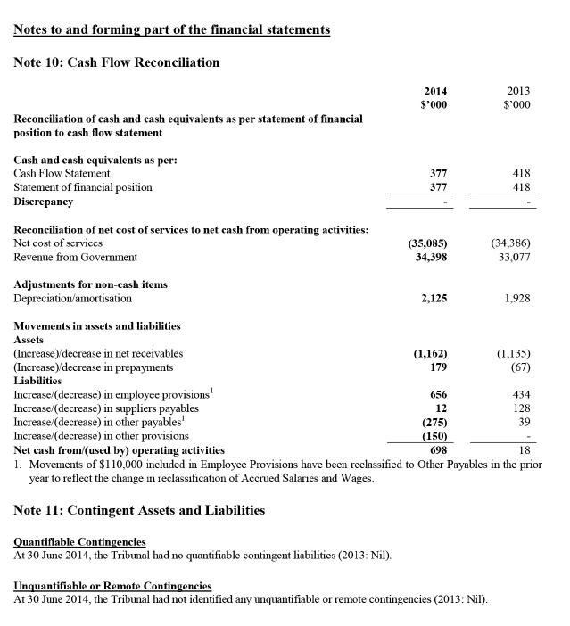
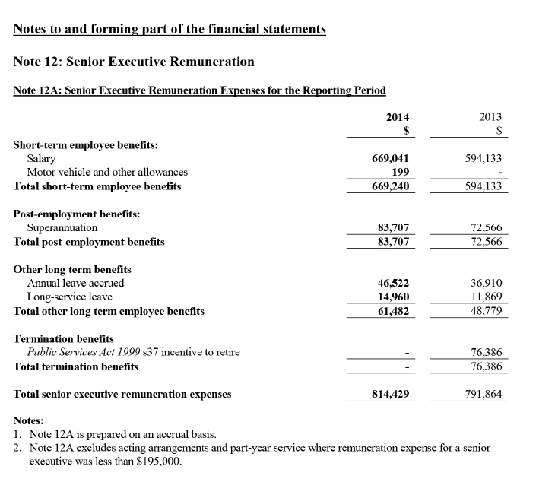
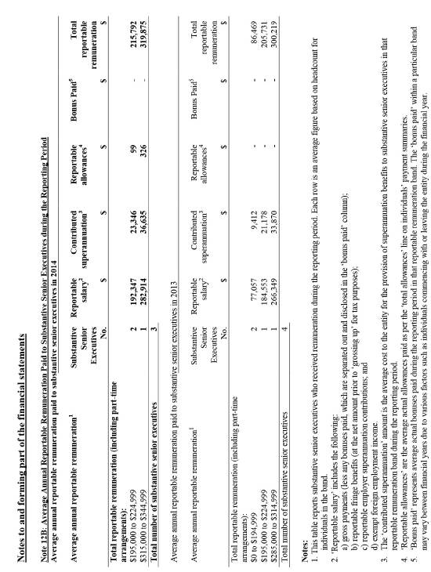
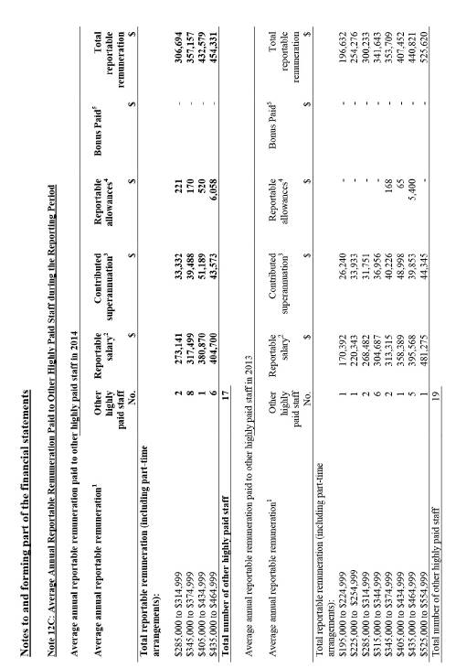
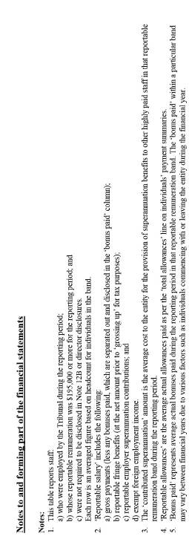
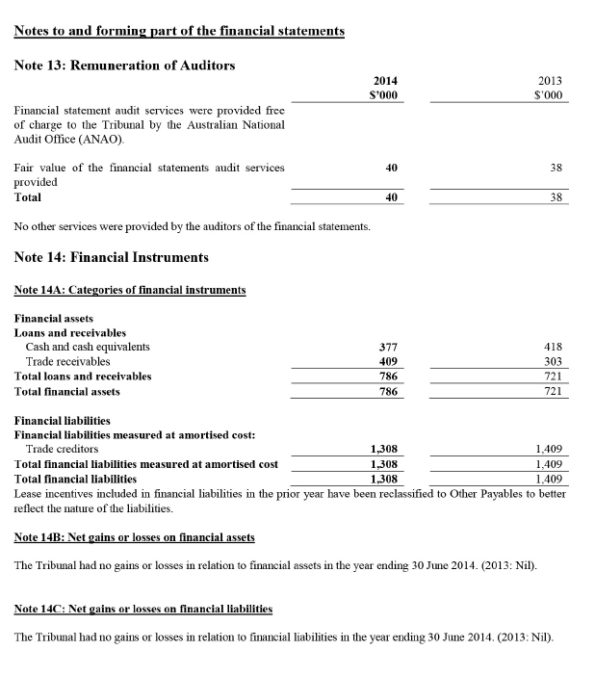
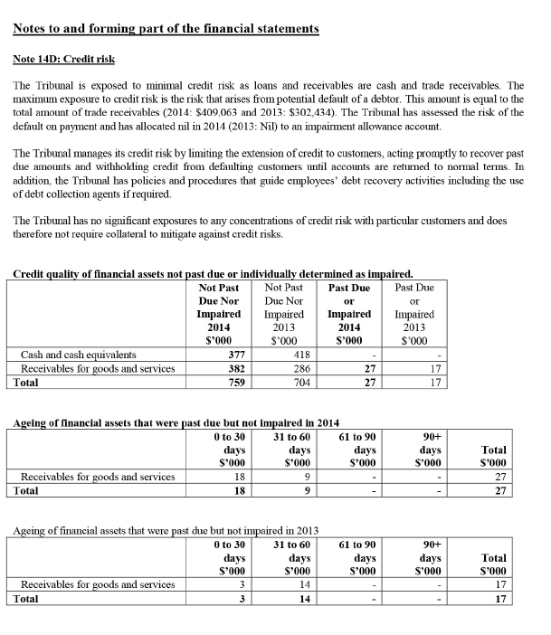
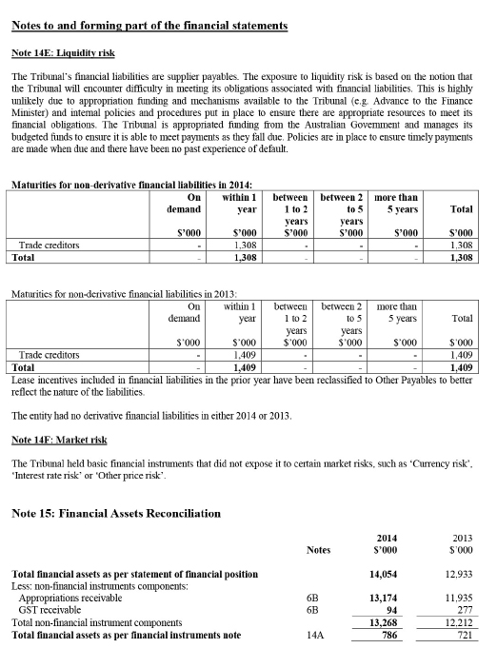
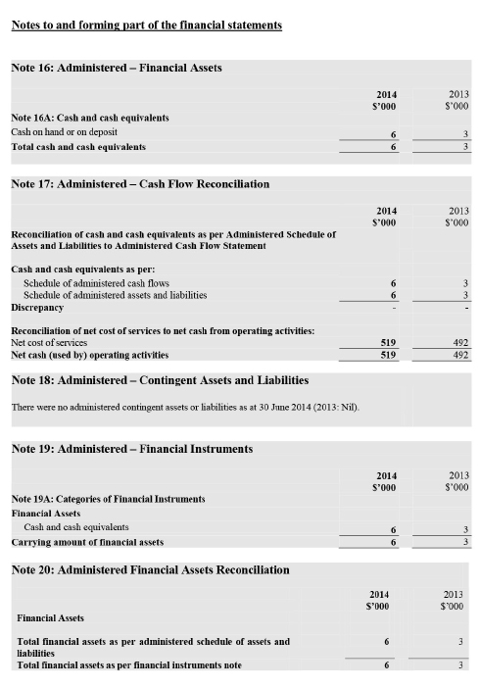
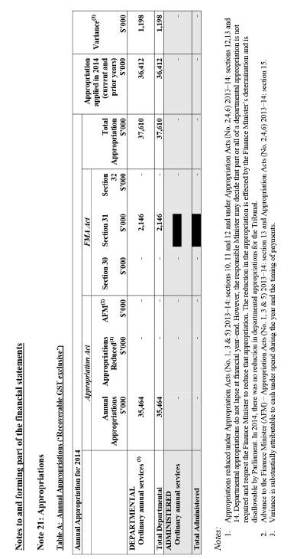
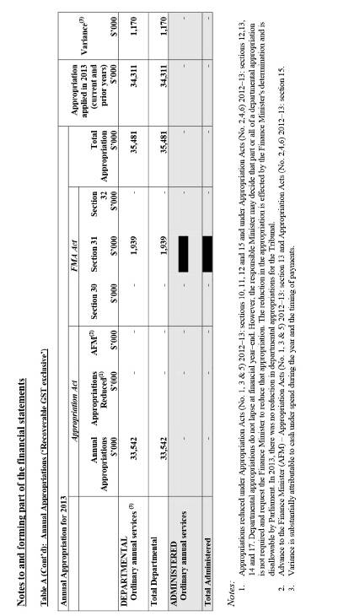
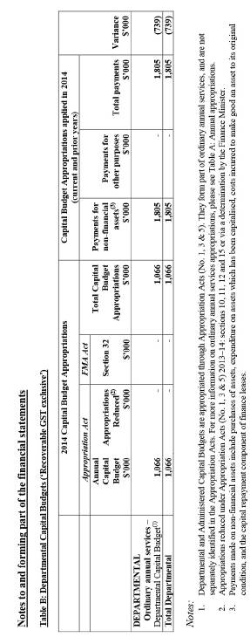
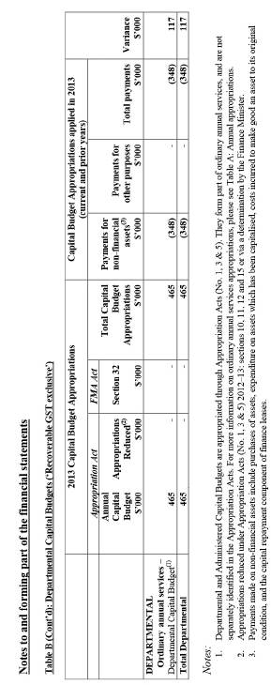
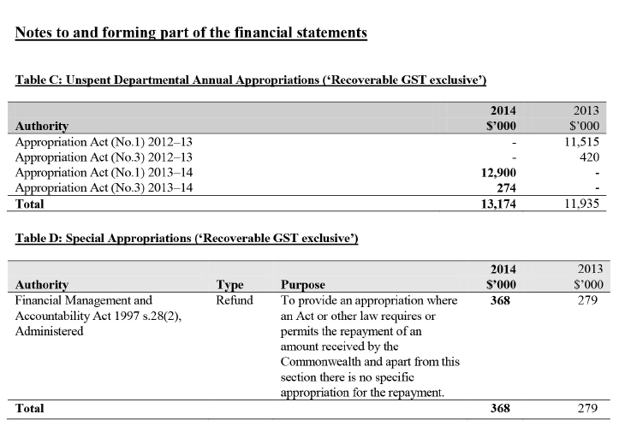
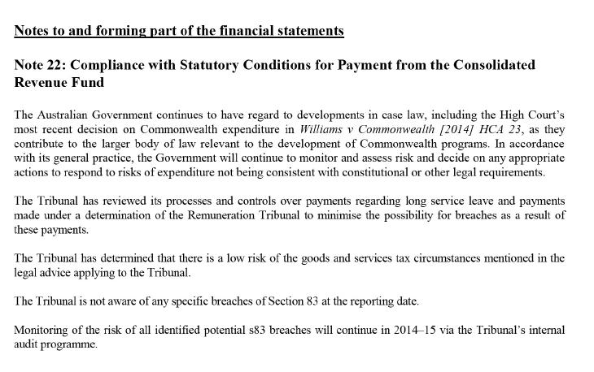
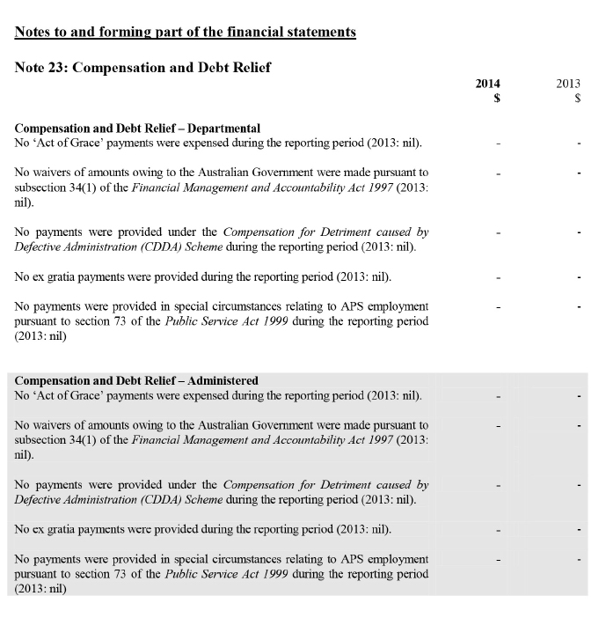
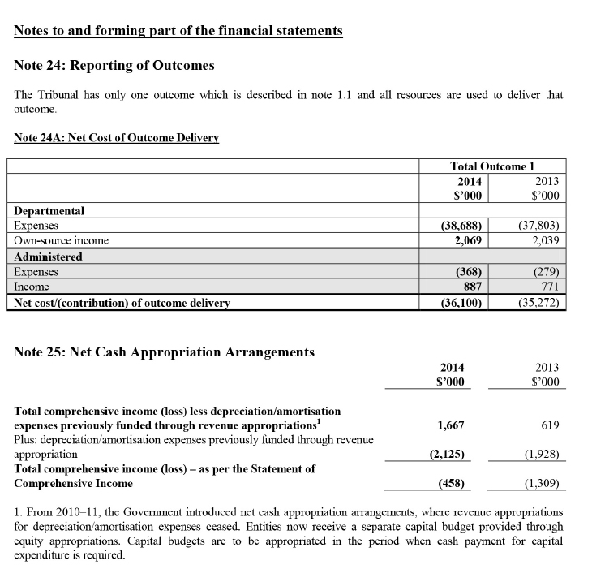

Appendixes

Appendix 1: Members of the Tribunal

TRIBUNAL MEMBERS, 30 JUNE 2014
President
The Hon Justice DJC Kerr, Chev LH

NEW SOUTH WALES

Presidential members

Federal Court
The Hon Justice AC Bennett AO
The Hon Justice RF Edmonds
The Hon Justice JM Jagot
The Hon Justice N Perram

Deputy Presidents
The Hon BJM Tamberlin QC
Mr RP Handley
Professor R Deutsch
Mr SE Frost

Non-presidential members

Senior Members
Ms G Ettinger (G,S,T,V)
Ms NP Bell (G,N,S,V)
Ms N Isenberg (G,S,V)
Mr PW Taylor SC (G,T,V)
Ms JF Toohey (G,N,S,V)
Ms AK Britton (G,N,S,V)
Mr D Letcher QC (G,N,T,V)
Ms JL Redfern (G,N,S,T,V)
Mrs G Lazanas (G,T,V)
Dr TM Nicoletti (G,V)

Members
Dr IS Alexander (G,V)
Mr R Bartsch (G)
Dr M Couch (G,V)
Mr N Gaudion (G)
Dr H Haikal-Mukhtar (G,V)
Dr W Isles (G,N,V)
Professor GAR Johnston AM (G,V)
Professor RC McCallum AO (G,N)
Professor TM Sourdin (G,V)
Dr SH Toh (G,N,V)

VICTORIA

Presidential members

Federal Court
The Hon Justice SC Kenny
The Hon Justice JE Middleton

Deputy Presidents
Miss SA Forgie
Mr JW Constance
Ms FJ Alpins

Non-presidential members

Senior Members
Mr JR Handley (G,N,T,V)
Mr GD Friedman (G,S,V)
Mr FD O’Loughlin (G,T,V)
Mr E Fice (G,S,T,V)

Members
Dr R Blakley (G,V)
Ms L Coulson Barr (G,N)
Brigadier C Ermert (ret’d) (G,T,V)
Dr GL Hughes (G,T,V)
Dr RJ McRae (G,N,V)
Ms RL Perton OAM (G,N,S,V)
Miss EA Shanahan (G,V)

QUEENSLAND

Presidential members

Federal Court
The Hon Justice AP Greenwood
The Hon Justice JA Logan RFD

Deputy Presidents
Mr PE Hack SC
Mr I Molloy

Non-presidential members

Senior Members
Mr BJ McCabe (G,S,T,V)
Associate Professor PM McDermott RFD (G,T,V)
Dr KStC Levy RFD (G,T,V)
Mr RG Kenny (G,T,V)

Members
Dr ML Denovan (G,V)
Dr GJ Maynard, Brigadier (ret’d) (G,V)
Dr M Sullivan (G,V)
Dr PL Wulf (G,T)

SOUTH AUSTRALIA

Presidential members

Federal Court
The Hon Justice JR Mansfield AM

Family Court
The Hon Justice CE Dawe

Deputy President
Ms KJ Bean

Non-presidential members

Senior Members
Mr RW Dunne (G,T,V)
Dr NA Manetta (G,V)

Members
Professor D Ben-Tovim (G,N,V)
Lt Col R Ormston (ret’d) (G,S,V)
Professor PL Reilly AO (G,N,V)
Mr I Thompson (G,N)

WESTERN AUSTRALIA

Presidential members

Federal Court
The Hon Justice AN Siopis
The Hon Justice ML Barker

Deputy Presidents
Mr SD Hotop
The Hon RD Nicholson AO

Non-presidential members

Senior Members
Mr S Penglis (G,T,V)
Ms CR Walsh (G,T,V)

Members
Dr JL Chaney (G,V)
Mr WG Evans (G,V)
Dr ARL Frazer (G,V)
Ms KL Hogan (G,S,T,V)
Brigadier AG Warner AM LVO (ret’d) (G,S,V)

TASMANIA

Presidential members

Family Court
The Hon Justice RJC Benjamin

Deputy President
The Hon RJ Groom AO

Non-presidential members

Senior Member
Ms AF Cunningham (G,N,S,T,V)

Members
Ms S Taglieri (G,N)
Dr RJ Walters RFD (G,V)

AUSTRALIAN CAPITAL TERRITORY

Presidential member

Family Court
The Hon Justice MM Finn

Non-presidential members

Senior Member
Professor RM Creyke (G,N,S,T,V)

Members
Air Vice-Marshal FD Cox AO (ret’d) (G,V)
Dr B Hughson (G,N,V)
Mr MG Hyman (G)
Mr S Webb (G,T,V)
Dr PS Wilkins MBE (G,N,V)

NOTES
Presidential members and Senior Members are listed by date of appointment to the Tribunal in that category of membership. Members are listed alphabetically.
Presidential members may exercise the powers of the Tribunal in all of the Tribunal’s divisions. Senior Members and Members may exercise the powers of the Tribunal only in the divisions to which they have been assigned. The divisions to which Senior Members and Members have been assigned as at 30 June 2014 are indicated as follows:
G General Administrative Division
N National Disability Insurance Scheme Division
S Security Appeals Division
T Taxation Appeals Division
V Veterans’ Appeals Division

APPOINTMENTS AND CESSATIONS, 2013–14

NEW APPOINTMENTS
Senior Member Dr Nicholas Manetta
Member Lynne Coulson Barr
Member Professor Ronald McCallum AO
Member Sandra Taglieri
Member Ian Thompson

RE-APPOINTMENTS
The Hon Brian Tamberlin QC

CESSATIONS
The Hon Justice Dennis Cowdroy OAM
The Hon Justice Bruce Lander
Senior Member Narelle Bell
Member Dr Kerry Breen AM

MEMBER PROFILES

THE HON JUSTICE DUNCAN KERR, CHEV LH
LLB BA (SocW)
President
First appointed 16 May 2012; current appointment until 15 May 2017
Justice Kerr became a judge of the Federal Court of Australia and President of the Administrative Appeals Tribunal in May 2012. He was elected to the executive of the Council of Australasian Tribunals in June 2013 and as Chair in June 2014. He is an Adjunct Professor of Law at the University of Tasmania.
Before his appointment, Justice Kerr practised as a barrister and specialised in public law, constitutional and administrative law, refugee and human rights law and appellate work. He was appointed Senior Counsel in 2004. He was also President of Greening Australia Ltd in 2011–12.
Justice Kerr served in the Commonwealth Parliament as the member for Denison for 23 years (1987–2010). He was Attorney-General (1993) and Minister for Justice (1993–96) in the Keating Government and Parliamentary Secretary for Pacific Island Affairs (2007–09) in the Rudd Government.
Before his election to the House of Representatives, Justice Kerr served as Crown Counsel for the State of Tasmania, Dean of the Faculty of Law, University of Papua New Guinea and Principal Solicitor for the Aboriginal Legal Service (NSW).

DR ION ALEXANDER
MBBS (Hons) LLB FRACP FCICM
Part-time Member, NSW
First appointed 2 August 2004; current appointment until 25 October 2014
Ion Alexander is a Senior Staff Specialist at Sydney Children’s Hospital at Randwick and was a Clinical Director from 2001 to 2008. In September 2011, he took up a temporary appointment as Associate Director of Medical Administration at the Children’s Hospital Westmead. He has been a member of the NSW Health Care Complaints Peer Review Panel since 1997 and was a member of the Professional Services Review Panel from 2001 to 2010.

FIONA ALPINS
BComm LLB (Hons)
Part-time Deputy President, Vic
First appointed 5 April 2012; current appointment until 4 April 2017
Fiona Alpins has been a member of the Victorian Bar since 1996, having been admitted to practice in Victoria in 1995. She practises mainly in revenue law and also practises in commercial law.
Deputy President Alpins was a Senior Fellow at the Faculty of Law, University of Melbourne in 2002 and 2004–05, where she lectured in superannuation law to postgraduate students. From 1997 to 2002, she lectured at Central Queensland University in subjects including commercial law, contract law and taxation law.

RONALD BARTSCH
BA BSc LLB LLM DipEd
Part-time Member, NSW
First appointed 11 April 2013; current appointment until 10 April 2018
Ronald Bartsch has extensive experience in aviation consulting and auditing having established Aviation Consultancy Services in 1986. He has wide ranging operational and senior management experience in the aviation industry, occupying positions as Head of Safety and Regulatory Compliance at Qantas and Manager of Air Transport with the Civil Aviation Safety Authority.
Mr Bartsch is currently the Managing Director of AvLaw Pty Ltd, an international aviation consultancy firm that provides specialist advice to the aviation sector on a range of operational, legal, regulatory and safety issues. He is also a Director of Regional Express Holdings Ltd and a Director of the Australian Association of Unmanned Systems.
Mr Bartsch is an experienced pilot, a former high school mathematics and science teacher, currently a Senior Visiting Fellow in the School of Aviation at the University of New South Wales and the author of numerous aviation publications. He has formal qualifications in the arts, education, law and science and was admitted as a barrister of the High Court of Australia in 1993.

KATHERINE BEAN
BA LLB MA GradDipLegPrac
Full-time Deputy President, SA
First appointed 7 December 2009; current appointment until 31 May 2018
Katherine Bean was admitted as a solicitor of the Supreme Court of New South Wales in 1990. She joined the office of the Australian Government Solicitor in Sydney the same year and remained with the AGS until 2009, first in Sydney and later in Adelaide. Immediately prior to her appointment to the Tribunal as a Senior Member, she held the position of General Counsel with the AGS. Deputy President Bean has extensive administrative law experience, having practised in the Tribunal since 1996, including in the immigration, social security, veterans’ affairs and workers’ compensation jurisdictions. She was appointed as a Deputy President of the Tribunal in 2013.
During 2013–14, Deputy President Bean was the Executive Deputy President for South Australia, and a member of the Tribunal’s Executive Deputy Presidents Committee and the Practice and Procedure Consultative Group.

NARELLE BELL
BA LLB
Full-time Senior Member, NSW
First appointed 1 July 2001; current appointment until 30 June 2014
Narelle Bell was appointed to the Tribunal as a full-time Member in 2001 and as a full-time Senior Member in 2004. She is a former legal member of the Social Security Appeals Tribunal (1994–2001), Judicial Member/Mediator with the NSW Administrative Decisions Tribunal (1994–2001), Consultant Reviewer with the Office of the Legal Services Commissioner (1995–2001), member of the Professional Standards Council of New South Wales and Western Australia, and legal policy consultant. She has worked as a corporate counsel and legal adviser (part-time) for the NSW State Rail Authority (1994–95), as a policy officer and Assistant Director in the Legislation and Policy Division of the NSW Attorney-General’s Department (1988–94) and as a solicitor at the Anti-Discrimination Board (1986–88), Redfern Legal Centre (1983–86) and for a private law firm (1982–83).
Senior Member Bell continued her involvement in decision writing training in 2013–14, presenting seminars to members of the Tribunal and to chairpersons and members of the various NSW Health Professions Tribunals and Committees. She also continued in her role as a legal member of the Human Research Ethics Committee of the Western Sydney Local Health District.
Senior Member Bell was the Tribunal’s Mentoring Coordinator during 2013–14 and a member of the Tribunal’s Professional Development Committee. Senior Member Bell was Convenor of the 2014 AAT National Conference.

PROFESSOR DAVID BEN-TOVIM
PhD MBBS MRCPsych FRANZCP
Part-time Member, SA
First appointed 1 December 2010; current appointment until 30 November 2015
David Ben-Tovim is a psychiatrist and clinical epidemiologist. He trained in medicine at the Middlesex Hospital in London, and in psychiatry and clinical epidemiology at St Georges University Hospital and as a Wellcome research fellow at the Institute of Psychiatry, also in London. He worked for three years in Botswana developing a mental health service before coming to Australia in 1984.
Professor Ben-Tovim was Director of the Department of Psychiatry at the Repatriation General Hospital in Adelaide for a number of years, as well as Director of Mental Health Services for South Australia for several years in the late 1980s. During that period, he was the inaugural medical assessor on the Mental Health Review Tribunal constituted within the District Court of South Australia. He has been a World Health Organisation consultant on a number of occasions. He has an interest in the analysis and redesign of health service provision and has worked in that capacity with a number of health services in Australia and the Asia–Pacific region.
Professor Ben-Tovim holds a Bachelor of Medicine and Surgery and a Doctor of Philosophy from London University, is a Member of the Royal College of Psychiatrists in the United Kingdom and is a Fellow of the Royal Australian and New Zealand College of Psychiatry. He is also a Professor in the Faculty of Medicine, Nursing and Health Sciences at Flinders University.

DR ROSLYN BLAKLEY
Part-time Member, Vic
First appointed 1 June 2010; current appointment until 31 May 2015
Roslyn Blakley has been the Regional Health Director – Southern Region with the Department of Defence since 2013, having previously held the position of Regional Health Director, Victoria and Tasmania. Her experience in the Australian Regular Army included acting as Director of Army Health at Australian Army Headquarters (2005–08) and Deputy Director of the Joint Health Support Agency (2002–04) in Canberra. She also performed numerous medical administrative and clinical appointments during her military career.
Dr Blakley was awarded the Conspicuous Service Cross in the Queen’s Birthday Honours List in 2004 for outstanding achievements in the Australian Defence Force in the area of health administration. She holds a Bachelor of Medicine and Bachelor of Surgery from the University of Queensland, a Master of Health Administration from the University of New South Wales and a Master in Health Law from the University of Sydney.

DR KERRY BREEN AM
MBBS MD FRACP
Part-time Member, Vic
First appointed 1 July 2006; appointment ended 31 May 2014
Kerry Breen is a consultant physician. He has served as President of the Australian Medical Council and President of the Medical Practitioners Board of Victoria. From 2000 to 2006, he chaired the Australian Health Ethics Committee of the National Health and Medical Research Council. From 2007 to 2013, he served as the Commissioner of Complaints for the NHMRC. He is a member of the Australian Research Integrity Committee of the Australian Research Council and the NHMRC.
Dr Breen holds an appointment as an Adjunct Professor in the Department of Forensic Medicine at Monash University. He is co-author of Good Medical Practice: Professionalism, ethics and law published in 2010, and author of So You Want to be a Doctor: A guide to prospective medical students in Australia published in 2012.

ANNE BRITTON
BA LLB
Full-time Senior Member, NSW
First appointed 26 October 2009; current appointment until 25 October 2014
Anne Britton was a Deputy President of the NSW Administrative Decisions Tribunal before being appointed to the Tribunal in 2009. She has served as an arbitrator with the NSW Workers Compensation Commission, Chair of the NSW Government and Related Employees Appeal Tribunal, a member of the NSW Consumer, Trader and Tenancy Tribunal and on the board of the NSW Legal Aid Commission. Senior Member Britton is an accredited mediator. She has lectured in media and entertainment law, most recently in the Master of Laws program at the University of New South Wales. She has been a member of the board of Sydney’s Belvoir Street Theatre for more than a decade.
Senior Member Britton is the Secretary of the Council of Australasian Tribunals and the Convenor of COAT’s NSW Chapter. She chaired the planning committee for the 2012 COAT/Australasian Institute of Judicial Administration Tribunals Conference, ‘The Tribunal of Tomorrow’, and also the planning committees for the NSW Chapter’s 2012, 2013 and 2014 annual conferences.
During 2013–14, Senior Member Britton was a member of the Tribunal’s Professional Development Committee.

DR JAN CHANEY
Part-time Member, WA
First appointed 26 October 2009; current appointment until 25 October 2014
Jan Chaney has been in general medical practice in Perth since 1980 and was a part-time member of the Social Security Appeals Tribunal from 1989 to 1999. Prior to 1980, Dr Chaney was a resident medical officer in the Sir Charles Gairdner Hospital and the King Edward Memorial Hospital in Western Australia.

JAMES CONSTANCE
BA LLB (Hons)
Full-time Deputy President, Vic
First appointed 16 August 2004; current appointment until 8 December 2015
James Constance practised as a barrister and solicitor in the Australian Capital Territory and New South Wales from 1970 as an employed solicitor, sole practitioner and, for more than 22 years, as a partner in legal firms. He graduated from the Australian National University with a Bachelor of Arts degree, a Bachelor of Laws with First Class Honours and the University Prize in Law in 1968. In general practice, he dealt with many areas of the law including administrative law, taxation law, employment law, disciplinary proceedings, personal injury compensation, wills and estates, criminal law and coronial inquests. He was appointed as a Senior Member of the Tribunal in 2004 and as a Deputy President in 2010.
During 2013–14, Deputy President Constance was the Executive Deputy President for Victoria. He was also Chair of the Trustees of the AAT Benevolent Trust, and a member of the Tribunal’s Executive Committee, the Executive Deputy Presidents Committee and the Practice and Procedure Consultative Group.

DR MICHAEL COUCH
Part-time Member, NSW
First appointed 5 April 2012; current appointment until 4 April 2017
Michael Couch has been a consultant occupational physician for more than 20 years. He has worked with a wide range of industries, including mining, manufacturing, police and other emergency services, transport, and Commonwealth and state government departments. Over the past ten years, he has worked as a medico-legal consultant, through a national medico-legal consultancy and his own practice.
Dr Couch is an Independent Occupational Physician advising CGU Workers Compensation New South Wales. He was a Medical Appeal Panel member of the NSW Workers Compensation Commission from 2002 until 2006. He is currently a Medical Review Panel member for the NSW Motor Accidents Authority Medical Assessment Service. He is a Fellow of the Australasian Faculty of Occupational and Environmental Medicine and of the Australasian Faculty of Public Health Medicine.

LYNNE COULSON BARR
Part-time Member, Vic
First appointed 5 August 2013; current appointment until 4 August 2018
Lynne Coulson Barr was appointed as Victoria’s first Mental Health Complaints Commissioner in April 2014. Before this appointment, she was the Deputy Commissioner with the Disability Services Commissioner in Victoria from its establishment as an independent statutory complaints body in July 2007. She was the President of the Victorian Intellectual Disability Review Panel from 2004 to 2007, having served as a sessional member of this panel since 1999. This panel reviewed statutory decisions about eligibility for services and the content of individual service plans.
Ms Coulson Barr has worked as a member of various state and Commonwealth tribunals and statutory bodies, including current sessional member appointments on the Victorian Mental Health Review Board since 2003, the Victorian Civil and Administrative Tribunal since 2005 and the Victorian Suitability Panel since 2007. Past appointments include the Social Security Appeals Tribunal from 1997 to 2007, the Accreditation Decisions Review Committee from 2000 to 2011, the Victorian Institute of Teaching from 2003 to 2006, and the Victorian Multiple and Complex Needs Panel from 2007 to 2009.

AIR VICE-MARSHAL FRANKLIN D COX AO (RET’D)
Part-time Member, ACT
First appointed 24 August 2006; current appointment until 30 November 2015
Frank Cox trained with the Royal Australian Air Force as a pilot and held numerous flying and staff appointments during his military career. The last senior appointment he held was Assistant Chief of the Defence Force – Personnel. Air Vice-Marshal Cox is a graduate of the Royal College of Defence Studies (London) and the United States Air Force Air War College. After service with the RAAF, he worked as a consultant in human resource management. He was appointed to the Defence Force Remuneration Tribunal in 1999 and held the position of ex-service member for six years.

PROFESSOR ROBIN CREYKE
Full-time Senior Member, ACT
First appointed 14 September 2009; current appointment until 13 September 2014
Robin Creyke holds a Master of Laws from the Australian National University, a Bachelor of Laws from the University of Western Australia and a graduate diploma in small group learning and teaching from the University of Western Sydney. She has been a Professor of Law at the Australian National University since 2002 and held the Alumni Chair of Administrative Law from 2003. She has also held the position of Integrity Adviser to the Australian Taxation Office, Commissioner of the ACT’s Independent Competition and Review Commission, member of the Social Security Appeals Tribunal and member of the ACT Nursing Homes and Hostels Review Panel. Professor Creyke was a member of the Administrative Review Council for 12 years until 2009 and is a member of the Administrative Law Committee of the Law Council of Australia.
During 2013–14, Professor Creyke was the Executive Senior Member for the Australian Capital Territory as well as a member of the Tribunal’s Executive Deputy Presidents Committee, the Practice and Procedure Consultative Group and the Warrants Committee.

ANN CUNNINGHAM
LLB (Hons) FAICD
Part-time Senior Member, Tas
First appointed 5 September 1995; current appointment until 30 November 2017
Ann Cunningham was appointed as a part-time Member of the Tribunal in 1995 and became a Senior Member in 2006. She is a Presiding Member of the Tasmanian Resource Management and Planning Appeal Tribunal and holds an appointment as a Commissioner with the Tasmanian Planning Commission. Senior Member Cunningham is an accredited mediator and arbitrator and has worked as a mediator for the Supreme Court of Tasmania and the Magistrates Court. She worked as a barrister and solicitor in private practice for a number of years. Between 1984 and 1999, she was a Deputy Registrar of the Family Court of Australia.
Other positions that Senior Member Cunningham has held include Chairperson of the Board of the Public Trustee, Deputy President of the Tasmanian Mental Health Tribunal, Complaints Commissioner with the University of Tasmania and Independent Merits Reviewer for the Independent Protection Assessment Office. She is a Fellow of the Australian Institute of Company Directors, a Councillor on the Tasmanian AICD and a member of the Tasmanian Government Director Selection Advisory Panel.

DR MARELLA DENOVAN
BSc MBBS FRACGP JD
Part-time Member, Qld
First appointed 15 December 2005; current appointment until 30 November 2015
Marella Denovan holds a Bachelor of Science from Griffith University (1984), a Bachelor of Medicine/Bachelor of Surgery from the University of Queensland (1990), and a Juris Doctor from the University of Queensland (2004). She was a general practitioner in private practice between 1992 and 2001, and was awarded Fellowship of the Royal Australian College of General Practitioners in 2000. Dr Denovan was a part-time medical adviser with the Department of Veterans’ Affairs between 2000 and 2001. She has also been a member of the Veterans’ Review Board (2001−07) and the Social Security Appeals Tribunal (2003−05).

PROFESSOR ROBERT DEUTSCH
Part-time Deputy President, NSW
First appointed 5 April 2012; current appointment until 4 April 2017
Robert Deutsch is a Professor of Taxation in the School of Taxation and Business Law within the Australian School of Business at the University of New South Wales. He was first appointed as a professor at UNSW in 1992 and was a Director of ATAX (1997–2001). He worked as a barrister in New South Wales from 1993 to 2006 and has also held positions as special counsel at Henry Davis York Solicitors (2006–07) and as a Director at KPMG (2007–11). Prior to joining UNSW, Professor Deutsch practised as a solicitor. He was a consultant, solicitor and then partner with Mallesons Stephen Jaques specialising in taxation law.
Professor Deutsch is a prolific author in tax and related fields. His key recent contributions have included numerous chapters in the Australian Tax Handbook, Principles and Practice of Double Tax Agreements and Accounting: a Question and Answer Handbook for Non-Accountants. He also presents seminars for The Tax Institute, UNSW CLE and many other providers.

RODNEY DUNNE
LLB FCPA
Part-time Senior Member, SA
First appointed 15 June 2005; current appointment until 31 May 2015
Rod Dunne was admitted as a barrister and solicitor of the Supreme Court of South Australia in 1982 and is a qualified accountant. He continues to practise part‑time as a special counsel in the Adelaide commercial law firm Donaldson Walsh where he specialises in taxation and revenue law, superannuation and estate planning. He is a member of the Law Society of South Australia and a Fellow of The Tax Institute.
Senior Member Dunne is a former lecturer and tutor in income tax law as part of the commerce degree. He is also a past lecturer and examiner in taxation administration as part of the Master of Legal Studies degree with the law school at the University of Adelaide.

BRIGADIER CONRAD ERMERT (RET’D)
MSc FIEAust CPEng
Part-time Member, Vic
First appointed 19 June 1991; current appointment until 31 May 2015
Conrad Ermert is a practising engineering consultant. He had 31 years’ service in the Australian Army, retiring in the rank of Brigadier. From 1990 to 1995, he was the director of major capital projects for the Alfred Group of Hospitals before establishing his consultancy practice. Brigadier Ermert is the immediate past Chairman of AMOG Holdings, the immediate past Chairman of the AIF Malayan Nursing Scholarship Board, a past Chairman of the Victoria Division, Institution of Engineers, Australia and was Chairman of the Judges of the Institution’s Engineering Excellence Awards from 2003 until 2009. Brigadier Ermert successfully completed his Graduate Diploma in Legal Studies in 2012.

GERI ETTINGER
BA (Economics) LLB
Part-time Senior Member, NSW
First appointed 19 June 1991; current appointment until 25 October 2014
Geri Ettinger has worked both in the private and public sectors. She was Chief Executive of the Australian Consumers’ Association, publisher of CHOICE Magazine, for more than 10 years and was also a long-serving member of the board of St George Bank.
Senior Member Ettinger has practised alternative dispute resolution for more than 20 years in relation to a wide range of disputes. She conducts ADR training, is a Specialist Accredited Dispute Resolution Practitioner under the Law Society of New South Wales program, and is accredited under the National Mediator Accreditation System. She is a Mediator at the NSW Workers Compensation Commission. Senior Member Ettinger is a member of the Dispute Resolution Committee of the Law Society of New South Wales and of the Law Council of Australia’s Alternative Dispute Resolution Committee.
Senior Member Ettinger held appointments for many years as a part-time member of the NSW Consumer, Trader and Tenancy Tribunal and its predecessors. She has been a member of the NSW Medical Tribunal and continues to sit on disciplinary proceedings relating to medical practitioners in the NSW Civil and Administrative Tribunal. She chairs Professional Standards Committees on behalf of the Medical Council of New South Wales. She is also a member of a Human Research Ethics Committee of the University of Sydney.
Senior Member Ettinger was a member of the Tribunal’s Alternative Dispute Resolution Committee in 2013–14.

WARREN EVANS
GradDipLogisticsManagement CertBusinessStudies FAIM
Part-time Member, WA
First appointed 21 September 2006; current appointment until 30 November 2016
Warren Evans served in the Australian Army from 1967 until 1989, including in South Vietnam in 1970–71, and undertook extensive and diversified training, gaining considerable experience in aviation, administration, logistics, recruiting, Special Forces and intelligence. During 1978–79, he was Honorary Aide-de-Camp to Sir Roden Cutler VC, Governor of New South Wales. From 1986 to 1989, he was Chairman of the Defence Armaments Committee and on the Steering Committee of Monash University’s Logistics Degree Course. Retiring as a Lieutenant Colonel in 1989, Mr Evans took several CEO appointments, directing several successful company recoveries.
Since establishing a company in 1996, Mr Evans has concentrated on corporate forensic intelligence work in the public and private sectors. He has also supervised students undertaking PhD studies in logistics management at Curtin University and was a member of the WA Government’s Aviation Training Advisory Committee, the WA Department of Main Roads Consultative Committee and the Jandakot Airport Chamber of Commerce. From 2001 to 2005, Mr Evans held a senior appointment with the Defence Materiel Organisation associated with the $6 billion ANZAC Ship Project. In 2007, he was appointed Honorary Colonel of the Royal Australian Army Ordnance Corps — Western Region. He is a long-time Fellow of the Australian Institute of Management.

EGON FICE
BBus LLB (Hons) LLM
Full-time Senior Member, Vic
First appointed 12 June 2003; current appointment until 31 May 2015
Egon Fice was appointed to the Tribunal as a part-time Member in 2003 and appointed on a full-time basis in 2005. He was appointed as a Senior Member in 2010. Prior to taking up his full-time appointment, Mr Fice was a partner in Charles Fice, Solicitors. He was a partner specialising in litigation in Phillips Fox from 1995 to 1998 and worked in insolvency and commercial litigation law from 1990 until 2005. From 1967 to 1980, he was a pilot in the Royal Australian Air Force before working as a pilot for eight years with Associated Airlines (BHP and CRA Corporate Airline).

STEPHANIE FORGIE
LLB (Hons)
Full-time Deputy President, Vic
First appointed 8 September 1988; current appointment until 3 November 2021
Stephanie Forgie taught the law of contract and was in private practice before becoming the Deputy Master of the Supreme Court of the Northern Territory with quasi-judicial and management responsibilities. She worked in legal policy positions in the Attorney-General’s Department and was closely involved in developing the Freedom of Information Act 1982, Insurance Contracts Act 1984 and Federal Proceedings (Costs) Act 1981. She represented Australia at meetings considering international trade law and private international law issues and worked on the implementation of the United Nations Convention on Contracts for the International Sale of Goods. In 1985–86, she was Legal Adviser to the Deputy Prime Minister and Attorney-General, the Hon Lionel Bowen.
From 1987 to 1988, Deputy President Forgie was the Tribunal’s Registrar. Since 1988 she has been a Deputy President. She has also held part-time positions as Deputy Chairperson, Land Tribunal and Member, Land Court (Queensland). For many years, she was responsible for case management in Brisbane and then in Melbourne and Adelaide and was a member of the Tribunal’s management committees. She was a member of the inaugural committee of the Victorian Chapter of the Council of Australasian Tribunals.
Deputy President Forgie has held positions on professional associations, an arts council and a charitable organisation.

DR AMANDA FRAZER
Part-time Member, WA
First appointed 26 October 2009; current appointment until 25 October 2014
Amanda Frazer has been Executive Director for the Women and Newborn Health Service in Perth since 2006. Between 2002 and 2006, Dr Frazer was Medical Director of the King Edward Memorial Hospital for Women and the Clinical Director of Revenue Capture in the WA Department of Health. Dr Frazer was a part-time member of the Social Security Appeals Tribunal from 1994 until 2001.

GRAHAM FRIEDMAN
BEc LLB GradDipAdmin
Full-time Senior Member, Vic
First appointed 1 July 2001; current appointment until 31 May 2015
Graham Friedman was appointed as a full-time Member of the Tribunal in 2001 and then as a Senior Member in 2005. He was a Senior Member of the Migration Review Tribunal from 1999 to 2001 and Chairman/Convenor of the Disciplinary Appeal Committee of the Public Service and Merit Protection Commission from 1993 to 2000. Senior Member Friedman represented the Victorian Department of Human Services as Prosecutor, Child Protection from 1993 to 1999. He was Chairman, Grievance Review Tribunal, Victorian Department of Conservation and Natural Resources from 1994 to 1996. Prior to this, Senior Member Friedman practised at the Victorian Bar (1988–93). He has previous experience in administrative law with the Australian Government Attorney-General’s Department.

STEPHEN FROST
BA (Hons) Dip Law (BAB)
Part-time Deputy President, NSW
First appointed 24 August 2006; current appointment until 4 April 2017
Stephen Frost was admitted as a legal practitioner in New South Wales in 1989. He joined the Tribunal as a part-time Member in 2006, was appointed as a Senior Member in 2009 and Deputy President in 2012. In 2010, he was appointed as a part-time Judicial Member of the NSW Administrative Decisions Tribunal and became a Senior Member of the NSW Civil and Administrative Tribunal when that body was established on 1 January 2014. He is also an accredited mediator.
Deputy President Frost was a tax partner at KPMG between 1995 and 2008 and a tax manager at KPMG between 1989 and 1995. From 1977 until 1989, he worked at the Australian Taxation Office in both Sydney and Canberra.

NICHOLAS GAUDION
BBus CA
Part-time Member, NSW
First appointed 11 April 2013; current appointment until 10 April 2018
Nick Gaudion has been the Director of Forensic Accounting at Cutcher & Neale since 2006. He has practised as a chartered accountant for over 15 years. Mr Gaudion specialises in damage quantification and valuations for litigation and other dispute resolution forums. Mr Gaudion began his career with Deloitte Touche Tohmastu in Melbourne in 1991. He conducted audits of small to medium size private and public companies for a number of years. After specialising in forensic accounting, he was seconded to Deloitte in Calgary, Canada for a period of 18 months to provide assistance with damage quantification claims in the manufacturing sector. Mr Gaudion has assisted in many areas of law including breach of contract, personal injury and family law.

THE HON RAYMOND GROOM AO
LLB
Part-time Deputy President, Tas
First appointed 5 July 2004; current appointment until 4 July 2014
Raymond Groom was admitted to practice in the Supreme Court of Victoria in 1968 and Tasmania in 1970. He was a partner in the Tasmanian firm of Crisp Hudson & Mann and committee member of the Bar Association of Tasmania. Whilst in practice, he appeared regularly as counsel before the Supreme Court and other Tasmanian courts and tribunals. He is a former Premier of Tasmania and Attorney-General of Tasmania.
Deputy President Groom was the sole assessor of claims under the Stolen Generations of Aboriginal Children Act 2006 (Tas) and also the sole Independent Assessor of claims by individuals who had suffered abuse when in State care. Deputy President Groom is the chairman or director of several charities and community bodies.
During 2013–14, Deputy President Groom was the Executive Deputy President for Tasmania. He was also a member of the Tribunal’s Executive Deputy Presidents Committee, the Practice and Procedure Committee, and the Practice and Procedure Consultative Group.

PHILIP HACK SC
Full-time Deputy President, Qld
First appointed 9 January 2006; current appointment until 30 November 2015
Philip Hack took office as a Deputy President after a career as a barrister in private practice extending over some 23 years. He was admitted to practice as a barrister in 1981 and commenced private practice the following year. He was appointed Senior Counsel in and for the State of Queensland on 1 December 2000. Deputy President Hack had a broad practice at the Bar, successfully undertaking both criminal and criminal appellate work, as well as general civil, commercial, insolvency, revenue and public law cases at both trial and appellate level.
Deputy President Hack served on the Committee (later the Council) of the Bar Association of Queensland for more than 16 years until his appointment to the Tribunal. He was, for a number of years, the Honorary Treasurer of the Bar Association of Queensland and the Australian Bar Association. In 2011, he was elected an honorary life member of the Bar Association of Queensland. He is on the board of Hockey Queensland.
During 2013–14, Deputy President Hack was the Executive Deputy President for Queensland and the Northern Territory. He was also a member of the Executive Deputy Presidents Committee, the Practice and Procedure Committee and the Practice and Procedure Consultative Group.

DR HADIA HAIKAL-MUKHTAR
BSc (Hons) MBBS FRACGP DipGerMed LLB (Hons) GradCertHealthProfEd
Part-time Member, NSW
First appointed 2 November 2009; current appointment until 1 November 2014
Hadia Haikal-Mukhtar holds degrees in science, medicine and law and is a Fellow of the Royal Australian College of General Practitioners. She has been a general practitioner since 1984 and has extensive experience in aged care. She is currently head of the Auburn Clinical School of the Sydney School of Medicine of the University of Notre Dame Australia and is a member of the Governing Board of the Western Sydney Local Health District. She is an examiner for the RACGP and the Australian Medical Council for international medical graduates. Dr Haikal-Mukhtar is a former member of the Medical Practitioners Board of Victoria and is currently a member of the Professional Standards Panels of the Victorian Board of the Medical Board of Australia. She also holds an appointment as a Deputy Director of the Professional Services Review Panel.

JOHN HANDLEY
Full-time Senior Member, Vic
First appointed 14 June 1989; current appointment until 3 May 2018
John Handley was appointed as a member of the Victorian Administrative Appeals Tribunal in 1988 and as a full-time tenured Senior Member of this Tribunal in 1989. He is a barrister and solicitor of the Supreme Court of Victoria and the High Court of Australia, and was in private practice between 1981 and 1988. He was a part-time member of the Crimes Compensation Tribunal during 1987 and 1988. From 1981 until 1988, he was a member of the Goulburn Valley College of TAFE. While in private legal practice in Shepparton during this time, he was also involved in the Shepparton self-help group and Council for Disabled Persons and, for a time, served as its President. He is an accredited mediator and has a special interest in dispute resolution and ombudsry.
Senior Member Handley was a member of the Tribunal’s Alternative Dispute Resolution Committee, the NDIS Monitoring Committee and the Warrants Committee in 2013–14.

ROBIN HANDLEY
LLB (Hons) LLM
Full-time Deputy President, NSW
First appointed 1 January 1998; current appointment until 16 August 2014
Robin Handley is admitted as a solicitor in the United Kingdom and as a legal practitioner in the Australian Capital Territory and New South Wales. He has 25 years’ experience as an academic lawyer with a particular interest in administrative law. He taught for many years at the University of Wollongong, serving as Dean there for two years from October 1999. He also served as a part-time member of the Social Security Appeals Tribunal for eight years until 1997.
Deputy President Handley was first appointed as a Senior Member of the Tribunal in 1998 and served as a Deputy President between July 2001 and July 2004. Before being reappointed to the Tribunal as a Deputy President in August 2009, he served as a part-time Acting Deputy President of the NSW Workers Compensation Commission, part-time Judicial Member and later part-time Deputy President of the NSW Administrative Decisions Tribunal, and part-time legal member of the NSW Mental Health Review Tribunal.
During 2013–14, Deputy President Handley was the Executive Deputy President for New South Wales. He was the Convenor of the Tribunal’s Warrants Committee and a member of the Executive Deputy Presidents Committee, the Practice and Procedure Committee and the Practice and Procedure Consultative Group.

KATHRYN HOGAN
Part-time Member, WA
First appointed 1 June 2010; current appointment until 31 May 2015
Kathryn Hogan is a barrister and solicitor of the Supreme Courts of Victoria and Western Australia and of the High Court of Australia. She was a partner at Holding Redlich in Melbourne from 1987 to 1993 and at Dwyer Durack in Perth from 1993 to 1998. Since 2005, she has practised as a barrister, primarily in the areas of personal injuries and medical negligence.
Ms Hogan was a part-time Conference Registrar of the Tribunal from 2007 until her appointment as a Member. Since 2010, she has also held positions as an Independent Merits Reviewer for the Independent Protection Assessment Office and as a Deputy Registrar of the District Court of Western Australia.
Ms Hogan is a member of the Western Australian Bar Association, the Law Society of Western Australia and the Women Lawyers Association of Western Australia Inc. She is an accredited mediator.

STANLEY HOTOP
BA LLB LLM
Full-time Deputy President, WA
First appointed 19 June 1991; current appointment until 31 May 2015
Stan Hotop was appointed as a part-time Deputy President in 2002 and became a full-time Deputy President in 2005. He was an Associate Professor of Law at the University of Sydney from 1980 to 1988 and at the University of Western Australia from 1989 to 2005. He was Dean and Head of the Law School at the University of Western Australia from 1990 to 1993 and was President of the Australasian Law Teachers’ Association from 1990 to 1991. He taught administrative law in university law schools from 1971, first at the University of Sydney (1971–88) and subsequently at the University of Western Australia (1989–2005). He is the author of several textbooks in the area of administrative law.
During 2013–14, Deputy President Hotop was the Executive Deputy President for Western Australia. He was also the Convenor of the Tribunal’s Library Committee and the Professional Development Committee, the Coordinator of the Members’ Appraisal Scheme, and a member of the Executive Deputy Presidents Committee and the Practice and Procedure Consultative Group.

DR GORDON HUGHES
LLB (Hons) LLM PhD FAAL
Part-time Member, Vic
First appointed 5 July 2004; current appointment until 8 September 2014
Gordon Hughes is a partner at Ashurst Australia and practises in the areas of information technology law, data protection law, electronic commerce, privacy and intellectual property rights. He is a past president of the Law Institute of Victoria (1992–93), the Law Council of Australia (1999–2000) and LAWASIA (2001–03), and was a member of the International Legal Services Advisory Council. He is Chair of the Law Council’s International Law Section.
Dr Hughes has authored several legal textbooks, including one on accident compensation and one on privacy. He is a qualified Grade 1 arbitrator and an Adjunct Professor at RMIT University. In 2010, he was elected a Fellow of the Australian Academy of Law.

DR BERNARD HUGHSON
MBBS FRANZCP
Part-time Member, ACT
First appointed 1 December 2010; current appointment until 30 November 2015
Bernard Hughson graduated in medicine in 1962. After graduation, he worked in hospital and general practice for some years before specialising in psychiatry. He then worked as a consultant psychiatrist in public and private practice. He was actively engaged in teaching medical students and trainees in psychiatry and has been an examiner for the Royal Australian and New Zealand College of Psychiatrists. He served as Director of Mental Health for the Australian Capital Territory (1984–93) and on various secondments: Director of Mental Health for the NSW Department of Health; Director of Psychiatry, Greenslopes Hospital; and Chief Psychiatrist, Queensland Department of Health. He retired from clinical practice in 2009. He continues to teach in the Clinical Skills stream at the Australian National University Medical School.

MARK HYMAN
Part-time Member, ACT
First appointed 26 October 2009; current appointment until 25 October 2014
Mark Hyman has more than 17 years’ experience as a senior executive in developing and implementing policies and providing advice to government on a broad range of environment protection issues and legislation. He was formerly the Director of the Canberra Office of the WA Department of Premier and Cabinet. From 1992 to 2005, Mr Hyman was an Assistant Secretary in the Commonwealth Department of Environment and Heritage.

NAIDA ISENBERG
LLB
Part-time Senior Member, NSW
First appointed 1 July 2001; current appointment until 30 November 2017
Naida Isenberg was appointed as a part-time Member of the Tribunal in 2001 and as a part-time Senior Member in 2006. She is a Senior Member of the NSW Civil and Administrative Tribunal and a Member of the Migration and Refugee Review Tribunals. She is also an accredited mediator, serving as a mediator for the Law Society of New South Wales, the NSW Dust Diseases Tribunal and the Australian Defence Force.
Senior Member Isenberg was formerly a part-time Senior Member of the Veterans’ Review Board and a District Court Arbitrator. Her previous experience also includes: general counsel of a major insurance company; Director of Crown Legal Services, NSW; and Deputy Director of the Australian Government Solicitor.
Senior Member Isenberg is a Lieutenant Colonel in the Army Reserve (Legal Corps). She is a Fellow of the Institute of Chartered Secretaries and Administrators, serving on the Institute’s Public Sector Advisory Group. She is a non-member Director of the War Widows’ Guild and is Deputy Chair of the board. She also serves on the Advisory Board of the anti-bullying organisation, Courage to Care.
Senior Member Isenberg was a member of the Tribunal’s Library Committee and the Warrants Committee in 2013–14.

DR WILLIAM ISLES
MBBS MPH FAFOEM
Part-time Member, NSW
First appointed 5 April 2012; current appointment until 4 April 2017
Bill Isles graduated in medicine at the University of Queensland in 1973. After 10 years in general practice, he pursued an interest in occupational medicine. He completed a Master of Public Health (Occupational Health) at the University of Sydney in 1992 and gained a Fellowship of the Australasian Faculty of Occupational and Environmental Medicine in 2004. During this time, he was working for Qantas in both aviation and occupational medicine fields. In the latter part of his career, he was manager of the combined Medical Services at Qantas. Dr Isles is a Director of the Australasian Medical Review Officers Association which sets standards and trains and accredits medical practitioners in drug and alcohol testing programs.

PROFESSOR GRAHAM JOHNSTON AM
BSc MSc PhD DPharm FRACI FTSE
Part-time Member, NSW
First appointed 19 June 1991; current appointment until 30 November 2014
Graham Johnston is Emeritus Professor of Pharmacology and Medicinal Chemistry at the University of Sydney and trained as an organic chemist at the universities of Cambridge and Sydney. He brings expertise in chemistry, pharmacology and toxicology to the Tribunal. His scientific research is directed to the discovery of drugs to treat Alzheimer’s disease, amnesia, anxiety, epilepsy and schizophrenia.

GRAHAM KENNY
BA LLB (Hons) LLM
Part-time Senior Member, Qld
First appointed 1 July 2001; current appointment until 8 September 2014
Graham Kenny was appointed as a part-time Member of the Tribunal in 2001 and as a part-time Senior Member in 2009. He was a part-time Member and Senior Member of the Veterans’ Review Board from 1988 until 2004. He was a part‑time legal member of the Social Security Appeals Tribunal from 1995 until 2001 and Queensland convenor (part-time) of the Student Assistance Review Tribunal from 1988 until 1994.
In 2008, Senior Member Kenny retired from his position of senior lecturer in the School of Law at the University of Queensland, having joined in 1976. His responsibilities in the Law School included Chair of the Law School Teaching and Learning Committee, Director of the Bachelor of Laws and Juris Doctor programs and Chief Examiner. Senior Member Kenny practised as a barrister from 1978 until 1989. From 1964 until 1974, he was a teacher with the Queensland Department of Education.
GINA LAZANAS
Part-time Senior Member, NSW
First appointed 5 April 2012; current appointment until 4 April 2017
Gina Lazanas has been a partner at Balazs Lazanas and Welch LLP since 2009. She was a partner at Baker & McKenzie from 2002 until 2009 where she led the Australian Tax Group for three years. From 2000 to 2002, she was a partner at PricewaterhouseCoopers.
Senior Member Lazanas was Chair of The Tax Institute’s GST Subcommittee and a representative at the Australian Taxation Office’s National Tax Liaison GST Sub-committee for three years from 2008. She has a particular interest in promoting early dispute resolution and between 2011 and 2013 was the Chair of The Tax Institute’s Legal and Dispute Resolution Subcommittee and a representative at the Australian Taxation Office’s National Tax Liaison Dispute Resolution Sub-committee. In addition to being a member of The Tax Institute, she is also a member of the Taxation Committee of the Law Council of Australia and a founding member of the Hill GST Discussion Group.

DEAN LETCHER QC
Part-time Senior Member, NSW
First appointed 26 October 2009; current appointment until 25 October 2014
Dean Letcher has been in private practice as a barrister in New South Wales, the Australian Capital Territory and Papua New Guinea since 1972. He was appointed Queen’s Counsel in 1988. Senior Member Letcher was appointed as a part-time member of the NSW Mental Health Review Tribunal in September 2008 and has also held appointments as a mediator, arbitrator and contributions assessor with the Supreme and District Courts of New South Wales and the Dust Diseases Tribunal.

DR KENNETH LEVY RFD
BA BCom LLB PhD FCA FCPA MAPS Barrister-at-Law
Part-time Senior Member, Qld
First appointed 5 July 2004; current appointment until 30 November 2016
Ken Levy worked in the Queensland Public Service for more than 40 years, retiring as Director-General of the Department of Justice in December 2003. He was appointed as a part-time Member of the Tribunal in 2004 and as a part-time Senior Member in 2006. In 2004–05, he served as National President of the professional accounting body CPA Australia. He has been a Professor of Law at Bond University, teaching in the areas of criminal law, evidence, succession, superannuation and taxation.
In May 2013, Senior Member Levy was appointed as Acting Chairperson of the Queensland Crime and Misconduct Commission. He was appointed Acting Chairman of the Queensland Crime and Corruption Commission in July 2014.
Dr Levy serves in the Standby Reserve of the Australian Army and holds the rank of Honorary Colonel. He has been awarded the Reserve Force Decoration, the Centenary Medal, the Australian Defence Medal and the National Service Medal.

DR NICHOLAS MANETTA
Part-time Senior Member, SA
First appointed 5 August 2013; current appointment until 4 August 2018
Nick Manetta joined the Crown Solicitor’s Office of South Australia in 1994 and has been a Managing Solicitor in the Administrative and Environment Section since 2002. He was junior counsel to the Solicitor-General from 1994 to 1997. He specialises in administrative, constitutional, planning and environmental, and revenue law. He is a Doctor of Philosophy in Administrative Law (Cambridge), and is also a part-time lecturer in administrative law at the University of South Australia.

BRIGADIER GRAHAM MAYNARD (RET’D)
MBBS MSc (OCC MED) DIH DTM&H
Part-time Member, Qld
First appointed 5 July 2004; current appointment until 8 September 2014
After graduating in 1965, Graham Maynard spent 27 years as an Australian Army medical officer commencing with duties as an Infantry Battalion Medical Officer in SVN and finishing as Director of Medical Services for the Army in 1990. His career included postings in clinical positions, hospital command, malaria research and senior command. From 1990 to 2002, he was employed as a senior medical officer in the Commonwealth Department of Health with responsibilities at various times in food safety, Australian Government Health Service management, Creutzfeld-Jacob disease matters and finally as Chief Medical Adviser for Medical Devices at the Therapeutic Goods Administration.

BERNARD MCCABE
BA LLB GradDipLegPrac LLM (Corp&Comm) (Dist)
Full-time Senior Member, Qld
First appointed 1 July 2001; current appointment until 30 November 2016
Bernard McCabe was appointed as a part-time Member of the Tribunal in 2001 and as a full-time Senior Member in 2003. He was a member of the Faculty of Law at Bond University from 1992 until 2006 and has subsequently held appointments as an Adjunct Professor of Law at Bond University. From 1998 to 2001, he served as a member of the Legal Committee of the Companies and Securities Advisory Committee, the Commonwealth Government’s peak corporate law advisory body.
Senior Member McCabe continues to edit the consumer protection section of the Australian Journal of Competition and Consumer Law and is a member of the editorial committee of the Corporate Governance eJournal. During the past year, he has published in the areas of trade practices law and administrative law. He has also lectured at Bond University and spoke about company law, legal education and administrative justice at conferences in Australia and overseas.
Senior Member McCabe was a member of the Tribunal’s Professional Development Committee in 2013–14.

PROFESSOR RONALD MCCALLUM AO
Part-time Member, NSW
First appointed 5 August 2013; current appointment until 4 August 2018
Ron McCallum has been blind since birth. In 1993, he was appointed as Professor of Industrial Law at the University of Sydney, the first totally blind person to be appointed to a professorship at any Australian or New Zealand university. From 2002 to 2007, he served as Dean of the University of Sydney Law School, and from 2001 to 2009 he was Foundation President of the Australian Labour Law Association. In 2011, he was appointed as an Emeritus Professor of the University of Sydney.
In 2008, Professor McCallum was elected as an inaugural member of the United Nations Committee on the Rights of Persons with Disabilities which monitors the UN Convention on the Rights of Persons with Disabilities. He served as Chairperson from 2010 to 2013 and is now a vice-chairperson.
In 2003, Professor McCallum was awarded a Centenary Medal for his roles as a labour law scholar and as a disabled citizen. In the 2006 Queen’s Birthday honours list, he received the designation of Officer in the Order of Australia for his services to tertiary education, for industrial relations advice to governments, for assistance to visually impaired persons and for social justice. He was Senior Australian of the Year for 2011.

ASSOCIATE PROFESSOR PETER MCDERMOTT RFD
LLB (Hons) LLM PhD
Part-time Senior Member, Qld
First appointed 15 November 2004; current appointment until 14 November 2014
Peter McDermott is a Reader in Law at the University of Queensland where he has also served as an elected member of the Academic Board. In 2013, he was a Research Fellow at the University of Manchester.
Senior Member McDermott was admitted as a barrister of the Supreme Court of Queensland in 1978 and is a member of the Bar Association of Queensland. He has acted as Crown Counsel for the State of Queensland. In the Wik case, he was junior counsel to the late Sir Maurice Byers QC who appeared for the Thayorre People. He has served as an officer of the Queensland Law Reform Commission and was later appointed Deputy Chair. In 1998, he accepted a term appointment as an Assistant Commissioner of Taxation to contribute to the Ralph reform process. He has served on a number of Queensland tribunals, including the South Queensland Regional Community Corrections Board and the Children Services Tribunal. He is currently a member of the Queensland Civil and Administrative Tribunal.
Senior Member McDermott has published widely. He is the author of Equitable Damages (1994) and is a co-author of Principles of the Law of Trusts (3rd ed, 1996), Company Law (2nd ed, 2008) and Fundamental Company Legislation 2008.
Senior Member McDermott was a member of the Tribunal’s Library Committee in 2013–14.

DR RODERICK MCRAE
MBBS (Hons) BMedSc (Hons) FAMA PGDipEcho MBioeth JD
Part-time Member, Vic
First appointed 1 January 2006; current appointment until 31 May 2015
Roderick McRae was admitted as a barrister and solicitor of the Supreme Court of the Australian Capital Territory in December 2004 and of the Supreme Court of Victoria in February 2005. He was appointed to the Tribunal in 2006.
Dr McRae is a practising anaesthetist and intensive care physician. He works primarily in the public healthcare sector providing medical care to non-neonatal patients undergoing complex surgical interventions, as well as participating in many hospital committees. He is a past Chairman of the Federal Council of the Australian Medical Association, Deputy Chairman of the Australasian Medical Publishing Company and Chairman of the Council of AMA Victoria. He is a Fellow of the AMA. He is a qualified bioethicist who sits on the AMA’s Ethics and Medico-Legal Committee, several hospital ethics committees and national government committees related to medical workforce and other healthcare issues. Dr McRae undertakes consultancies related to human research legal and ethical issues. He has significant undergraduate and postgraduate teaching experience and is an Adjunct Senior Lecturer at Monash University’s Department of Epidemiology and Preventive Medicine.

IAN MOLLOY
LLB LLM GradDipTax
Part-time Deputy President, Qld
First appointed 11 April 2013; current appointment until 10 April 2018
Ian Molloy is a graduate of the University of Sydney and University of Queensland. He was initially admitted as a solicitor in New South Wales having completed articles of clerkship. He joined the Queensland Bar in 1979 and also practises as counsel in Papua New Guinea and the Solomon Islands. His major fields of practice are commercial law and administrative law. He has appeared in several commissions of inquiry, and is an experienced arbitrator and mediator.

THE HON ROBERT NICHOLSON AO
BA LLB LLM MA
Part-time Deputy President, WA
First appointed 6 September 2007; current appointment until 26 October 2015
Robert Nicholson was a Judge of the Federal Court of Australia from 1995 to 2007, having been a Judge of the Supreme Court of Western Australia for six and a half years and Chair of the Guardianship and Administration Board of Western Australia. He was in legal practice in Perth before being appointed as a Deputy President of this Tribunal (1986–88).
As Secretary of the LAWASIA Judicial Section, Deputy President Nicholson was a resource person to the Conference of Chief Justices of Asia and the Pacific and, on behalf of the Federal Court, engaged in judicial training and education in Indonesia and the Philippines. A member of the International Commission of Jurists, he edited and contributed to the CIJL Yearbook and conducted a trial observership. He was Foundation Secretary-General of the Law Council of Australia, Deputy Secretary-General of the International Bar Association, has represented the Australian legal profession at international meetings and has published legal papers in Australian legal journals.
Deputy President Nicholson received the Centenary Medal in 2001 for service to the judiciary, education and the community, and was made an Officer of the Order of Australia in 2002. He was a Foundation Fellow and foundation President of the Australian Academy of Law, and is a former President of the Royal Western Australian Historical Society.

DR TERESA NICOLETTI
BSc (Hons) PhD GCertPharmEcon Dip Law GCertLegPrac
Part-time Senior Member, NSW
First appointed 24 August 2006; current appointment until 30 November 2017
Teresa Nicoletti is a partner at Piper Alderman Lawyers with more than 20 years’ experience in the pharmaceutical, biotechnology and medical device industries in Australia and New Zealand. She has also worked across a number of other product-related industries, including food, cosmetics, agrochemicals and industrial chemicals. Dr Nicoletti has a PhD in organic chemistry from the University of Western Australia and worked in the pharmaceutical industry for 13 years, both in senior management roles and as a consultant, before commencing legal practice.

FRANK O’LOUGHLIN
BEc LLB (Hons)
Part-time Senior Member, Vic
First appointed 23 September 2009; current appointment until 22 September 2014
Frank O’Loughlin is a practising member of the Victorian Bar. Prior to that, he was a partner of the firm Corrs Chambers Westgarth practising in taxation and commercial law.
Senior Member O’Loughlin is a Senior Fellow of the Melbourne Law School at the University of Melbourne, teaching in the Melbourne Law Masters program. He is also a member of the Council of Mannix College at Monash University. He is the immediate past Chair and current Treasurer of the Business Law Section of the Law Council of Australia and a member of its Taxation Committee. He is also a member of the Law Council of Australia’s Federal Litigation Section and the Melbourne Federal Court Users Group.

LIEUTENANT COLONEL BOB ORMSTON (RET’D)
BA MA PhD
Part-time Member, SA
First appointed 1 September 2011; current appointment until 31 August 2016
Bob Ormston served as an infantry officer in the Australian Army from 1967 until 1990. His postings included two tours in Papua New Guinea, subunit command in the 8th/9th Battalion, The Royal Australian Regiment as well as attendance at the Royal Military College of Science, Shrivenham UK and the British Army Staff College, Camberley. He then worked for 10 years in strategic intelligence for the Office of National Assessments and in strategic policy for the Department of Defence. From 2000, he worked in the major events industry, including as General Manager/CEO 2007 World Police and Fire Games. He is currently the editor of the Australian Defence Force Journal, the official publication of the ‘profession of arms’ in Australia.

STEVEN PENGLIS
BJuris LLB
Part-time Senior Member, WA
First appointed 15 June 2005; current appointment until 31 May 2015
Steven Penglis is a senior member of the legal profession in Western Australia. Now practising solely as a barrister, he was with the national law firm Freehills from 1983 until 2012, becoming a partner in 1987. He was an elected member of the Legal Practice Board of Western Australia from 1996 until 2011, and was Chairman from 2002 until 2007. Senior Member Penglis was an elected member of the Council of the Law Society of Western Australia between 2002 and 2012.

REGINA PERTON OAM
BA LLB DipEd
Full-time Member, Vic
First appointed 9 August 2004; current appointment until 8 August 2014
Prior to joining the Tribunal in 2004, Regina Perton was a Senior Member of the Migration Review Tribunal and a Member of the Refugee Review Tribunal. She has also served as a member of the Immigration Review Tribunal, as a member of the Victorian Equal Opportunity Commission and as a Commissioner of the Victorian Multicultural Commission. She has held management positions in several tribunals and also worked as a secondary teacher and in real estate.
Ms Perton has been a member of various boards and committees of professional, health and community organisations. She is currently on the board of COTA Victoria and is also a member of the Ministerial Advisory Committee for Senior Victorians. She has been awarded a Centenary Medal, and a Medal of the Order of Australia for service to administrative law and to the community, particularly in the areas of equal opportunity and multiculturalism.
Ms Perton is a member of the committees of the Victorian Chapters of the Australian Institute of Administrative Law and the Council of Australasian Tribunals.

JAN REDFERN PSM
BEc LLM AGIA
Part-time Senior Member, NSW
First appointed 2 November 2009; current appointment until 1 November 2014
Jan Redfern has over 30 years of experience in legal practice and has worked in both the private and public sectors. She was a partner of national law firm Hunt & Hunt Lawyers from 1989 to 1999 and held a number of senior executive positions with the Australian Securities and Investments Commission from 1999 to 2008, including as Executive Director, Enforcement. She was awarded a Commonwealth Public Service Medal in 2007 for outstanding public service in the field of corporate and financial services regulation and enforcement.
Senior Member Redfern was a member of the Enforcement Committee of the International Organisation of Securities Commissions from 2004 to 2007 and a member of the Law Committee of the Australian Institute of Company Directors from 2009 until 2012. She is a Fellow of the Institute of Chartered Secretaries and Administrators and a member of the Legislation Review Committee of Chartered Secretaries Australia.
In 2010, Senior Member Redfern was appointed as a part-time legal member of the NSW Guardianship Tribunal. She was appointed as a part-time Deputy President in 2013 and became a Principal Member in the Guardianship Division of the NSW Civil and Administrative Tribunal when that body was established on 1 January 2014. Senior Member Redfern is also an independent consultant in governance, risk and compliance.

PROFESSOR PETER REILLY AO
Part-time Member, SA
First appointed 1 July 2006; current appointment until 30 November 2014
Peter Reilly has been a practising neurosurgeon since 1976. From 1994 until 2005, he was head of the Department of Neurosurgery at the Royal Adelaide Hospital where he is an Emeritus Professor. He has also been a visiting staff specialist at Flinders Medical Centre and the Women’s and Children’s Hospital. He was Clinical Professor of Neurosurgery in the School of Medical Sciences at the University of Adelaide.
Professor Reilly has been on the advisory committees of several national and international neurotrauma societies. He is a former President of the International Neurotrauma Society and the Neurosurgical Society of Australasia (1996–98), Chair of the Neurosurgical Board of the Royal Australasian College of Surgeons (1991–94) and supervisor of neurosurgical training for South Australia. He has a Bachelor of Medical Science, Doctorate of Medicine and Bachelor of Surgery from the University of Adelaide. He is a fellow of the Royal Australasian College of Surgeons and of the Faculty of Pain Medicine.
Professor Reilly was made an Officer in the General Division of the Order of Australia in 2002 for service to the advancement of neurosurgery in the prevention and treatment of head injuries through clinical practice, research, education and membership of relevant professional organisations. He remains actively involved in the study of traumatic brain injuries.

ELIZABETH ANNE SHANAHAN
BSc MBBS FRACS LLB
Part-time Member, Vic
First appointed 19 June 1991; current appointment until 8 September 2014
Anne Shanahan is a cardiothoracic surgeon, now retired, who worked both in public and private hospitals in Victoria for 43 years. She is also a barrister, a Harvard alumnus and former Fulbright scholar. From 1973 until 1985, Miss Shanahan was a senior lecturer in the Department of Surgery at Monash University. She has served on numerous hospital committees and a hospital board of management, as well as the Health Service Commissioner’s Review Council, a Health Insurance Commission committee and the Red Cross International Humanitarian Law Committee. Miss Shanahan is also a part-time member of the Superannuation Complaints Tribunal and the Victorian Civil and Administrative Tribunal.
Miss Shanahan was a member of the Tribunal’s Professional Development Committee in 2013–14.

PROFESSOR TANIA SOURDIN
BA LLB GradDipLegPrac LLM PhD
Part-time Member, NSW
First appointed 1 July 2001; current appointment until 1 November 2014
Tania Sourdin is the Chair and Director of the Australian Centre for Justice Innovation at Monash University. She was previously the Director of the Conflict Resolution Centre at La Trobe University and Co-Director of the Alternative Dispute Resolution program at the University of Queensland. She is an active mediator, conciliator and adjudicator and is a member of a number of tribunals and panels. She is also the dispute resolution advisor for the National Broadband Network.
Professor Sourdin wrote the National Mediator Accreditation Standards and has led national research projects and produced important recommendations for court and non-adversarial justice reform. She has conducted research into conflict resolution and disputant perceptions in relation to eight courts and six independent conflict schemes and currently has a number of evaluation projects in this area.
Professor Sourdin has worked across Australia, in New Zealand, Hong Kong, Canada, the United States of America, the United Kingdom, the United Arab Emirates and the Pacific. She is the author of books (including Alternative Dispute Resolution (4th ed, 2012) and The Multi-Tasking Judge (2013)), articles and papers and has presented widely on a range of topics including commercial dispute resolution, mediation, conflict resolution, complaints management, case management, collaborative lawyering, judicial dispute resolution, high conflict disputants and organisational change.

DR MARIAN SULLIVAN
Part-time Member, Qld
First appointed 5 April 2012; current appointment until 4 April 2017
Marian Sullivan is a psychiatrist and has been in active clinical practice in adult, child and adolescent psychiatry for more than 25 years. She is a Fellow of the Royal Australian and New Zealand College of Psychiatrists. She has been a member of the Executive of the Faculty of Child and Adolescent Psychiatry of the RANZCP and was the editor of the Bulletin of the Faculty of Child and Adolescent Psychiatry. Dr Sullivan has also had involvement with the teaching of medical students and postgraduate trainees in psychiatry.
From 2006 to 2010, Dr Sullivan was a member of the Medical Board of Queensland. She was also Chair of the Board’s Health Assessment and Monitoring Committee which supervised impaired practitioners. Dr Sullivan has been an examiner for the Australian Medical Council. In 2008, Dr Sullivan was an invited delegate to the Australia 2020 Summit.

SANDRA TAGLIERI
Part-time Member, Tas
First appointed 5 August 2013; current appointment until 4 August 2018
Sandra Taglieri is a barrister specialising in injury compensation law as well as administrative, anti-discrimination, coronial, insurance and industrial law. She is also a sessional member of the Tasmanian Guardianship and Administration Board. Prior to commencing practice at the Independent Bar in 2009, Ms Taglieri was a partner at Phillips Taglieri, Barristers and Solicitors specialising in personal injury litigation. She has also worked as a lawyer in other areas, including criminal, family and commercial law.
Ms Taglieri has been a member of the Supreme Court of Tasmania Rule Committee since 2011, a member of the Legislative Review Anomaly Committee of the WorkCover Tasmania Board since 2007 and a lecturer in industrial law at the Legal Practice Course of the University of Tasmania since 2009. She was a trustee of a charitable fund established to assist miners affected by the Beaconsfield Mine disaster in 2006.

THE HON BRIAN TAMBERLIN QC
BA LLB LLM
Part-time Deputy President, NSW
First appointed 23 November 2005; current appointment ends 29 June 2015
Brian Tamberlin was a Judge of the Federal Court of Australia where he served for a term of 14 years until 2009. He was appointed as a part-time judicial member of the Tribunal in 2005 and then as a Deputy President in 2009. From 2009 to 2011, he also served as an Acting Justice of the Supreme Court of New South Wales and was appointed as Commissioner inquiring into Electricity Transactions in NSW in 2011. Prior to his appointment as a Judge, Deputy President Tamberlin was at the New South Wales Bar for 28 years, 14 as Queen’s Counsel. Prior to that, he was a solicitor for several years and an in-house counsel.
Deputy President Tamberlin has taught constitutional law, world trade law and environment law at the University of Sydney Law School, and intellectual property law in Virginia (United States of America), Vietnam and Thailand. Over the past eight years, he has been actively involved in international forums on administrative law.
Deputy President Tamberlin was a member of the Tribunal’s Alternative Dispute Resolution Committee in 2013–14.

PETER TAYLOR SC
Part-time Senior Member, NSW
First appointed 24 August 2006; current appointment until 30 November 2017
Peter Taylor is a barrister in private practice in New South Wales. He graduated from the University of Adelaide in 1974 with a Bachelor of Laws (Honours) and was made Senior Counsel in New South Wales in 1993. Senior Member Taylor practises in the following areas of law: commercial, building and construction, insurance, professional liability, equity and trusts, and public authority tort. He was the Chair of the New South Wales Bar Association Advocacy Committee from 1996 to 2000 and a member of the Legal Profession Admission Board of New South Wales from 1994 to 2008.
From 1984 until 2005, Senior Member Taylor was the General Editor of Ritchie’s NSW Supreme Court Practice. Since 2005, he has been the General Editor of Ritchie’s NSW Uniform Civil Procedure.

IAN THOMPSON
BSocAdmin LLB
Part-time Member, SA
First appointed 5 August 2013; current appointment until 4 August 2018
Ian Thompson has been the Director of Governance and People at Novita Children’s Services since 2008. Previous positions he has held include Senior Lawyer for the South Australian Commission of Inquiry into Children in State Care (2005 to 2008), Executive Manager and Senior Social Worker at Minda Inc. working in the management of services to people with intellectual disabilities (1996 to 2005) and Director of Law Claims at the Law Society of South Australia (1992 to 1995). From 1978 to 1990, Mr Thompson was a senior partner at Ward & Partners, practising in a range of areas, including child protection, criminal law, family law, litigation and insurance. He has been a member of boards of non-government agencies and is a former chair of the South Australian Council of Social Services.

DR SAW HOOI TOH
MBBS FRACGP
Part-time Member, NSW
First appointed 24 August 2006; current appointment until 30 November 2017
Saw Hooi Toh is a general practitioner with a special interest in medical education. She has been a member of the NSW Medical Tribunal and continues to sit on disciplinary proceedings relating to medical practitioners in the NSW Civil and Administrative Tribunal. She sits on Professional Standards Committees and Health Program panels of the Medical Council of New South Wales and is also a panel member of the Health Programs of the Dental, Nursing and Midwifery and Pharmacy Councils of New South Wales. Dr Toh is a Senior Examiner for the Australian Medical Council Board of Examiners.

JILL TOOHEY
Full-time Senior Member, NSW
First appointed 17 August 2009; current appointment until 16 August 2014
Jill Toohey was appointed as a full-time Senior Member of the Tribunal in 2009. She holds a Bachelor of Jurisprudence and Bachelor of Laws from the University of Western Australia. She is an accredited mediator.
Senior Member Toohey has worked in private practice and in community legal centres in Western Australia and was a Commissioner of the Legal Aid Commission of Western Australia. Her experience includes public administration and management, personal injury litigation, workers’ compensation, refugee and migration law, guardianship and administration, and equal opportunity matters. Between 1993 and 2004, she was a full-time member, and then Registrar, of the Refugee Review Tribunal in Sydney. From 2005 to 2009, she was the Senior Member of the Human Rights stream of the WA State Administrative Tribunal.
Senior Member Toohey chaired the Tribunal’s NDIS Monitoring Committee and was a member of the Professional Development Committee in 2013–14.

CHELSEA WALSH
Part-time Senior Member, WA
First appointed 1 June 2010; current appointment until 31 May 2015
Before joining the Tribunal, Chelsea Walsh was a Senior Associate in the tax practice group of Allens Arthur Robinson. She has worked in the tax practice groups of first-tier law firms and at boutique taxation law practices in Perth and Sydney. She has also worked as a Tax Attorney at Fried Frank Harris Shriver & Jacobson in New York, and was the Associate to Justice Graham Hill in the Federal Court of Australia in 1997. Senior Member Walsh has a Master of Laws (with Honours) from the University of Sydney. Her masters degree and honours dissertation both had a taxation law focus.

DR ROBERT WALTERS RFD
Part-time Member, Tas
First appointed 16 November 2006; current appointment until 30 November 2017
Rob Walters is a general practitioner in Hobart. He is a past Chair of the Australian Divisions of General Practice (now Australian General Practice Network), a position he held between 2002 and 2005, and is a past Chair of the Cancer Council of Tasmania. He has sat, and continues to sit, on a number of other national boards and councils, including Headspace and the Asbestos Safety and Eradication Council. He is also the Medical Director on the WorkCover Tasmania Board.
Dr Walters is Secretary to the Medical Protection Society of Tasmania and a medico-legal adviser to the Medical Indemnity Protection Society. As well as providing case advice, he regularly presents to medical practitioners and medical students on matters related to medical indemnity and the medico-legal aspects of medical practice.
Dr Walters holds the rank of Colonel in the Australian Army Reserve, having joined the Australian Defence Force in 1972 as a National Serviceman. He is currently the Senior Medical Officer for Tasmania and a consultant to the Surgeon General of the Australian Defence Force on General Practice for the Army, Navy and Air Force. He served in East Timor in 2002.

BRIGADIER GERARD WARNER AM LVO (RET’D)
BSc (Hons) DipMilStud FAICD
Part-time Member, WA
First appointed 15 June 2005; current appointment until 31 May 2015
Gerry Warner’s military career included extensive command experience, tours on the staff of Governor-Generals, operations and personnel staff roles, and UN peacekeeping on the Golan Heights and in Southern Lebanon. He was the senior Defence representative in Western Australia in 1996–97 and his final posting was Chief of Staff, Land Headquarters in Sydney. From 2005 until 2013, Mr Warner was CEO of a major not-for-profit organisation in the aged care and retirement village sector. Since 2006, he has been a Trustee of the WA Government ANZAC Day Trust. He is a company director and serves on the WA State Administrative Tribunal, Prisoners Review Board and Mental Health Review Board.

SIMON WEBB
Full-time Member, ACT
First appointed 16 July 2001; current appointment until 15 July 2014
Prior to his appointment to the Tribunal, Simon Webb held the office of Deputy Director of the Commonwealth Classification Board with extensive periods acting in the office of Director (1997–2001). During this period, he was Secretary of the Commonwealth, State and Territory Censorship Ministers’ Council. From 1996 to 1998, he worked with the Australian Customs Service reviewing prohibited import and export regulations and related administrative procedures. In 1994, Mr Webb was appointed to the Film Censorship Board and in 1995 he worked with Commonwealth, State and Territory ministers and officials to establish the Classification Board and the Classification Review Board, implementing revised censorship laws in a cooperative national legislative classification scheme. Prior to that, Mr Webb conducted a management consultancy and was General Manager of the Arts Council of Australia. He has more than 30 years’ senior management and public administration experience and is an experienced mediator.

DR PETER WILKINS MBE
BA MBBS MHP MLitt GradDipHum FAFOEM FAFPHM
Part-time Member, ACT
First appointed 24 August 2006; current appointment until 30 November 2015
Peter Wilkins served full-time in the Royal Australian Air Force for 22 years and as a member of its Specialist Reserve for a further 19 years. He has held senior management positions with the Australian Medical Association, NSW Health and as Director of Aviation Medicine for the Civil Aviation Safety Authority. He was a part-time forensic medical officer for the Australian Federal Police from 1982 until 2012. His main current work is consultant practice in occupational medicine.
Dr Wilkins was a member of the Tribunal’s Library Committee in 2013–14.

DR PETER WULF
BSc (Hons) LLB LLM PhD Scholar Barrister-at-Law
Part-time Member, Qld
First appointed 9 September 2009; current appointment until 8 September 2014
Peter Wulf is a scientist and barrister with more than 27 years’ experience in industry, government, academic and research institutions. His experience includes undertaking environmental and cumulative impact assessments, freshwater and marine research, water quality assessment and dredging (port) studies. His PhD investigated best environmental management practices for land-based water quality pollution entering the Great Barrier Reef World Heritage Area from cane lands. He has led large marine and terrestrial conservation projects in the Asia-Pacific, North, Central and South America, and in the Caribbean.
Mr Wulf is admitted as a barrister of the Supreme Court of Queensland and the High Court of Australia and practises in administrative law, international and domestic environmental law (including climate, environmental impact statements, fisheries, marine, oil and gas, and water) and native title/Indigenous law. He was a member of the Queensland Civil and Administrative Tribunal, the former Queensland Building and Development Tribunal and the Fisheries Tribunal. Mr Wulf has a background in negotiations and his experience as a qualified mediator in both legal and non-legal disputes allows him to undertake negotiations for win-win outcomes. He has also been an environmental and legal educator at a number of universities.
Mr Wulf was a member of the Tribunal’s Alternative Dispute Resolution Committee in 2013–14.

Appendix 2: Staff of the Tribunal
Table A2.1 Employment by registry, 30 June 2014
Registries
Classification | Adelaide | Brisbane | Canberra | Hobart | Melbourne | Perth | Sydney | Principal | Total
APS Level 2 | – | 5 | – | – | – | 5 | – | – | 10
AAT Broadband 3/4 | 11 | 15 | 7 | 2 | 15 | 7 | 20 | 5 | 82
APS Level 5 | – | – | – | – | – | – | 1 | 7 | 8
APS Level 6 | 2 | 1 | 1 | – | 3 | 2 | 3 | 8 | 20
Executive Level 1 | – | – | – | – | – | – | – | 11 | 11
Executive Level 2 | 3 | 3 | 3 | – | 4 | 2 | 5 | 3 | 23
SES Band 1 | – | – | – | – | – | – | – | 2 | 2
Total | 16 | 24 | 11 | 2 | 22 | 16 | 29 | 36 | 156
There are no staff at APS Level 1.
These figures include all full-time and part-time ongoing and non-ongoing staff and 20 staff employed for irregular or intermittent duties. Staff on long-term leave are not included but replacement staff are included.
Principal Registry staff are based in Sydney (19), Brisbane (14), Hobart (2) and Perth (1).
Table A2.2 Equal employment opportunity data, 30 June 2014
Classification | Total | Women | Men | A&TSI | NESB | PWD
APS Level 2 | 10 | 9 | 1 | – | 1 | –
AAT Broadband 3/4 | 82 | 63 | 19 | 1 | 25 | 3
APS Level 5 | 8 | 5 | 3 | – | 2 | –
APS Level 6 | 20 | 9 | 11 | – | 8 | –
Executive Level 1 | 11 | 6 | 5 | – | 3 | –
Executive Level 2 | 23 | 18 | 5 | – | 4 | –
SES Band 1 | 2 | 1 | 1 | – | – | –
Total | 156 | 111 | 45 | 1 | 43 | 3
A&TSI Aboriginal and Torres Strait Islanders
NESB People of non-English-speaking background
PWD People with disability
The data in this table is based in part on information voluntarily provided.
Table A2.3 Employment status and arrangements, 30 June 2014
Classification | Salary range | Employment status |  |  | Total | Employment arrangements
 |  | Full-time | Part-time | Irregular/ Intermittent |  | AA | IFA* | S24D
APS Level 1 | $42,745 – 47,240 | – | – | – | – | – | – | –
APS Level 2 | $48,374 – 54,419 | – | – | 10 | 10 | 10 | – | –
AAT Broadband 3/4 | $57,282 – 66,675 | 64 | 9 | 9 | 82 | 82 | – | –
APS Level 5 | $68,491 – 72,629 | 7 | – | 1 | 8 | 8 | – | –
APS Level 6 | $74,196 – 84,975 | 16 | 4 | – | 20 | 20 | – | –
Executive Level 1 | $93,976 – 110,611 | 10 | 1 | – | 11 | 11 | 2 | –
Executive Level 2 | $112,527 – 127,929 | 14 | 9 | – | 23 | 23 | 2 | –
SES Band 1 | $126,686 – 145,259 | 2 | – | – | 2 | – | – | 2
Total |  | 113 | 23 | 20 | 156 | 154* | 4 | 2
AA Agency Agreement
IFA Individual Flexibility Arrangement
S24D Determination made under section 24(1) of the Public Service Act 1999.
* The Executive Level 1 and 2 staff with Individual Flexibility Arrangements are covered by the Agency Agreement.

Appendix 3: Tribunal jurisdiction
This appendix lists the laws — the Acts and legislative instruments — under which decisions may be made that are subject to review by the Tribunal as at 30 June 2014. The list does not include laws that were assented to or made in the reporting period but had not commenced at 30 June 2014.
The laws listed in bold conferred new jurisdiction on the Tribunal to review decisions made under that enactment.

Commonwealth laws
A New Tax System (Australian Business Number) Act 1999
A New Tax System (Family Assistance) Act 1999
A New Tax System (Family Assistance) (Administration) Act 1999
A New Tax System (Goods and Services Tax) Act 1999
A New Tax System (Goods and Services Tax) Regulations 1999
A New Tax System (Goods and Services Tax Transition) Act 1999
A New Tax System (Wine Equalisation Tax) Act 1999
Aboriginal and Torres Strait Islander Act 2005
Aboriginal and Torres Strait Islander Commission Amendment Act 2005
ACIS Administration Act 1999
Administrative Appeals Tribunal Act 1975
Administrative Appeals Tribunal Regulations 1976
Adult Disability Assessment Determination 1999
Age Discrimination Act 2004
Aged Care Act 1997
Agricultural and Veterinary Chemical Products (Collection of Levy) Act 1994
Agricultural and Veterinary Chemicals (Administration) Act 1992
Agricultural and Veterinary Chemicals (Administration) Regulations 1995
Agricultural and Veterinary Chemicals Code Act 1994
Agricultural and Veterinary Chemicals Code Regulations 1995
Air Navigation Act 1920
Air Navigation (Aircraft Engine Emissions) Regulations
Air Navigation (Aircraft Noise) Regulations 1984
Air Navigation (Aviation Security Status Checking) Regulations 2004
Air Navigation (Coolangatta Airport Curfew) Regulations 1999
Air Navigation (Essendon Airport) Regulations 2001
Air Navigation (Fuel Spillage) Regulations 1999
Air Navigation Regulations 1947
Air Services Act 1995
Air Services Regulations 1995
Aircraft Noise Levy Collection Act 1995
Airports Act 1996
Airports (Building Control) Regulations 1996
Airports (Control of On-Airport Activities) Regulations 1997
Airports (Environment Protection) Regulations 1997
Airports (Ownership – Interests in Shares) Regulations 1996
Airports (Protection of Airspace) Regulations 1996
Airports Regulations 1997
Antarctic Marine Living Resources Conservation Act 1981
Antarctic Marine Living Resources Conservation Regulations 1994
Antarctic Treaty (Environment Protection) Act 1980
Anti-Money Laundering and Counter-Terrorism Financing Act 2006
Archives Act 1983
AusCheck Regulations 2007
Australian Charities and Not-for-profits Commission Act 2012
Australian Citizenship Act 2007
Australian Education Act 2013
Australian Hearing Services Act 1991
Australian Jobs Act 2013
Australian Meat and Live-stock Industry Act 1997
Australian Meat and Live-stock Industry (Beef Export to the USA – Quota Year 2014) Order 2013
Australian Meat and Live-stock Industry (Export Licensing) Regulations 1998
Australian National Registry of Emissions Units Act 2011
Australian Participants in British Nuclear Tests (Treatment) Act 2006
Australian Passports Act 2005
Australian Passports Determination 2005
Australian Postal Corporation Regulations 1996
Australian Radiation Protection and Nuclear Safety Act 1998
Australian Radiation Protection and Nuclear Safety Regulations 1999
Australian Securities and Investments Commission Act 2001
Australian Security Intelligence Organisation Act 1979
Australian Sports Anti-Doping Authority Regulations 2006
Australian Transaction Reports and Analysis Centre Supervisory Cost Recovery Levy (Collection) Act 2011
Automotive Transformation Scheme Regulations 2010
Aviation Transport Security Act 2004
Aviation Transport Security Regulations 2005
Banking Act 1959
Bankruptcy Act 1966
Bankruptcy Regulations 1996
Biological Control Act 1984
Broadcasting Services Act 1992
Building Energy Efficiency Disclosure Act 2010
Business Names Registration Act 2011
Business Names Registration (Transitional and Consequential Provisions) Act 2011
Carbon Credits (Carbon Farming Initiative) Act 2011
Chemical Weapons (Prohibition) Act 1994
Child Care Benefit (Eligibility of Child Care Services for Approval and Continued Approval) Determination 2000
Child Disability Assessment Determination 2001
Child Support (Assessment) Act 1989
Child Support (Registration and Collection) Act 1988
Civil Aviation Act 1988
Civil Aviation (Buildings Control) Regulations 1988
Civil Aviation Regulations 1988
Civil Aviation Safety Regulations 1998
Classification (Publications, Films and Computer Games) Act 1995
Clean Energy Act 2011
Clean Energy Advances for Approved Care Organisations Administrative Scheme Determination 2012
Clean Energy Regulations 2011
Clothing and Household Textile (Building Innovative Capability) Scheme 2010
Coal Mining Industry (Long Service Leave) Payroll Levy Collection Act 1992
Coastal Trading (Revitalising Australian Shipping) Act 2012
Commerce (Trade Descriptions) Act 1905
Commercial Television Conversion Scheme 1999
Commonwealth Electoral Act 1918
Compensation (Japanese Internment) Act 2001
Competition and Consumer Act 2010
Continence Aids Payment Scheme 2010
Copyright Act 1968
Copyright Regulations 1969
Corporations (Aboriginal and Torres Strait Islander) Act 2006
Corporations Act 2001
Criminal Code Act 1995
Cultural Bequests Program Guidelines (No 1) 1997
Customs Act 1901
Customs (Prohibited Exports) Regulations 1958
Customs (Prohibited Imports) Regulations 1956
Customs Regulations 1926
Customs Tariff Act 1995
Dairy Adjustment Levy Collection Regulations 2000
Dairy Produce Act 1986
Dairy Produce Regulations 1986
Defence Act 1903
Defence (Areas Control) Regulations 1989
Defence Determination 2005/15
Defence Force (Home Loans Assistance) Act 1990
Defence Force Regulations 1952
Defence Force Retirement and Death Benefits Act 1973
Defence Force (Superannuation) (Productivity Benefit) Determination 1988
Defence Home Ownership Assistance Scheme Act 2008
Defence Home Ownership Assistance Scheme Regulations 2008
Defence (Prohibited Words and Letters) Regulations 1957
Defence Reserve Service (Protection) Act 2001
Defence Service Homes Act 1918
Defence Trade Controls Act 2012
Defence Trade Controls Regulation 2013
Designs Act 2003
Designs Regulations 2004
Development Allowance Authority Act 1992
Disability (Access to Premises – Buildings) Standards 2010
Disability Discrimination Act 1992
Disability Services Act 1986
Eastern Tuna and Billfish Fishery Management Plan 2010
Education Services for Overseas Students Act 2000
Energy Efficiency Opportunities Act 2006
Environment Protection and Biodiversity Conservation Act 1999
Environment Protection and Biodiversity Conservation Regulations 2000
Environment Protection and Management Ordinance 1987
Environment Protection (Sea Dumping) Act 1981
ETR Payments Administrative Scheme (FaHCSIA) Determination 2012
Excise Act 1901
Excise Regulations 1925
Explosives Transport Regulations 2002
Export Control (Animals) Order 2004
Export Control (Eggs and Egg Products) Orders 2005
Export Control (Fees) Orders 2001
Export Control (Fish and Fish Products) Orders 2005
Export Control (Hardwood Wood Chips) Regulations 1996
Export Control (Meat and Meat Products) Orders 2005
Export Control (Milk and Milk Products) Orders 2005
Export Control (Organic Produce Certification) Orders
Export Control (Plants and Plant Products) Order 2011
Export Control (Poultry Meat and Poultry Meat Products) Orders 2010
Export Control (Prescribed Goods — General) Order 2005
Export Control (Rabbit and Ratite Meat) Orders 1985
Export Control (Unprocessed Wood) Regulations
Export Control (Wild Game Meat and Wild Game Meat Products) Orders 2010
Export Inspection and Meat Charges Collection Act 1985
Export Market Development Grants Act 1997
Fair Entitlements Guarantee Act 2012
Fair Work (Building Industry – Accreditation Scheme) Regulations 2005
Family Assistance Legislation Amendment (Child Care Budget and Other Measures) Act 2008
Family Law (Family Dispute Resolution Practitioners) Regulations 2008
Family Law (Fees) Regulation 2012
Farm Household Support Act 1992
Federal Circuit Court of Australia Act 1999
Federal Court and Federal Circuit Court Regulation 2012
Financial Institutions Supervisory Levies Collection Act 1998
Financial Sector (Business Transfer and Group Restructure) Act 1999
Financial Sector (Collection of Data) Act 2001
First Home Saver Accounts Act 2008
Fisheries Management Act 1991
Flexible Care Subsidy Principles 1997
Food Standards Australia New Zealand Act 1991
Foreign Passports (Law Enforcement and Security) Act 2005
Freedom of Information Act 1982
Fringe Benefits Tax Assessment Act 1986
Fuel Quality Standards Act 2000
Fuel Quality Standards Regulations 2001
Fuel Tax Act 2006
Gene Technology Act 2000
Gene Technology Regulations 2001
Governor-General Act 1974
Great Barrier Reef Marine Park Act 1975
Great Barrier Reef Marine Park (Aquaculture) Regulations 2000
Great Barrier Reef Marine Park Regulations 1983
Greenhouse and Energy Minimum Standards Act 2012
Hazardous Waste (Regulation of Exports and Imports) Act 1989
Hazardous Waste (Regulation of Exports and Imports) (OECD Decision) Regulations 1996
Hazardous Waste (Regulation of Exports and Imports) Regulations 1996
Health and Other Services (Compensation) Act 1995
Health Insurance Act 1973
Health Insurance (Eligible Collection Centres) Approval Principles 2010
Healthcare Identifiers Act 2010
Hearing Service Providers Accreditation Scheme 1997
Hearing Services Administration Act 1997
Hearing Services Rules of Conduct 2012
Hearing Services Voucher Rules 1997
High Court of Australia (Fees) Regulation 2012
Higher Education Funding Act 1988
Higher Education Support Act 2003
Horse Disease Response Levy Collection Act 2011
Horticulture Marketing and Research and Development Services (Export Efficiency) Regulations 2002
Immigration (Guardianship of Children) Act 1946
Imported Food Control Act 1992
Income Tax Assessment Act 1936
Income Tax Assessment Act 1997
Income Tax Regulations 1936
Income Tax (Transitional Provisions) Act 1997
Industrial Chemicals (Notification and Assessment) Act 1989
Industrial Chemicals (Notification and Assessment) Regulations 1990
Industry Research and Development Act 1986
Insurance Acquisition and Takeovers Act 1991
Insurance Act 1973
Interactive Gambling Act 2001
Interstate Road Transport Act 1985
Interstate Road Transport Regulations 1986
Judges’ Pensions Act 1968
Lands Acquisition Act 1989
Law Officers Act 1964
Leases (Special Purposes) Ordinance 1925
Life Insurance Act 1995
Liquid Fuel Emergency Act 1984
Marine Orders Parts 6, 9, 11, 12, 15, 16, 17, 18, 19, 21, 25, 27, 28, 30, 31, 32, 33, 34, 35, 41, 42, 43, 44, 47, 49, 50, 51, 52, 54, 58, 59, 60, 64, 70, 91, 93, 96, 97, 502, 503, 504, 505, 506 and 507
Maritime Safety (Domestic Commercial Vessel) National Law Act 2012
Maritime Transport and Offshore Facilities Security Act 2003
Maritime Transport and Offshore Facilities Security Regulations 2003
Marriage Act 1961
Meat Export Charge Collection Act 1984
Medibank Private Sale Act 2006
Medical Indemnity Act 2002
Medical Indemnity (Prudential Supervision and Product Standards) Act 2003
Midwife Professional Indemnity (Commonwealth Contribution) Scheme Act 2010
Migration Act 1958
Military Rehabilitation and Compensation Act 2004
Military Rehabilitation and Compensation Act Education and Training Scheme 2004
Minerals Resource Rent Tax 2012
Motor Vehicle Compensation Scheme 2004
Motor Vehicle Standards Act 1989
Motor Vehicle Standards Regulations 1989
Mutual Recognition Act 1992
Narcotic Drugs Act 1967
National Consumer Credit Protection Act 2009
National Consumer Credit Protection Regulations 2010
National Disability Insurance Scheme Act 2013
National Environment Protection Measures (Implementation) Act 1998
National Greenhouse and Energy Reporting Act 2007
National Greenhouse and Energy Reporting Regulations 2008
National Health Act 1953
National Health (Pharmaceuticals and Vaccines – Cost Recovery) Regulations 2009
National Health (Pharmaceutical Benefits) Regulations 1960
National Health Security Act 2007
National Library Regulations 1994
National Measurement Act 1960
National Measurement Regulations 1999
National Rental Affordability Scheme Regulations 2008
National Television Conversion Scheme 1999
National Vocational Education and Training Regulator Act 2011
National Vocational Education and Training Regulator (Transitional Provisions) Act 2011
Native Title (Prescribed Bodies Corporate) Regulations 1999
Native Title (Tribunal) Regulations 1993
Navigation Act 2012
Northern Prawn Fishery Management Plan 1995
Nuclear Non-Proliferation (Safeguards) Act 1987
Occupational Health and Safety (Maritime Industry) (National Standards) Regulations 2003
Offshore Minerals Act 1994
Offshore Petroleum and Greenhouse Gas Storage Act 2006
Offshore Petroleum and Greenhouse Gas Storage (Resource Management and Administration) Regulations 2011
Ombudsman Act 1976
Ozone Protection and Synthetic Greenhouse Gas Management Act 1989
Ozone Protection and Synthetic Greenhouse Gas Management Regulations 1995
Paid Parental Leave Act 2010
Papua New Guinea (Members of the Forces Benefits) Regulations 1961
Papua New Guinea (Staffing Assistance) Act 1973
Parliamentary Contributory Superannuation Act 1948
Patents Act 1990
Patents Regulations 1991
Personal Property Securities Act 2009
Personally Controlled Electronic Health Records Act 2012
Petroleum Excise (Prices) Act 1987
Petroleum Resource Rent Tax Assessment Act 1987
Petroleum Resource Rent Tax Assessment Regulations 2005
Pig Industry Act 2001
Plant Breeder’s Rights Act 1994
Plant Breeder’s Rights Regulations 1994
Pooled Development Funds Act 1992
Premium Support (Medical Indemnity Provider) Scheme 2006
Primary Industries (Customs) Charges Act 1999
Primary Industries (Excise) Levies Act 1999
Primary Industries Levies and Charges Collection Act 1991
Primary Industries Levies and Charges Collection Regulations 1991
Primary Industries Levies and Charges (National Residue Survey Levies) Regulations 1998
Privacy Act 1988
Private Health Insurance Act 2007
Product Grants and Benefits Administration Act 2000
Product Stewardship Act 2011
Product Stewardship (Voluntary Arrangements) Instrument 2012
Protection of Cultural Objects on Loan Act 2013
Protection of Movable Cultural Heritage Act 1986
Protection of the Sea (Civil Liability) Act 1981
Protection of the Sea (Civil Liability for Bunker Oil Pollution Damage) Act 2008
Public Lending Right Act 1985
Quality Agency Principles 2013
Radiocommunications Act 1992
Radiocommunications (Spectrum Licence Allocation – 2GHz Band) Determination 2000
Radiocommunications (Spectrum Licence Allocation) Determination 2000
Radiocommunications (Trading Rules for Spectrum Licences) Determination 2012
Registration of Deaths Abroad Act 1984
Renewable Energy (Electricity) Act 2000
Renewable Energy (Electricity) Amendment (Transitional Provision) Regulations 2010
Renewable Energy (Electricity) Regulations 2001
Resale Royalty Right for Visual Artists Act 2009
Research Involving Human Embryos Act 2002
Residential Care Subsidy Principles 1997
Retirement Savings Accounts Act 1997
Retirement Savings Accounts Regulations 1997
Roads and Public Places Ordinance 1937
Safety, Rehabilitation and Compensation Act 1988
Sanctions Principles 1997
Sea Installations Act 1987
Seafarers Rehabilitation and Compensation Act 1992
Sex Discrimination Act 1984
Shipping Reform (Tax Incentives) Act 2012
Shipping Registration Act 1981
Small Superannuation Accounts Act 1995
Social Security Act 1991
Social Security (Administration) Act 1999
Social Security and Veterans’ Affairs Legislation Amendment (One-Off Payments and Other 2007 Budget Measures) Act 2007
Social Security (International Agreements) Act 1999
Social Security (Pension Valuation Factor) Determination 1998
South-east Commonwealth Marine Reserves Network Management Plan 2013–23
Southern Bluefin Tuna Fishery Management Plan 1995
Southern Squid Jig Fishery Management Plan 2005
Space Activities Act 1998
Space Activities Regulations 2001
Steel Transformation Plan 2012
Stronger Futures in the Northern Territory Act 2012
Student Assistance Act 1973
Student Identifiers Act 2014
Superannuation Act 1922
Superannuation Contributions Tax (Assessment and Collection) Act 1997
Superannuation Contributions Tax (Members of Constitutionally Protected Superannuation Funds) Assessment and Collection Act 1997
Superannuation Guarantee (Administration) Act 1992
Superannuation Industry (Supervision) Act 1993
Superannuation Industry (Supervision) Regulations 1994
Superannuation (Self Managed Superannuation Funds) Taxation Act 1987
Superannuation (Unclaimed Money and Lost Members) Act 1999
Sydney Airport Curfew Act 1995
Sydney Harbour Federation Trust Regulations 2001
Tax Agent Services Act 2009
Tax Agent Services Regulations 2009
Taxation Administration Act 1953
Taxation Administration Regulations 1976
Telecommunications Act 1997
Telecommunications (Annual Numbering Charge – Late Payment Penalty) Determination 2000
Telecommunications (Consumer Protection and Service Standards) Act 1999
Telecommunications (Freephone and Local Rate Numbers) Allocation Determination 2007 (No. 1)
Telecommunications Integrated Public Number Database Scheme 2007
Telecommunications Numbering Plan 1997
Telecommunications (Service Provider — Identity Checks for Prepaid Mobile Carriage Services) Determination 2013
Telecommunications Service Provider (Mobile Premium Services) Determination 2010 (No. 1)
Telecommunications Service Provider (Mobile Premium Services) Determination 2010 (No. 2)
Telecommunications Universal Service Management Agency Act 2012
Telecommunications Universal Service Management Agency (Eligible Revenue) Determination 2013
Television Licence Fees Regulations 1990
Telstra Corporation Act 1991
Termination Payments Tax (Assessment and Collection) Act 1997
Tertiary Education Quality and Standards Agency Act 2011
Tertiary Education Quality and Standards Agency (Consequential Amendments and Transitional Provisions) Act 2011
Textile, Clothing and Footwear Post-2005 Strategic Investment Program Scheme 2005
Textile, Clothing and Footwear Strategic Investment Program Scheme 1999
Therapeutic Goods Act 1989
Therapeutic Goods (Medical Devices) Regulations 2002
Therapeutic Goods Regulations 1990
Tobacco Advertising Prohibition Act 1992
Trade Marks Act 1995
Trade Marks Regulations 1995
Trade Practices (Consumer Product Information Standards) (Cosmetics) Regulations 1991
Tradespersons’ Rights Regulation Act 1946
Tradex Scheme Act 1999
Trans-Tasman Mutual Recognition Act 1997
Trust Recoupment Tax Assessment Act 1985
Venture Capital Act 2002
Veterans’ Entitlements Act 1986
Veterans’ Entitlements (Clarke Review) Act 2004
Veterans’ Entitlements Regulations 1986
Veterans’ Entitlements (Rehabilitation Allowance) Regulations
Veterans’ Entitlements (Special Assistance — Motorcycle Purchase) Regulations 2001
Veterans’ Entitlements (Special Assistance) Regulations 1999
Veterans’ Vocational Rehabilitation Scheme
Water Act 2007
Water Efficiency Labelling and Standards Act 2005 (ACT)
Water Efficiency Labelling and Standards Act 2005 (Cth)
Water Efficiency Labelling and Standards Act 2005 (Qld)
Water Efficiency Labelling and Standards Act 2005 (Tas)
Water Efficiency Labelling and Standards Act 2005 (Vic)
Water Efficiency Labelling and Standards Act 2006 (NT)
Water Efficiency Labelling and Standards Act 2006 (WA)
Water Efficiency Labelling and Standards Determination 2013
Water Efficiency Labelling and Standards (New South Wales) Act 2006 (NSW)
Wine Australia Corporation Act 1980
Wine Australia Corporation Regulations 1981
Work Health and Safety Regulations 2011

Norfolk Island laws
Absentee Landowners Levy Act 1976
Animals (Importation) Act 1983
Apiaries Act 1935
Associations Incorporation Act 2005
Birds Protection Act 1913
Bookmakers and Betting Exchange Act 1998
Brands and Marks Act 1949
Building Act 2002
Business Names Act 1976
Business Transactions (Administration) Act 2006
Business Transactions (Levy Imposition) Act 2006
Companies Act 1985
Crown Lands Act 1996
Customs Act 1913
Electricity (Licensing and Registration) Act 1985
Environment Act 1990
Financial Institutions Levy Act 1985
Fuel Levy Act 1987
Goods and Services Tax Act 2007
Healthcare Levy Act 1990
Land Administration Fees Act 1996
Land Titles Act 1996
Land Valuation Act 2012
Liquor Act 2005
Lotteries and Fundraising Act 1987
Medical Practitioners Registration Act 1983
Migratory Birds Act 1980
Norfolk Island Broadcasting Act 2001
Norfolk Island National Park and Norfolk Island Botanic Garden Act 1984
Planning Act 2002
Public Health Act 1996
Public Reserves Act 1997
Roads Act 2002
Social Services Act 1980
Subdivision Act 2002
Telecommunications Act 1992
Tourist Accommodation Act 1984
Tourist Accommodation (Ownership) Act 1989
Trees Act 1997

Appendix 4: Applications, outcomes, listings and appeals statistics
Table or Chart | Title
A4.1 | Applications lodged and applications finalised in 2013–14
A4.2 | Applications lodged, by state and territory
A4.3 | Applications finalised, by state and territory
A4.4 | Percentage of applications finalised without a hearing
A4.5 | Outcomes of applications for review of a decision finalised in 2013–14
A4.6 | Applications current at 30 June 2014 – By state and territory
A4.7 | Alternative dispute resolution processes, interlocutory hearings and hearings conducted by the Tribunal
A4.8 | Constitution of tribunals for hearings
A4.9 | Appeals against decisions of the Tribunal – By jurisdiction
A4.10 | Outcomes of appeals against Tribunal decisions – By jurisdiction
Table A4.1 Applications lodged and applications finalised, 2013–14
 | Applications lodged |  | Applications finalised
 | No | % | No | %
APPLICATIONS FOR REVIEW OF DECISIONS — MAJOR JURISDICTIONS
NATIONAL DISABILITY INSURANCE SCHEME
Eligibility to access scheme | 10 |  | 5
Review of supports in participant plan | 9 |  | 3
Subtotal | 19 | < 1 | 8 | < 1
SOCIAL SECURITY
Age pension/Pension bonus scheme | 114 |  | 125
Austudy payment | 13 |  | 9
Baby bonus | 18 |  | 26
Carer allowance and carer payment | 54 |  | 51
Compensation preclusion period | 69 |  | 63
Disability support pension | 1,026 |  | 1,033
Disaster recovery payment | 5 |  | 12
Family tax benefit | 73 |  | 61
Mobility allowance | 11 |  | 9
Newstart allowance | 81 |  | 91
Overpayments and debt recovery | 387 |  | 355
Parenting payment | 29 |  | 20
Participation failure | 28 |  | 30
Rent assistance | 17 |  | 14
Special benefit | 15 |  | 20
Youth allowance | 25 |  | 18
Other | 39 |  | 29
Subtotal | 2,004 | 28 | 1,966 | 29
Veterans’ affairs
Military Rehabilitation and Compensation Act 2004 | 77 |  | 61
Veterans’ Entitlements Act 1986
Disability pension | 204 |  | 217
Service pension/Income support supplement/Pension bonus | 29 |  | 28
Widows pension | 61 |  | 58
Other | 3 |  | 6
Subtotal | 374 | 5 | 370 | 5
Workers’ compensation
Safety, Rehabilitation and Compensation Act 1988, by decision-maker
Asciano Services | 12 |  | 13
Australian air Express Pty Limited | 15 |  | 16
Australian Postal Corporation | 299 |  | 280
BIS Industries Limited | 13 |  | 14
Comcare | 511 |  | 429
Commonwealth Bank of Australia and related companies | 35 |  | 39
John Holland Group Pty Limited and related companies | 18 |  | 18
K & S Freighters Pty Limited | 31 |  | 24
Linfox Armaguard Pty Limited/  Linfox Australia Pty Limited | 136 |  | 106
Military Rehabilitation and Compensation Commission | 139 |  | 157
National Australia Bank Limited/National Wealth Management Services Limited | 29 |  | 36
Optus Administration Pty Limited | 10 |  | 7
Prosegur Australia Pty Limited | 3 |  | 13
Telstra Corporation Limited | 92 |  | 77
TNT Australia Pty Limited | 28 |  | 25
Transpacific Industries Pty Limited | 31 |  | 34
Other decision-makers | 20 |  | 15
Seafarers Rehabilitation and Compensation Act 1992 | 85 |  | 50
Subtotal | 1,507 | 21 | 1,353 | 20
TAXATION
Taxation Appeals Division
Australian Business Number | 3 |  | 2
Excess contributions tax | 9 |  | 16
Fringe benefits tax | 46 |  | 41
Goods and services tax | 103 |  | 169
Income tax (other than tax schemes) | 1,503 |  | 1,210
Income tax (tax schemes) | 1 |  | 1
Private rulings | 24 |  | 43
Self-managed superannuation fund regulation | 4 |  | 10
Superannuation contributions surcharge | 1 |  | 2
Superannuation guarantee charge | 59 |  | 68
Taxation administration | 14 |  | 12
Other | 31 |  | 17
Subtotal | 1,798 | 25 | 1,591 | 24
Small Taxation Claims Tribunal
Goods and services tax | 3 |  | 2
Income tax | 120 |  | 125
Refusal of extension of time to lodge objection | 19 |  | 24
Release from taxation liabilities | 72 |  | 89
Superannuation guarantee charge | 3 |  | 2
Other | 2 |  | 0
Subtotal | 219 | 3 | 242 | 4
Subtotal | 2,017 | 28 | 1,833 | 27
SUBTOTAL for major jurisdictions | 5,921 | 82 | 5,530 | 82
APPLICATIONS FOR REVIEW OF DECISIONS — BY PORTFOLIO
AGRiCULTURE, FISHERIES AND forestry
Agricultural and veterinary chemicals | 6 |  | 1
Fisheries | 0 |  | 1
Meat and livestock | 1 |  | 1
Research participation certificates for Conservation Tillage Refundable Tax Offset | 2 |  | 0
Subtotal | 9 | < 1 | 3 | < 1
Attorney-General’s
Access to National Library of Australia and its collection | 1 |  | 1
Background checking | 9 |  | 9
Bankruptcy | 23 |  | 20
Human rights | 1 |  | 0
Marriage celebrants | 4 |  | 3
Personal property securities | 2 |  | 2
Protection of movable cultural heritage | 0 |  | 1
Waiver of fees in courts | 4 |  | 3
Subtotal | 44 | < 1 | 39 | < 1
Defence
Defence Force retirement and death benefits | 4 |  | 4
Other | 8 |  | 5
Subtotal | 12 | < 1 | 9 | < 1
Education
Child care services | 3 |  | 3
Education services for overseas students | 17 |  | 18
Higher education loan program | 46 |  | 37
Tertiary education quality and standards | 4 |  | 1
Subtotal | 70 | < 1 | 59 | < 1
EMPLOYMENT
Fair entitlements guarantee | 9 |  | 6
Subtotal | 9 | < 1 | 6 | < 1
ENVIRONMENT
Carbon farming initiative | 3 |  | 1
Environment protection and biodiversity | 1 |  | 1
Great Barrier Reef Marine Park | 2 |  | 0
Hazardous waste | 1 |  | 1
Subtotal | 7 | < 1 | 3 | < 1
Finance
Electoral matters | 4 |  | 1
Lands acquisition | 1 |  | 1
Superannuation Acts | 1 |  | 1
Subtotal | 6 | < 1 | 3 | < 1
Foreign Affairs and Trade
Export market development grants | 8 |  | 8
Passports | 8 |  | 10
Subtotal | 16 | < 1 | 18 | < 1
Health
Industrial chemicals | 0 |  | 1
Medicare | 4 |  | 3
Pharmacists | 7 |  | 9
Sports anti-doping | 3 |  | 0
Therapeutic goods | 8 |  | 8
Subtotal | 22 | < 1 | 21 | < 1
Human Services
Child support – percentage of care review | 34 |  | 31
Child support – review of SSAT refusal to extend time | 8 |  | 5
Child support – other | 19 |  | 19
Subtotal | 61 | < 1 | 55 | < 1
Immigration and BORDER PROTECTION
Business visa cancellation | 1 |  | 0
Citizenship | 263 |  | 203
Customs | 47 |  | 25
Migration agent registration | 5 |  | 10
Prohibited imports and exports | 0 |  | 1
Protection visa cancellation or refusal | 5 |  | 0
Visa cancellation or refusal on character grounds | 33 |  | 45
Subtotal | 354 | 5 | 284 | 4
INDUSTRY
Automotive industry | 1 |  | 0
Industry research and development | 2 |  | 2
Mutual recognition of occupations | 3 |  | 5
National measurement system | 0 |  | 1
National vocational education and training | 34 |  | 58
Patents, designs and trade marks | 1 |  | 4
Trans-Tasman mutual recognition | 0 |  | 1
Subtotal | 41 | < 1 | 71 | 1
Infrastructure and REGIONAL DEVELOPMENT
Airports regulation | 1 |  | 1
Aviation and maritime transport security | 3 |  | 4
Civil aviation | 58 |  | 50
Coastal trading regulation | 2 |  | 1
Maritime safety | 1 |  | 1
Motor vehicle standards | 11 |  | 10
National land decisions | 1 |  | 0
Subtotal | 77 | 1 | 67 | < 1
prime minister and cabinet
Aboriginal corporations, councils and associations | 0 |  | 1
Subtotal | 0 | 0 | 1 | < 1
SOCIAL SERVICES
Aged care | 30 |  | 10
Disability services | 2 |  | 1
National rental affordability scheme | 1 |  | 1
Paid parental leave | 15 |  | 18
Subtotal | 48 | < 1 | 30 | < 1
treasury
Auditors and liquidators registration | 3 |  | 3
Business names registration | 14 |  | 11
Consumer credit regulation | 8 |  | 9
Corporations and financial services regulation | 18 |  | 24
Insurance and superannuation regulation | 4 |  | 2
Tax agent registration | 28 |  | 25
Subtotal | 75 | 1 | 74 | 1
SUBTOTAL for portfolios | 851 | 12 | 743 | 11
APPLICATIONS FOR REVIEW OF DECISIONS — OTHER
Security appeals
ASIO security assessments | 6 |  | 8
Decisions of National Archives of Australia relating to ASIO records | 4 |  | 3
Subtotal | 10 | < 1 | 11 | < 1
Whole of government
Archives Act 1983 | 26 |  | 8
Freedom of Information Act 1982 | 35 |  | 35
Subtotal | 61 | < 1 | 43 | < 1
JURISDICTION and Tribunal decisions
Decisions not subject to review by the Tribunal | 189 |  | 195
Review of decisions relating to fees | 8 |  | 8
Review of decisions relating to taxation of costs | 0 |  | 1
Subtotal | 197 | 3 | 204 | 3
SUBTOTAL for other | 268 | 4 | 258 | 4
APPLICATIONS — OTHER, ADMINISTRATIVE APPEALS TRIBUNAL ACT
Applications for extension of time to lodge an application for review of a decision | 222 |  | 216
Applications under the AAT Act relating to a finalised case | 1 |  | 1
Subtotal | 223 | 3 | 217 | 3
APPLICATIONS — NORFOLK ISLAND
 | 0 |  | 0
Subtotal | 0 | 0 | 0 | 0
TOTALa | 7,263 | 100 | 6,748 | 100
a Percentages do not total 100% due to rounding.
Chart A4.2 Applications lodged – By state and territory
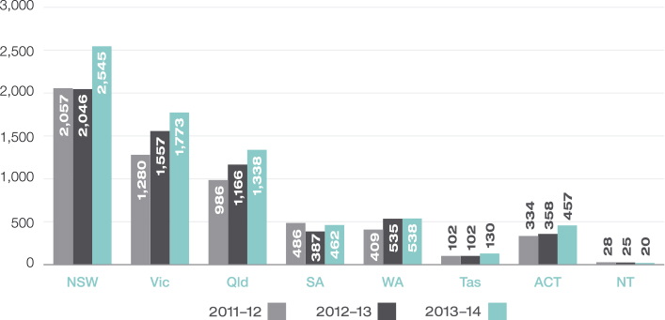
Chart A4.3 Applications finalised – By state and territory
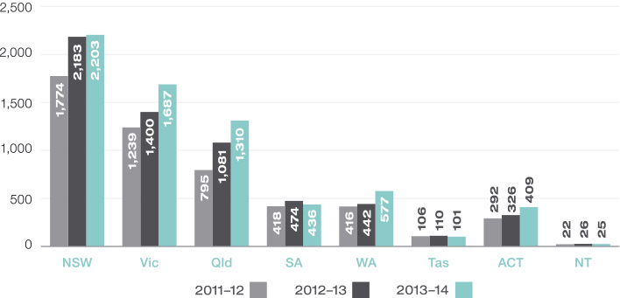
Table A4.4 Percentage of applications finalised without a hearinga
Jurisdiction | 2011–12  % | 2012–13  % | 2013–14  %
All | 79 | 79 | 82
Social security | 77 | 76 | 77
Veterans’ affairs | 73 | 71 | 72
Workers’ compensation | 87 | 87 | 86
Taxation
Taxation Appeals Division | 79 | 85 | 87
Small Taxation Claims Tribunal | 90 | 73 | 86
a Applications finalised by the Tribunal without it completing the review and giving a decision on the merits under section 43 of the AAT Act. Includes applications finalised in accordance with terms of agreement lodged by the parties (sections 34D and 42C), applications withdrawn by the applicant (section 42A(1A)) and applications dismissed by the Tribunal (sections 42A and 42B).
Table A4.5 Outcomes of applications for review of a decision finalised in 2013–14
 | All applications |  | Social security |  | Veterans’ affairs |  | Workers’  compensation |  | Taxation
 |  |  |  |  |  |  |  |  | Taxation Appeals Division |  | Small Taxation Claims Tribunal
 | No | % | No | % | No | % | No | % | No | % | No | %
By consent or withdrawn
Decision affirmeda | 435 | 7 | 8 | < 1 | 4 | 1 | 406 | 30 | 10 | < 1 | 7 | 3
Decision varieda | 632 | 10 | 25 | 1 | 21 | 6 | 60 | 4 | 465 | 29 | 51 | 21
Decision set asidea | 1,294 | 20 | 313 | 16 | 94 | 25 | 314 | 23 | 379 | 24 | 80 | 33
Dismissed by consentb | 91 | 1 | 26 | 1 | 2 | < 1 | 14 | 1 | 28 | 2 | 0 | 0
Dismissed by operation of lawc | 228 | 3 | 228 | 12 | 0 | 0 | 0 | 0 | 0 | 0 | 0 | 0
Withdrawn by applicant | 1,944 | 30 | 700 | 36 | 132 | 36 | 318 | 24 | 423 | 27 | 64 | 26
Subtotal | 4,624 | 71 | 1,300 | 66 | 253 | 68 | 1,112 | 82 | 1,305 | 82 | 202 | 83
By decision
Decision affirmedd | 864 | 13 | 357 | 18 | 76 | 20 | 133 | 10 | 129 | 8 | 30 | 12
Decision variedd | 71 | 1 | 19 | < 1 | 2 | < 1 | 6 | < 1 | 33 | 2 | 1 | < 1
Decision set asided | 272 | 4 | 73 | 4 | 25 | 7 | 56 | 4 | 45 | 3 | 3 | 1
Subtotal | 1,207 | 18 | 449 | 23 | 103 | 28 | 195 | 14 | 207 | 13 | 34 | 14
Other
Dismissed by Tribunale | 208 | 3 | 100 | 5 | 8 | 2 | 13 | < 1 | 45 | 3 | 1 | < 1
No jurisdictionf | 278 | 4 | 32 | 2 | 4 | 1 | 24 | 2 | 13 | < 1 | 3 | 1
Extension of time refused | 104 | 2 | 76 | 4 | 1 | < 1 | 5 | < 1 | 2 | < 1 | 0 | 0
No application fee paid | 89 | 1 | 0 | < 1 | 1 | < 1 | 0 | 0 | 16 | 1 | 1 | < 1
Otherg | 21 | < 1 | 9 | < 1 | 0 | 0 | 4 | < 1 | 10 | < 1 | 1 | < 1
Subtotal | 700 | 11 | 217 | 11 | 14 | 4 | 46 | 3 | 79 | 5 | 6 | 2
Totalh | 6,531 | 100 | 1,966 | 100 | 370 | 100 | 1,353 | 100 | 1,591 | 100 | 242 | 100
a Applications finalised by the Tribunal in accordance with terms of agreement reached by the parties either in the course of an alternative dispute resolution process (section 34D of the AAT Act) or at any stage of review proceedings (section 42C).
b Applications dismissed by consent under section 42A(1) of the AAT Act.
c If an application in the family assistance and social security area relates to the recovery of a debt, the parties may agree in writing to settle the proceedings. On receipt of the agreement, the application is taken to have been dismissed: section 146 of the A New Tax System (Family Assistance) (Administration) Act 1999, section 182 of the Social Security (Administration) Act 1999, and section 326A of the Student Assistance Act 1973.
d Applications finalised by a decision of the Tribunal under section 43 of the AAT Act.
e Applications dismissed under section 42A(2) of the AAT Act (non-appearance at a case event), section 42A(5) (failure to proceed with an application or to comply with a direction of the Tribunal) and section 42B(1) (application is frivolous or vexatious).
f Applications in relation to which the Tribunal has determined it does not have jurisdiction or dismissed under section 42A(4) of the AAT Act on the basis that the applicant has failed to demonstrate that a decision is reviewable.
g Includes applications for review of a decision that have been lodged out of time and in relation to which no extension of time application is subsequently received.
h Percentages do not total 100% due to rounding.
Chart A4.6 Applications current at 30 June 2014 – By state and territory
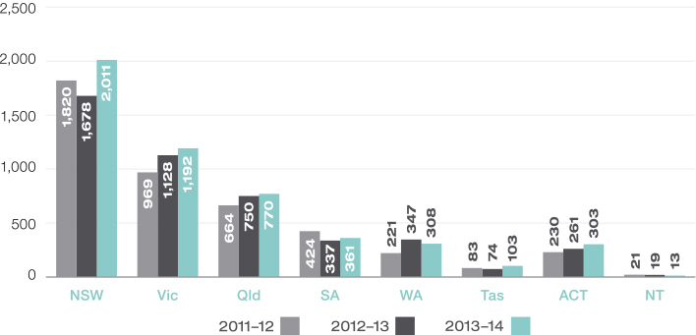
Table A4.7 Alternative dispute resolution processes, interlocutory hearings and hearings conducted by the Tribunal
Event type | 2011–12 | 2012–13 | 2013–14
Conferences | 6,761 | 7,606 | 7,636
Case appraisals | 4 | 3 | 3
Conciliations | 469 | 485 | 555
Mediations | 49 | 42 | 39
Neutral evaluations | 39 | 32 | 22
Interlocutory hearingsa | 373 | 437 | 524
Hearings | 993b | 1,063b | 1,083
a Includes hearings relating to the jurisdiction of the Tribunal and hearings relating to applications for orders of the following kind:
– to extend the time to lodge an application for review
– to be joined as a party to a proceeding
– to make a confidentiality order under section 35 of the AAT Act
– to stay the operation or implementation of a reviewable decision
– to dismiss an application
– to reinstate an application.
b The figures for the number of hearings conducted by the Tribunal in 2011–12 and 2012–13 differ from those that appeared in the annual reports for those years. A technical issue led to some hearings not being counted in the reports for those years.
Table A4.8 Constitution of tribunals for hearings
Tribunal type | 2011–12a |  | 2012–13a |  | 2013–14
 | No | % | No | % | No | %
Judge alone | 3 | < 1 | 0 | 0 | 3 |  | < 1
Judge with 1 other member | 7 | < 1 | 8 | < 1 | 4 |  | < 1
Judge with 2 other members | 2 | < 1 | 1 | < 1 | 3 |  | < 1
Deputy President alone | 144 | 15 | 187 | 18 | 242 |  | 22
Deputy President with 1 other member | 51 | 5 | 51 | < 1 | 29 |  | 3
Deputy President with 2 other members | 4 | < 1 | 2 | < 1 | 0 |  | 0
Senior Member alone | 488 | 49 | 469 | 44 | 491 |  | 45
Senior Member with 1 other member | 95 | 10 | 93 | 9 | 56 |  | 5
Senior Member with 2 other members | 0 | 0 | 2 | < 1 | 1 |  | < 1
Member alone | 187 | 19 | 239 | 22 | 243 |  | 22
Two Members | 12 | 1 | 11 | 1 | 11 |  | 1
Three Members | 0 | 0 | 0 | 0 | 0 |  | 0
Totalb | 993 | 100 | 1,063 | 100 | 1,083 |  | 100
Total multi-member tribunals | 171 | 17 | 168 | 16 | 104 |  | 10
a The figures for the number of hearings conducted by the Tribunal in 2011–12 and 2012–13 differ from those that appeared in the annual reports for those years. A technical issue led to some hearings not being counted in the reports for those years.
b Percentages do not total 100% due to rounding.
Table A4.9 Appeals against decisions of the Tribunal – By jurisdiction
Jurisdiction | 2011–12 |  | 2012–13 |  | 2013–14
 | Section 44a | Otherb | Section 44a | Otherb | Section 44a | Otherb
Social security | 11 | 1 | 8 | 0 | 19 | 1
Veterans’ affairs | 10 | 0 | 8 | 1 | 11 | 0
Workers’ compensation | 18 | 1 | 17 | 2 | 24 | 2
Taxation
Taxation Appeals Division | 17 | 1 | 22 | 4 | 18 | 0
Small Taxation Claims Tribunal | 0 | 0 | 0 | 0 | 0 | 0
Immigration and citizenship | 7 | 14 | 4 | 21 | 6 | 7
Other | 12 | 2 | 13 | 2 | 18 | 1
Total | 75 | 19 | 72 | 30 | 96 | 11
a Appeals lodged in the Federal Court under section 44 of the AAT Act. In some circumstances, a party may lodge an application seeking relief under section 44 of the AAT Act and under another enactment. These applications are treated as section 44 appeals for statistical purposes.
b Applications for judicial review made under other enactments, including the Administrative Decisions (Judicial Review) Act 1977, the Judiciary Act 1903, Part 8 of the Migration Act 1958 and section 75(v) of the Constitution.
Table A4.10 Outcomes of appeals against Tribunal decisions – By jurisdiction
Outcome | 2011–12 |  | 2012–13 |  | 2013–14
 | Section 44 | Other | Section 44 | Other | Section 44 | Other
Social security
Allowed/Remitted | 1 | 0 | 4 | 0 | 4 | 0
Dismissed | 10 | 2 | 6 | 0 | 13 | 0
Discontinued | 2 | 0 | 1 | 0 | 1 | 0
Subtotal | 13 | 2 | 11 | 0 | 18 | 0
Veterans’ affairs
Allowed/Remitted | 6 | 0 | 5 | 0 | 5 | 0
Dismissed | 9 | 1 | 3 | 1 | 6 | 0
Discontinued | 0 | 0 | 0 | 0 | 0 | 0
Subtotal | 15 | 1 | 8 | 1 | 11 | 0
Workers’ compensation
Allowed/Remitted | 6 | 0 | 9 | 0 | 10 | 1
Dismissed | 16 | 0 | 9 | 1 | 14 | 1
Discontinued | 4 | 0 | 1 | 0 | 3 | 0
Subtotal | 26 | 0 | 19 | 1 | 27 | 2
Taxation
Taxation Appeals Division
Allowed/Remitted | 7 | 1 | 7 | 1 | 6 | 1
Dismissed | 5 | 1 | 11 | 1 | 11 | 0
Discontinued | 5 | 0 | 3 | 0 | 1 | 0
Subtotal | 17 | 2 | 21 | 2 | 18 | 1
Small Taxation Claims Tribunal
Allowed/Remitted | 0 | 0 | 0 | 0 | 0 | 0
Dismissed | 0 | 0 | 0 | 0 | 0 | 0
Discontinued | 0 | 0 | 0 | 0 | 0 | 0
Subtotal | 0 | 0 | 0 | 0 | 0 | 0
Subtotal | 17 | 2 | 21 | 2 | 18 | 1
immigration and citizenship
Allowed/Remitted | 1 | 3 | 1 | 9 | 0 | 3
Dismissed | 6 | 9 | 2 | 12 | 3 | 11
Discontinued | 1 | 2 | 2 | 1 | 1 | 1
Subtotal | 8 | 14 | 5 | 22 | 4 | 15
Other
Allowed/Remitted | 4 | 0 | 2 | 0 | 3 | 1
Dismissed | 8 | 3 | 7 | 2 | 14 | 1
Discontinued | 4 | 0 | 0 | 0 | 2 | 0
Subtotal | 16 | 3 | 9 | 2 | 19 | 2
Total | 95 | 22 | 73 | 28 | 97 | 20
ALL
Allowed/Remitted | 25 | 4 | 28 | 10 | 28 | 6
Dismissed | 54 | 16 | 38 | 17 | 61 | 13
Discontinued | 16 | 2 | 7 | 1 | 8 | 1
Total | 95 | 22 | 73 | 28 | 97 | 20
a Where a decision of a judge of the Federal Circuit Court, a single judge of the Federal Court or the Full Court of the Federal Court has been appealed, only the ultimate result is counted for the purpose of these statistics.

Appendix 5: Resourcing tables
The Tribunal has one outcome specified in the 2013–14 Portfolio Budget Statements:
Access to a fair, just, economical, informal and quick review mechanism for applicants through reviews of government administrative decisions, including dispute resolution processes and independent formal hearings.
The Tribunal is a single program agency. The primary deliverable is completed reviews of decisions, and there are two paths to achieving it:
- applications finalised without a hearing
- applications finalised with a hearing.

Resource Statement
Table A5.1 shows the Tribunal’s various sources of funding.
Table A5.1 Tribunal resource statement, 2013–14
 | Actual available appropriation for 2013–14  $’000 | Payments made 2013–14  $’000 | Balance remaining 2013–14  $’000
 | (a) | (b) | (a) – (b)
Ordinary Annual Servicesa
Departmental appropriationb | 49,963 | 36,412 | 13,551
Total Available Annual Appropriations and payments | 49,963 | 36,412
Special appropriations
Special appropriations limited by entitlement
FMA Act 1997 s28(2) |  | 368
Total special appropriations |  | 368
Total net resourcing and payments for Administrative Appeals Tribunal | 49,963 | 36,780
a Appropriation Bill (No. 1) 2013–14 and Appropriation Bill (No. 3) 2013–14. Includes $12.353m from prior periods and $2.146m in section 31 agency receipts.
b Includes an amount of $1.066m in 2013–14 for the Departmental Capital Budget. For accounting purposes this amount has been designated as ‘contributions by owners’.

Expenses by Outcome
Table A5.2 shows how the 2013–14 budget appropriations for the Tribunal translate to total resourcing for the Tribunal’s outcome, including administered expenses, revenue from the government (appropriation), revenue from other sources and the total price of the programs.
Table A5.2 Expenses for outcome
Outcome 1: Access to a fair, just, economical, informal and quick review mechanism for applicants through reviews of government administrative decisions, including dispute resolution processes and independent formal hearings. | Budgeta 2013–14  $’000 | Actual Expenses 2013–14  $’000 | Variation 2013–14  $’000
 | (a) | (b) | (a) – (b)
Program 1.1: Administrative Appeals Tribunal
Administered expenses
Special appropriations | 700 | 368 | 332
Departmental expenses
Departmental appropriationb | 35,483 | 35,169 | 314
Expenses not requiring appropriation in the Budget year | 3,214 | 3,519 | (305)
Total expenses for Outcome | 39,397 | 39,056 | 341

 | 2012–13 | 2013–14
Average Staffing Level (number) | 160 | 160
a Full year budget, including any subsequent adjustment made to the 2013–14 Budget.
b Departmental appropriation combines Ordinary annual services (Appropriation Bill No. 1) and Revenue from independent sources (section 31).

Appendix 6: Application fees

Application fees and refunds
The rules relating to the fees that are payable to lodge applications with the Tribunal are in the Administrative Appeals Tribunal Act 1975 and the Administrative Appeals Tribunal Regulations 1976. The primary rules for the payment and refund of fees are in regulations 19 and 19AA of the Administrative Appeals Tribunal Regulations. Subject to the exceptions described below, an application fee is payable for lodging an application:
- for review of a decision
- for a decision on whether a person was entitled to be given a statement of reasons for a decision
- for a declaration, under the Freedom of Information Act 1982, that a statement of reasons for a decision is not adequate.
If an application is not accompanied by an applicable fee, the Tribunal is not required to deal with the application unless and until the fee is paid. If the fee is not paid within six weeks after an application is lodged, the Tribunal may dismiss the application under section 69C of the AAT Act.

Application fee amounts
The standard application fee in 2013–14 was $816, and the fee to lodge an application in the Small Taxation Claims Tribunal was $81. From 1 July 2014, the standard application fee is $861, and the fee to lodge an application in the Small Taxation Claims Tribunal is $85.

Application fee not payable
Applications for review of the following types of decisions do not attract a fee:
- any decision specified in Schedule 3 to the Administrative Appeals Tribunal Regulations
- any decision under the Freedom of Information Act made in relation to a document that relates to a decision specified in Schedule 3 to the Administrative Appeals Tribunal Regulations.
Schedule 3 includes decisions in the areas of family assistance and social security, the National Disability Insurance Scheme, veterans’ affairs and workers’ compensation.

Reduced application fee payable
A reduced application fee of $100 is payable instead of the standard application fee if the person liable to pay the fee is:
- granted legal aid for the matter to which the application relates
- the holder of a health care card, a health benefit card, a pensioner concession card, a Commonwealth seniors health card or any other card that certifies entitlement to Commonwealth health concessions
- an inmate of a prison, in immigration detention or otherwise lawfully detained in a public institution
- a child under 18 years
- in receipt of youth allowance, Austudy payment or benefits under the ABSTUDY Scheme.
The Tribunal can order that a $100 fee is payable rather than the standard application fee if it considers that payment of the full fee would cause financial hardship to the person.
The fee payable to lodge an application in the Small Taxation Claims Tribunal must be paid in all circumstances.

One fee payable
If two or more applications relate to the same applicant and may be conveniently heard before the Tribunal at the same time, the Tribunal may order that only one fee is payable for those applications.

Refunds
A person is entitled to a:
- full refund if they have paid an application fee that was not payable
- partial refund if they paid the standard application fee but were entitled to pay the $100 fee.
A person is also entitled to a partial refund if the person paid the standard application fee or the equivalent of a standard application fee and the Tribunal certifies that proceedings terminated in a manner favourable to the applicant. The refund amount is the difference between the application fee that was paid and $100. There is no refund if the person paid the reduced application fee or if their application was dealt with in the Small Taxation Claims Tribunal.

Application fees in 2013–14
In 2013–14 the Tribunal received $887,260 and refunded $367,590 in application fees.
Total revenue forgone on the basis that a person was eligible to pay a reduced fee or only one fee was payable for multiple applications lodged by the same person was $918,978 (see Tables A6.1, 6.2, 6.3).
The Tribunal refused nine applications to reduce the application fee on financial hardship grounds. There were eight applications to the Tribunal for review of decisions of this kind. The decision was set aside in four applications and affirmed (unchanged) in three applications. One application was withdrawn.
Table A6.1 Fee revenue summary: total, refunded and forgone
Fees and applications | Amount and number
Total fee revenue | $887,260
Total refunded | $367,590
Total revenue forgone | $918,978
Applications: fees reduced | 311
Applications: fees not paid | 895
Table A6.2 Reduced fees paid
Reason | Number of applications affected
Applicant eligible to pay reduced fee | 212
Fee reduced by Tribunal on financial hardship grounds | 99
Total | 311
Table A6.3 Applications for which no fee paid where otherwise payable
Category | Number of applications for which fee was not collected
Applications for review of an FOI decision about a document relating to a decision in respect of which no fee is payable | 1
Additional applications where one fee payable for two or more applications lodged by the same applicant
Standard application fee | 848
Reduced fee | 32
STCT fee | 14
Total | 895

Appendix 7: Decisions of interest

Aviation

Confidential and Civil Aviation Safety Authority
[2013] AATA 927; 20 December 2013
Senior Member Egon Fice
Whether the applicant’s pilot licences should be suspended because of alleged conduct relating to one of the qualifying exams
To obtain a pilot’s licence, a person must pass a theory examination consisting of seven separate subject-parts, one of which relates to flight planning. Since 2002, the flight planning exam has been conducted on a computer with candidates asked a subset of the questions available in the exam database. The applicant failed the flight planning exam twice but passed on the third occasion in March 2011. At that time, the exam questions were based on a Boeing 727-200 series aeroplane and candidates were permitted to bring the Boeing 727 Performance and Operating Handbook (Abbreviated) into the exam room to refer to when answering the questions.
In September 2012, the Civil Aviation Safety Authority (CASA) received an email from an informant alleging the widespread use of cheat sheets in the flight planning exam. It was suggested that sheets containing sufficient material to identify particular exam questions and their answers were inserted into the Operating Handbook. The informant alleged that he had received the cheat sheet from the applicant.
Regulation 298A of the Civil Aviation Regulations 1988 proscribes various types of conduct in relation to exams, including:
- giving another person any information about the questions contained in the examination paper, being information that might give anyone an unfair advantage in the examination
- during the examination, using any material or aid that CASA does not permit to be used.
CASA found that the applicant had passed the cheat sheet to another person in contravention of regulation 298A and decided to suspend his pilot licences for a period of six months.
The Tribunal noted that regulation 298A was in substantially the same form as when it was first introduced in 1994, at which time the exam was conducted in a paper format. The term ‘examination paper’ was defined in the regulation to mean ‘all of the documents provided by the person conducting a written examination to persons attempting the examination’. The Tribunal held that it was appropriate to interpret the regulation such that references to the examination paper were references to any of the questions that could be put to a candidate during the exam, not only the questions put to any particular candidate.
The Tribunal was satisfied on the evidence that the applicant had knowingly given another person information about questions in the exam which might give a person an unfair advantage. While there was no direct evidence that the applicant had cheated when he passed the flight planning exam, the Tribunal drew inferences from the probative evidence and found that the applicant did have access to, and used, the cheat sheet in that exam, material which a candidate was prohibited from taking into the exam room.
The Civil Aviation Regulations allow CASA to vary, suspend or cancel a licence if the holder:
- has failed in his or her duty with respect to any matter affecting the safe navigation or operation of an aircraft, or
- is not a fit and proper person to have the responsibilities and exercise and perform the functions and duties of a holder of such a licence.
The Tribunal was satisfied that the applicant’s conduct in cheating in the exam and passing the cheat sheet on to other potential candidates amounted to a breach of his duty regarding the safe navigation or operation of an aircraft. It also found the applicant was not a fit and proper person to hold a pilot’s licence.
The Tribunal affirmed the decision to suspend the applicant’s licences, ordering that the period of the suspension commence from the date of the Tribunal’s decision. The Tribunal also noted that the applicant would be required to take the flight planning exam again.

Environment

Zoubi and Minister for the Environment
[2014] AATA 86; 24 February 2014
Deputy President Robin Handley
Whether the applicant should be granted permits to export two Gang-gang Cockatoos and two Glossy Black Cockatoos
In early 2012, Mr Zoubi requested information from the Department of Sustainability, Environment, Water, Population and Communities about whether he could export a Gang-gang Cockatoo as a pet or for exhibition purposes. The Department advised that these birds are not eligible for export as pets and that, for the exception for exhibition purposes to apply, the birds must be used in a public exhibition with cultural, scientific or conservation content.
In June 2012, Mr Zoubi applied for a permit to export two Gang-gang Cockatoos and two Glossy Black Cockatoos for research purposes. This application was refused. The Minister’s delegate was not satisfied Mr Zoubi had sufficient resources and qualifications to conduct the research and pointed to a lack of evidence that the primary purpose of Mr Zoubi acquiring the cockatoos was for research. Mr Zoubi made a further application in January 2013 which was accompanied by a letter from a zoologist at the Jerusalem Zoo stating he would provide support for Mr Zoubi’s research. This application was also refused by the Minister’s delegate on the same grounds. Mr Zoubi applied to the Tribunal for review of that decision.
The granting of export permits for native birds is governed by the Environment Protection and Biodiversity Conservation Act 1999 and the Environment Protection and Biodiversity Conservation Regulations 2000. The principal issue for the Tribunal was whether the export of the birds was for the purposes of research and, more specifically, whether the following requirements were met:
- the specimens would be used for the purpose of scientific research
- the research was for the acquisition of a better understanding and/or increased knowledge of the taxons to which the specimens belong
- the research would be done by a person or institution that has sufficient resources and qualifications
- the animals would be held in a way that is known to result in minimal stress and risk of injury.
The Tribunal considered that Mr Zoubi’s initial contact with the Department raised questions about the purpose for which he was seeking to export the birds and that a reasonable decision-maker would look to further evidence to be satisfied the concerns were not justified. In the context of an application of this kind, the Tribunal expected that a research proposal would provide an appropriate level of detail. The Tribunal found, however, that the information provided was less than satisfactory. Mr Zoubi had also not established how his proposed research would contribute to a better understanding and/or increased knowledge of the cockatoos.
The Tribunal was not satisfied that Mr Zoubi had any relevant qualifications or experience in conducting research. While curriculum vitae of the zoologist at the Jerusalem Zoo indicated he had qualifications and experience to guide Mr Zoubi, the Tribunal emphasised that the research itself was to be conducted by Mr Zoubi. The Tribunal also considered it relevant that the Department had found Mr Zoubi was not suitably equipped to manage, confine and care for the birds.
The Tribunal was not satisfied the export of the birds was for the purposes of research and affirmed the decision.

Industry and Research Development

Mount Owen Pty Limited and Innovation Australia
[2013] AATA 573; 16 August 2013
Deputy President Brian Tamberlin and Member Conrad Ermert
Whether activities claimed to be undertaken by the applicant were research and development activities for the purposes of the Income Tax Assessment Act 1936
The applicant is the owner of an open-cut coal mine at Mount Owen in New South Wales. It decided to mine to depths of 250 metres and beyond in order to extract the high quality coal seams located at those depths. Increasing the depth of the pits to more than 250 metres presented a number of challenges and the applicant engaged in activities to meet these challenges.
The applicant claimed to have conducted numerous activities between January 2000 and December 2005 which qualified for the purpose of the research and development tax incentive under the Income Tax Assessment Act 1936. These activities included mine modelling and concept design, experimentation and trial testing, wall control systems, through-seam blasting and evaluation of results. Innovation Australia decided that only some of the claimed activities were research and development activities. The applicant applied to the Tribunal for a review of that decision.
There was extensive evidence before the Tribunal, oral evidence from the applicant’s General Manager and from experts in geology, mining engineering, geotechnical engineering and blasting. The experts in geology and mining gave their evidence at the same time in accordance with the Tribunal’s concurrent evidence procedure. The Tribunal also visited the mine site in order to better understand the evidence.
The Tribunal considered whether the claimed activities could be characterised as research and development activities within the meaning of section 73B of the Act. This involved assessing whether the activities:
- were systematic, investigative and experimental, involved either innovation or high levels of technical risk, and were carried out for the purpose of acquiring new knowledge, or creating new or improved materials, products, devices, service or processes, or
- were undertaken for a purpose directly related to the carrying on of those core activities.
The Tribunal was not satisfied on the evidence that any of the activities could be characterised either as core activities or directly related activities.
In considering whether the activities had in fact been carried out as claimed, the Tribunal observed that the oral and documentary evidence did not provide any sufficient basis for determining that this was the case. The contemporaneous material and other records did not approach the level of precision which would be expected of a systematic investigation process or a well-documented research and development program.
The Tribunal set aside Innovation Australia’s decision and substituted a decision that none of the applicant’s claimed activities should be accepted as being research and development activities.

MOTOR VEHICLE STANDARDS

Gadhvi and Minister for Infrastructure and Regional Development
[2014] AATA 65; 11 February 2014
Senior Member Rodney Dunne and Senior Member Nicholas Manetta
Whether the applicant should be allowed to import a motorcycle that did not meet Australian standards
Mr Gadhvi purchased a new motorcycle in India 11 months before he emigrated to Australia. The Bajaj Pulsar motorcycle did not meet Australian design requirements and was therefore a ‘non-standard vehicle’ under the Motor Vehicle Standards Act 1989. Mr Gahhvi wanted to import the motorcycle into Australia and applied for permission to do so under the Motor Vehicle Standard Regulations 1989.
The Minister has a general discretion under regulation 11 to approve the importation of a non-standard motor vehicle. Regulation 13 addresses cases where a present or prospective Australian citizen or permanent resident has purchased and used a vehicle overseas and is moving to Australia with the intention of remaining indefinitely. It allows the Minister to approve an importation if certain preconditions are satisfied, one of which is that the applicant must have owned the vehicle for a continuous period of 12 months immediately before arriving in Australia.
The Minister’s delegate, the Administrator of Vehicle Standards, refused Mr Gadhvi’s application to import the motorcycle. He found that the requirements of regulation 13 were not met as Mr Gadhvi had owned the motorcycle for only 11 months before arriving in Australia. The Minister decided not to exercise the discretion in regulation 11.
The Tribunal agreed it could not approve the importation under regulation 13 as Mr Gadhvi did not satisfy the precondition relating to length of ownership of the vehicle.
In relation to the application of the general discretion in regulation 11, the Tribunal considered whether it could take into account that Mr Gadhvi had fallen marginally short of the 12-month period of continuous ownership but otherwise satisfied all of the preconditions in regulation 13. It held that there is nothing in the Act or the Regulations to indicate that these matters cannot be taken into account. The general discretion can be used to alleviate the arbitrariness of the 12-month precondition in regulation 13.
The Tribunal considered a range of other matters. It noted that Mr Gadhvi had only modest means and would prefer to use the motorcycle rather than his car. There was also no evidence that Mr Gadhvi wished to bring the vehicle into Australia for the purposes of resale nor that the motorcycle had been judged unfit on safety grounds.
The Tribunal set aside the decision and remitted the matter with a direction that importation of the motorcycle be approved subject to such conditions, if any, that ought to be attached to the approval so that the motorcycle may be safely used on Australian roads.

National Disability Insurance Scheme

Mulligan and National Disability Insurance Agency
[2014] AATA 374; 13 June 2014
Senior Member Jill Toohey and Professor Ronald McCallum, Member
Whether Mr Mulligan met the disability criteria for access to the National Disability Insurance Scheme
Mr Mulligan has a number of medical conditions, including chronic ischaemic heart disease, cardiomyopathy and sciatica from ruptured discs in his lower back. Since 1994 he has been on a Disability Support Pension while continuing to work when he is able. Mr Mulligan applied to become a participant in the National Disability Insurance Scheme. He was seeking funding for someone to mow his lawn which he cannot manage himself because he experiences severe shortness of breath when he exerts himself.
To be eligible for the National Disability Insurance Scheme, a person must meet the access criteria set out in the National Disability Insurance Scheme Act 2013. These comprise age, residence and disability requirements. The National Disability Insurance Agency determined that Mr Mulligan met the age and residency requirements but did not meet the disability requirements. Mr Mulligan applied to the Tribunal for review of that decision.
The disability requirements are specified in section 24 of the Act and all of them must be met. In determining whether Mr Mulligan satisfied those requirements, the Tribunal considered the terms of the Act and the content of the National Disability Insurance Scheme (Becoming a Participant) Rules 2013.
The Tribunal found that Mr Mulligan met the following requirements in the ACT:
- he has a disability that is attributable to one or more intellectual, cognitive, neurological, sensory or physical impairments or to one or more impairments attributable to a psychiatric condition
- the impairments are, or are likely to be, permanent
- the impairments affect his capacity for social or economic participation
- he is likely to require support under the NDIS for his lifetime.
The Tribunal was not satisfied, however, that he met the requirement that his impairments result in substantially reduced functional capacity to undertake, or psychosocial functioning in undertaking, one or more of the following activities: communication, social interaction, learning, mobility, self-care or self-management. Having considered evidence given by Mr Mulligan and an occupational therapist, the Tribunal acknowledged that Mr Mulligan’s capacity for functioning in the areas of mobility, self-care and social interaction was undoubtedly reduced. However, it was not satisfied that his capacity is substantially reduced. The Tribunal did not believe Mr Mulligan’s inability to mow his laws was sufficient to say that he has substantially reduced functional capacity in relation to self-management which the Tribunal understood to mean ‘a person’s ability to plan and manage their everyday life including his or her financial affairs’.
The Tribunal affirmed the decision that Mr Mulligan was not eligible to become a participant in the National Disability Insurance Scheme.

Young and National Disability Insurance Agency
[2014] AATA 401; 20 June 2014
Senior Member John Handley and Senior Member Jill Toohey
Whether a portable oxygen concentrator and an insulin pump were reasonable and necessary supports for the applicant
Mr Young’s medical conditions include type 1 diabetes and emphysema. He relies on insulin for his diabetes which he administers using an insulin pump. He needs supplementary oxygen for his emphysema. When outside the house, he uses a portable oxygen cylinder on a trolley.
In August 2013, Mr Young became a participant in the National Disability Insurance Scheme. When a person becomes a participant, the National Disability Insurance Agency helps the person prepare an individual plan which includes a statement of the general supports that will be provided to the participant and the reasonable and necessary supports that will be funded through the National Disability Insurance Scheme. Mr Young’s plan included funding for a range of supports. He requested funding for a portable oxygen concentrator and an insulin pump but the National Disability Insurance Agency decided that both are more appropriately funded through the health system. Mr Young applied to the Tribunal for review of that decision.
For a support to be funded under the National Disability Insurance Scheme, it must meet the criteria set out in section 34 of the National Disability Insurance Scheme Act 2013 which include whether the support is most appropriately funded or provided through the National Disability Insurance Scheme and not other general systems of service delivery or support services such as the health, employment or education systems. The National Disability Insurance Scheme (Supports for Participants) Rules 2013 set out considerations that must be taken into account in deciding whether a support is most appropriately funded through the National Disability Insurance Scheme. These include that the National Disability Insurance Scheme:
- will be responsible for supports related to a person’s ongoing functional impairment and that enable the person to undertake activities of daily living
- will not be responsible for the diagnosis and clinical treatment of health conditions.
The Tribunal found that a portable oxygen concentrator would be more convenient and less embarrassing for Mr Young than using a portable oxygen cylinder and that the insulin pump had made a great difference to his life. However, the Tribunal was not satisfied that Mr Young is unable to undertake daily living activities or participate in the community without them because alternatives exist. The Tribunal also found that the primary purpose of both the oxygen concentrator and insulin pump is the treatment of his health conditions. Their essential character as clinical treatment is not changed by the fact that they are different methods of delivering oxygen and insulin.
It was argued for Mr Young that, because funding for the oxygen concentrator and insulin pump is not available through mainstream health services, they are most appropriately funded through the National Disability Insurance Scheme. The Tribunal held, however, that whether or not funding is available through other general systems is not the test of whether a support is most appropriately funded or provided through the National Disability Insurance Scheme. The fact that the health system does not fund entirely, or even at all, what is essentially clinical treatment, or some other form of support does not make it the responsibility of the National Disability Insurance Scheme.
The Tribunal affirmed the National Disability Insurance Agency’s decision.

NATIONAL SECURITY AND Passports

BLBS and Director-General of Security and Anor
[2013] AATA 820; 19 November 2013
President Justice Duncan Kerr, Deputy President James Constance and Senior Member Graham Friedman
Whether ASIO had reasonable grounds to suspect the applicant would be likely to engage in conduct that might prejudice the security of Australia or a foreign country – whether the applicant’s Australian passport should be cancelled and he should be required to surrender his foreign travel documents in order to prevent him from engaging in that conduct
BLBS, an Australian citizen, planned to travel overseas in 2010, including to Yemen. When he arrived at the airport, he was taken aside, interviewed by the Australian Federal Police and ordered to surrender his Australian passport and other travel documents. The Australian Security Intelligence Organisation had made an adverse security assessment about BLBS and then requested the Minister for Foreign Affairs to cancel his passport and order the surrender of his foreign travel documents. The Minister accepted those recommendations and made decisions accordingly. BLBS applied to the Tribunal for review of ASIO’s adverse security assessment and the decisions made by the Minister as a consequence of that assessment.
Section 14 of the Australian Passports Act 2005 provides that ASIO can make a request for the refusal or cancellation of an Australian passport if it suspects on reasonable grounds that the person would be likely to engage in conduct that might prejudice the security of Australia or a foreign country and that the person should be refused a passport in order to prevent the person from engaging in the conduct. Section 15 of the Foreign Passports (Law Enforcement and Security) Act 2005 is expressed in similar terms but allows the Minister to order the surrender of a person’s foreign travel documents.
Before considering the merits of the decisions that had been made, the Tribunal dealt with three preliminary issues.
- The Tribunal considered whether ASIO’s requests to the Minister under the Acts complied with the law. The Tribunal held that the critical jurisdictional fact that must exist for the Minister to exercise the power to make a cancellation or refusal decision under the Australian Passports Act is that the relevant suspicion be held by ASIO, whether or not it has been communicated in terms to the Minister. However, a failure by ASIO to provide details of the nature of the suspicion would mean the Minister cannot perform the statutory duty. In this case, the Tribunal was satisfied that the nature of ASIO’s suspicions was adequately conveyed to the Minister, albeit not strictly in terms of the language of the legislation.
- The second issue was whether the Tribunal is required to defer to the assessments and opinions of ASIO and its officers when reviewing the security assessment decision. It was submitted that Australian courts, when considering public interest immunity, have emphasised the significance which must be given to the views of senior government officials on matters of national security. The Tribunal held that its merits review function is not analogous to judicial review. The Tribunal’s function would be devalued and its credibility undermined if it did not submit every challenged security assessment to independent and rigorous examination.
- The third issue was whether the Tribunal could set aside a decision of the Minister under the Australian Passports Act or Foreign Passports Act even if it is not persuaded to set aside ASIO’s adverse security assessment. The Tribunal disagreed with its earlier decision in TCXG and Director-General of Security and Anor [2013] AATA 284 (10 May 2013), that this could not occur. It held that the assessment and the Minister’s decision are legally distinct matters and can thus be each separately reviewed.
The evidence before the Tribunal included unclassified and classified material. The matters in the unclassified material said to give rise to ASIO’s security concerns were summarised as: BLBS had maintained associations with persons of security concern and was likely to share their view that violence was acceptable to achieve a political and religious end; BLBS had planned to travel to Yemen without plans and preparation for a course of religious studies that he had stated he intended to undertake; and, in interviews with ASIO, BLBS had responded to questions about his beliefs by stating it was a person’s choice to travel overseas to fight in the defence of Islam if Islam was under attack. The Tribunal was also invited to draw adverse conclusions about his intentions from alleged inconsistencies and evasions in his responses to questioning by ASIO and the Australian Federal Police. Restricting its consideration to the unclassified materials, the Tribunal was not satisfied that ASIO’s adverse security assessment could be justified.
The Tribunal also had to take into account the classified materials and evidence, much of which was covered by certificates issued by the Attorney-General preventing its disclosure to the applicant. The Tribunal undertook that any questions BLBS’s counsel wanted to put to classified witnesses would be asked by the Tribunal in closed proceedings which it did.
Taking into account all of the evidence, the Tribunal concluded that ASIO had a proper basis for making an adverse assessment and reasonable grounds to suspect BLBS would be likely to engage in conduct which might prejudice the security of a foreign country and that his passport should be cancelled to prevent him from doing so. The Tribunal also found that the Minister’s decisions to cancel BLBS’s passport and require the surrender of his foreign travel documents were correct and preferable.
The Tribunal affirmed the decisions.

Personal Property Securities

Cirillo and Registrar of Personal Property Securities
[2013] AATA 733; 11 October 2013
Deputy President Katherine Bean
Whether the Registrar should have removed an entry on the Personal Properties Register that Mr Cirillo’s vehicle continued to secure a debt
In 2007, Mr Cirillo purchased a motor vehicle with the assistance of finance provided by a finance company. In 2010, he borrowed additional funds which were consolidated with the original loan. The consolidated loan was secured against the vehicle. The finance company registered its interest in the vehicle on the New South Wales Register of Encumbered Vehicles (REVS) in 2007 and again in 2010. When the new national Personal Property Securities Register (PPS Register) was established on 30 January 2012, the details on REVS relating to Mr Cirillo’s debt were migrated to the PPS Register.
In December 2011, the finance company sold a number of debts to another finance company, including Mr Cirillo’s debt secured by the vehicle. In March 2012, the original company registered a change statement for the purposes of the PPS Register to change the secured party details to the second finance company and its parent company.
In July 2012, Mr Cirillo sought to remove the registration from the PPS Register by issuing what is known as an amendment demand to the second finance company and its parent company. Mr Cirillo then lodged an amendment statement with the Registrar, enclosing the amendment demand. Following correspondence with the second finance company and its parent company, the Registrar decided not to amend the PPS Registrar as requested. Mr Cirillo applied to the Tribunal for review of that decision.
The principal issue for the Tribunal was whether there were reasonable grounds for suspecting that the amendment sought by Mr Cirillo was not authorised under the Personal Property Securities Act 2009.
Mr Cirillo argued that the vehicle did not secure a debt owed by him for a variety of reasons, including that:
- one of the contracts he was alleged to have entered into with the original finance company was not signed
- the original finance company unlawfully assigned its rights to the second company
- the figures relating to the amount of the debt were inaccurate.
The Tribunal rejected Mr Cirillo’s arguments, finding that the evidence before it established that he continued to owe a debt, secured by the vehicle, that the debt had been lawfully sold to the second finance company and that the PPS Register had been appropriately amended to reflect the change of secured parties. The Tribunal concluded there were reasonable grounds to suspect that the amendment demanded by Mr Cirillo to remove the registration was not authorised under the Act.
The Tribunal affirmed the decision.

Practice and Procedure

Hawkins and Minister for the Arts

Hawkins and Minister for Infrastructure and Regional Development
[2013] AAT 835; 25 November 2013
[2014] AAT 152; 11 March 2014
Deputy President Ray Groom and Member Sandra Taglieri
Whether the Tribunal had jurisdiction to decide the application – whether the application should be dismissed as frivolous and vexatious
Mr Hawkins was an agent appointed by Mr Kennedy to negotiate the sale of the ‘Kennedy Collection’, an important collection of Australian art, furniture, silver, jewellery, pottery and porcelain. After rejecting an offer from the National Museum of Australia, an overseas buyer was found for parts of the collection. The sale was negotiated subject to the granting of an export permit allowing the items selected by the buyer to be exported as a single collection. Mr Hawkins corresponded with the Department of Regional Australia, Local Government, Arts and Sport about obtaining an export permit for the ‘collection as a collection’ under the Protection of Movable Cultural Heritage Act 1986.
The Department advised Mr Hawkins that it was not possible for the Minister to grant an export permit for the objects as a single entity. Each object would need to be assessed separately. Mr Hawkins ultimately made applications for permits for the export of eight items of jewellery.
On 10 May 2013, a delegate of the Minister advised Mr Hawkins that she had decided to refuse export permits for seven of the eight items. The export permit for the eighth item was granted, subject to a condition. Mr Hawkins applied to the Tribunal for review of those decisions. In his reasons for the application, he stated that he was contesting the right of the Government to select items from the Kennedy Collection, destroying its integrity and compromising the sale.
The Minister asked the Tribunal to dismiss the application under section 42A(4) of the Administrative Appeals Tribunal Act 1975, contending that the applicant was content with the actual decision that was made and wanted the Tribunal to review decisions that were not reviewable by the Tribunal: namely, the refusals to grant a permit to export the collection.
The Tribunal noted that the Protection of Movable Cultural Heritage Act allows for application to be made to the Tribunal for review of any decision by the Minister to refuse to grant a permit or to impose a condition. Mr Hawkins had applied for review of the decisions dated 10 May 2013 and the Tribunal concluded that it did have jurisdiction to review the decisions. Moreover, the Tribunal could not dismiss the application under section 42A(4) of the AAT Act as that section applies only when the Tribunal Registrar or a Deputy Registrar forms a view that a decision does not appear to be reviewable by the Tribunal and writes to the applicant inviting the person to show, within a specified time, that the decision is reviewable. As no such letter was written to Mr Hawkins, the Tribunal held it was not empowered to dismiss the application under that provision.
The Tribunal then considered whether the application should be dismissed under section 42B of the AAT Act on the basis that it was frivolous or vexatious. Mr Hawkins’s own statements indicated that he considered the decisions of 10 May 2013 were correct. The proceedings were not instituted for the purpose of obtaining an adjudication on those decisions but for the collateral purpose of seeking a ruling on the interpretation of the word ‘collection’ and other related questions.
The Tribunal held it is well-established that litigation is vexatious if it is not a bona fide attempt to have a court or tribunal adjudicate the issues specified to be in dispute. The Tribunal was satisfied that these proceedings were initiated for a collateral purpose and also that they were futile with no reasonable prospect at all of success.
The Tribunal dismissed the application under section 42B of the AAT Act.

Superannuation guarantee

Dominic B Fishing Pty Ltd and Commissioner of Taxation
[2014] AATA 205; 10 April 2014
Senior Member Bernard McCabe
Whether the owner of a commercial fishing vessel had to pay compulsory superannuation contributions for the crew
The applicant was operating a commercial fishing vessel out of a port in central Queensland and held a commercial fisher’s licence under the Fisheries Regulation 2008 (Qld). The vessel was usually captained by the director of the applicant and, on each voyage, he would be joined by up to four crew members, typically experienced fishermen. The Commissioner of Taxation decided the crew members were employees for the purposes of the Superannuation Guarantee (Administration) Act 1992 and that the applicant was obliged to make superannuation contributions in respect of those individuals. The applicant applied to the Tribunal for review of that decision.
The evidence before the Tribunal was that, while at sea, the vessel would anchor at a central spot each day and the fishermen would each board a small motorised boat called a ‘dory’. The dories would head off to remote locations where the crew members would spend all or part of the day fishing. Upon their return to the vessel, each fisherman would unload his catch, and the fish would be tallied and stored. When the vessel returned to port, the catch would be sold to a wholesaler or processor under the terms of a contact with the applicant. The applicant would pay each fisherman pursuant to a separate agreement between the applicant and the fisherman.
In advance of each voyage, each member of the crew was given a written document which provided that the parties were joint venturers for the purposes of a single voyage. It also provided that the cost of maintaining the vessel was the responsibility of the applicant but all of the parties would contribute a specified amount towards the operating costs. Each party was required to bear the costs of sickness and accident insurance and no party would be liable for any accident or mishap that occurred during the voyage. The evidence of the applicant’s director and a crew member was that the captain of the vessel was ultimately responsible for the safety of the vessel but decisions about where to fish and other operational matters were made jointly.
The Tribunal observed that, in deciding whether a worker is an employee, the courts have emphasised the need to consider:
- the extent to which the worker is subject to the direction and supervision of the would-be employer, and
- the extent to which the individual is integrated into the would-be employer’s organisation so that it can be said the individual is part of the same business, as opposed to operating his or her own business.
In relation to whether the crew members were acting under the control of the applicant, the Commissioner noted they were ‘assistant fishers’ for the purposes of the Fisheries Regulation which required them to act under direction of the licensed commercial fisher. However, the Tribunal was not persuaded this was decisive in this case. On the basis of all of the evidence, it concluded that the applicant’s characterisation of the crew members as independent businessmen who came together with the applicant to carry out a joint enterprise was to be preferred. It decided the crew members were not employees for the purposes of the Act.
The Tribunal set aside the decision.

TERTIARY EDUCATION REGULATION

WILLIAMS BUSINESS COLLEGE LTD AND MINISTER FOR EDUCATION; WILLIAMS BUSINESS COLLEGE LTD AND TERTIARY EDUCATION QUALITY AND STANDARDS AGENCY
[2014] AATA 371; 12 June 2014
Senior Member Anne Britton
Whether an additional condition should be imposed on the College’s registration for the Bachelor of Business degree – whether the College’s application for registration renewal should be refused
In December 2011, Williams Business College Ltd was approved by the NSW Department of Education and Training as a higher education provider that could offer a Bachelor of Business course. On 29 January 2012, it became registered under the Tertiary Education Quality and Standards Agency Act 2011 (TEQSA Act), the then new national law for the regulation of higher education. The majority of the College’s students were overseas students and so it was also subject to the Education Standards for Overseas Students Act 2000 (ESOS Act).
In the early days of offering the Bachelor of Business course, the College faced significant problems, in part because of personnel problems and debts inherited from its previous operations. In early 2013, the Dean of the College, the Chair and most members of its Governing Council, and all of the members of its Academic Board, resigned. New appointments were subsequently made, including a new Dean in April 2013 and a new Chair of the Council in May 2013. The College also approved a Higher Education Governance Charter.
In March 2013, the Tertiary Education Quality and Standards Agency (TEQSA), acting as delegate of the Minister under the ESOS Act, imposed a condition on the College that it not issue any new confirmations of enrolment. TEQSA found that the College was in breach of a number of requirements, including that it was continuing to provide misleading information to students and prospective students in its marketing. In October 2013, TEQSA decided to refuse the College’s application for renewal of registration on the basis that it was not continuing to meet the Higher Education Threshold Standards Framework (Threshold Standards) 2011. The College applied to the Tribunal for review of both decisions. The Tribunal stayed the operation of the decisions pending completion of the review.
Before the Tribunal, the College contended that it had delivered quality education throughout its two years of operation, and that the shortcomings identified by TEQSA, none of which related to educational quality, had progressively been addressed under the leadership of the new Chair of the Council and the Dean. The Tribunal agreed there had been significant improvements, but also found that problems continued.
The Tribunal focused on three aspects of the Threshold Standards: the financial viability and sustainability of a higher education provider, its corporate and academic governance and its history in managing business operations. Having considered the available information about the College’s financial position and budgets, the Tribunal was not satisfied that the College was financially viable. In relation to governance, the Tribunal found that the Council had failed to take steps to appraise itself of the true financial position of the College, constituting a failure to regularly monitor a potential risk to its higher education operations. As such, the College had not shown sound corporate governance as required under the Standards. The Tribunal was also not satisfied that the College had shown a sound track record in managing its business operations. Having found that the College did not continue to meet the Threshold Standards, the Tribunal held that it could not renew the College’s registration.
The Tribunal affirmed both of TEQSA’s decisions but decided to delay the date of operation of the decision to refuse the College’s registration to allow the students to complete the current semester.

Appendix 8: Speeches, publications and other activities
Tribunal members and staff undertake a wide range of activities that assist to raise awareness of the Tribunal’s role, procedures and activities. Members and staff give speeches at conferences and seminars, participate in training and education activities, publish articles and undertake other engagement activities. The record of activities for 2013–14 is in four lists: speeches and presentations; competition adjudication and training; publications; and other engagement activities. The lists in Tables A8.1, A8.2 and A8.4 are arranged by date and the list in Table A8.3 is in alphabetical order.
Table A8.1 Speeches and presentations
Title/role | Event/organisation | Participant/speaker(s) | Date
The Role of the AAT | Tribunal Advocacy Course, Department of Veterans’ Affairs, Canberra | Conference Registrar Siobhan Ni Fhaolain | 1 July 2013
Administrative Law in an Interconnected World: Where to from here? | 2013 National Administrative Law Conference, Australian Institute of Administrative Law, Canberra | Justice Duncan Kerr, President | 19 July 2013
After the Shooting Stops | Biennial Member and Staff Conference, Veterans’ Review Board, Brisbane | Justice Duncan Kerr, President | 7 August 2013
Diagnosing Psychiatric Disorders | Biennial Member and Staff Conference, Veterans’ Review Board, Brisbane | Member Dr Marian Sullivan | 7 August 2013
Appraisal including Peer Review | Claims Assessment and Resolution Service, NSW Motor Accidents Authority, Sydney | Senior Member Bernard McCabe | 14 August 2013
Keeping the AAT from Becoming a Court | Seminar, NSW Chapter of the Australian Institute of Administrative Law, Sydney | Justice Duncan Kerr, President | 27 August 2013
Welcome and Opening | 2013 Annual Conference, NSW Chapter of COAT, Sydney | Senior Member Anne Britton | 13 September 2013
Tribunal Advocacy | Bar Readers’ Course, South Australian Bar Association, Adelaide | Deputy President Katherine Bean | 19 September 2013
Keeping the AAT from Becoming a Court | Annual General Meeting, SA Chapter of COAT, Adelaide | Justice Duncan Kerr, President | 20 September 2013
Launch address | Launch of the Merits Review Special Edition of the University of Queensland Law Journal, Brisbane | Justice Duncan Kerr, President | 8 October 2013
Making Submissions and Providing Reasons | Advanced Administrative Law course, ANU College of Law, Canberra | Senior Member Professor Robyn Creyke | 26 October 2013
Decision Writing for Chairpersons of NSW Health Professionals Disciplinary Councils | Seminar, Health Professional Councils Authority, Sydney | Senior Member Narelle Bell | November 2013
The NDIS and the AAT – Expectations, planning and first experiences | Salvos Legal Lecture Series, Salvation Army, Sydney | Justice Duncan Kerr, President | 9 November 2013
The Administrative Appeals Tribunal and Public Sector Accountability | Information sessions on the Australian legal system and anti-corruption measures for a delegation of officials from the People’s Republic of China, Bond University, Gold Coast | Senior Member Bernard McCabe | 11 November 2013
ADR at the AAT | Dispute Resolution Multilateral Event, Australian Taxation Office, Sydney | Justin Toohey,  Director ADR | 12 November 2013
Cooperation or Conflict? The relationship between courts and tribunals in Australia | Public Law Weekend 2013, ANU College of Law, Canberra | Senior Member Professor Robyn Creyke | 15 November 2013
The Basics of Running a Claim in the Administrative Appeals Tribunal | Litigation Convention 2013, Tasmanian Law Society, Launceston | Justice Duncan Kerr, President | 16 November 2013
The Administrative Appeals Tribunal for Experienced Practitioners | Litigation Convention 2013, Tasmanian Law Society, Launceston | Justice Duncan Kerr, President | 16 November 2013
Challenges Facing Administrative Tribunals | 2013 Twilight Seminar, Victorian Chapter of COAT, Melbourne | Justice Duncan Kerr, President | 18 November 2013
Ethics and Lawyers in the Workplace | Law students seminar, Faculty of Law, University of NSW | Athena Harris Ingall,  Manager Learning and Development | 4 December 2013
Opening Address | Hot Topics in Commonwealth Compensation Seminar, Law Council of Australia, Sydney | Justice Duncan Kerr, President | 13 December 2013
Practical Advice to People Appearing at the AAT | Law students seminar, University of Tasmania, Hobart | Michelle Corcoran,  Member Support Team Leader | 13 January 2014
The AAT: Practical aspects | Lecture, postgraduate students in Administrative Law, University of Canberra, Canberra | Conference Registrar Siobhan Ni Fhaolain | 20 February 2014
Social Security Appeals at the AAT | Civil Law Conference, Legal Aid Queensland, Brisbane | Justin Toohey,  Director ADR | 6 March 2014
Ensuring Procedural Fairness in the Decision-Making Process | Decision-Making and Reason Writing Seminar, Legalwise, Sydney | Senior Member Jan Redfern | 13 March 2014
The Merits Review of Decisions by the National Disability Insurance Agency | Assisting Unrepresented Litigants – A Challenge for Courts and Tribunals Conference, Australasian Institute of Judicial Administration, Sydney | Senior Member Jill Toohey | 15 April 2014
Innovations in Timeliness: Latest Ideas in Case Management – A tribunal perspective | Timeliness in the Justice System Forum, Australia Centre for Justice Innovation, Melbourne | Philip Kellow, Registrar | 17 May 2014
Helpful Harry? The Duty to Assist – The view of a Tribunal Member | Hot Topics in Commonwealth Compensation Seminar, Law Council of Australia, Melbourne | Senior Member Professor Robin Creyke | 23 May 2014
Welcome and Opening | 2014 COAT Annual Tribunals Conference, Auckland, New Zealand | Justice Duncan Kerr, President | 5 & 6 June 2014
Performance Appraisal of Tribunal Members: Pitfalls and Benefits | 2014 COAT Annual Tribunals Conference, Auckland, New Zealand | Senior Member Anne Britton | 5 & 6 June 2014
Access to Justice | National Conference for Administrative Appeals Tribunal Advocates, Department of Human Services, Sydney | Justice Duncan Kerr, President | 20 June 2014
The Role of the State in Regulating Citizenry | Lectures, Contemporary Issues in Law and Society course, Bond University, Gold Coast | Senior Member McCabe | Semester based
Administrative Law | Lectures, graduate and undergraduate law programs, Bond University, Gold Coast | Senior Member McCabe | Semester based
Table A8.2 Competition adjudication and training
Title/role | Event/organisation | Participant(s)/presenter(s) | Date
Advocacy Skills Development | Tribunal Advocacy Course, Department of Veterans’ Affairs, Canberra | Senior Member Graham Kenny | 4 & 5 July 2013
Negotiation Competition Adjudicator | Negotiation Competition, University of New South Wales | Michelle Corcoran,  Members Support Team Leader  Athena Harris Ingall, Manager Learning and Development | July 2013 – May 2014
Negotiation Competition Adjudicator | Allens Advanced Negotiation Competition, University of New South Wales | Michelle Corcoran,  Members Support Team Leader  Athena Harris Ingall,  Manager Learning and Development | July 2013 – May 2014
Mooting Competition Adjudicator | National Mooting Competition, Administrative Appeals Tribunal | Justice Duncan Kerr, President  Deputy Presidents Philip Hack, Robin Handley, Stanley Hotop and Katherine Bean  Former Deputy President Deane Jarvis  Senior Members Anne Britton, Robyn Creyke, Egon Fice, Graham Kenny, Gina Lazanas, Bernard McCabe, Peter McDermott, Frank O’Loughlin, Steven Penglis and Jill Toohey  Members Conrad Ermert and Peter Wulf | August – October 2013
Mooting Competition Adjudicator | Mooting Competition, University of Tasmania | Justice Duncan Kerr, President  Michelle Corcoran,  Member Support Team Leader | 13 & 14 January 2014
Decision Writing Workshop | Health Professional Councils Authority, Sydney | Senior Member Narelle Bell | 7 April 2014
Table A8.3 Publications
Title | Author | Citation/Publisher
Administrative Law in an Interconnected World:  Where to from here? | Justice Duncan Kerr, President | AIAL Forum Journal No. 74, October 2013: 34–44
Closed Hearing, Anonymisation and Media Access | Aneita Browning and Michelle Corcoran | Precedent (Sydney, NSW) No. 117, July/August 2013:48–52
Community Values and Correct or Preferable Decisions in Administrative Practice | Senior Member Bernard McCabe | (2013) 32 UQLJ 103
Integrity in Tribunals | Senior Member Professor Robyn Creyke | (2013) 32 UQLJ 45
Merits Review Special Edition | Senior Member Peter McDermott | Editor: (2013) 32 UQLJ
Pragmatism and Policy:  Attitude of Australian Courts and Tribunals to Inquisitorial Process | Senior Member Professor Robyn Creyke | Ch 2, L Jacobs & S Baglay (eds), The Nature of Inquisitorial Processes in Administrative Regimes: Global Perspectives (Ashgate Publishing Ltd, 2013)
The Intersection of Merits and Judicial Review: Looking Forward | Justice Duncan Kerr, President | (2013) 32 UQLJ 9
The Uniformity of Tax Penalties in Australia | Senior Member Peter McDermott | (2013) 39(1) Monash University Law Review 214
Tribunals and Merits Review | Senior Member Professor Robyn Creyke | Ch 18, M Groves (ed), Modern Administrative Law in Australia (Cambridge University Press, 2014) 393–415
Table A8.4 Other engagement activities
Title | Event/organisation | Participant/speaker(s) | Date
National Disability Insurance Scheme Overview | Stakeholder meeting, Hobart.  Presentation with Advocacy Tasmania, Legal Aid Commission of Tasmania and National Disability Insurance Agency | Justice Duncan Kerr, President  Deputy President Raymond Groom  Nerrilee Cuthbertson, Executive Director Operations  District Registrar Catherine Scott | 3 September 2013
The Appeal Process at the AAT in Centrelink Matters | Community Workers Forum, Centrelink and Financial Management, Christies Beach.  Presentation with Social Security Appeals Tribunal and Welfare Rights Centre | District Registrar Clare Byrt | 6 December 2013
The Appeal Process at the AAT in Centrelink Matters | Department of Human Services Community Consultative Meeting, Perth.  Presentation with Social Security Appeals Tribunal | District Registrar Barry Johnson | 18 December 2013
A Guide to the Review of NDIS Decisions in the AAT | Information session for disability advocates and stakeholders, Adelaide.  Presentation with Brain Injury Network of SA, Legal Services Commission of SA and National Disability Insurance Agency | District Registrar Clare Byrt | 5 February 2014
National Disability Insurance Scheme Overview | Law Society of South Australia Forum 2014  Presentation with National Disability Insurance Agency | District Registrar Clare Byrt | 6 February 2014
The Appeal Process at the AAT in Centrelink Matters | Community Workers Forum, Centrelink and Financial Management, Nowra.  Presentation with Social Security Appeals Tribunal and Welfare Rights Centre | Michelle Corcoran, Member Support Team Leader | 11 February 2014
An Overview of the AAT | Seminar, Wagga Wagga.  Presentation with Social Security Appeals Tribunal | Senior Member Professor Robyn Creyke | 26 February 2014
The Appeal Process at the AAT in Centrelink Matters | Community Workers Forum, Centrelink and Financial Management, Wagga Wagga.  Presentation with Social Security Appeals Tribunal and Welfare Rights Centre | Senior Member Professor Robin Creyke | 27 February 2014
Integrated Dispute Resolution at the AAT | ADR Inter-Agency Group meeting, Canberra | Justin Toohey,  Director ADR | 5 March 2014
A Guide to the Review of NDIS Decisions in the AAT | Information session for disability advocates and stakeholders, Newcastle.  Presentation with Disability Advocacy NSW, Legal Aid NSW and National Disability Insurance Agency | Deputy President Robin Handley  Senior Member Jill Toohey  Conference Registrar Tracy Sheedy  District Registrar Carolyn Krochmal | 19 March 2014
A Guide to the Review of NDIS Decisions in the AAT | Information session for disability advocates and stakeholders, Melbourne.  Presentation with National Disability Insurance Agency, Regional Information and Advocacy Council and Victoria Legal Aid | District Registrar Susan Woodford | 26 March 2014
A Guide to the Review of NDIS Decisions in the AAT | Information session for disability advocates and stakeholders, Hobart.  Presentation with Advocacy Tasmania, community legal centres and National Disability Insurance Agency | Deputy President Raymond Groom  District Registrar Catherine Scott | 1 April 2014
The Appeal Process at the AAT in Centrelink Matters | Community Workers Forum, Centrelink and Financial Management, Rockdale  Presentation with Social Security Appeals Tribunal and Welfare Rights Centre | District Registrar Carolyn Krochmal | 9 April 2014
Appealing Centrelink and NDIS Decisions to the AAT | Outreach visit to Anangu Pitjantjatjara Yankunytjatjara Lands with Brain Injury Network of SA, Social Security Appeals Tribunal and Welfare Rights Centre | Conference Registrar Jennifer Lock | 5–9 May 2014
The Appeal Process at the AAT in Centrelink Matters | Community Workers Forum, Centrelink and Financial Management, Port Adelaide.  Presentation with Social Security Appeals Tribunal and Welfare Rights Centre | Conference Registrar Jennifer Lock | 23 May 2014
The Appeal Process at the AAT in Centrelink Matters | Community Workers Forum, Centrelink and Financial Management, Rockdale.  Presentation with Social Security Appeals Tribunal and Welfare Rights Centre | Michelle Corcoran,  Member Support Team Leader | 25 June 2014

Appendix 9: Other reporting requirements

Advertising and market research
The Tribunal did not undertake any advertising campaigns in 2013–14.
Non-campaign advertising expenditure of $1,041.18 (incl GST) was paid to Adcorp Australia for advertising employment vacancies in 2013–14. Amounts paid for non-campaign advertising in the last three reporting periods is shown in Table A9.1.
Table A9.1 Trends in non-campaign advertising
Year | Organisation | Cost (incl GST)
2011–12 | Adcorp Australia | $13,949.97
2012–13 | Adcorp Australia | $38,524.29
2013–14 | Adcorp Australia | $1,041.18
The Tribunal did not pay any amounts to market research, polling or direct mailing organisations during the reporting year.

Ecologically sustainable development and environmental performance
The Tribunal is a review body and therefore does not administer policy that has a major effect on the environment.
When arranging new leases and refurbishments, the Tribunal gives consideration to the principles of ecologically sustainable development: the new lease for the Canberra Registry, signed in February 2014, includes a Green Lease Schedule. The specification for the fit-out for the new Canberra Registry premises included provisions for environmentally sensitive inclusions such as sensor-controlled lighting and dual-flush cisterns.
The Tribunal limits its impact on the environment in day-to-day administrative functions by implementing simple measures such as switching off lights, recycling office waste and encouraging leasing of vehicles with a high Green Vehicle Guide rating. The Tribunal also participates in awareness raising activities such as Earth Hour.
Table A9.2 Environmental performance reporting
Theme | Steps taken to reduce effect | Measures to review and improve reducing the effect
Energy efficiency | Asking staff to switch off lights when offices and meeting rooms are not in use. Energy ratings of office machines are a consideration when replacement is necessary. | General energy consumption across all registries rose by 3.5% during the reporting year.
Vehicles | Ensuring that the average Green rating of the Tribunal’s leased vehicles is as high as possible. | The Tribunal’s one leased vehicle as at 30 June 2014 has a Green rating of 15.5.
Waste | Using office waste recycling schemes. | All registries recycle paper.  Two registries also recycle glass, plastics and metals, and two other registries recycle toner cartridges.  The Adelaide Registry also recycles comingled, organic and battery materials.  As the Tribunal uses whole-of-building recycling schemes, separate data on recycling quantities is not currently available.
Water | The Tribunal installs water saving devices such as dual-flush cisterns and waterless urinals in any updates to premises. | The Tribunal is not able to access data on water consumption in each of its tenancies, as there are no separate water meters.

Grants programs
The Tribunal does not administer any grants programs.

Changes to disability reporting in annual reports
Since 1994, Commonwealth departments and agencies have reported on their performance as policy adviser, purchaser, employer, regulator and provider under the Commonwealth Disability Strategy. In 2007–08, reporting on the employer role was transferred to the Australian Public Service Commission’s State of the Service Report and the APS Statistical Bulletin. These reports are available at www.apsc.gov.au. From 2010–11, departments and agencies have no longer been required to report on these functions.
The Commonwealth Disability Strategy has been overtaken by the National Disability Strategy 2010–2020, which sets out a ten year national policy framework to improve the lives of people with disability, promote participation and create a more inclusive society. A high level two-yearly report will track progress against each of the six outcome areas of the Strategy and present a picture of how people with disability are faring. The first of these reports will be available in late 2014, and can be found at www.dss.gov.au.

End matter

Glossary
Term | Definition
AAT | Administrative Appeals Tribunal
ADR | Alternative dispute resolution
Affirm | If the Tribunal affirms a decision under review, the original decision stands (is unchanged).
Alternative dispute resolution | A process for resolving a dispute, other than at a hearing. The Tribunal employs five processes: conference, conciliation, mediation, case appraisal and neutral evaluation.
Applicant | The person, organisation, department or agency that has lodged an application with the Tribunal.
Application for extension of time | An application for review of a decision must be lodged with the Tribunal within a certain time limit. However, an application may be made to the Tribunal to extend the time for lodging an application.
APS | Australian Public Service
Case appraisal | An alternative dispute resolution process conducted by a Tribunal member or other person, chosen on the basis of their knowledge of the subject matter, who assists the parties to resolve the dispute by providing a non-binding opinion on the facts in dispute and likely outcomes.
COAT | Council of Australasian Tribunals
Conciliation | An alternative dispute resolution process in which a Tribunal member or Conference Registrar assists the parties to identify the issues in dispute and endeavour to reach an agreement. The conciliator has no determinative role but may advise on or determine the conciliation process, make suggestions on terms of settlement and actively encourage the parties to reach an agreement.
Conference | A meeting conducted by a Tribunal member or Conference Registrar with the parties and/or their representatives. Conferences provide an opportunity to discuss and define the issues in dispute, identify further evidence that may be gathered, explore whether the matter can be settled and discuss the future conduct of the matter.
Confidentiality order | The Tribunal may make an order directing that a hearing or part of a hearing be held in private. The Tribunal may also give directions prohibiting or restricting the publication of the names of a party or witnesses, evidence given before the Tribunal or matters contained in documents lodged with the Tribunal.
CSS | Commonwealth Superannuation Scheme
Directions hearing | A hearing to deal with procedural matters such as the exchange of statements or documents, to clarify issues relating to the conduct of a hearing to progress a matter in which there has been delay by a party. Directions hearings are conducted by Tribunal members.
Dismissal of application | The Tribunal may, in certain circumstances, dismiss an application without proceeding to review the decision. An application may be dismissed, for example, at the request of the parties, if the applicant fails to appear at an ADR process, directions hearing or hearing, or if the Tribunal is satisfied that the application is frivolous or vexatious.
FMO | Finance Minister’s Order
GST | Goods and Services Tax
Hearing | The occasion at which the parties may present to the Tribunal evidence and submissions in relation to the decision under review. Parties may call witnesses to give evidence. A hearing is conducted by one, two or three Tribunal members.
HSR | Health and Safety Representative
IASAJ | International Association of Supreme Administrative Jurisdictions
Interlocutory application | Any application made by a party that relates to an application for review of a decision, including an application: for an extension of time to lodge an application; to stay the operation of the decision under review; or for a confidentiality order.
Mediation | An alternative dispute resolution process during which a Tribunal member or Conference Registrar assists the parties to identify the issues in dispute, develop options, consider alternatives and endeavour to reach an agreement. The mediator has no advisory or determinative role in relation to the content of the dispute but may advise on or determine the mediation process.
MRT | Migration Review Tribunal
NAATI | National Accreditation Authority for Translators and Interpreters
NDIA | National Disability Insurance Agency
NDIS | National Disability Insurance Scheme
Neutral evaluation | An alternative dispute resolution process in which a Tribunal member or other person, chosen on the basis of their knowledge of the subject matter, assists the parties to resolve the dispute by evaluating the facts and law at issue in the dispute and providing a non-binding opinion on the likely outcomes.
OPA | Official Public Account
Outreach | A Tribunal program that provides self-represented parties with information about Tribunal practices and procedures and other assistance in the review process.
Party | A participant in the proceedings before the Tribunal. A party can be the person who makes the application to the Tribunal, the decision-maker or other respondent to the application and any other person joined to the proceedings.
Party joined | A person, department or agency whose interests are affected by a decision under review may be made a party to the proceeding by order of the Tribunal. This person, department, or agency is a party joined.
Portfolio Budget Statements | Statements prepared to explain the Budget appropriations for agencies within a portfolio in terms of outcomes and programs.
PSS | Public Sector Superannuation Scheme
PSSap | Public Sector Superannuation accumulation plan
RRT | Refugee Review Tribunal
Remit | The Tribunal may set aside a decision and remit it (send it back) to the original decision-maker to be reconsidered in accordance with any directions or recommendations of the Tribunal.
Respondent | The party who responds to or answers an application; usually the department, agency or organisation that made the original decision.
Section 37 Documents | The statement and documents that a decision-maker must provide to the Tribunal and the other party under section 37 of Administrative Appeals Tribunal Act 1975. They are generally known as the ‘T Documents’ and include the reasons for the decision under review and all other relevant documents.
Set aside | The Tribunal may set aside a decision under review. The effect is that the Tribunal disagrees with the original decision and may make a new decision or remit the matter (send it back) to the original decision-maker.
SSAT | Social Security Appeals Tribunal
Stay order | An order of the Tribunal to suspend the operation or implementation of the decision under review until the matter is determined or resolved.
Summons | A notice issued by the Tribunal calling a person to appear before it to give evidence or to produce documents to it.
T Documents | see ‘Section 37 Documents’.
TRACS | The Tribunal’s electronic case management system.
Vary | The Tribunal may vary a decision under review. This means that the Tribunal changes or alters the original decision.
VRB | Veterans’ Review Board

List of requirements
DESCRIPTION | PAGE
Letter of transmittal | iii
Table of contents | iv
Index | 210
Glossary | 204
Contact officer(s) | ii
Internet home page address and Internet address for report | ii
Review by agency head
Review by the President | 2
Review by the Registrar | 5
Summary of significant issues and developments* | 2–9
Overview of performance and financial results* | 2–6
Outlook for the following year* | 2–6
Significant issues and developments – portfolio* | Not applicable
Agency Overview
Role and functions | 12
Organisational structure | 13–16
Outcome and programme structure | 29
Where outcome and programme structures differ from Portfolio Budget Statements/Portfolio Additional Estimates Statements or other portfolio statements accompanying any other additional appropriation bills (other portfolio statements), details of variation and reasons for change | Not applicable
Portfolio structure | Not applicable
Report on Performance
Review of performance during the year in relation to programmes and contribution to outcomes | 24–32
Actual performance in relation to deliverables and KPIs set out in Portfolio Budget Statements/Portfolio Additional Estimates Statements or other portfolio statements | 29–30
Where performance targets differ from the Portfolio Budget Statements/Portfolio Additional Estimates Statements, details of both former and new targets, and reasons for the change | Not applicable
Narrative discussion and analysis of performance | 24–32
Trend information | 24–32
Significant changes in nature of principal functions/services* | Not applicable
Performance of purchaser/provider arrangements | Not applicable
Factors, events or trends influencing agency performance* | 24–32
Contribution of risk management in achieving objectives* | 53–4
Performance against service charter customer service standards, complaints data, and the agency’s response to complaints | 34–6
Discussion and analysis of the agency’s financial performance | 52
Discussion of any significant changes in financial results from the prior year, from budget or anticipated to have a significant impact on future operations | Not applicable
Agency resource statement and summary resource tables by outcomes | 176–7
Management and Accountability
Corporate Governance
Agency heads are required to certify that their agency complies with the ‘Commonwealth Fraud Control Guidelines’ | 54
Statement of the main corporate governance practices in place | 13–18, 52–4
Names of the senior executive and their responsibilities* | 13–16
Senior management committees and their roles* | 17–18, 53–4
Corporate and operational plans and associated performance reporting and review* | 5, 52
Internal audit arrangements including approach adopted to identifying areas of significant financial or operational risk and arrangements to manage those risks* | 53–4
Policy and practices on the establishment and maintenance of appropriate ethical standards* | 54–5
How nature and amount of remuneration for senior executive service officers is determined* | 57
External Scrutiny
Significant developments in external scrutiny | Not applicable
Judicial decisions and decisions of administrative tribunals and by the Australian Information Commissioner | 33–4
Reports by the Auditor-General, a Parliamentary Committee, the Commonwealth Ombudsman or an agency capability review | 34
Management of Human Resources
Assessment of effectiveness in managing and developing human resources to achieve agency objectives | 56–62
Workforce planning, staff turnover and retention* | 56–7
Impact and features of enterprise or collective agreements, individual flexibility arrangements (IFAs), determinations, common law contracts and Australian Workplace Agreements (AWAs)* | 57
Training and development undertaken and its impact* | 58–60
Work health and safety performance* | 60–1
Productivity gains* | 62
Statistics on staffing | 56, 146–7
Enterprise or collective agreements, IFAs, determinations, common law contracts and AWAs | 57
Performance pay | 57
Assets Management
Assessment of effectiveness of assets management | Not applicable
Purchasing
Assessment of purchasing against core policies and principles | 52–3
Consultants
The annual report must include a summary statement detailing the number of new consultancy services contracts let during the year; the total actual expenditure on all new consultancy contracts let during the year (inclusive of GST); the number of ongoing consultancy contracts that were active in the reporting year; and the total actual expenditure in the reporting year on the ongoing consultancy contracts (inclusive of GST). The annual report must include a statement noting that information on contracts and consultancies is available through the AusTender website. | 53
Australian National Audit Office Access Clauses
Absence of provisions in contracts allowing access by the Auditor-General | 53
Exempt contracts
Contracts exempted from publication in AusTender | 53
Financial statements | 66–114
Other mandatory information
Work health and safety (Schedule 2, Part 4 of the Work Health and Safety Act 2011 | 60–1
Advertising and Market Research (Section 311A of the Commonwealth Electoral Act 1918) and statement on advertising campaigns | 200
Ecologically sustainable development and environmental performance (Section 516A of the Environmental Protection and Biodiversity Conservation Act 1999) | 200
Compliance with the agency’s obligations under the Carer Recognition Act 2010 | Not applicable
Grant programmes | 201
Disability reporting – explicit and transparent reference to agency level information available through other reporting mechanisms | 201
Information Publication Scheme statement | 34
Correction of material errors in previous annual report | Not applicable
Agency Resource Statements and Resources for Outcomes | 176–7
List of Requirements | 207–9
* Items marked with an asterisk are suggested rather than mandatory items for inclusion in the annual report.

Index

A
AAT Alerts, see communication
accessibility of Tribunal, 20–1
Agency Multicultural Plan, 44
Indigenous access, 44–5
interpreting services, 21
Outreach program, 19, 20, 35
people with disability 21, 40, 45
Administrative Appeals Tribunal
committees, see committees
divisions, 13, 116–18
establishment, 12
functions and powers, 12
members, see Members
organisational structure, 13–18
relationships, 46–50
strategic plan, 5, 8, 17, 40, 46, 52, 62
Administrative Review Council, 48
advertising, 200
agency agreement, 54, 57, 58
alternative dispute resolution, 7, 15, 18, 20, 29, 40, 42–3, 59, 204, 205
guidelines, 7, 20, 43
number of processes, 35, 172
raising awareness of, 43
see also committees, Alternative Dispute Resolution Committee
amalgamation of tribunals, 4, 5, 43, 47–8, 79
appeals against decisions of Tribunal, 33, 173–5
applications,
management of, 18–9
National Disability Insurance Scheme, 28, 162
outcomes of applications finalised, 170–1
portfolio, lodged and finalised by, 164–8
social security, 25–6, 162
taxation, 27–8, 163–4
timeliness, 3, 5, 7, 29–32
veterans’ affairs, 26, 162
workers’ compensation, 27, 163
audit, 53–4
see also committees, Audit Committee
Auditor-General, reports by, 34
Australian Workplace Agreements (AWAs), 57

B
Benevolent Trust, 62

C
case appraisal, 18, 19, 204
number of, 172
case management, see also practice and procedure,
case management process, 18–19
committees,
Alternative Dispute Resolution Committee, 17
Audit Committee, 53–4
Executive Committee, 17
Executive Deputy Presidents Committee, 17
Health and Safety Committee, 61
Library Committee, 17, 63
National Consultative Committee, 61
NDIS Monitoring Committee, 17
Practice and Procedure Committee, 17, 40
Practice and Procedure Consultative Group, 17, 40
Professional Development Committee, 18, 58
Warrants Committee, 18
Workplace Diversity Committee, 61
Commonwealth Ombudsman, 34
communication,
AAT Alerts, 45–6
awareness raising activities, 40, 43, 45, 49–50, 193–9
consultation and liaison, 40, 41, 43–4, 46–8
information about the Tribunal, 20, 44, 45
internal, 9, 62
media, 62
website, 21, 46
competitions,
mooting competition, 8, 49–50
negotiating competition, 8, 43, 49–50
complaints, 21
Australian Human Rights Commission, to, 34
Commonwealth Ombudsman, to, 34
Officer of the Australian Information Commissioner, to, 34
Tribunal, to, 35–6
conciliation, 18, 19, 41, 45, 204
number of, 172
concurrent evidence, 183
guidelines, 20
Conference Registrars, 3, 15, 16, 43, 50, 59
conferences (ADR), 15, 18, 19, 21, 30, 35, 36, 41, 204
number of, 172
timeliness of first, 30–1, 35
consultancies, 53
Council of Australasian Tribunals, 3, 48

D
decisions, 18, 29
decisions of interest, 181–92
timeliness of delivery, 30, 31, 35
Deputy Presidents, 13, 15
additional functions, 36–7
Executive Deputy Presidents, 15
number of, 14
disability reporting, 201
District Registrars, 15, 16

E
electronic service delivery/eServices, 43
environmental performance, 200–01
equal employment opportunity statistics, 146
ethical standards, 54–5
external scrutiny of Tribunal, 33–4
expert evidence,
guidelines, 20

F
Family Court of Australia, 4, 13, 14, 55
Federal Court of Australia, 4, 8, 13, 14, 15, 48, 55
appeals to, 33, 173–5
Federal Circuit Court of Australia, 33, 175
fees, 178–180
financial management, 6, 52
fraud control, 53–4
freedom of information, 12, 33–4
applications relating to, 167
Information Publication Scheme, 34
merits review of decisions, transfer to the Tribunal, 6, 47
practice direction, 20
requests to the Tribunal, 33

G
guides, 19–20
guidelines
alternative dispute resolution, 7, 20, 43
practice and procedure, 19–20
website accessibility, 21

H
hearings, 15, 18, 19, 20, 29, 35, 40, 41, 205
constitution of tribunals for, 173
number of, 172–3
timeliness of, 30–1, 32
human resource management, 56–62

I
information and records management, 6, 7, 8, 41–2, 64
information technology, see technology services
integrated dispute resolution, 3, 6, 9, 42
international relationships, 49
delegations, 49
International Association of Supreme Administrative Jurisdictions, 49
interpreting services, 21

J
judicial review of decisions, 33, 173–5
jurisdiction
Administrative Appeals Tribunal, of, 12–13, 148–60
changes to, 6, 12, 47

L
learning and development, 9, 58–60
National Conference, 3, 9, 42, 58
legal advice schemes, 21
legal and policy services, 63
library and information services, 63

M
market research, 200
mediation, 18, 35, 205
accreditation of mediators, 43
number of, 172
members, 13–15, 116–18
additional functions, 36–7
appointment of, 4, 13–14
changes to membership, 4, 118
number of, 14
professional development, 9, 58–9
profiles, 119–45

N
National Disability Insurance Scheme
applications, 6, 18, 29, 162
decisions of interest, 185–6
engagement activities, 40, 45, 197–9
management of applications, 2, 5, 7, 18–19
practice direction, 2, 19
neutral evaluation, 18, 205
number of, 172
Norfolk Island, 12, 15, 49
applications, 168
jurisdiction of Administrative Appeals Tribunal, 13, 47, 159–60

O
occupational health and safety, see work health and safety
Office of the Australian Information Commissioner, 6, 34, 47
outcome and program information, 29–30
resourcing tables, 176–7
Outreach program, 20, 35, 205

P
Parliamentary committees, 33
performance
deliverables, 29
highlights and achievements, 7–9
key performance indicators, 29
results, 29–30
practice and procedure, 18–19
changes to, 40–2
guides to, 19–20
guidelines, 19–20
practice directions, 19–20
President, 13, 15, 17
additional functions, 36–7
overview by, 2–4
profile of, 119
presidential members, 13, 14
additional functions, 36–7
Principal Registry, 15
staff, 146
proceeds of crime examinations, 37
productivity gains, 62
professional development, see learning and development
property, 6, 8, 55
purchasing, 52–3

R
Registrar, 14
review by, 5–6
registries, 3, 15
contact details, inside front cover
energy consumption, 201
new accommodation, 6, 8, 55
staff, 146
risk management, 53–4

S
security, 6, 8, 55
self-represented parties, 21, 35
Senior Executive Service officers
Executive Directors, 14
remuneration, 57
Senior Members, 13, 15
additional functions, 36–7
number of, 14
Service Charter, 21, 34–6
service standards, 34–5
Small Taxation Claims Tribunal
appeals against decisions of, 173
applications, 25, 27–8, 164
fees, 178–80
outcomes of appeals finalised, 174
outcomes of applications finalised, 170–1
timeliness, 31–2
social security
appeals against decisions of Tribunal, 173
applications, 25–6, 162
outcomes of appeals finalised, 174
outcomes of applications finalised, 170–1
timeliness, 31–2
speeches and presentations, 193–5
staff, 13, 14, 15
administrative structure, 16
changes to staff, 6, 57
learning and development, 9, 58–60
number of, 56, 146–7
performance management, 58
salary and remuneration, 57, 147
studies assistance, 59

T
taxation, see also Small Taxation Claims Tribunal and Taxation Appeals Division
applications, 27–8, 163–4
Taxation Appeals Division
appeals against decisions of Tribunal, 173
applications, 25, 27–8, 163–4
outcomes of appeals finalised, 174
outcomes of applications finalised, 170–1
timeliness, 3, 7, 31–2
technology services, 64
time standards, 30–2
tribunals,
liaison with other Commonwealth tribunals, 47–8
resource-sharing arrangements, 48–9

U
users of the Tribunal, 40–6
see also accessibility of Tribunal and communication

V
veterans’ affairs
appeals against decisions of Tribunal, 173
applications, 25, 26, 162
outcomes of appeals finalised, 174
outcomes of applications finalised, 170–1
timeliness, 31–2

W
warrants, 36–7
work experience placements, 8, 45, 50
work health and safety, 60–1
workers’ compensation
appeals against decisions of Tribunal, 173
applications, 25, 27, 163
outcomes of appeals finalised, 174
outcomes of applications finalised, 170–1
timeliness, 31–2
workplace diversity, 61

