|  |
| --- |
|  |
|  |



**Migration & Refugee Division**

**Practitioner guide to virtual hearings using Microsoft Teams**

[**aat.gov.au**](http://www.aat.gov.au)

# Table of contents

Table of contents 2

1 Introduction 3

2 Before the hearing 3

2.1 Appropriateness of an MS Teams hearing 3

2.2 Outreach by the Tribunal 3

2.3 Preparation and testing 5

3 Participants’ preparation for the virtual hearing 6

3.1 Relevant documents 6

3.2 Sharing the virtual hearing room link for video hearings 6

4 Video Hearings: Connecting to the virtual hearing room 6

4.1 Using a Computer 6

4.2 Using a Phone/Tablet 7

5 During an Audio and Video Hearing 7

5.1 What happens at the hearing? 7

5.2 Etiquette 7

5.3 Navigating the Virtual Hearing Room for Video Hearings 8

**Pinning participants** 8

5.4 Leaving the Virtual Hearing Room 9

5.5 Access to Recordings 9

6 Appendix 1: Technology requirements for a video hearing 10

6.1 Software 10

6.2 Equipment 10

7 Appendix 2: Visual guide 11

7.1 Windows 10 11

7.2 Mac OS 14

7.3 Android 17

7.4 iPhone/iPad 18

# Introduction

Pursuant to a written direction by the President, the Tribunal will no longer conduct ‘in-person’ hearings until further notice. The Tribunal may require participants to participate by telephone or other electronic communications equipment such as audio-visual teleconferencing.

This guide will cover preparing for and participating in audio and visual hearings (‘a virtual hearing’) in the Migration and Refugee Division (MRD) using Microsoft Teams (MS Teams).

# Before the hearing

## Appropriateness of an MS Teams hearing

Before an MRD hearing using MS Teams is set down for hearing, the member will consider whether it is appropriate for the case to be heard by audio or video using MS Teams. The Member will consider the following:

* The type of matter being heard. For example, sensitive matters such as sexual or gender-based violence claims may be reserved for a face-to-face hearing;
* For complex cases including those involving an interpreter the Tribunal may prefer a video hearing over audio;
* The number of parties and witnesses involved, and the ability to ensure the integrity of the hearing including testing credibility, may require a video or face-to-face hearing;
* Whether parties and witnesses have access to a device with a camera, microphone and stable internet connection;
* Whether photographic evidence or other types of information needs to be presented. For example, this may include the applicant’s social media account;
* Any other issue that is relevant to the conduct of the hearing.

## Outreach by the Tribunal

For audio hearings no additional technology and no outreach is required as the Tribunal will dial applicants and representatives on their preferred telephone numbers.

If the member chooses to proceed with a video hearing, outreach will be undertaken by Tribunal staff to ensure the participants have the appropriate technology (see Appendix One).

Following the decision to proceed, a hearing invitation will be sent. The new hearing invitation response form will help the member confirm whether the pathway is appropriate. The response form is intended to provide the Tribunal with detailed information about witnesses and the documents that you wish to rely on at the hearing, as well as whether there are any reasons as to why the hearing should not proceed by audio or video. This form is required to be completed within seven days of receipt. The member will then decide whether to proceed with a directions hearing, an audio or video hearing or alternatively postpone the hearing until such time as an in-person hearing is possible.

The below flow chart shows the stages prior to the hearing:

## Preparation and testing

At least 48 hours prior to the hearing the Tribunal will contact all participants to test the technology.

Each participant must download the free Microsoft Teams desktop or mobile application from one of the below links:

* Windows and Mac: [Microsoft Teams Desktop Application](https://www.microsoft.com/en-au/microsoft-365/microsoft-teams/download-app);
* Google Play Store: [Microsoft Teams for Android](https://play.google.com/store/apps/details?id=com.microsoft.teams&lm=deeplink&lmsrc=downloadPage&cmpid=downloadAndroidGetApp);
* App Store: [Microsoft Teams for iOS](https://apps.apple.com/au/app/microsoft-teams/id1113153706) (iPhone and iPad).

**Make a test call**

It is also strongly recommended that the parties test their connection and ability to use Microsoft Teams and ensure they are familiar with the microphone, webcam and speakers on their device well before the day of the hearing. A broadband internet connection is required. If a mobile device is being used, then a 4G or 5G connection is strongly recommended.

To make a test call and ensure the audio and video options on your device are connected:

* Click on the **Profile** icon in the top right-hand corner to reveal a drop-down menu;
* From this menu click **Settings**, then **Devices**;
* From the **Device** screen you will be able to check your microphone and camera settings to ensure they are working;
* Click on **Make a test call** which will run a test for you and play back the results.

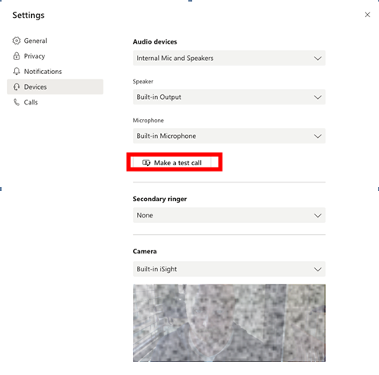

# Participants’ preparation for the virtual hearing

Participants will need to undertake a few additional steps to ensure that hearings through MS Teams run smoothly.

## Relevant documents

All relevant documents that will be relied upon to establish that the applicant meets the criteria for the visa must be submitted seven days prior to the hearing. Additional information such as changes in circumstances should also be included in information provided seven days prior to the hearing. Any documents or written arguments sent to the Tribunal should be in English and if not then accompanied by a translation from a qualified translator.

When conducting video hearings, MS Teams has screen sharing facilities which can also be used by the Tribunal to present documents electronically during the hearing to each of the participants. The member may arrange for a document to be shared on the screen.

For further information please refer to the [Migration and Refugee Division Practice Direction](https://www.aat.gov.au/resources/practice-directions-guides-and-guidelines) available on the Administrative Appeals Tribunal website under COVID-19 special measures.

## Sharing the virtual hearing room link for video hearings

In the case of a video hearing, the link in the email can be forwarded to any participants who will attend the hearing. Make sure to confirm the names of anyone who will attend the hearing on the Hearing Invitation Response Form to the Tribunal to ensure they are admitted into the virtual hearing room. Also provide them with any assistance in preparation to participate in the hearing including downloading MS Teams onto their devices.

# Video Hearings: Connecting to the virtual hearing room

You will receive an email invitation with a link to the virtual hearing room. You should copy this link in your calendar to make sure you do not lose it for your hearing. You should also forward the email containing the link to any other participant at the hearing.

## Using a Computer

* Click on the link, **Join Microsoft Teams Meeting** to connect to the virtual hearing room
* An option to download the MS Teams application for the device or to join in a browser will appear. If the MS Teams application is already downloaded, click the link to **Launch it now** to wait in a virtual lobby.
* Participants should wait in the virtual lobby until the Tribunal provides admittance into the virtual hearing room
* At this stage, check the MS Teams screen to see if the camera and microphone turned on.

Example of video and audio on:



Example of video off and audio on:



## Using a Phone/Tablet

* Click the link to **Join Microsoft Teams Meeting**
* If you have not downloaded the mobile application, you will be prompted to do so. Open the application and click the **Join as a guest** button. If this button does not appear, close the application and click on the link from the listing notice again.
* Type in your name and click **Join as a guest**. Allow Teams to record audio
* You will enter a virtual lobby until the Tribunal admits you into the hearing. Turn on your camera and audio.

# During an Audio and Video Hearing

## What happens at the hearing?

* At the beginning of the hearing, the AAT will tell you what you should and shouldn’t do during the hearing to make sure the hearing runs smoothly. This will usually include:
  + when to mute or unmute your microphone
  + if you are the applicant or a representative, how to signal that you want to speak to avoid people speaking over other participants.
* The AAT will make an audio and video recording of the hearing.
* **You must not record or transmit the hearing, or take any photographs or screenshots of the hearing without the AAT’s permission.**
* More information about what happens during an AAT hearing can be found on the AAT website, [aat.gov.au](http://www.aat.gov.au).

## Etiquette

The member may discuss with you what formalities need to be observed. Generally, you will not be expected to stand when the member enters and exits the hearing. You should avoid speaking over other participants except where that is essential.

Headphones with an inbuilt microphone can be used to improve your sound quality and avoid feedback issues.

During the hearing, please make sure to identify yourself before you begin speaking for audio and video hearings. This is for the benefit of anyone appearing by telephone in a video link and for all other participants during an audio hearing.

For video hearings, participants should dress as if attending an in-person hearing and participants’ phones should be on silent but if communication between the representative and applicant is required discrete use of the phone is acceptable. Consider setting your screen at a height so that you are looking straight at it.

## Navigating the Virtual Hearing Room for Video Hearings

In the virtual hearing room, an action bar will appear at the bottom of the screen when you move your mouse across the screen. The action bar has a number of functions:

8

2

3

4

5

6

9

1



7

|  |  |  |  |
| --- | --- | --- | --- |
| No. | Function | Button | Action |
| 1 | Timer |  | Displays the duration of the meeting. |
| 2 | Camera |  | Turn your camera on or off. |
| 3 | Microphone |  | Mute and unmute your microphone. |
| 4 | Share screen |  | Show others what is on your screen. |
| 5 | More actions |  | Find other settings including the option to change your background.[1] |
| 6 | Raise hand |  | Display a hand icon on your video feed to let others know that you would like to speak. |
| 7 | Chat |  | Show the conversation window for any messages sent to all participants.[2] |
| 8 | Participants |  | See a list of the other participants. |
| 9 | Hang up |  | Remove yourself from the virtual hearing room. |

### **Pinning participants**

In the hearing, you can right click on the face of different participants to ‘pin’ them to your screen. This will assign the person you have pinned to a particular location on your screen and they will not disappear when others speak. If a document is shared in the virtual hearing room, use the pinning function to see the parties instead of the document being shared.

## Leaving the Virtual Hearing Room

For adjournments in both audio and video hearings, the MS Teams session should end. The member will announce an adjournment and a time to reconvene, and then ask participants to end the call. You must end your call. If you are on a telephone, this can be done by hanging up. If you are on a video connection, then press the following button:

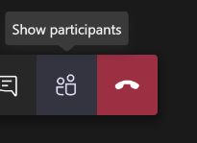

For adjournments in audio hearings, at the arranged resumption time, the Tribunal will dial all participants back into the hearing.

For video hearings please re-join the same way as you first joined, namely by clicking on the **Join Microsoft Teams Meeting** hyperlink.

## Access to Recordings

Recordings can be requested as usual.

# Appendix 1: Technology requirements for a video hearing

## Software

* Windows 10 with any browser
* Windows 10 with MS Teams app installed
* Windows 7 with Chrome as a browser or MS Teams plugin downloaded (this will be unlikely as Windows 7 is no longer supported by Microsoft, so most applicants will not have windows 7)
* Mac OS using Chrome browser or MS Teams app (Safari is not supported by Microsoft Teams)
* Smart phone (iOS or Android) using MS Teams app
* Smart phone (iOS) using Chrome as a browser (Safari is not supported by Microsoft Teams)
* Smart phone (Android) using any browser
* Tablet (iOS or Android) using MS Teams app
* Tablet (iOS) using Chrome as a browser (Safari is not supported by Microsoft Teams)
* Tablet (Android) using any browser

Note: Users without Office 365 will be prompted upon clicking “Join Microsoft Teams Meeting” to download the app. If the Applicant or participant does not feel comfortable downloading the app, they can open Microsoft Teams in the relevant browser.

## Equipment

* Computer or laptop with built in microphone, speaker and webcam
* Standalone webcam that can be connected to a laptop or computer
* Headphones with microphone that can be connected to a laptop, computer, tablet or smart phone
* Smart phone (iOS or Android)
* Tablet (iOS or Android)

# Appendix 2: Visual guide

## Windows 10

Step 1 – Below are two alternative views you may see. In both you have the option to open the Microsoft App or join through the web browser. Then follow the prompts.

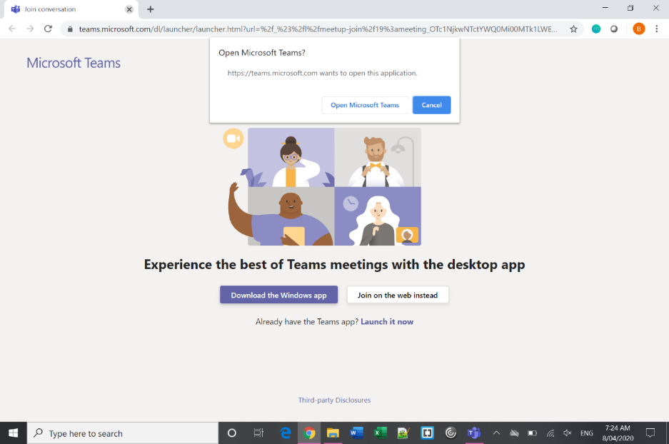

Or

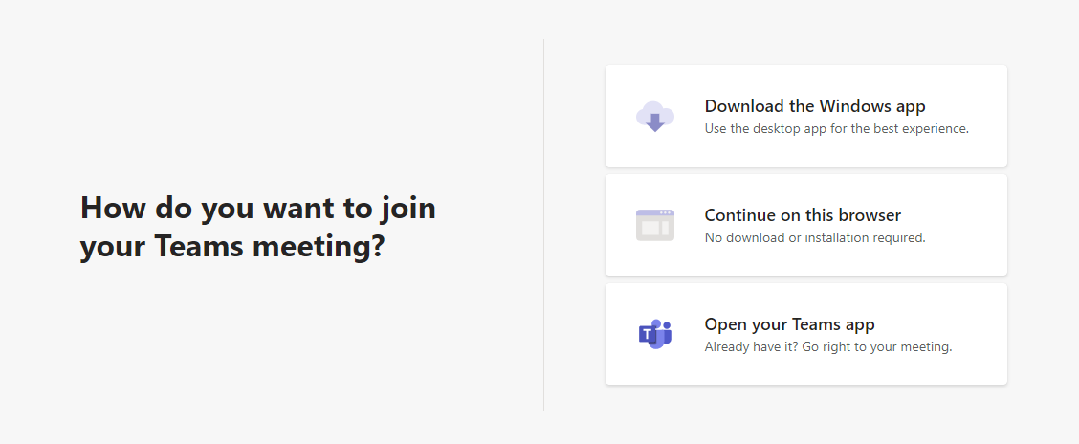

Step 2 – Enter your name

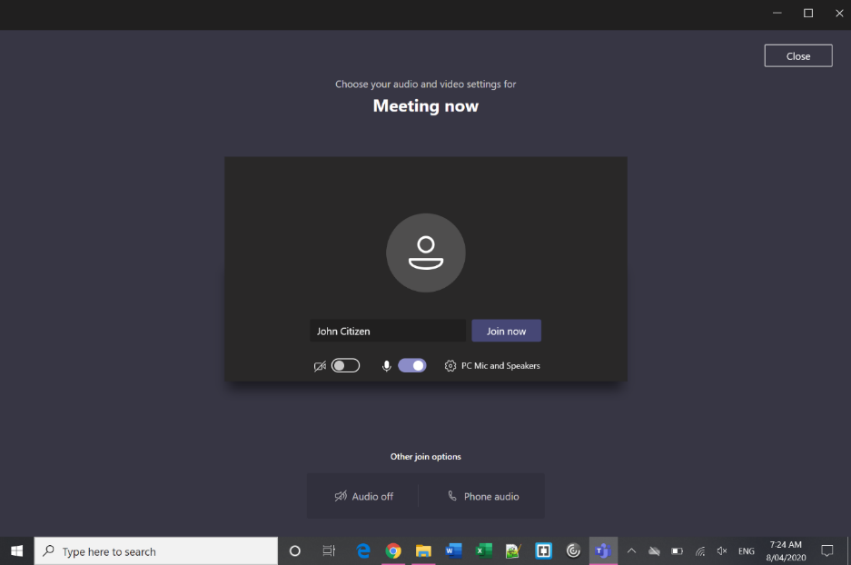

1. Type Your Name
2. Check camera & sound settings
3. Join Meeting

Step 3 – Wait in lobby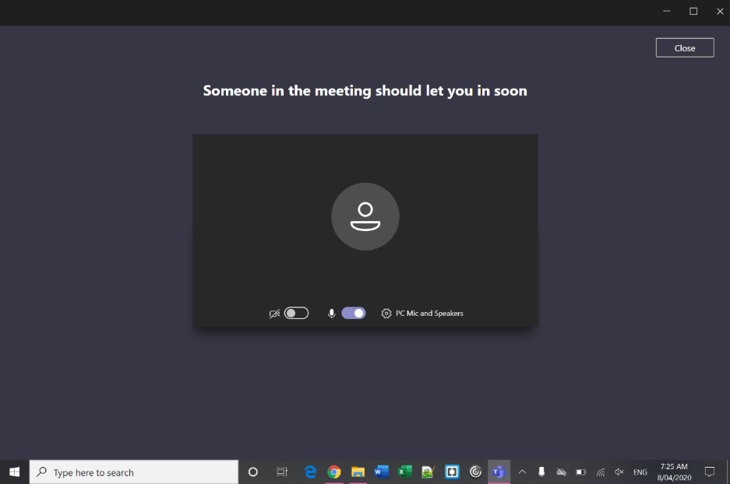

Step 4 – In the Virtual Hearing Room

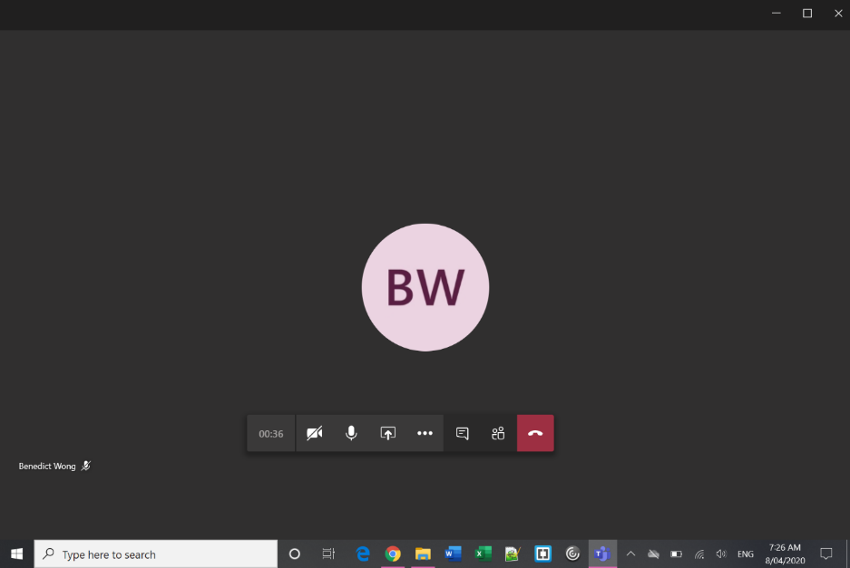

**Camera** – use this button to turn on/off your camera.

**Microphone** – unless you need to speak, stay muted to improve sound quality.

**Hang Up** – you can re-join the virtual hearing room using the same link and following the same process as above.

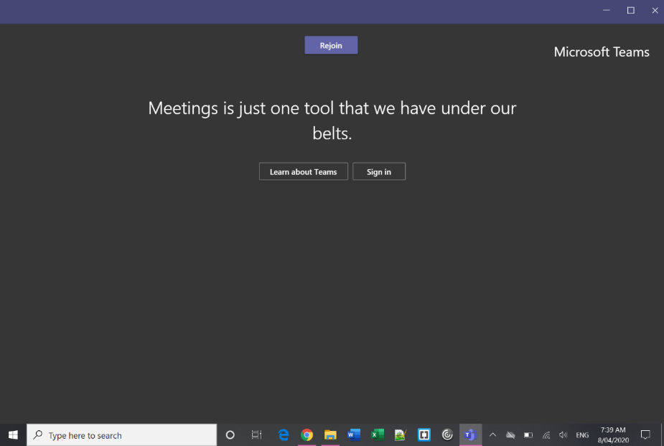Step 5 – Re-join after an adjournment

## Mac OS

Step 1 – Click the link and open in Microsoft Teams

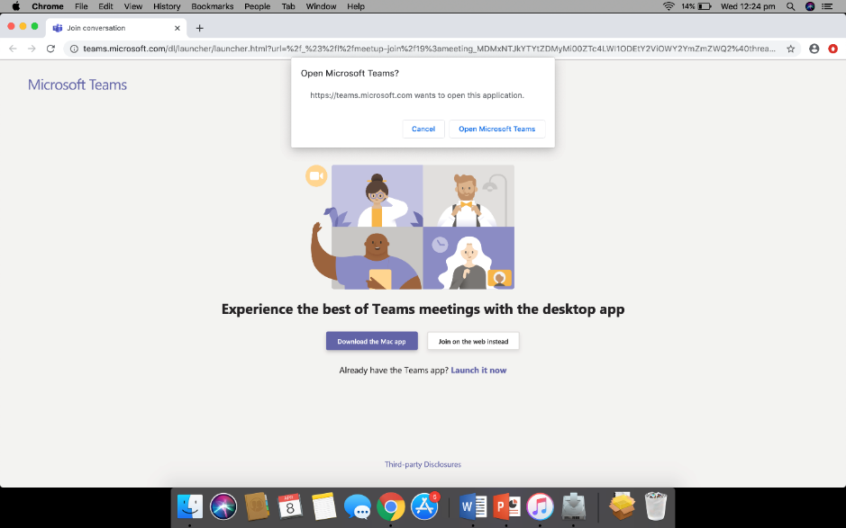

Step 2 – Enter your name

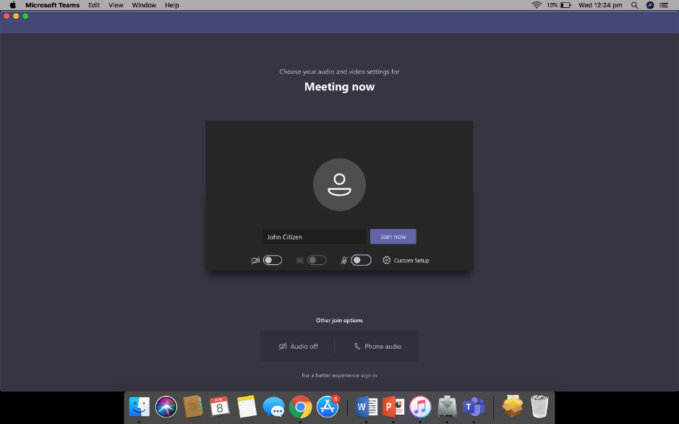

Step 3 – Wait in lobby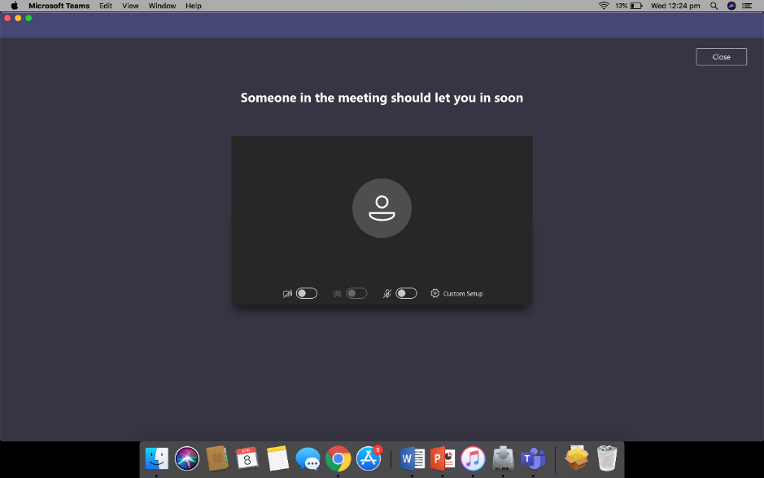

Step 4 – In the Virtual Hearing Room

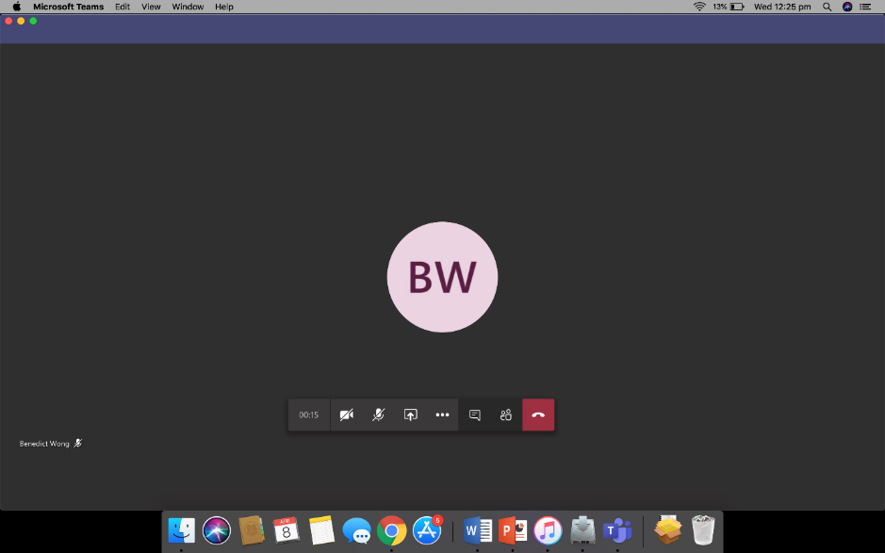

Step 5 – Re-join after an adjournment

**Camera** – use this button to turn on/off your camera.

**Microphone** – unless you need to speak, stay muted to improve sound quality.

**Hang Up** – you can re-join the virtual hearing room using the same link and following the same process as above.

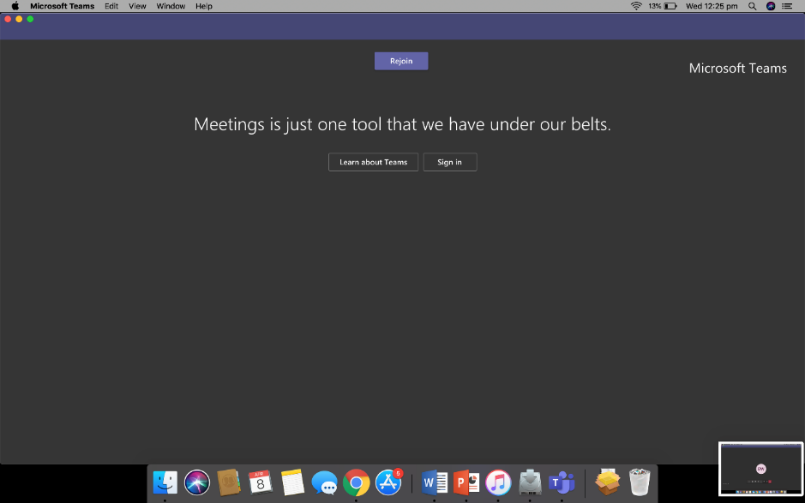

## Android

|  |  |  |  |
| --- | --- | --- | --- |
| Step 1 – Join as guest | Step 2 – Enter your name | | Step 3 – Wait in lobby |
|  |  | |  |
|  | Step 4 – In the meeting |

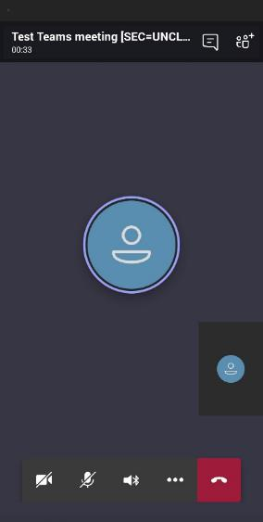

**Hang Up** – you can re-join the virtual hearing room using the same link and following the same process as above.

**Participants** – see who else is in the virtual hearing room.

**Camera Preview** – this will show how the others in the virtual hearing room see you.

**Main screen** – you can see the other people in the virtual hearing room. Only 4 faces are shown at a time based on who is talking.

**Camera** – use this button to turn on/off your camera.

**Microphone** – use this button to mute/unmute yourself – unless you need to speak, it’s a good idea to stay muted to improve sound quality.

**Speaker** – use this button to choose where your sound comes out. Use headphones to avoid feedback.

## iPhone/iPad

Step 1 – Join as guest



Step 2 – Enter your name

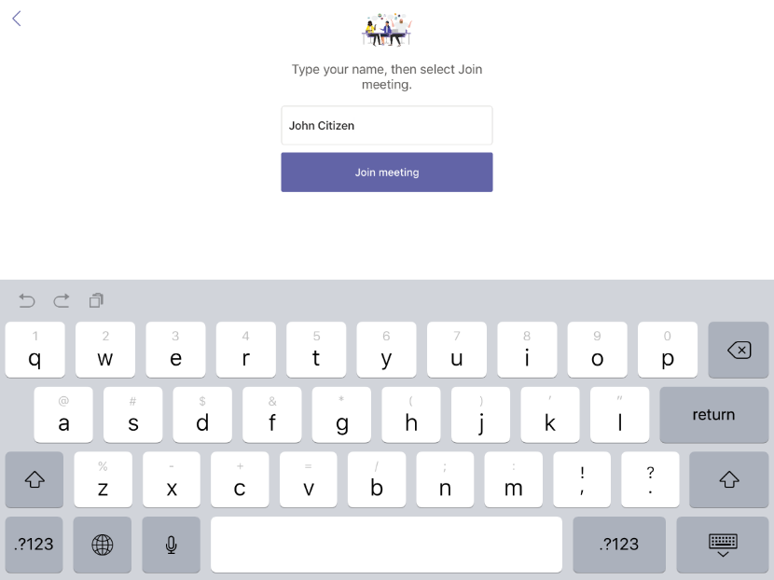

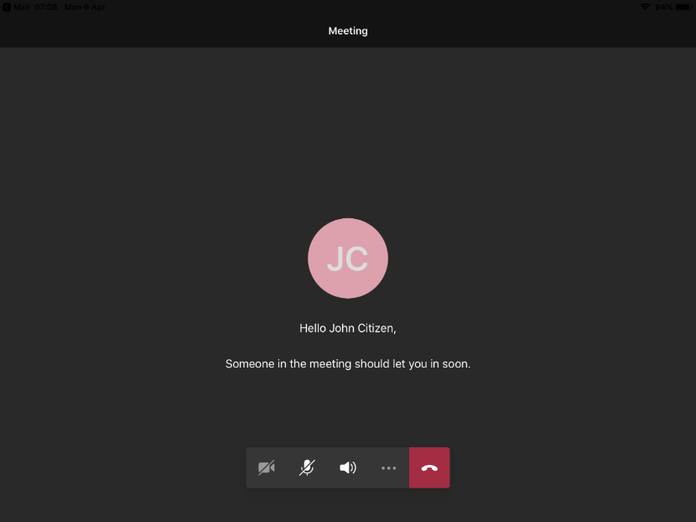Step 3 – Wait in lobby

Step 4 – In the meeting

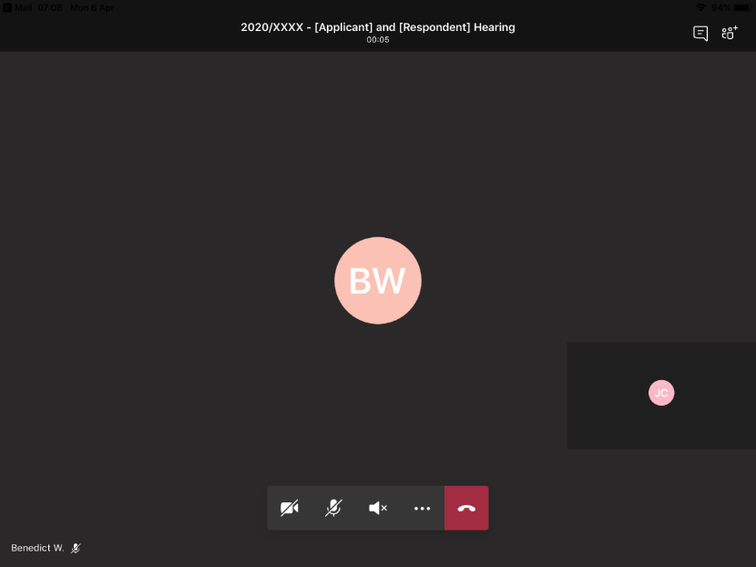

**Hang Up** – you can re-join the virtual hearing room using the same link and following the same process as above.

**Camera** – use this button to turn on/off your camera.

**Microphone** – unless you need to speak, stay muted to improve sound quality.

Step 5 – Re-join after an adjournment

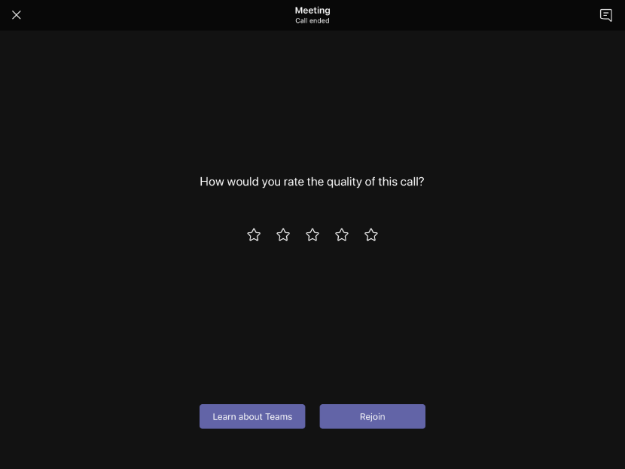

1. Changing and blurring backgrounds and other options depend on your device settings and are not available for all users.
2. Not all users will be able to send messages. The use of messaging during the virtual hearing is not recommended for any without-prejudice communications.