**User guide to video hearings using Microsoft Teams**

*This guide is for people who have been invited to attend an AAT video hearing using Microsoft Teams.*

[**aat.gov.au**](http://www.aat.gov.au)

Table of Contents

**1.** **Introduction** 3

**2.** **Privacy and information handling** 3

2.1. How safe is my information during a hearing using Microsoft Teams? 3

2.2. Protecting your information 3

**3.** **Preparing for the hearing** 4

3.1. Device and internet/network connection 4

3.2. Microsoft Teams 4

3.3. Making a test call 5

3.4. Participating in a test 6

**4.** **Joining the hearing** 7

4.1. Using a computer 7

4.2. Using a tablet or smartphone 8

**5.** **During the hearing** 9

5.1. What happens at the hearing? 9

5.2. Using the action bar 9

5.3. Re-joining the hearing 10

5.4. Pinning participants 10

5.5. Leaving the virtual hearing room 10

**6.** **Appendix 1: Technology requirements** 11

6.1. Equipment 11

6.2. Operating system/Software 11

**7.** **Appendix 2: Visual guide** 12

7.1. Computer with Windows 10 12

7.2. Apple Mac OS 15

7.3. Android 18

7.4. iPhone/iPad 19

1. **Introduction**

You have been invited to attend an AAT hearing that will be conducted by video using your own device. Follow the steps in this guide so you can participate in the hearing using your device.

1. **Privacy and information handling** 
   1. How safe is my information during a hearing using Microsoft Teams?

When we conduct a hearing using Microsoft Teams, the communication is encrypted.

Recordings of hearings are held securely within the AAT’s information technology environment which includes a cloud service that meets Australian Government security standards.

The AAT and our service providers must comply with the *Privacy Act 1988* in handling your personal information.

* 1. Protecting your information

You can protect your own privacy by ensuring you undertake the hearing in a location where you cannot be overheard, the background does not include personal information about you, and any Wi-Fi network used to access the internet is secure.

Look at our [Privacy Policy](http://www.aat.gov.au/AAT/media/AAT/Files/Corporate/PrivacyPolicy.pdf) for more information, including how you can access and seek correction of personal information we hold about you, make a complaint about the way we have handled your personal information and how we will deal with such a complaint.

1. **Preparing for the hearing**
   1. Device and internet/network connection

Determine which device and equipment you will use to join the video hearing. You can use a desktop or laptop computer, a tablet or a smartphone.

We recommend you use headphones with an inbuilt microphone as this will improve the sound quality.

You will need a broadband internet connection or a connection to a mobile network. If a mobile network is being used, then a 4G or 5G connection is strongly recommended.

* 1. Microsoft Teams

You can download the Microsoft Teams app for free onto the device you will be using from one of the links below:

* computer using Microsoft Windows: [Microsoft Teams Desktop Application](https://www.microsoft.com/en-au/microsoft-365/microsoft-teams/download-app)
* Apple Mac computer: [Microsoft Teams Desktop Application](https://www.microsoft.com/en-au/microsoft-365/microsoft-teams/download-app)
* Android tablet or phone: [Microsoft Teams for Android](https://play.google.com/store/apps/details?id=com.microsoft.teams&lm=deeplink&lmsrc=downloadPage&cmpid=downloadAndroidGetApp)
* Apple iPad or iPhone: [Microsoft Teams for iOS](https://apps.apple.com/au/app/microsoft-teams/id1113153706).

You can also download the app to your tablet or smartphone from the Apple App Store or Google Play.

If you do not want to download the app, you will need to have Microsoft Edge or Google Chrome installed on your device so you can open Microsoft Teams via the browser.

If you will be using a computer with Windows 7, you will need to either:

* download the MS Teams plugin for your web browser, or
* have Google Chrome installed on your computer so you can join via the browser.

**More information about the kind of device and the minimum technology requirements can be found in** **Appendix 1****.**

* 1. Making a test call

If you will be using a desktop or laptop computer, it is strongly recommended that you make a test call to:

* test your connection and ability to use Microsoft Teams; and
* make sure you are familiar with the microphone, speakers and webcam on your computer.

**MS Team apps for mobile and tablets do not contain a test call function.**

To make a test call on your computer, make sure the audio and video options on your device are connected:

* click on the **Profile** icon in the top right-hand corner to reveal a drop-down menu;
* from this menu click **Settings**, then **Devices**;
* from the **Device** screen you will be able to check your microphone and camera settings to make sure they are working;
* click on **Make a test call** which will run a test for you and play back the results.

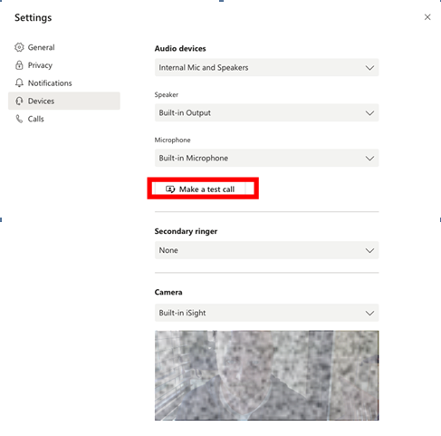

* 1. Participating in a test

If you are the applicant, we will contact you to arrange a test closer to the hearing date to ensure that the connection is working. We will also contact your representative and any witnesses you have asked to attend the hearing to test their technology.

In the days before the test, you should:

1. decide where you will be located when you participate in the hearing. Choose somewhere that:

* is quiet, private and where you won’t be interrupted
* has good internet connection
* has good lighting and an appropriate background
* is close to a charging station (power point) if you need one.

1. plan how you will set up your screen or camera/webcam so that you are looking directly at it from a front on position.
2. think about what you will wear to the hearing; you should dress as if you were attending the hearing in person.
3. **Joining the hearing**

**Before your hearing**:

* Set up your equipment just like you did to participate in the test (*See Section 2.4 – Participating in a test*)
* If you have headphones with an inbuilt microphone, connect these to your device.

**To ensure better sound quality and to minimise feedback issues, we prefer that you use headphones with an inbuilt microphone rather than placing your phone on loudspeaker.**

* Make sure you have the link to **Join Microsoft Teams Meeting** that we sent you ready to select on your device.

**The link is in the email from the AAT inviting you to the hearing.**

* Make sure any devices not being used in the hearing are set to silent mode.
* Ensure you have all relevant hearing documents with you.
  1. Using a computer
* At least **15 minutes before** the hearing, click on the link **Join Microsoft Teams Meeting**.
* You will be given the option to:
  + **Open Microsoft Teams** – Click this if you have already downloaded the app
  + **Join on the web instead** – Click this if you don’t have the app installed.

**Please note that you will be prompted upon clicking “Join Microsoft Teams Meeting” to download the app if you do not have Office 365.**

* On the Microsoft Teams screen, check your camera and microphone are turned on.

Example of video and audio on:



Example of video off and audio on:



* Type your name in the box if you are asked to do this: enter your first name and family name *(Please note this will appear to all other people attending the hearing by video).*
* Click **Join now** *(You will now enter the virtual lobby).*
* Wait in the virtual lobby until the Tribunal admits you into the virtual hearing room.

**More information on how to join a Teams hearing from your** **Windows** **or** **Mac** **computer can be found in Appendix 2.**

* 1. Using a tablet or smartphone
* At least **15 minutes before** the hearing, click on the link **Join Microsoft Teams Meeting***.*

*(If you have not downloaded the app, you will be prompted to do so. If you have already downloaded the app, it will open automatically).*

* Click **Join as a guest**. *(You will be asked to enter your name).*
* Type your name in the box: enter your first name and family name. *(Please note this will appear to all other people attending the hearing by video.)*
* Click **Join meeting** or **Join as a guest** *(You will enter the virtual lobby).*
* Turn on your camera by clicking the camera icon.
* Turn on your audio by clicking the microphone icon.
* Wait in the virtual lobby until the Tribunal admits you into the virtual hearing room.

**More information on how to join a Teams hearing from your** **Android** **or** **iOS** **device can be found in Appendix 2.**

1. **During the hearing** 
   1. What happens at the hearing?

* At the beginning of the hearing, the AAT will tell you what you should and shouldn’t do during the hearing to make sure the hearing runs smoothly. This will usually include:
  + when to mute or unmute your microphone
  + if you are the applicant or a representative, how to signal that you want to speak to avoid people speaking over other participants.
* The AAT will make an audio and video recording of the hearing.
* **You must not record or transmit the hearing, or take any photographs or screenshots of the hearing.**
* More information about what happens during an AAT hearing can be found on the AAT website, [aat.gov.au](http://www.aat.gov.au).
  1. Using the action bar

An ‘action bar’ will appear at the bottom of the screen when you move your mouse across the screen. The action bar has a number of functions that may be used during the hearing.

The functions displayed on the action bar may vary depending on your device. Please refer to Appendix 2 for more examples of action bars.

If you are using Teams on a computer, this is what the action bar will look like:

2

3

4

5

6

9

8

7



1

|  |  |  |  |
| --- | --- | --- | --- |
| No. | Function | Button | Action |
| 1 | Timer |  | Displays the duration of the meeting. |
| 2 | Camera |  | Turn your camera on or off. |
| 3 | Microphone |  | Mute and unmute your microphone. |
| 4 | Share screen |  | Show others what is on your screen. |
| 5 | More actions |  | Find other settings including the option to change your background.[1] |
| 6 | Raise hand |  | Display a hand icon on your video feed to let others know that you would like to speak. |
| 7 | Chat |  | Show the conversation window for any messages sent to all participants.[2] |
| 8 | Participants |  | See a list of the other participants. |
| 9 | Hang up |  | Remove yourself from the virtual hearing room. |

* 1. Re-joining the hearing

During the hearing, you may unintentionally disconnect from the virtual hearing room or the member may adjourn the hearing and ask you to disconnect. If you unintentionally disconnect, you should re-join the hearing by following the instructions set out in Part 4. If the member adjourns the hearing, you will be given a specific time when you should reconnect to the virtual hearing room. In either case, the member or hearing officer will be able to see if you have disconnected or re-joined the virtual hearing room.

* 1. Pinning participants

You can right click on the face of different participants to ‘pin’ them to your screen. This will assign the person you have pinned to a particular location on your screen and they will not disappear when others speak. If a document is shared in the virtual hearing room, use the pinning function to see the parties instead of the document being shared.

If you decide not to use the pinning function, Microsoft Teams will automatically display the active speaker and rearrange the other participants on your screen.

* 1. Leaving the virtual hearing room

When the hearing has ended, click the following button:

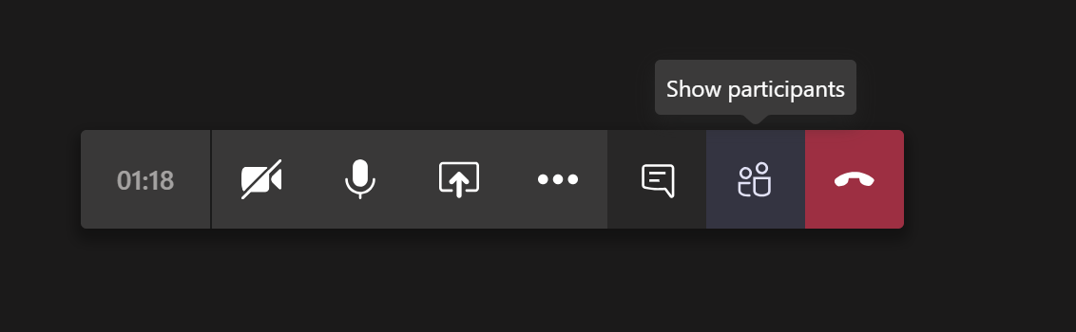

1. **Appendix 1: Technology requirements**
   1. Equipment

* Desktop or laptop computer with built in microphone, speaker and webcam
* Standalone webcam that can be connected to a desktop or laptop computer
* Headphones with microphone that can be connected to a laptop, computer, tablet or smart phone
* Smart phone (Apple iOS or Android)
* Tablet (Apple iOS or Android.
  1. Operating system/Software

**Desktop or laptop computers:**

* Windows 10 with any browser
* Windows 10 with MS Teams app installed
* Windows 7 but only with Microsoft Edge or Google Chrome as a browser or with the MS Teams plugin downloaded
* Apple Mac OS X 10.11 or later, using MS Teams app or Chrome as a browser (Safari is not supported by Microsoft Teams).

**Tablets:**

* Tablet (Apple iOS 10.0 or later or Android 4.4 or later) using MS Teams app
* Tablet (Apple iOS) using Chrome as a browser (Safari is not supported by Microsoft Teams)
* Tablet (Android) using any browser.

**Smartphones:**

* Smart phone (Apple iOS 10.0 or later or Android 4.4 or later) using MS Teams app
* Smart phone (Apple iOS) using Chrome as a browser (Safari is not supported by Microsoft Teams)
* Smart phone (Android) using any browser.

1. **Appendix 2: Visual guide**
   1. Computer with Windows 10

Step 1 – Below are two alternative views you may see. In both you have the option to open the Microsoft App or join through the web browser. Then follow the prompts.

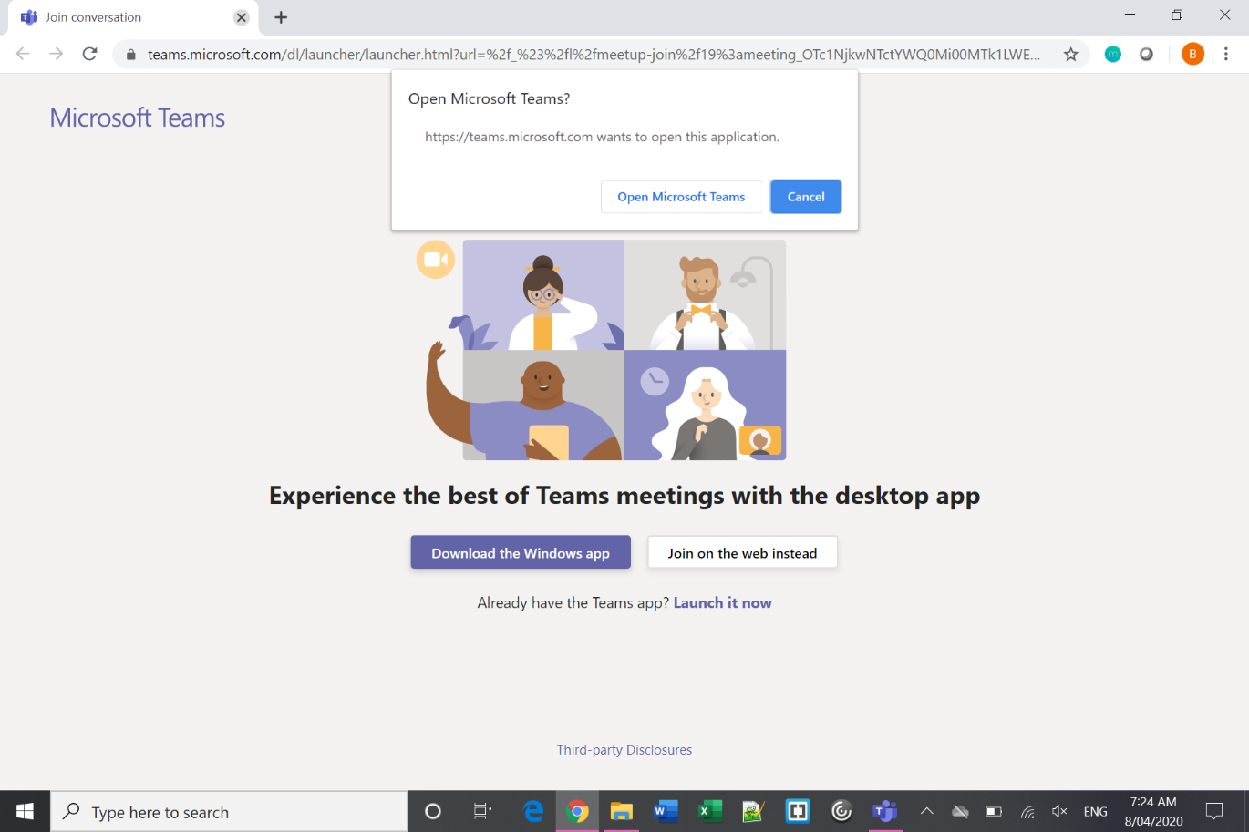

Or

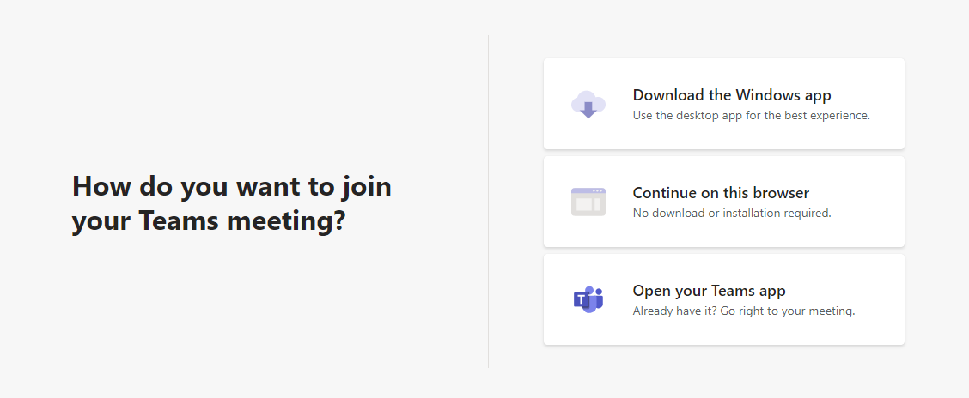

Step 2 – Enter your name

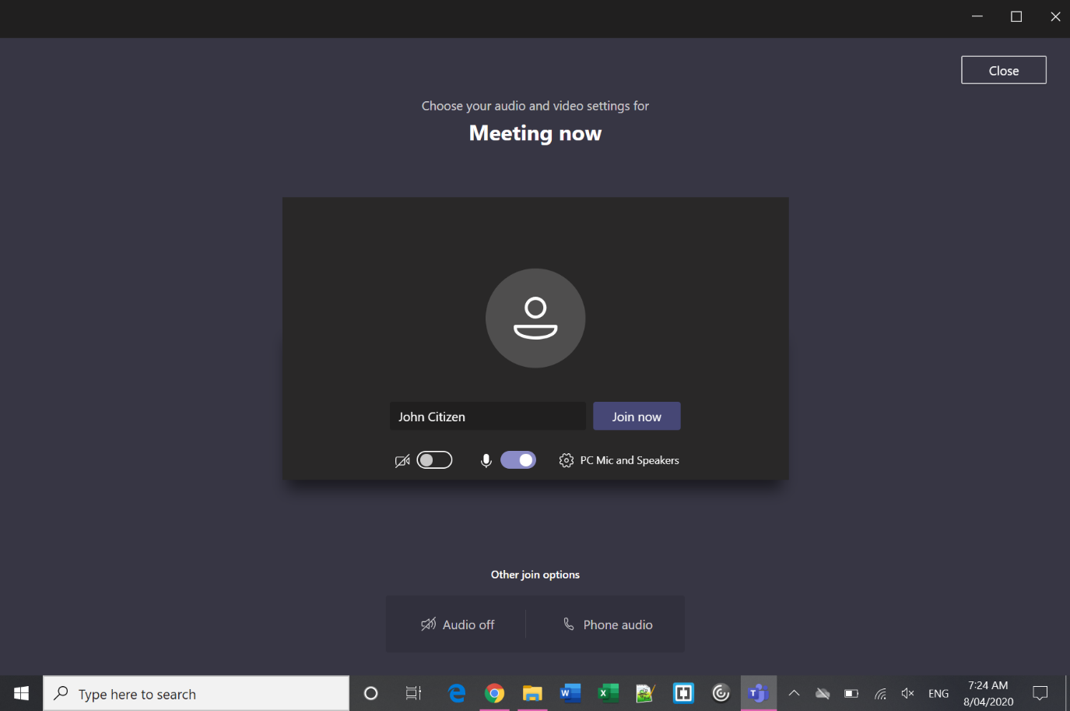

1. Type Your Name
2. Check camera & sound settings
3. Join Meeting

Step 3 – Wait in lobby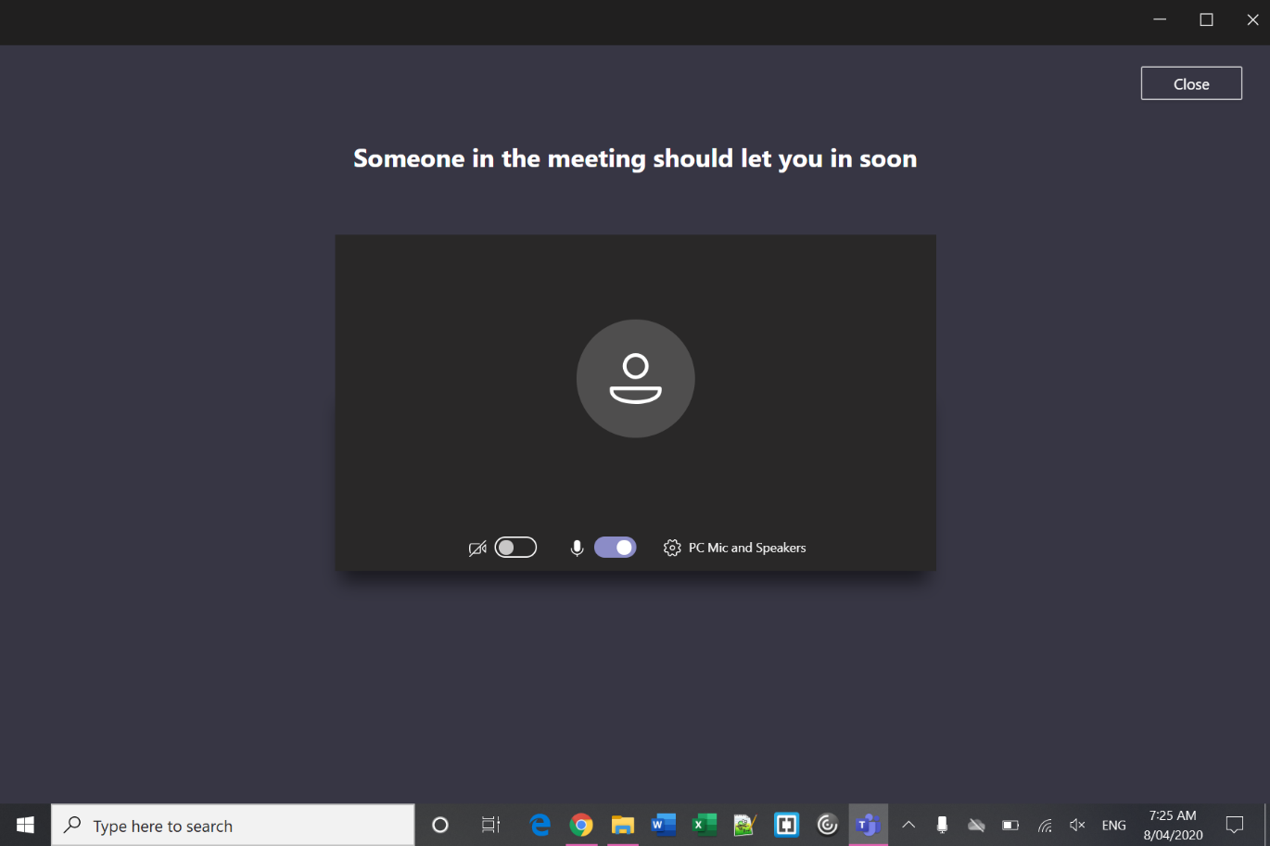

Step 4 – In the Virtual Hearing Room

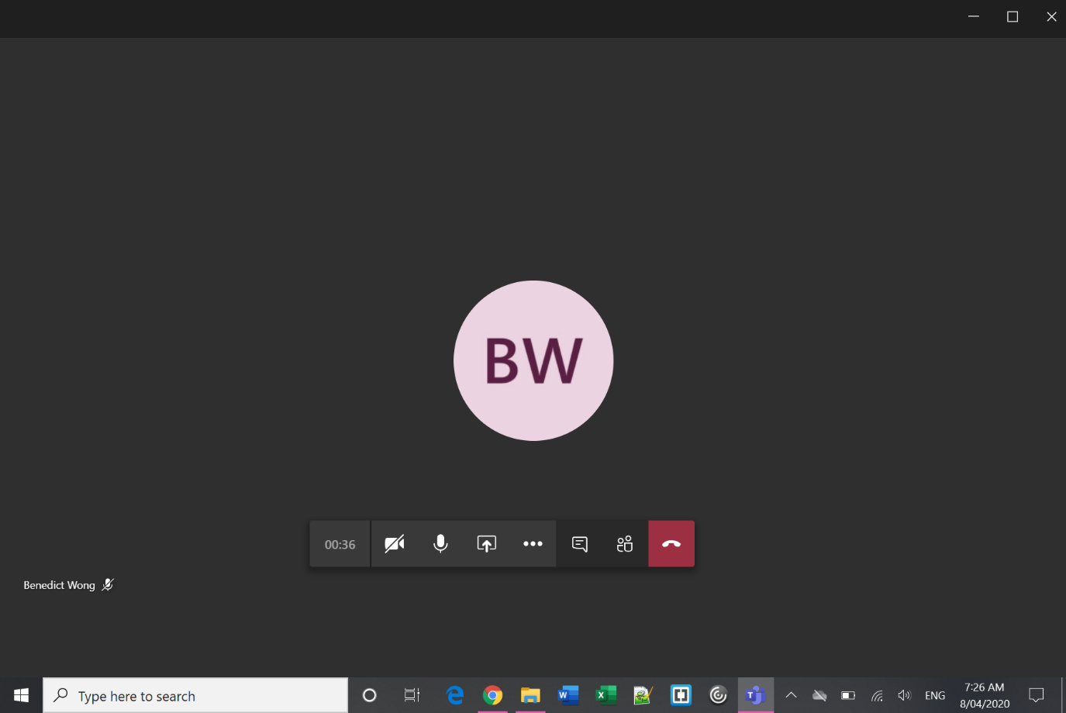

**Camera** – use this button to turn on/off your camera.

**Microphone** – unless you need to speak, stay muted to improve sound quality.

**Hang Up** – you can re-join the virtual hearing room using the same link and following the same process as above.

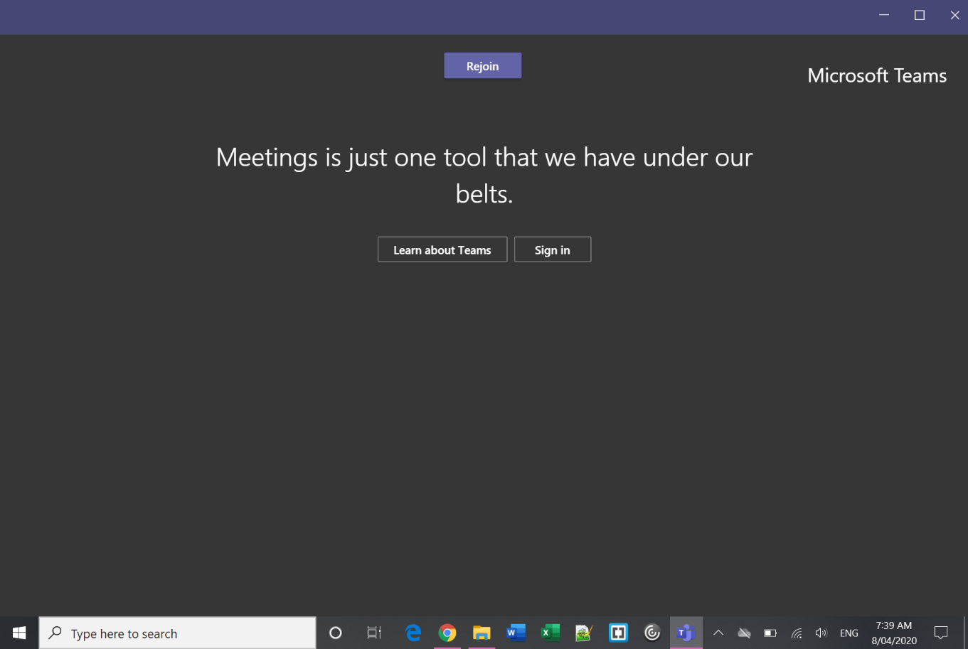Step 5 – Re-join after an adjournment

* 1. Apple Mac OS

Step 1 – Click the link and open in Microsoft Teams

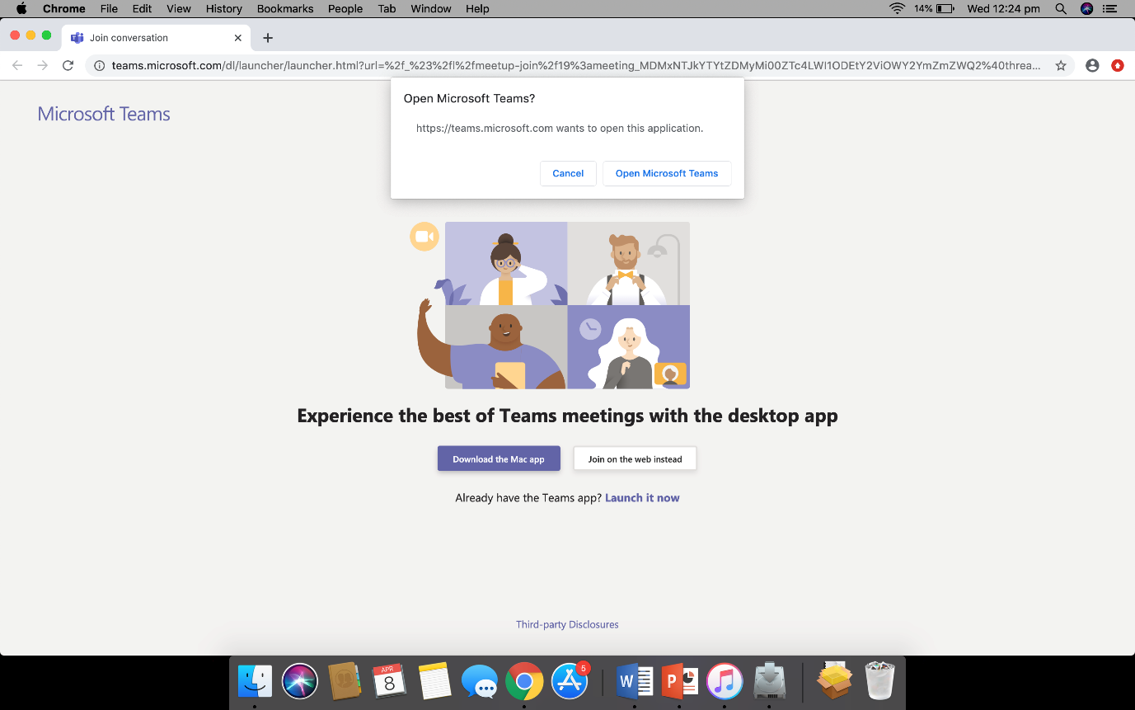

Step 2 – Enter your name

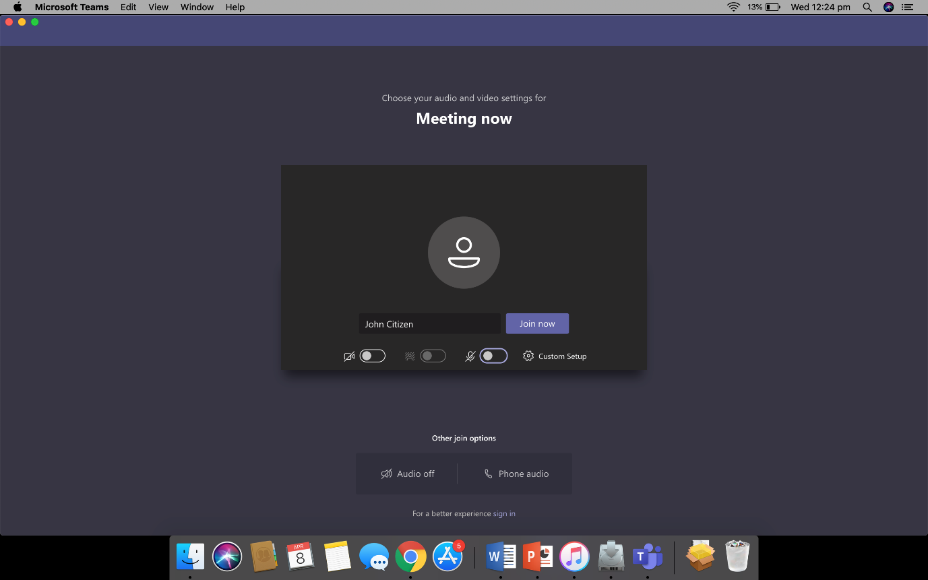

Step 3 – Wait in lobby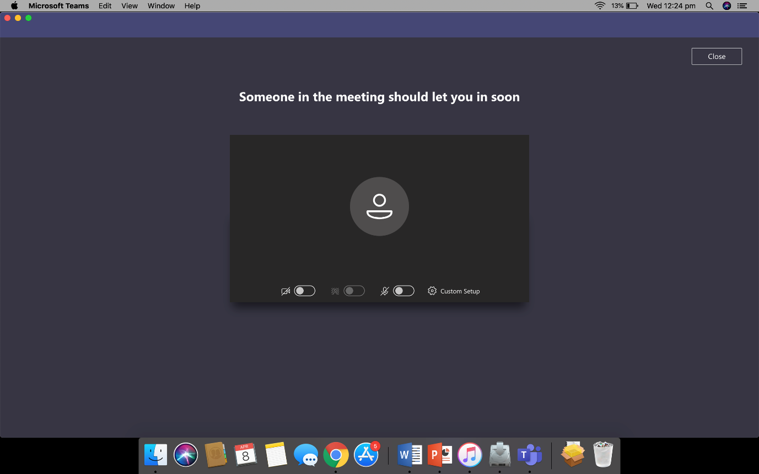

Step 4 – In the Virtual Hearing Room

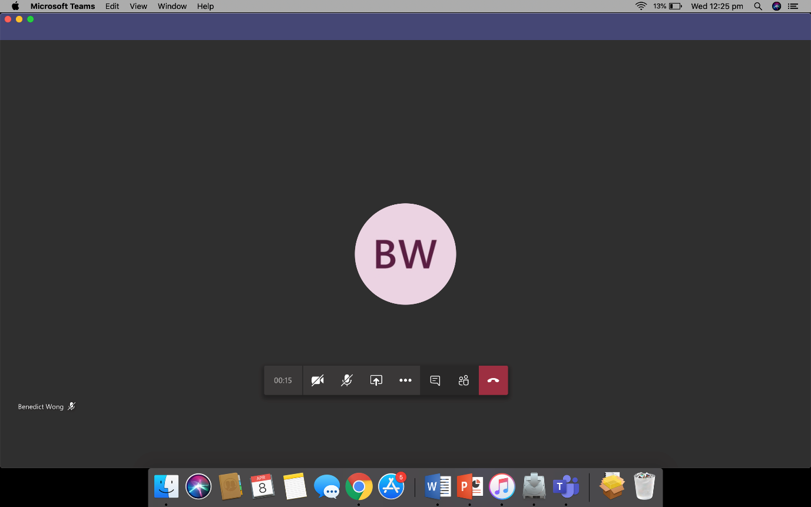

Step 5 – Re-join after an adjournment

**Camera** – use this button to turn on/off your camera.

**Microphone** – unless you need to speak, stay muted to improve sound quality.

**Hang Up** – you can re-join the virtual hearing room using the same link and following the same process as above.

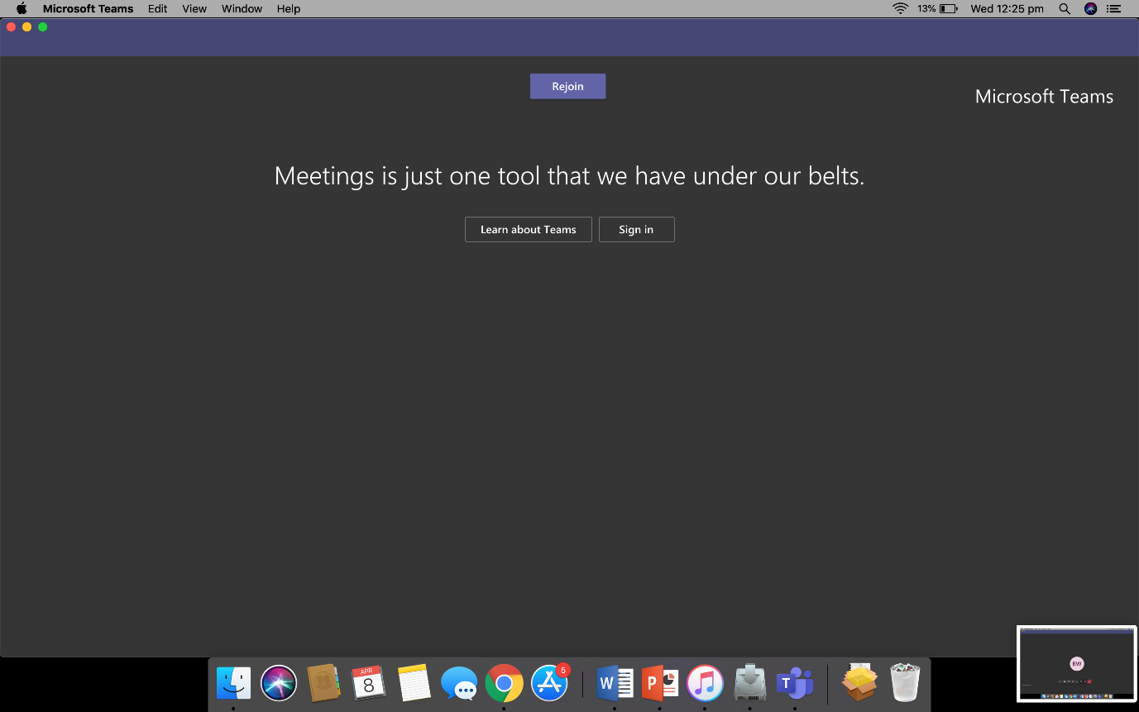

* 1. Android

|  |  |  |  |
| --- | --- | --- | --- |
| Step 1 – Join as guest | Step 2 – Enter your name | | Step 3 – Wait in lobby |
|  |  | |  |
|  | Step 4 – In the meeting |

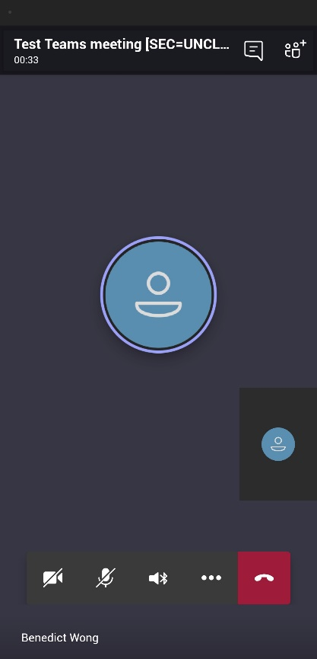

**Hang Up** – you can re-join the virtual hearing room using the same link and following the same process as above.

**Participants** – see who else is in the virtual hearing room.

**Camera Preview** – this will show how the others in the virtual hearing room see you.

**Main screen** – you can see the other people in the virtual hearing room. Only 4 faces are shown at a time based on who is talking.

**Camera** – use this button to turn on/off your camera.

**Microphone** – use this button to mute/unmute yourself – unless you need to speak, it’s a good idea to stay muted to improve sound quality.

**Speaker** – use this button to choose where your sound comes out. Use headphones to avoid feedback.

* 1. iPhone/iPad

Step 1 – Join as guest

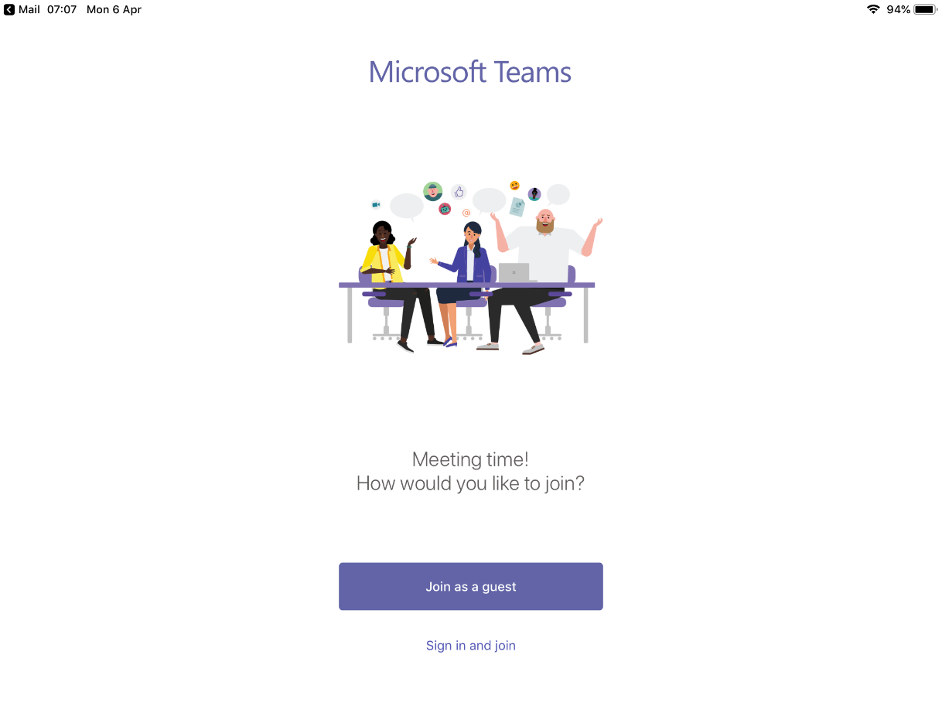

Step 2 – Enter your name

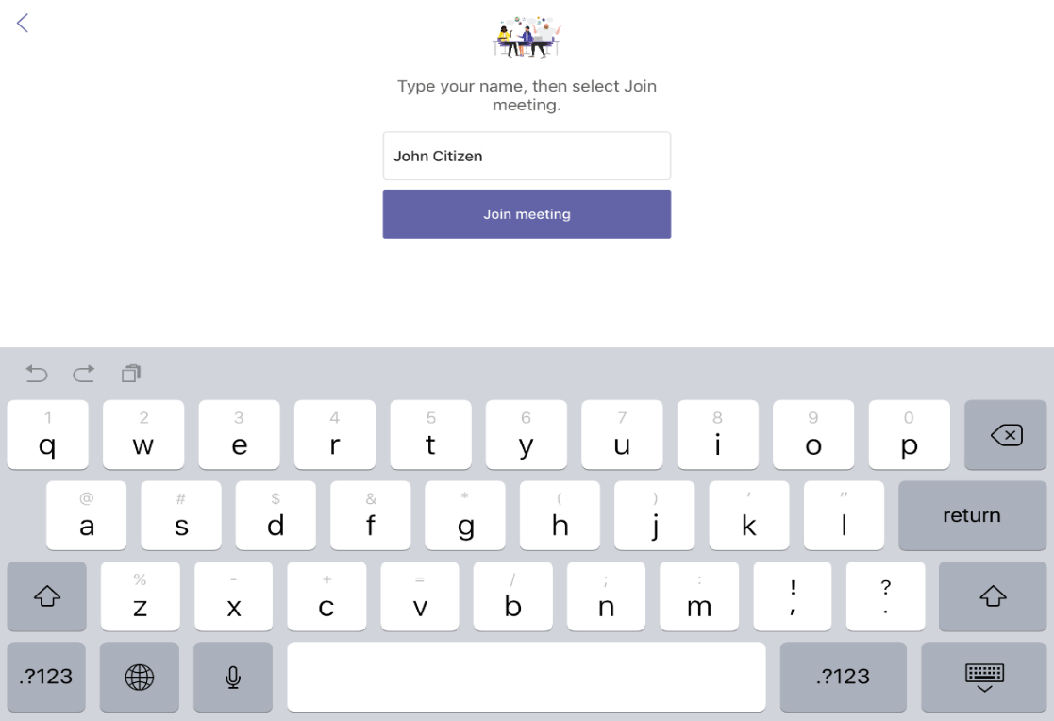

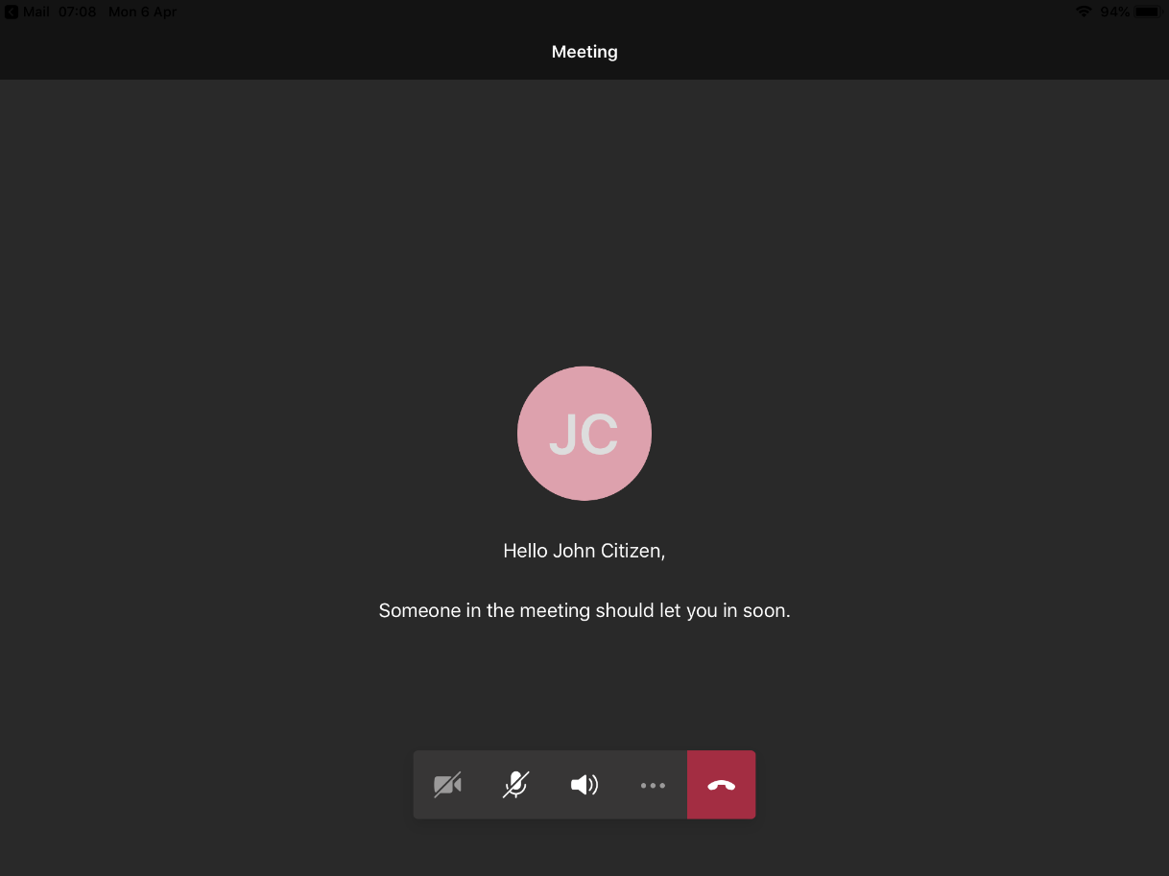Step 3 – Wait in lobby

Step 4 – In the meeting

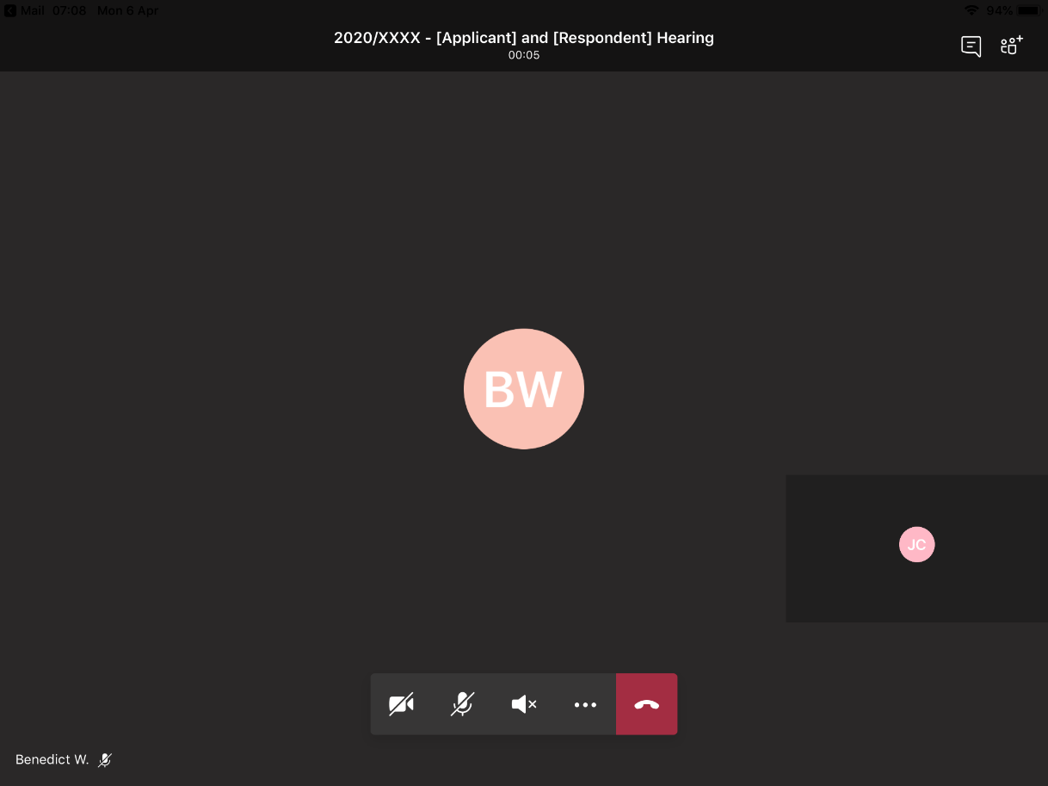

**Hang Up** – you can re-join the virtual hearing room using the same link and following the same process as above.

**Camera** – use this button to turn on/off your camera.

**Microphone** – unless you need to speak, stay muted to improve sound quality.

Step 5 – Re-join after an adjournment

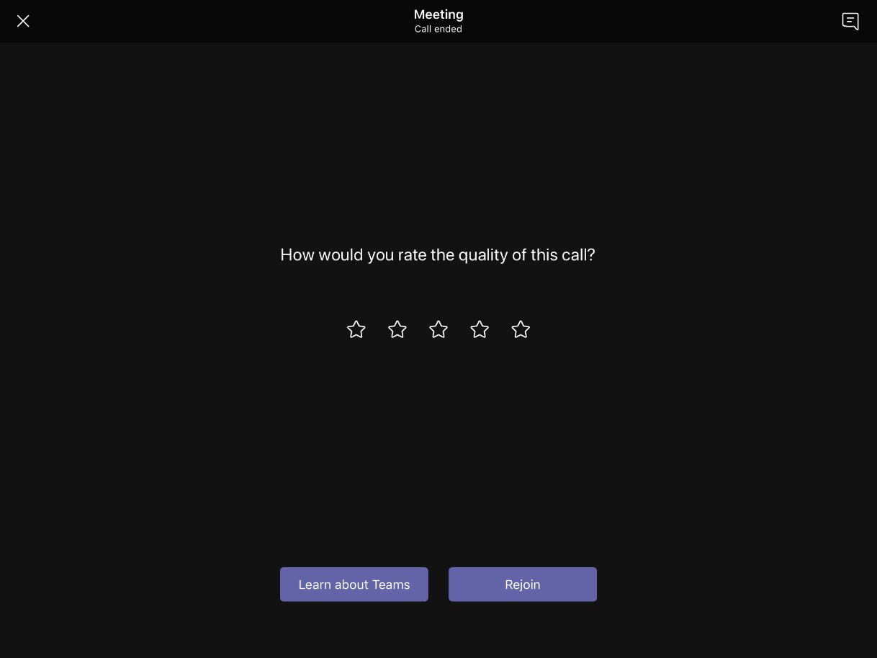

1. Changing and blurring backgrounds and other options depend on your device settings and are not available for all users.
2. Messages should not be sent during the hearing unless at the direction of the presiding member.